Setting up replication CloudBasix

The process should has no difference between RDS and On-Premise

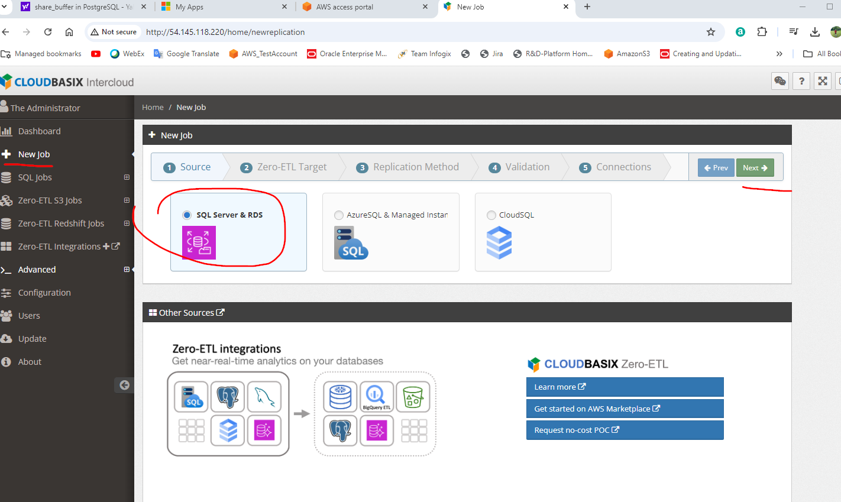

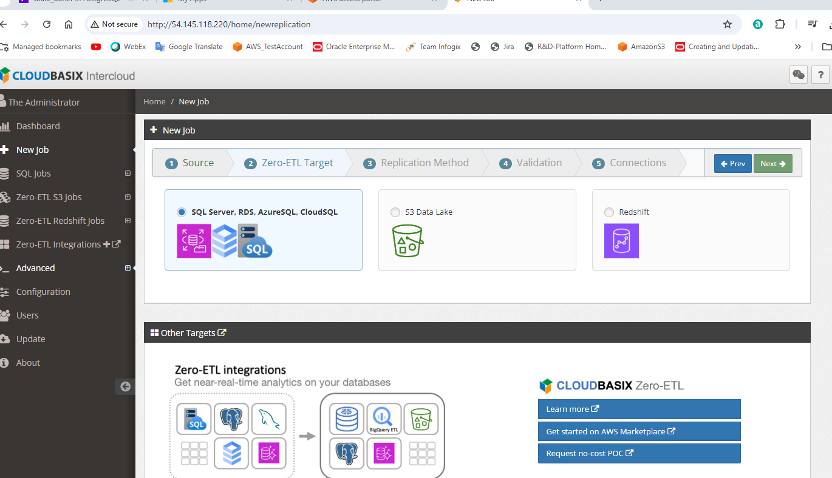

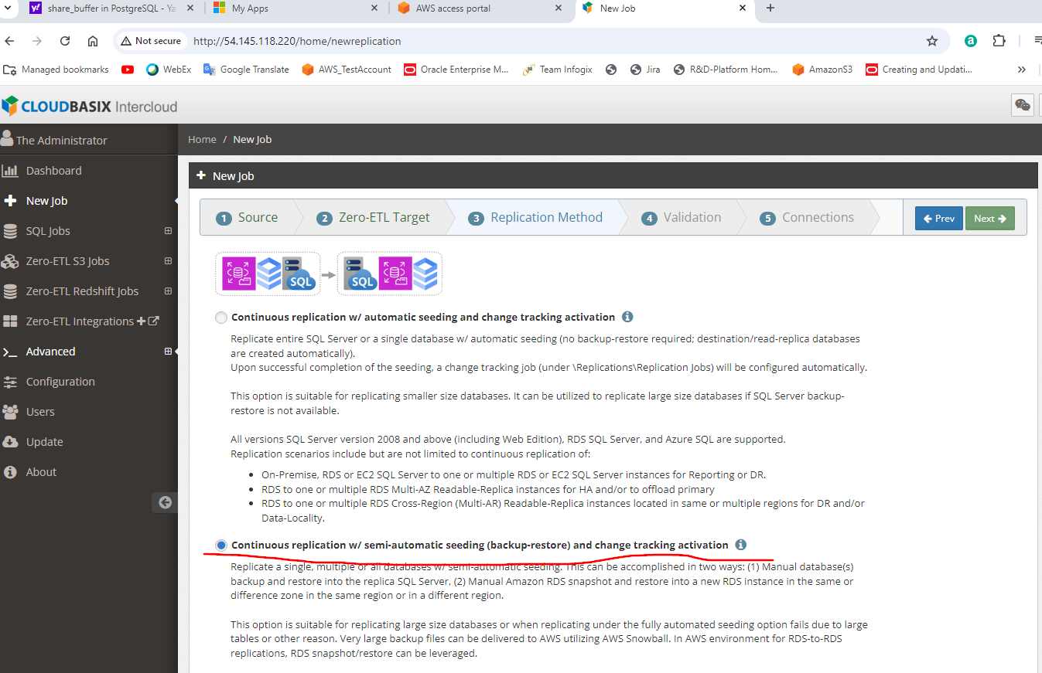

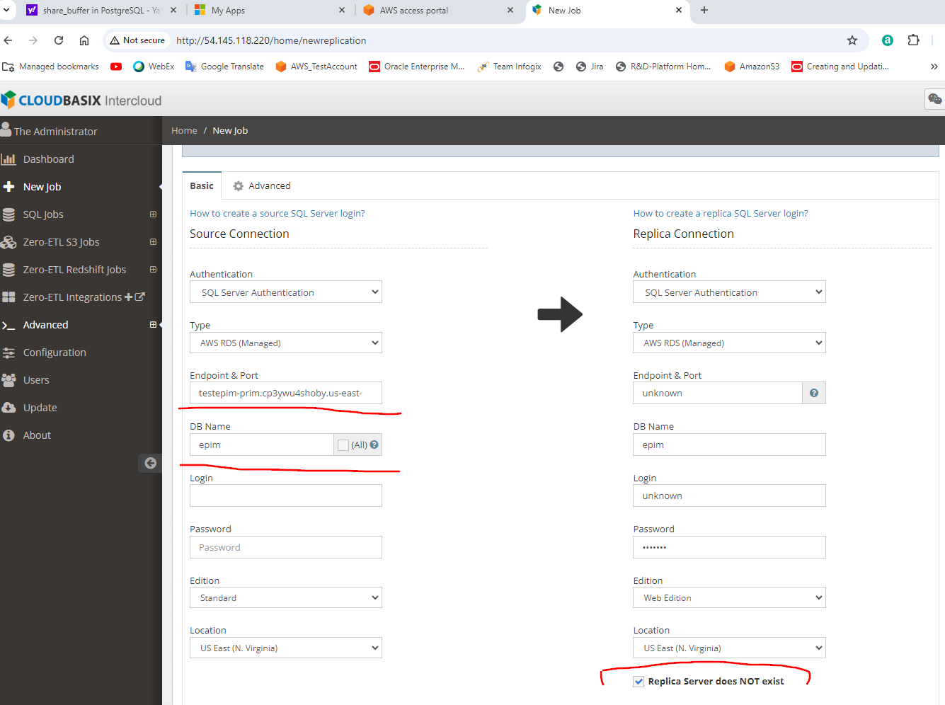

Click test connection after fill in source database information. Check “Replica Server does NOT exists”.

Click on “Start Replication” on top of the panel.

At some point, it will prompt to take the backup snapshot of the Primary(Writer) database and then restore it.

After that, just follow the instructions.

**It is important to split the table without PK, and especially the table contains XML column (binary column) to different job.**

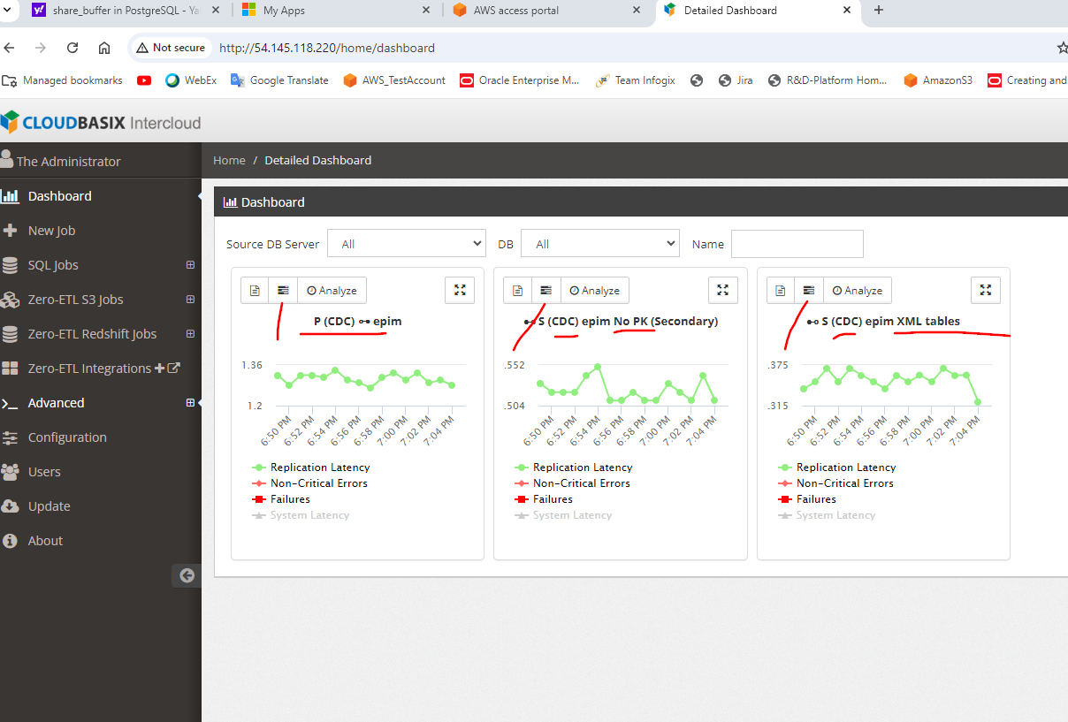

Icon to Step/Start replication:

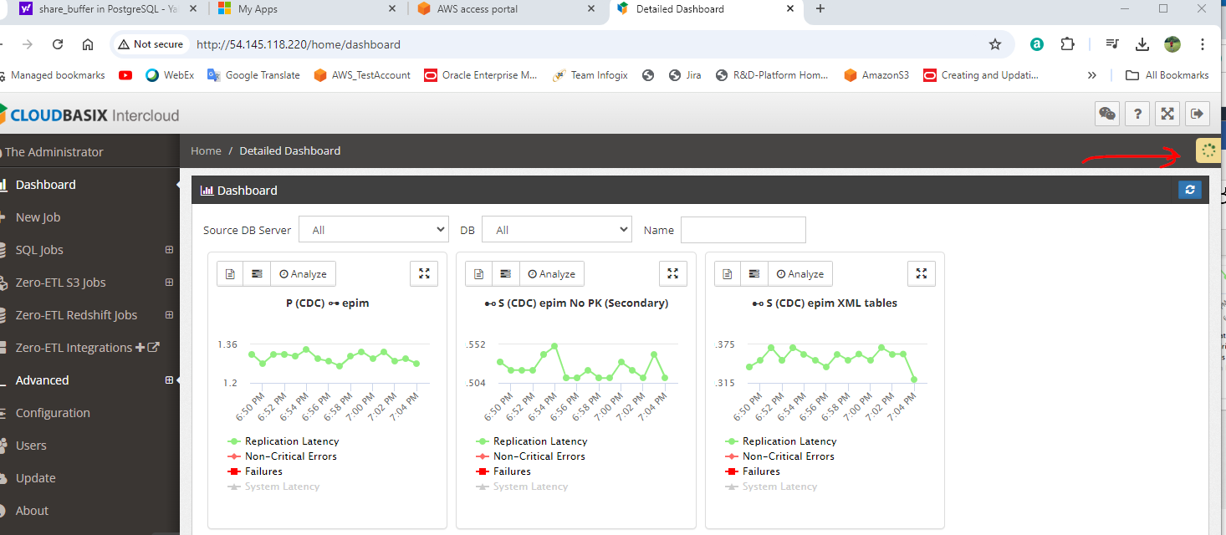

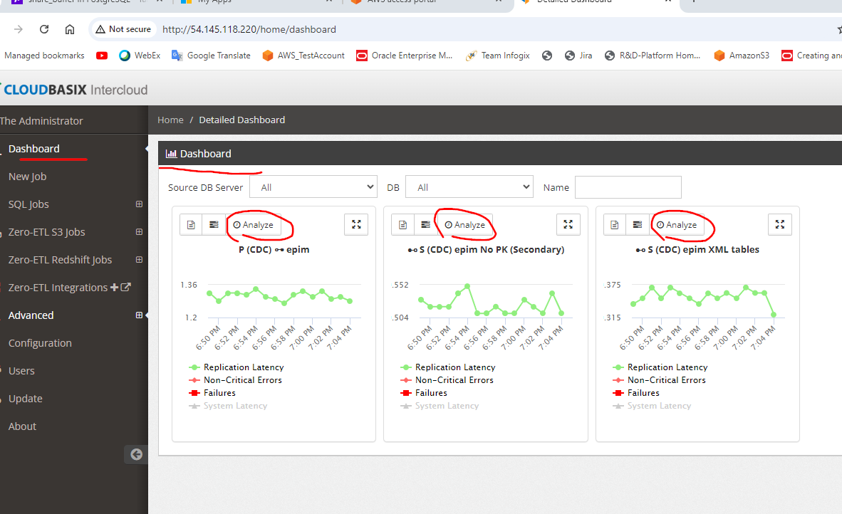

See the status (Pending Replicat…) click on Analyze button under dashboard.

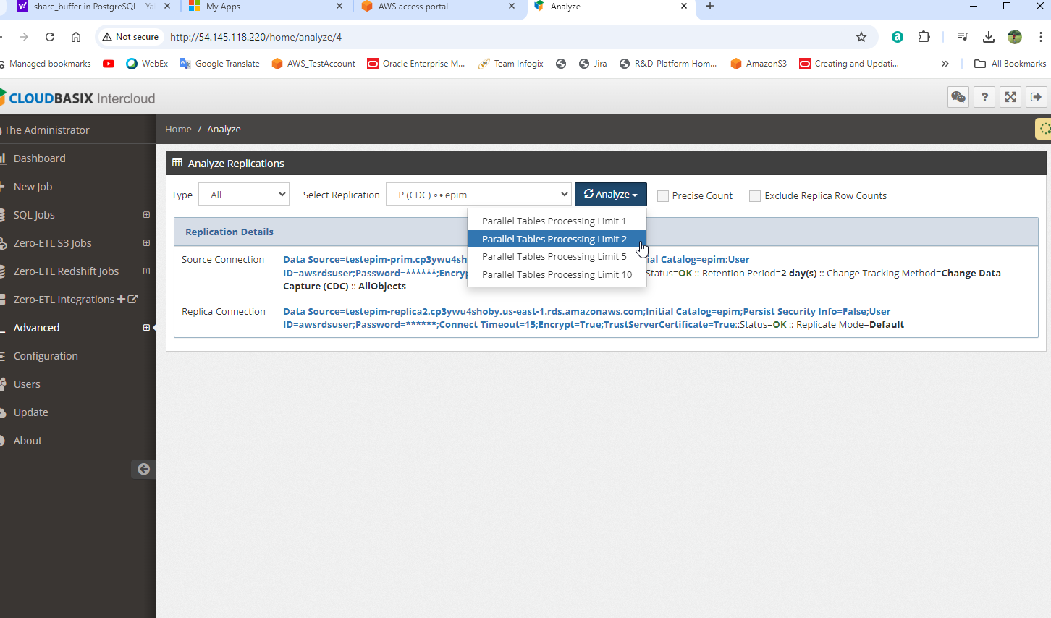

Select any item from Analyze button.

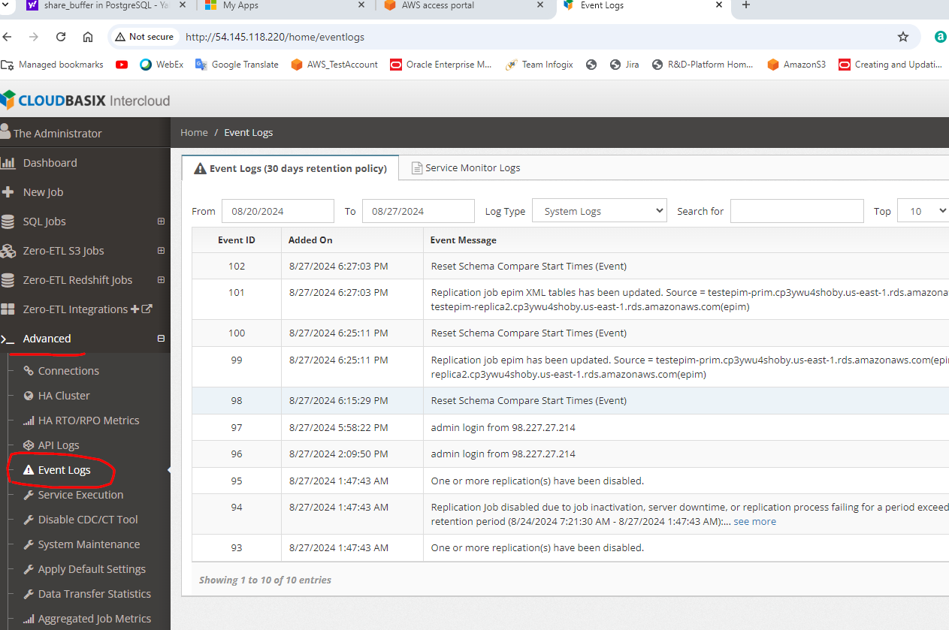

Find the event log.

Set auto detect dynamic table:

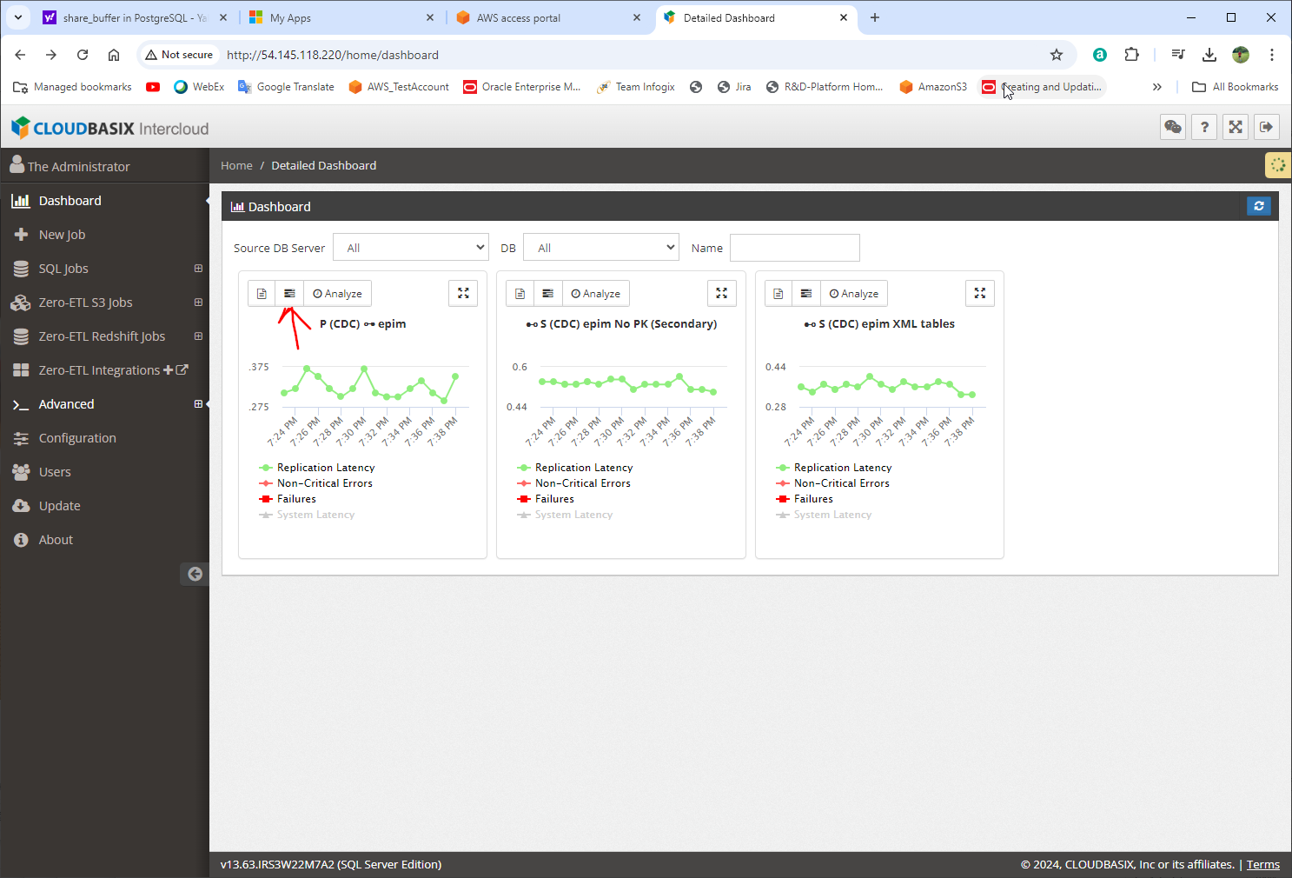

Click “setting” icon on Dashboard.

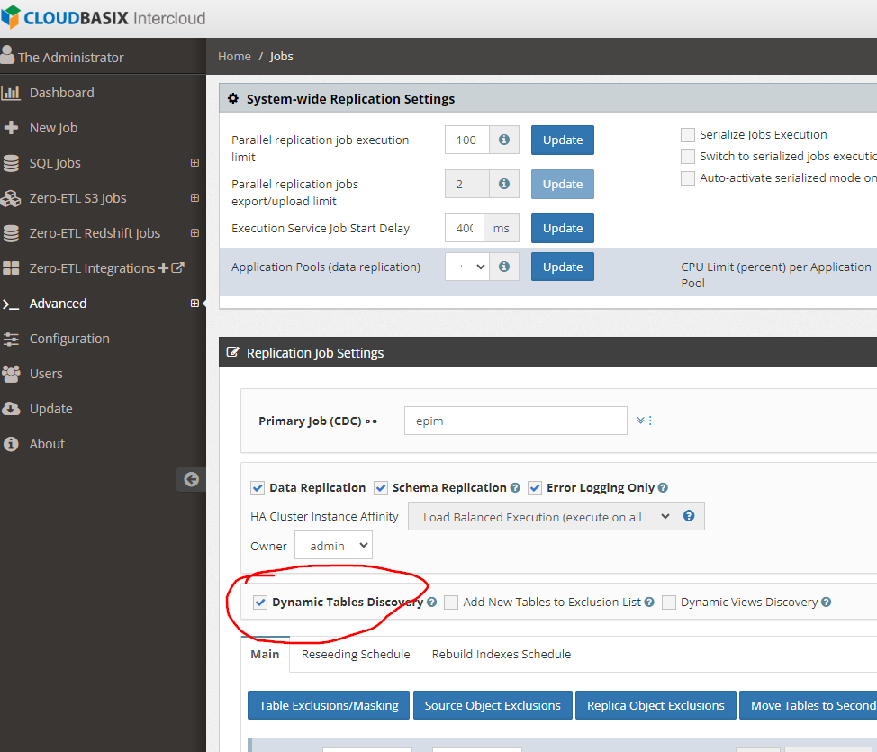

Select checkbox “Dynamic Tables Discovery”.

If we see the CPU% high when rest, mainly it’s due to schema change scan, the default is one hour, we can change to longer time to reduce CPU%.

