**SQL Server Performance Tools**

1. The monitoring tool created by Winshuttle will work on all SQL Server versions. Descriptions are in **DatabaseMonitoringTool.doc**.
2. SQL Server native performance tuning tool “**Query Store**” is only available from SQL Server 2016. It will be turned on by default for SQL Server 2022. It should not have any performance impact after turning on.

<https://learn.microsoft.com/en-us/sql/relational-databases/performance/monitoring-performance-by-using-the-query-store?view=sql-server-ver16>

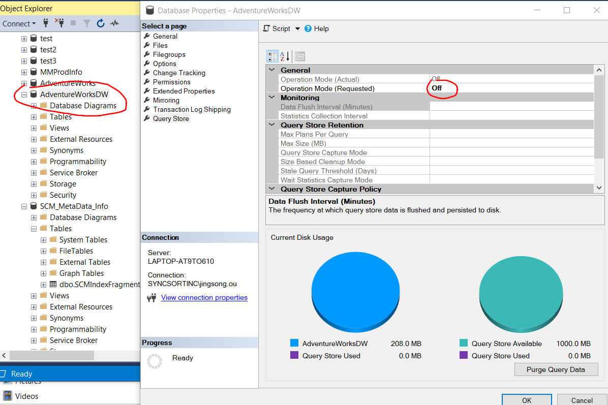

Query Store is off by default from SQL Server 2016 to SQL Server 2019. We need to turn it on manually.

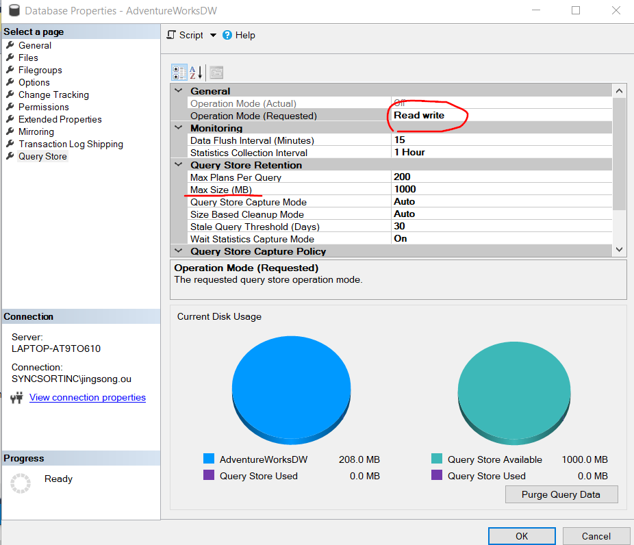

We should choose Operation Mode “Read Only” or “Read write”. If we are not sure, we can just choose “Read write”. We should make sure to set Max Size to prevent using too much disk space.

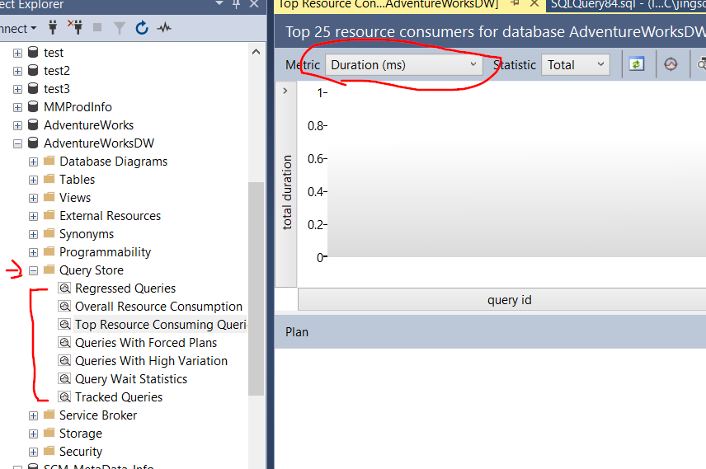

Once the Query Store enabled, we can see it from the database object category list, choose the analyze report we are interest in.

We can also use SQL Server “Database Engine Tuning Advisor” to do quick analyze based on result in Query Store, this analyze might not be accurate, we can just use as references.

1. **Deadlock** detection options:
2. From **SQL Log file**: we must turn on deadlock trace first in order to see the deadlock history. It is a simple method, but it may have minor performance impact.
   * + Check trace status (status=1 means turned on):

DBCC TRACESTATUS(1204);

DBCC TRACESTATUS(1222);

* + - Turn deadlock trace on:

DBCC TRACEON (1204, -1);

DBCC TRACEON (1222, -1);

* + - Turn off deadlock trace:

DBCC TRACEOFF (1204, -1);

DBCC TRACEOFF (1222, -1);

1. From **Extented Events**: It is recommended method vs trace.

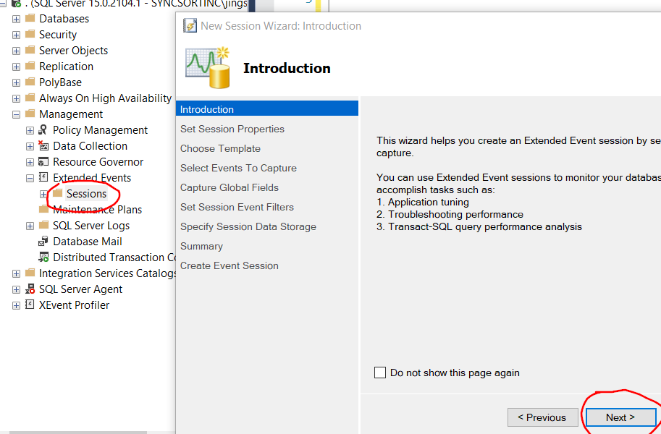

Right click Sessions-> New Session Wizard.

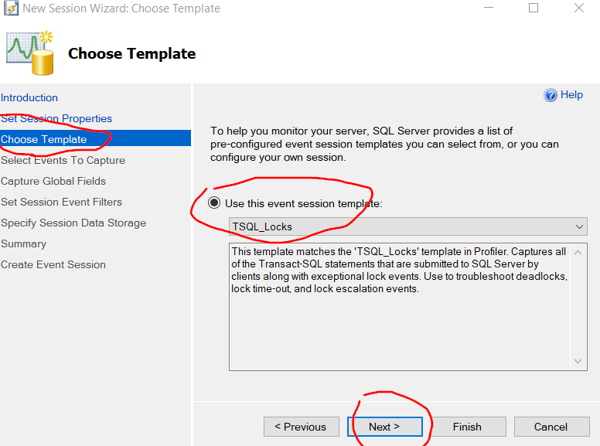

Choose “TSQL_Locks” templates. We can also choose custome event: Lock deadlock, Lock deadlock chain and Xml deadlock report.

Please note that we can also use this tool to investigate other performance issues.

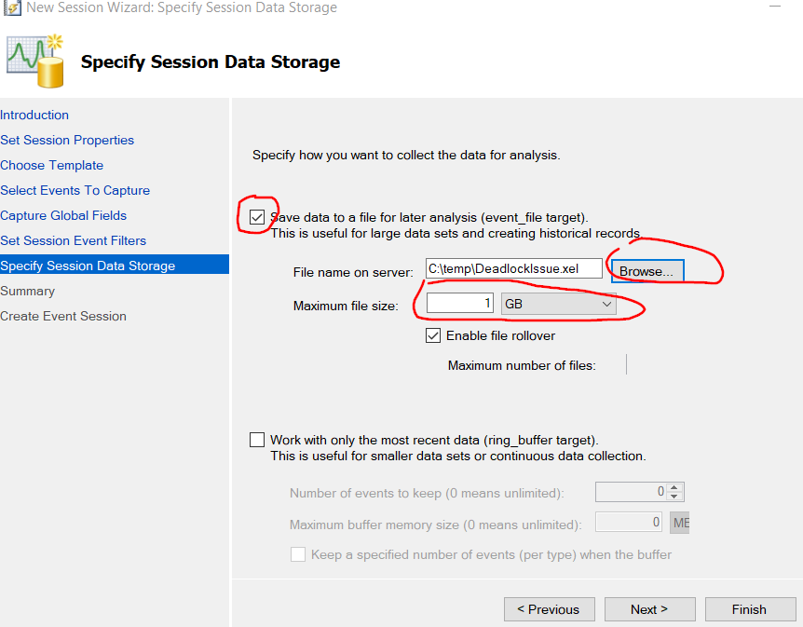

Save the result to a local file with maximum file size specified. We can share file and analyze the dead lock captured.

Click Finish. The session will be created. At this point, the session haven’t started yet.

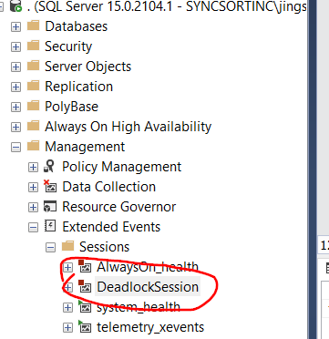

Right click the session and choose “Start Session”. The trace file will be created.

Once we believe we have finished trace, we can right click the session and choose “Stop Session”. In case we forget to turn it off, it will keep the maximum file size as we specified.

Open the trace result file from SSMS. We should be able to see graphic presentation of the deadlock.