The purpose of the testing is to compare the database performance between Partition and Non-Partition table [B_MASTER_REPOSITORY_ITEM]. Please note that this document did not include the Application Server preparation nor the UI job setting.

**Pre-requirement:**

1. SQL Server 2019 or higher with SE or EE.
2. We need two separate DB instance with the same configuration on maintenance plan, job agent, total disk space, free disk space, disk type, class type (vCPU and Memory).

**Preparing Steps:**

1. Create/restore the database backup/snapshot on first instance. Allocate two times more disk space than the database size. For example, if the database is 150 GB, allocate 500 GB disk space on the instance.
2. Do-reindex on the database.
3. Make sure the maintenance job and job agent are set properly. Maintenance job performance is part of the testing.
4. Keep a backup snapshot of the current database instance.
5. Run the scripts to get the information about the table [B_MASTER_REPOSITORY_ITEM].

Query 1 to get the table size the output “reserved” will be the total disk space for this table:

EXEC sp_spaceused 'B_MASTER_REPOSITORY_ITEM';

Query 2 to get the table data/index File Group name, we need to shrink these files after partition. Output “IndexType=CLUSTERED” will the File Group for Data, the rest will be for Index.

SELECT

t.name AS TableName,

i.name AS IndexName,

i.type_desc AS IndexType,

ds.name AS FileGroupName

FROM

sys.tables AS t

INNER JOIN

sys.indexes AS i ON t.object_id = i.object_id

INNER JOIN

sys.data_spaces AS ds ON i.data_space_id = ds.data_space_id

WHERE t.name = 'B_MASTER_REPOSITORY_ITEM';

1. Restore backup/snapshot to a new instance with the same setting including VPN, subnet, and Security Group.

**Transferring non-partition table [B_MASTER_REPOSITORY_ITEM] to Hash Partition table:**

1. Run script “1_HashPartition_EPIM_PrepareScript.sql” to generate script for partition. Make sure the first five parameters are correct.

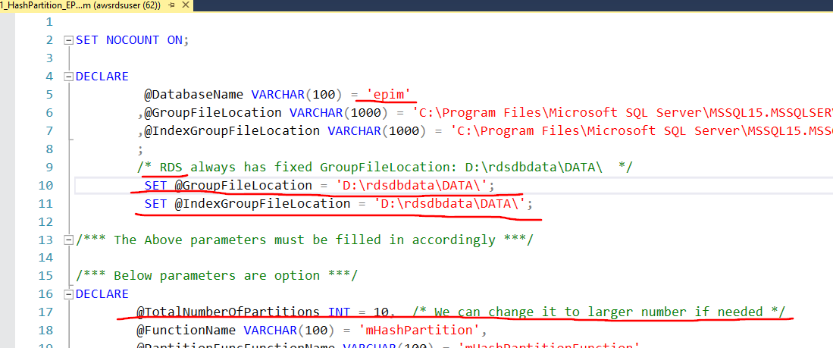

1. Remove the last line of the output with “Completion time:” and same it to a file and run it.

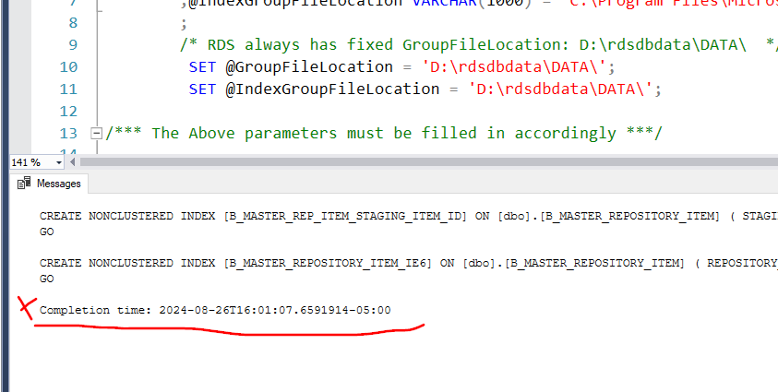

1. It takes more than 5 hours for a 150 GB database.

**After transforming steps:**

1. The data/index should distribute evenly on the newly file groups after previous steps. Open the SSMS to confirm it. If we choose TotalNumberOfPartitions = 10, then we will have 20 new File Groups created, 10 for data and rest for index.
2. Use the table [B_MASTER_REPOSITORY_ITEM] data/index size and File Group information we got from query in “Preparing Steps” as reference, Shrink the File size to proper level, since we moved data/index out, the original file should have additional free space.
3. After shrinking the file, the size of the “FreeStorageSpace” under Monitoring Tab should close to the non-partitioned database.
4. Set the DataDog to include these two instances, so we can collect the performance matrix information including “CPUUtilization,” “DiskQueueDepth,” “FreeableMemory,” “FreeStorageSpace,” “ReadIOPS,” “ReadLatency,” “WriteIOPS,” “WriteLatency” and “TotalIOPS.”