**Please note that this document is for Dot Food Performance testing ONLY.**

The purpose of the testing is to compare the database performance between Partition and Non-Partition table [B_MASTER_REPOSITORY_ITEM]. Please note that this document did not include the Application Server preparation nor the UI job setting.

**Pre-requirement:**

1. SQL Server 2019 or higher with SE or EE.
2. We need two separate DB instance (option, we don’t need two instance if the original instance as benchmark is reliable) with the same configuration on maintenance plan, job agent, total disk space, free disk space, disk type, class type (vCPU and Memory).

**Preparing Steps:**

1. Execute “Add_file_to_tempdb.sql” to add up to 8 data files for tempdb for both benchmark instance and target partitioned instance. **Please make sure data SIZS, MAXSIZE and GROWTH match the existing file.** This step will match the customer environment. This step is option, just make sure to keep both instances are the same.
2. Current DotFood instance has 1 TB out of 2 TB storage space and table [B_MASTER_REPOSITORY_ITEM] is only using 160GB disk space, this is enough for testing, we don’t need add disk space.
3. Make sure the maintenance job and job agent are set properly. Maintenance job performance should be part of the testing. Please note that I don’t have permission to view maintenance plan and SQL Agent job.
4. Run the scripts to get the information about the table [B_MASTER_REPOSITORY_ITEM].

Query 1 to get the table size the output “reserved” will be the total disk space for this table.

**Current [B_MASTER_REPOSITORY_ITEM] is 163 GB**.

EXEC sp_spaceused 'B_MASTER_REPOSITORY_ITEM';

Query 2 to get the table data/index File Group name, we need to shrink these files after partition. Output “IndexType=CLUSTERED” will the File Group for Data, the rest will be for Index.

**Current FileGroup is [PRIMARY]**

SELECT

t.name AS TableName,

i.name AS IndexName,

i.type_desc AS IndexType,

ds.name AS FileGroupName

FROM

sys.tables AS t

INNER JOIN

sys.indexes AS i ON t.object_id = i.object_id

INNER JOIN

sys.data_spaces AS ds ON i.data_space_id = ds.data_space_id

WHERE t.name = 'B_MASTER_REPOSITORY_ITEM';

1. Restore snapshot to a new instance with the same setting including VPN, subnet, and Security Group.

**Transferring non-partition table [B_MASTER_REPOSITORY_ITEM] to Hash Partition table:**

1. Run script “1_HashPartition_EPIM_PrepareScript.sql” to generate script for partition. Make sure the first five parameters are correct. We don’t need to make any change for attached file if we want to test 10 partition.

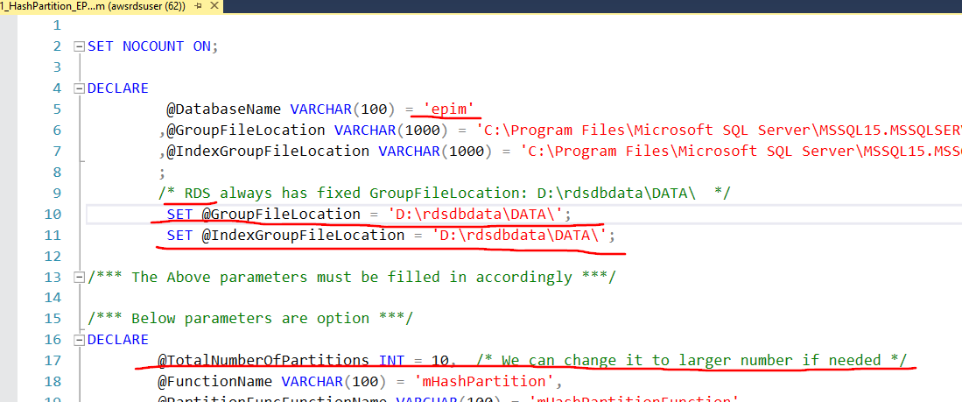

1. **Remove the last line of the output with “Completion time:”** and same it to a file and run it.

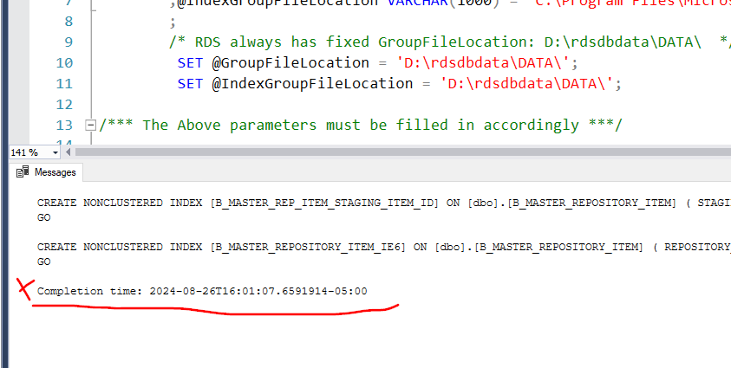

1. It takes more than 5 hours for a 150 GB database. We don’t know how long it will be on DotFood database yet.

**After transforming steps:**

1. The data/index should distribute evenly on the newly file groups after previous steps. Open the SSMS to confirm it. If we choose TotalNumberOfPartitions = 10, then we will have 20 new File Groups created, 10 for data and rest for index.
2. Use the table [B_MASTER_REPOSITORY_ITEM] data/index size and File Group information we got from query in “Preparing Steps” as reference, Shrink the File size to proper level, since we moved data/index out, the original file should have additional free space. For DotFood database, table [B_MASTER_REPOSITORY_ITEM]. Storage size is 163 GB on FileGroup [PRIMARY], so just **shrink the [PRIMARY] Data file from 972657.81 MB to 809657 MB** **on Partitioned Database**.
3. After shrinking the file, the size of the “FreeStorageSpace” under Monitoring Tab should close to the non-partitioned database.
4. **Set the DataDog to include the instance with Partitioned Database**, so we can collect the performance matrix information including “CPUUtilization,” “DiskQueueDepth,” “FreeableMemory,” “FreeStorageSpace,” “ReadIOPS,” “ReadLatency,” “WriteIOPS,” “WriteLatency” and “TotalIOPS.”
5. Maintenance task should be part of the testing, it might require to change shrink database to shrink data files. It is option.