**DMS ongoing replica for RDS SQL Server**

1. Preparation
2. Create RDS SQL Server 2019 (15.00.4365.2.v1) new instance for source (writer) database

Enable CDC

1. Create RDS SQL Server 2019 (15.00.4365.2.v1) new instance for target(reader) database

Create Link Server

Create Read-Only Login

1. Setup DMS

References

Please note that as 05/10/2024, we haven’t been able to set target(reader) database Read-Only yet. But it can be done by creating login with Read-Only permission meanwhile it can write data through link server point to source (writer) database.

**If target(reader) database set Read-ONLY=true, no data change will happen anymore.**

Objects that will **NOT** replicate (we can give ddlamin pemission to login to create them):

* **Index**
* View
* Stored Procedure
* **Temp table**

Objects/DML will replicate:

* Insert/Update
* New table, drop table
* New column, Alter column
* Primary key

1. **Preparation**

* If the RDS SQL Server database already exists, then RDS snapshot can be used for creating the target database instance. If the instance is not the same as desired version, upgrade both source/target to the proper version.
* If it’s from on-promise SQL Server, then take a backup of the database

1. Create a S3 bucket by using the default setting.
2. Create Policy (our example “DBBackupRestore”) to access the S3 bucket created on previous step. Replace {BucketName} in JSON

{

"Version": "2012-10-17",

"Statement": [

{

"Effect": "Allow",

"Action": [

"s3:ListBucket",

"s3:GetBucketLocation"

],

"Resource": "arn:aws:s3:::{BucketName}"

},

{

"Effect": "Allow",

"Action": [

"s3:GetObject",

"s3:PutObject",

"s3:ListMultipartUploadParts",

"s3:AbortMultipartUpload"

],

"Resource": "arn:aws:s3:::{BucketName}/*"

}

]

}

1. Create Role (our example “DBBackupRestoreRole”) by adding Policy created on previous step (our example “DBBackupRestore”)
2. Create RDS Option group by choosing “sqlserver-se” engine with version 15.00 (for SQL Server 2019), then edit option and add options by choosing SQLSERVER-BACKUP_RESTORE” and set IAM_ROLE_ARM to the role ARN created on previous step.

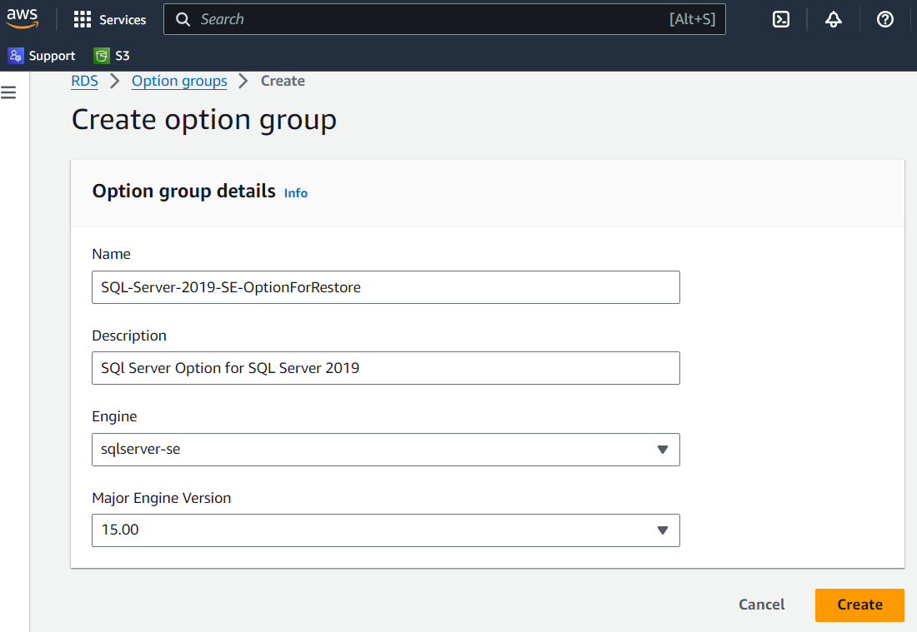

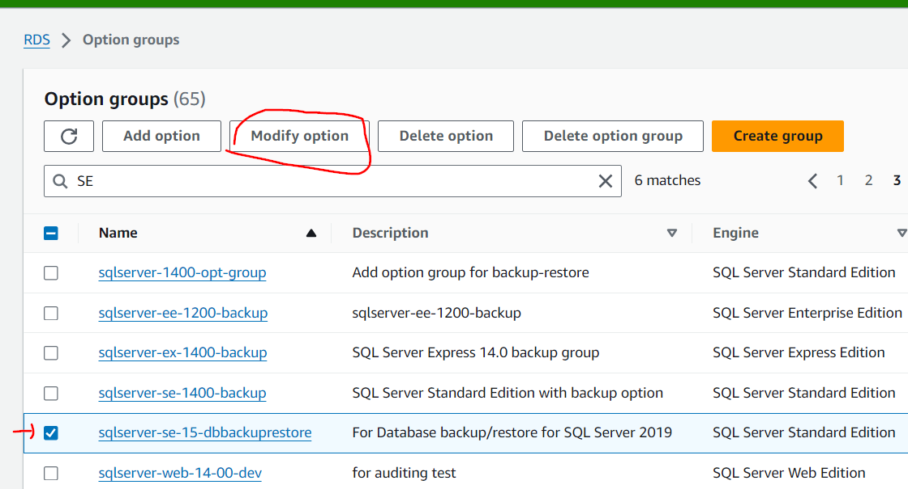

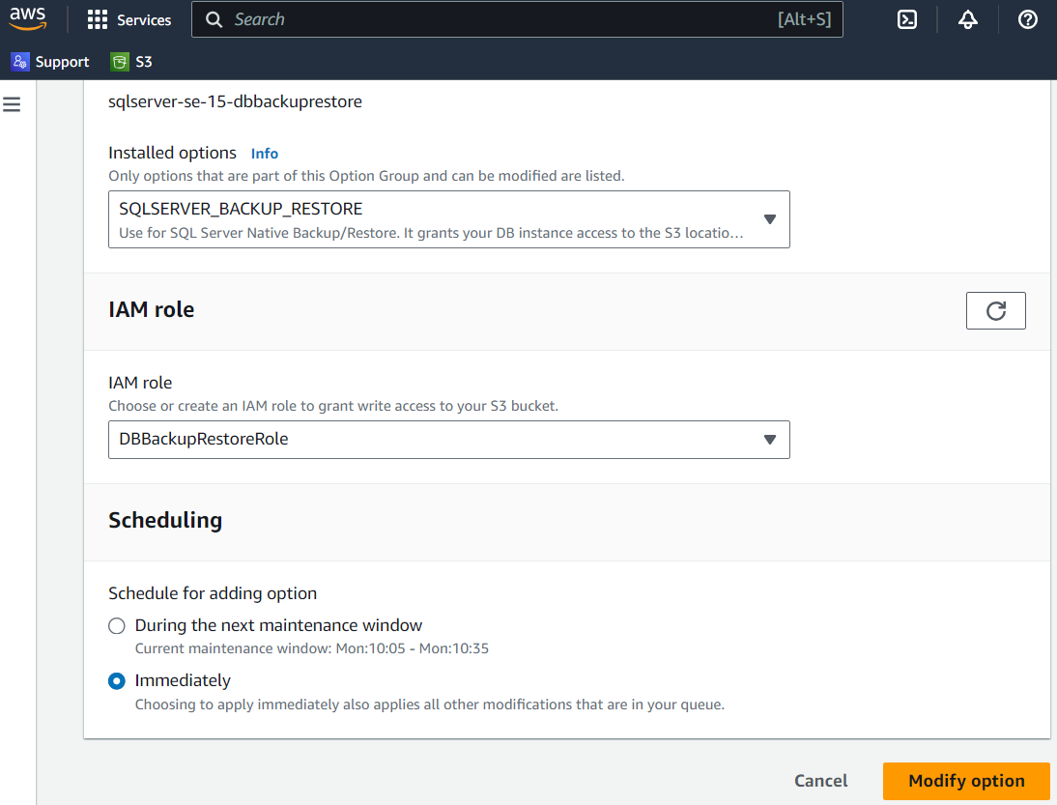

1. **Create RDS SQL Server(15.00.4365.2.v1) new instance for source (writer) database**

* Create new instance with SQL Server Standard Edition, if it’s from on-promise backup file, choose the option created at preparation step and run restore command:

EXEC msdb.dbo.rds_restore_database

@restore_db_name='test',

@s3_arn_to_restore_from='arn:aws:s3:::{S3 bucket)/{backupfile name}';

* Setup CDC by running the following SQL commands:

EXEC msdb.dbo.rds_cdc_enable_db '{database_name}'

Use the following Query to generate query for enable each table for CDC

SELECT 'exec sys.sp_cdc_enable_table @source_schema = N''dbo'', @source_name=''' + TABLE_NAME + ''',@role_name=NULL;'

FROM INFORMATION_SCHEMA.TABLES

WHERE TABLE_SCHEMA = 'dbo' AND TABLE_TYPE = 'BASE TABLE';

USE {database_name}

GO

EXEC [sys].[sp_cdc_add_job] @job_type = N'capture';

EXEC [sys].[sp_cdc_add_job] @job_type = N'cleanup';

USE {database_name}

GO

EXEC sys.sp_cdc_change_job @job_type = 'capture' ,@pollinginterval = 86399

EXEC sp_cdc_stop_job 'capture'

EXEC sp_cdc_start_job 'capture'

*pollinginterval =86399 means keep log in seconds (for a day)*

* Create login for link server from target (reader) database. The login should have read/write permission on source(writer) database and default database as source(writer) database

1. **Create RDS SQL Server(15.00.4365.2.v1) new instance for target(reader) database**

* Create new instance (Standard Edition) with the same VPC, subnet and security group as writer database, if it’s from on-promise backup file, choose the option created at preparation step step and run restore command:

EXEC msdb.dbo.rds_restore_database

@restore_db_name='test',

@s3_arn_to_restore_from='arn:aws:s3:::{S3 bucket)/{backupfile name}';

* Create link server for writing back to source(writer) from target(reader) by using the same Read-Only login.

EXEC master.dbo.sp_addlinkedserver @server = N'{LinkServerName}', @srvproduct=N'', @provider=N'MSOLEDBSQL', @datasrc='{Source RDS EndpointName}';

EXEC master.dbo.sp_addlinkedsrvlogin @rmtsrvname=N'{LinkServerName}',@useself=N'False',@locallogin=NULL,@rmtuser=N'{SourceDBUserName}',@rmtpassword='{SourceDBPassword}';

GO

SELECT * FROM {LinkServerName}.{databaseName}.dbo.{TableName}

INSERT INTO {linkserveraccess}.{databaseName}.dbo.{TableName}(columnName….)

Values(….);

* Create login with read only permission on target (reader) database, and set default database as target database.

This login will automatically insert data through link server (tested, it works).

Add ddladmin permission to login/user if we need the login on target(reader) database to have permission to add index/stored procedure/view.

USE test

GO

EXEC sp_addrolemember 'db_ddladmin', 'RepReader'

1. **Setup DMS**

* Create Replication instance

Make sure it is the same VPC, replication subnet and security group as RDS instance.

* Create Source Endpoint

Test it after creation.

* Create Target Endpoint

Test it after creation.

* Create DMS task

Choose the Migration type “**Migrate Change Data only**”.

Choose “start task manually”

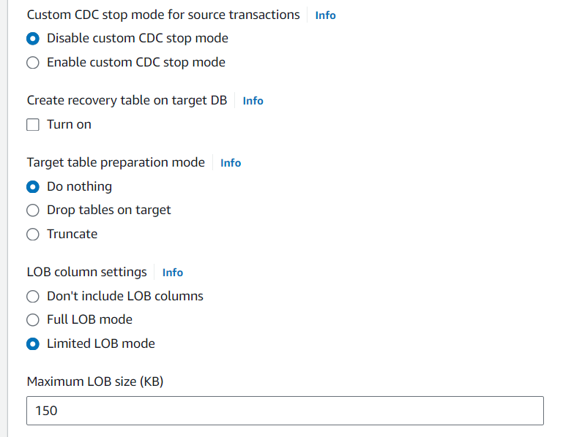

Since we have large XML/JSON column in table B_MASTER_REPOSITORY_ITEM table, we should use LOB size 150 KB (or even larger).

T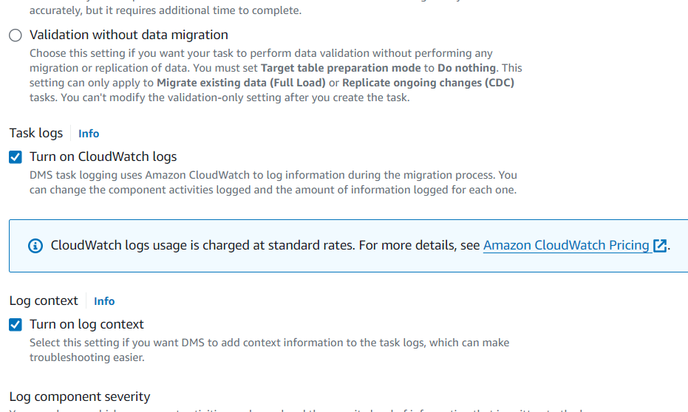

Turn on CloudWatch logs for troubleshooting any issue.

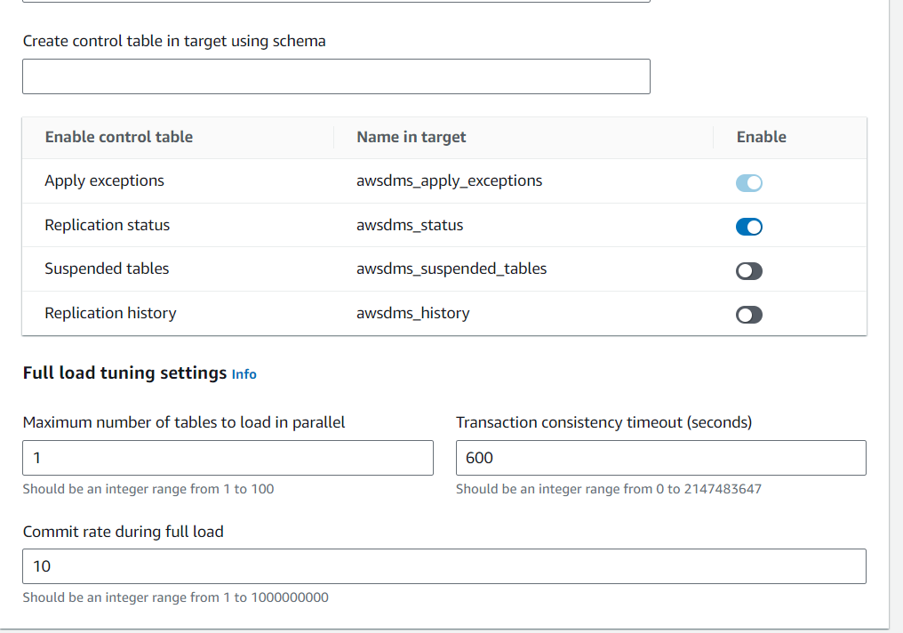

In Advanced setting, set “Maximum number of tables to load in parallel” to 1 and “Commit rate during full load” to 10. It is also for the large column size (XML/JSON column)

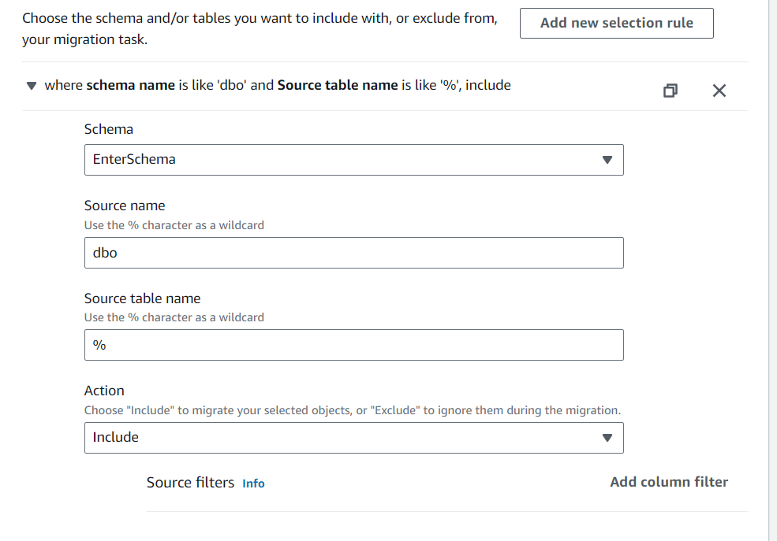

Click on “Add new selection rule”, select “EnterSchema” , Source name “dbo”,

Source table name”%” to include all the tables.

**References:**

[https://docs.aws.amazon.com/dms/latest/userguide/CHAP_Source.SQLServer.html#CHAP_Source.SQLServer.OptionalSettings](https://docs.aws.amazon.com/dms/latest/userguide/CHAP_Source.SQLServer.html%23CHAP_Source.SQLServer.OptionalSettings)

<https://learn.microsoft.com/en-us/answers/questions/211923/enable-cdc-in-sql-2019-cu5>

<https://docs.aws.amazon.com/AmazonRDS/latest/UserGuide/Appendix.SQLServer.CommonDBATasks.CDC.html>

<https://aws.amazon.com/blogs/database/implement-linked-servers-with-amazon-rds-for-microsoft-sql-server/>