King Saud University  College of Computer and Information Sciences  IT312 Web Applications Engineering  Project – Phase 1  First Term 2026–2027 | 

INTEREST CLUB WEBSITE
Phase 1 Planning and Wireframe Template
Website title | Khayt Studio
Group number | G6
Section / lab | 77743
Lab day and time | Monday 8-10 AM

Team members and distribution of tasks
Student Name | ID | Distribution of Tasks
Jouri AlSulaiman (Leader) | 445204405 | Sitemap + Wireframes (Club Manager Dashboard, Add New Offerings)
Ghadha Aldablan | 446202406 | Wireframes (Club Member Dashboard, Request to Join an Offering, Offering Evaluation, Manage Activity Leaders & Instructors + shared headers and footers) + Website concept and branding
Lara  Almani | 446202834 | Competitive Analysis + Required and Extra Functionality + Wireframe (Home page, Club Offering Page)
Reema Alessa | 446202304 | Site goal and Positive Mission + Site Audience + Wireframe (About us, Instructor Profile)

Part A — Website Planning
1. Site Goal and Positive Mission
Khayt is a fashion club website that introduces the club, showcases its workshops, classes, and experiences, and allows members to explore offerings, request participation, and share feedback about completed experiences. Khayt believes fashion is a thread that connects skill, creativity, and community. The club helps members learn practical skills such as sewing, styling, and design, express their creativity, and discover their personal identity through fashion. Khayt also promotes sustainable fashion by encouraging reuse and upcycling, and builds a supportive community where every member's story is valued.

2. Site Audience
The website is intended for fashion enthusiasts who want to explore styling, design, and current trends; beginners who want to learn practical skills such as sewing and outfit coordination; university students and young adults looking for a creative hobby and a community to belong to; sustainability-minded individuals interested in upcycling and reducing textile waste; and designers, tailors, and stylists who want to lead workshops and share their expertise, and club managers who oversee and organize club activities and offerings.
3. Required Functionalities
The Club Manager shall be able to:
- View a list of all offerings they have added
- Add a new offering by entering its title, description, category, price, and schedule details.
- View the list of activity leaders and instructors
- Add new activity leader/instructor
- Select and delete activity leaders
The Club Member shall be able to:
- Browse the home page and view offerings
- View the complete catalogue
- Sort offerings by name and price
- View their previous participation requests
- Submit a request to join an offering
- Evaluate a completed offering
- View activity leader profiles
Activity Leaders and Instructors:
- Are presented on the About Us page
- Have a dedicated profile page

4. Extra Functionalities
- The Club Member shall be able to save an offering to their “Favorites” list to easily return to it later.
- The system shall be able to generate a digital certificate of completion for members upon finishing a workshop.
- The system shall be able to send automated on-site notifications to members 24 hours before a registered workshop or event.

Part B — Competitive Analysis
Competitive Analysis:
The evaluation is a simple check Y/N; (Y=Yes, N=No) or a number from 1 to 10; (1 is the worst value; 10 is the best value).
Criteria |  | Site 1  Vogue Club  URL | Site 2  Istituto Marangoni  URL | Site 3  The Fashion Club  URL | Notes
Design | Layout. (1-10) | 8/10 | 6/10 | 9/10
Design | Navigation. (1-10)  (list three global navigation) | 8/10 | 8/10 | 8/10
Design | Navigation. (1-10)  (list three global navigation) | Consistency: Global nav present but limited.  Accessibility: Clear labels, FAQ links.  Interaction: Basic links, not many dynamic elements.  Navigation:  Videos  Community  Events | Consistency: Global nav present but limited.  Accessibility: Clear labels, FAQ links.  Interaction: Basic links, not many dynamic elements.  Navigation:  Fashion Courses  Design Courses  Admission | Consistency: Global nav present but limited.  Accessibility: Clear labels, FAQ links.  Interaction: Basic links, not many dynamic elements.  Navigation:  Home  Fashion Club Program  Fashion Club Products
Design | Look and Feel. (1-10) | 4/10 | 7/10 | 10/10
Features | Search box in all pages. (Y/N) | Y | N | Y
Features | Advanced Search. (Y/N)  (list the elements that guide the search) | Y | Y | Y
Features |  | Sort dropdown ("Relevance"), category navigation bar (Fashion, Runway, Beauty, Culture, Living), search for prompt suggestions, and topic tags. | Find Your Course" search button, study discipline selections (Fashion, Design, Art), and school location filters (Milano, London, Dubai, Riyadh). | Comprehensive filtering sidebar (Rating & Categories), content category tabs (Workshops, Articles, Paths, Digital Products), and sorting controls (Newest, Most Popular, Lowest Price).
Features | About Us page. (Y/N) | Y | Y | Y
Features | Contact Us page. (Y/N) | Y | Y | Y
Features | Site map. (Y/N) | N | N | N
Multimedia | Text. (Y/N) | Y | Y | Y
Multimedia | Audio. (Y/N)  (Add one link to it if Y) | N | N | N
Multimedia | Audio. (Y/N)  (Add one link to it if Y) | - | - | -
Multimedia | Video. (Y/N)  (Add one link to it if Y) | Y | Y | N
Multimedia | Video. (Y/N)  (Add one link to it if Y) | Video | Video | -
Ease of use | Effectiveness. (Y/N)  (Is the Web site successfully providing the information and accomplish tasks.) | Y | Y | Y | All three sites are effective in delivering content. However, The Fashion Club gives the best experience with smooth navigation and smart filters. Vogue Club is visually pleasing and easy to browse, while Istituto Marangoni feels cluttered and less efficient.
Ease of use | Efficiency. (Y/N)  (Is the Web site give the user ability to accomplish tasks quickly and easily?) | Y | N | Y
Ease of use | Satisfaction. (Y/N)  (Is user enjoying using the Web site?) | Y | N | Y

Part C — Sitemap

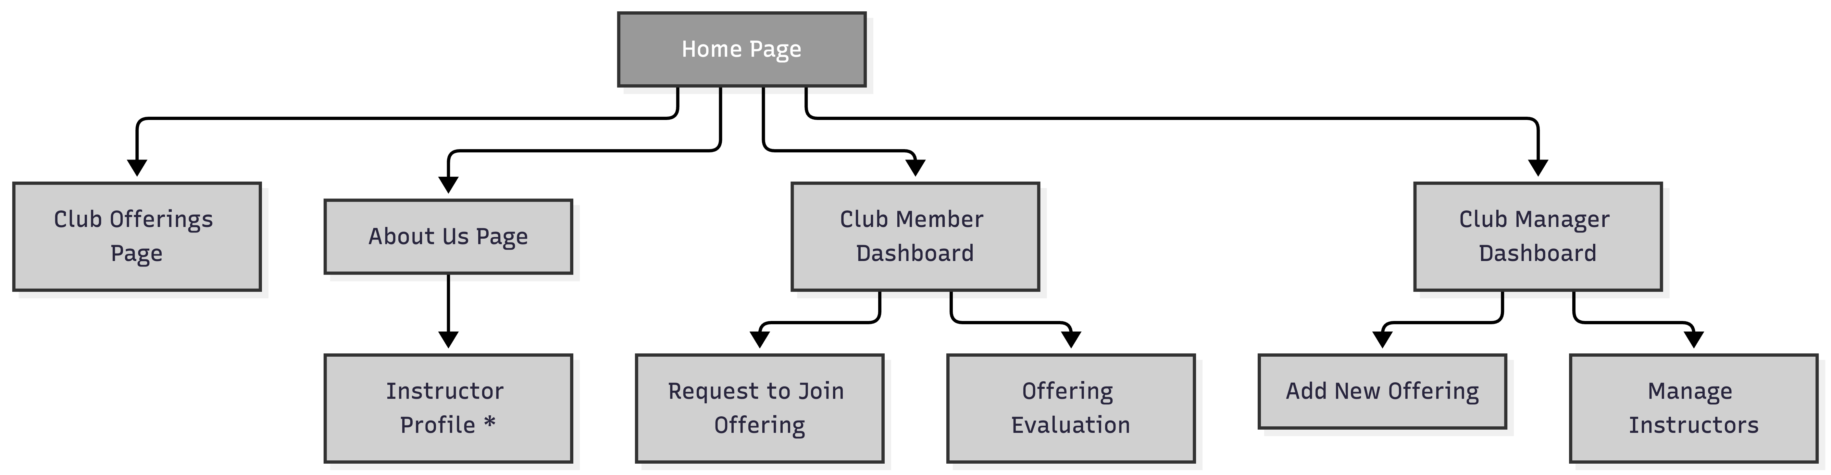

Part D — Wireframes
- Home Page
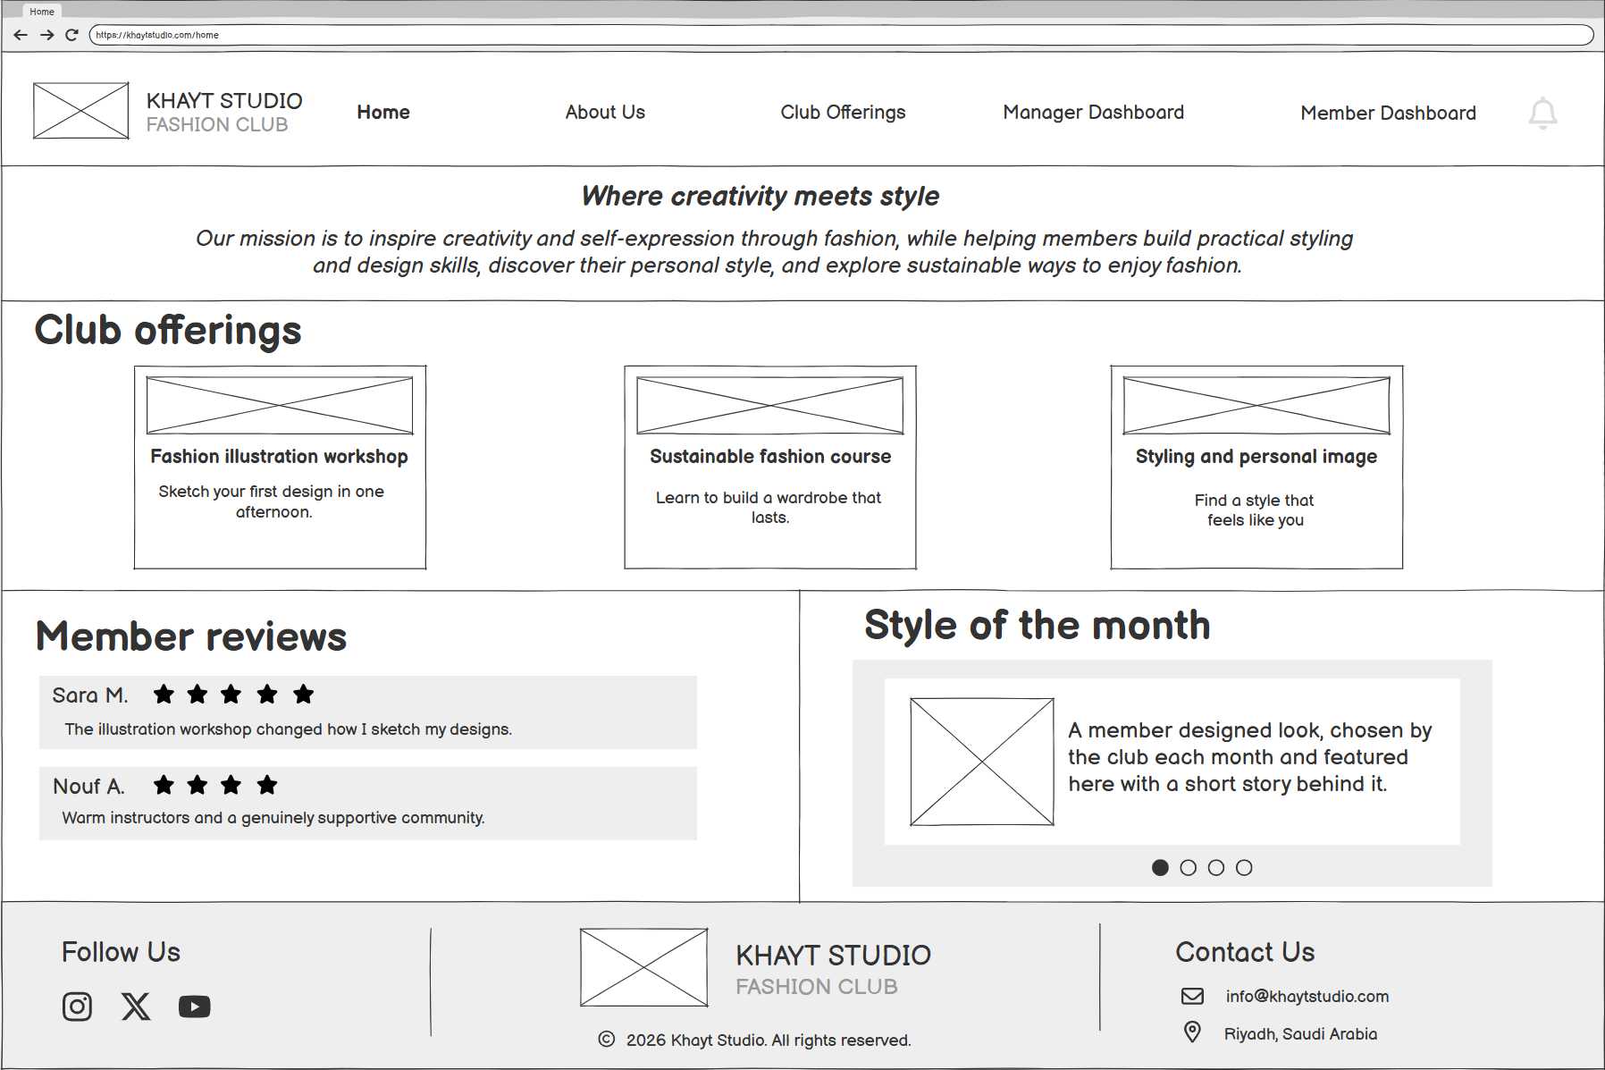
- Club Offerings Page
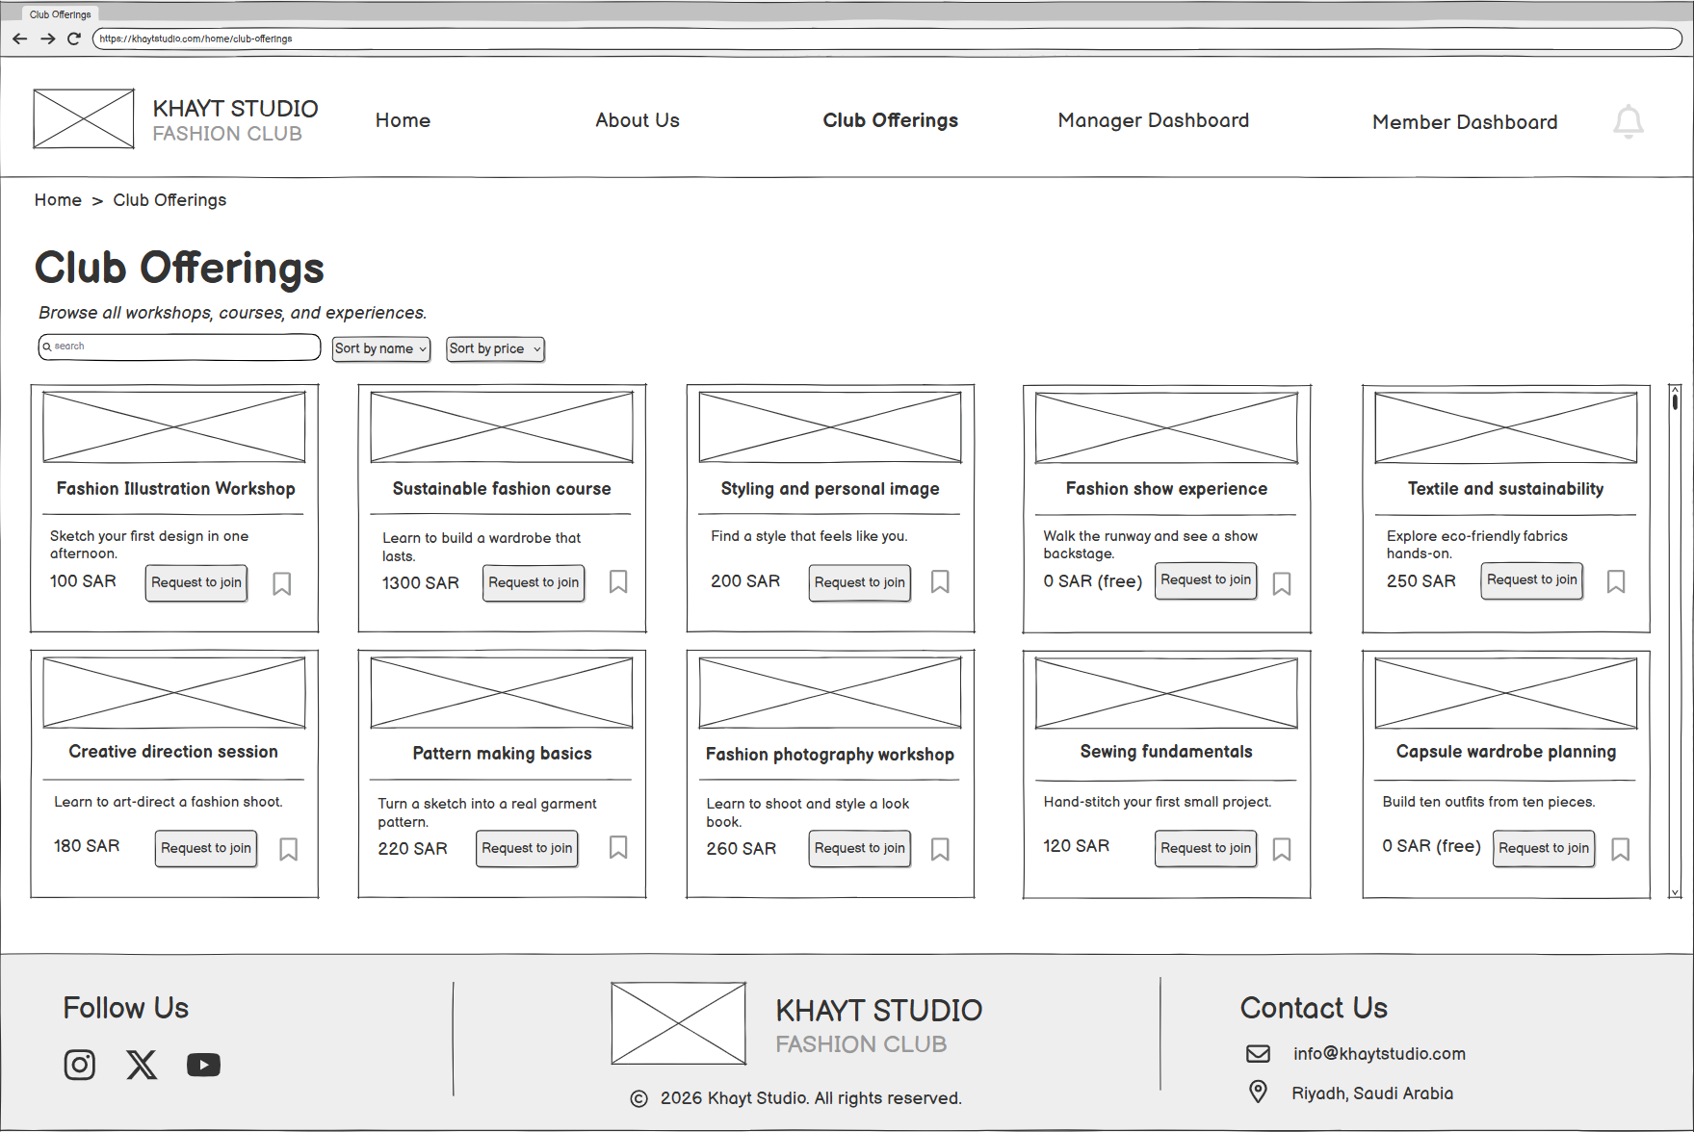

- About Us Page
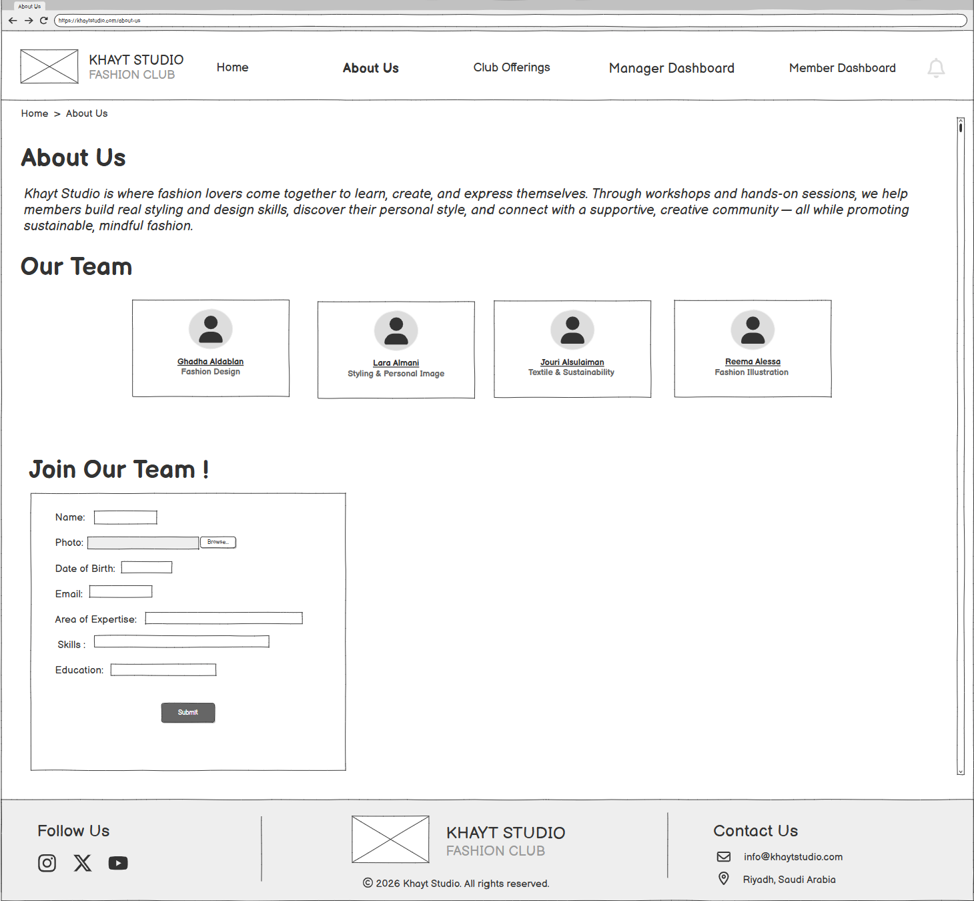
- Activity Leader / Instructor Profile Page

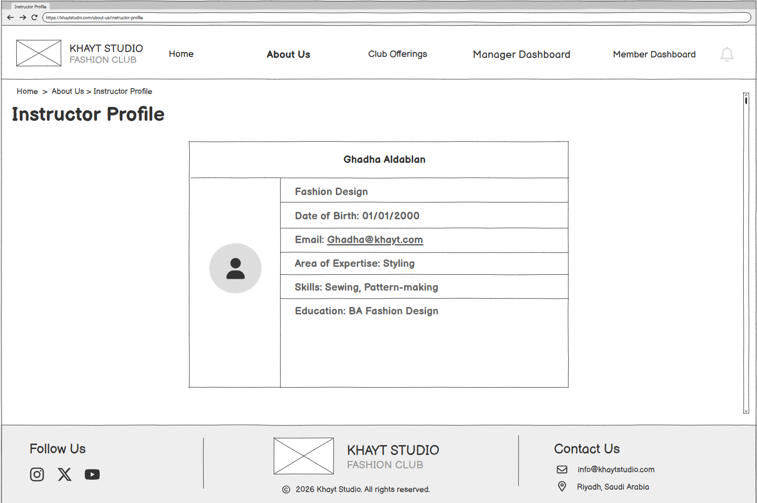

- Club Member Dashboard Page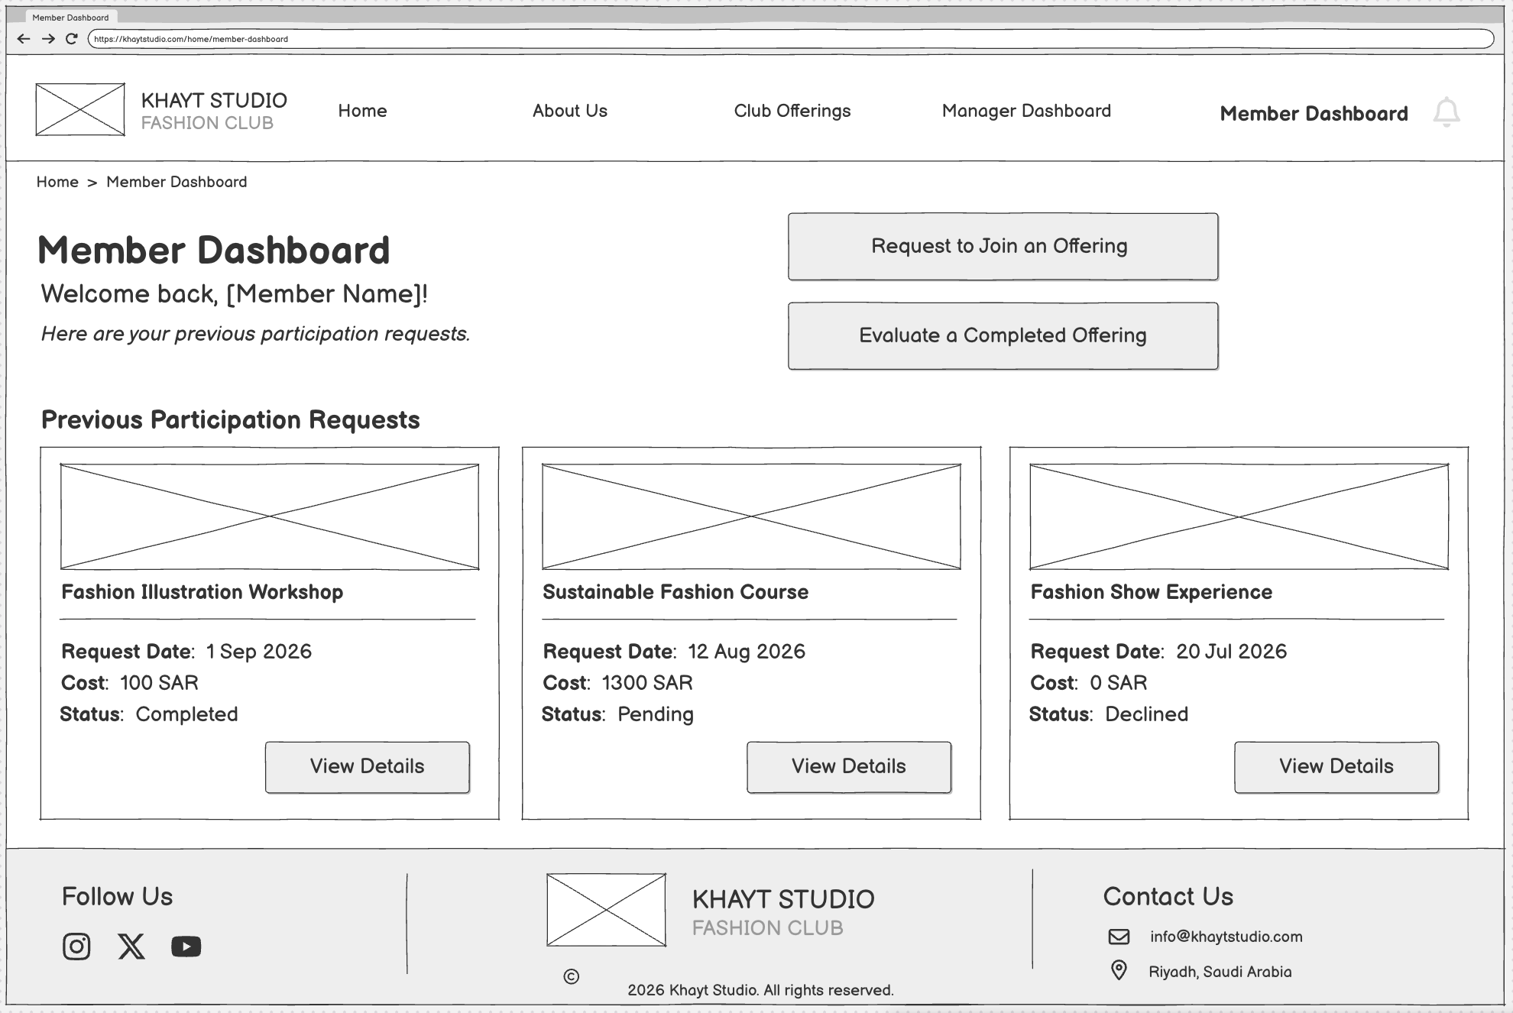
- Request to Join an Offering Page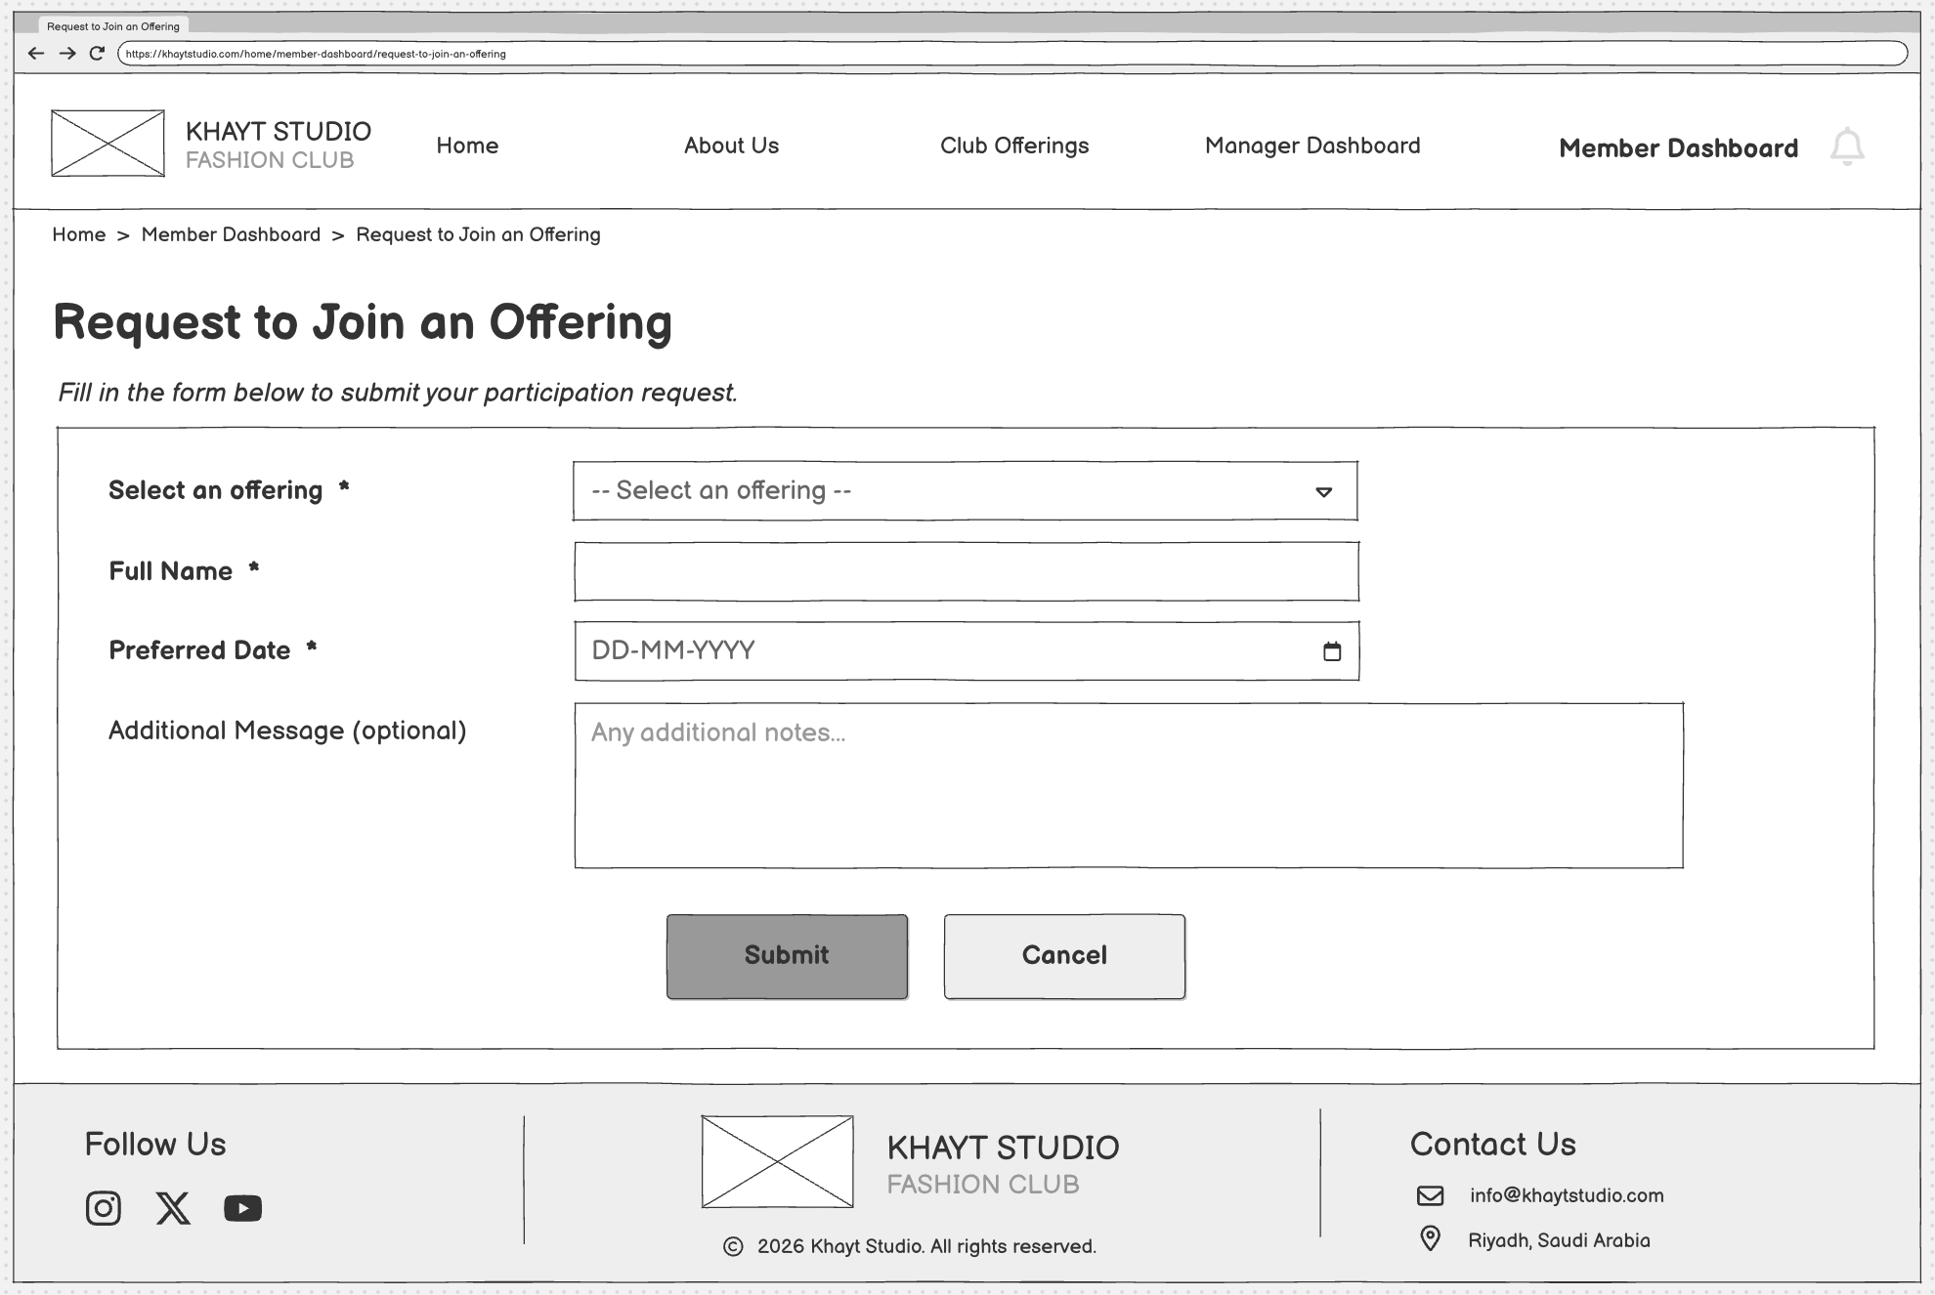
- Offering Evaluation Page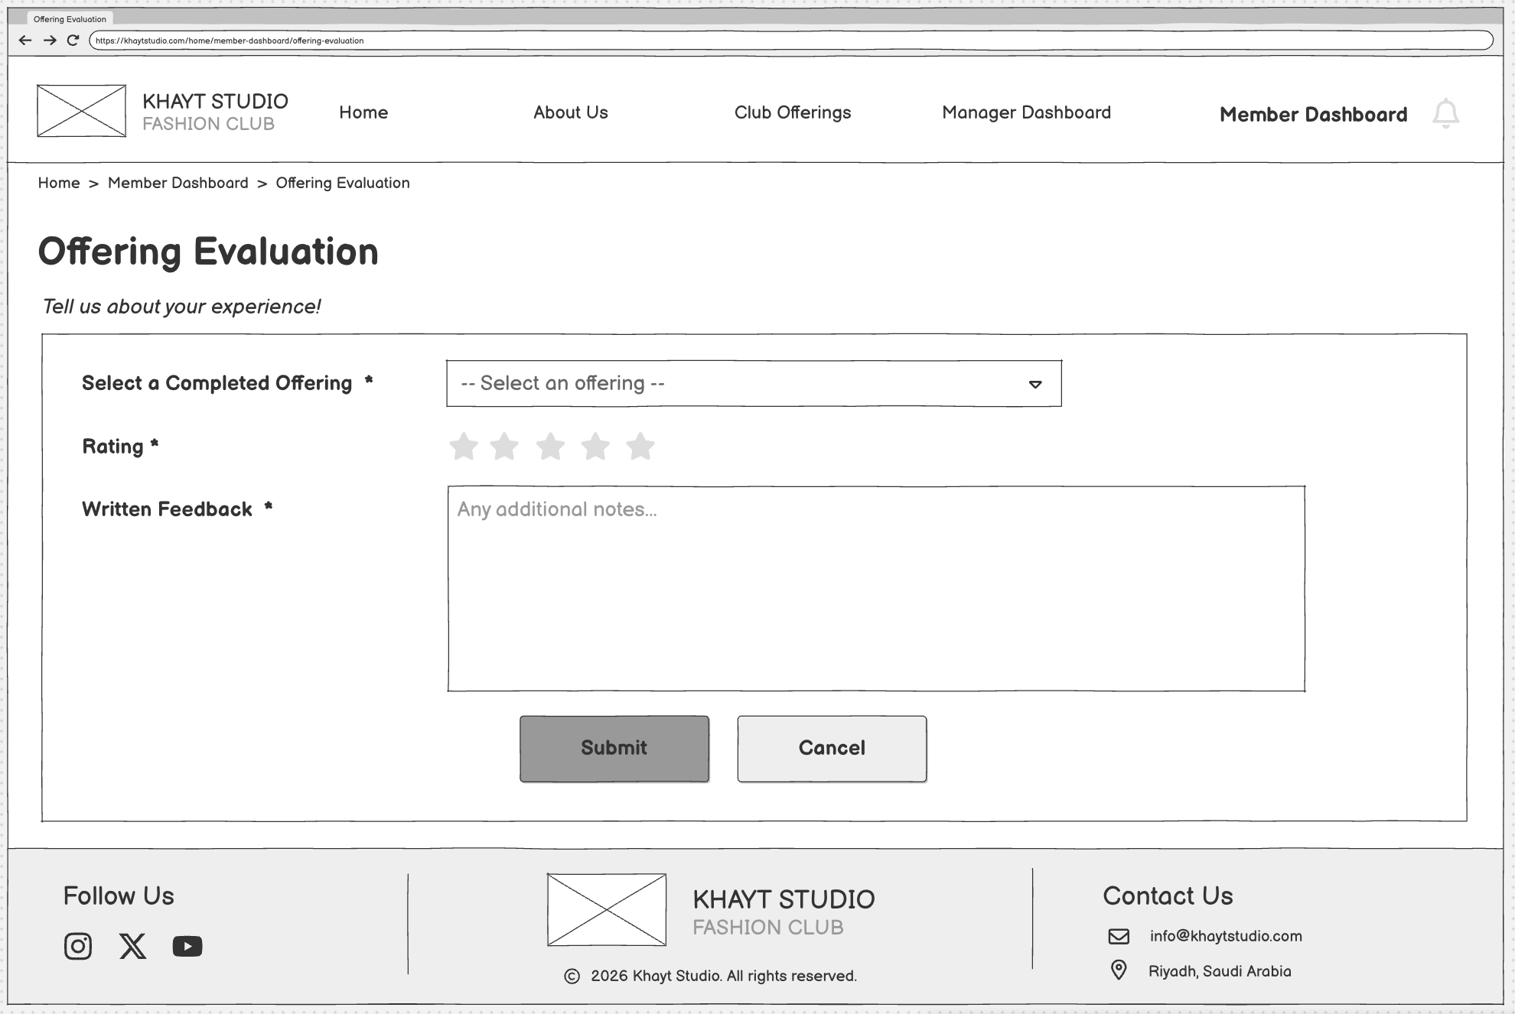
- Club Manager Dashboard Page
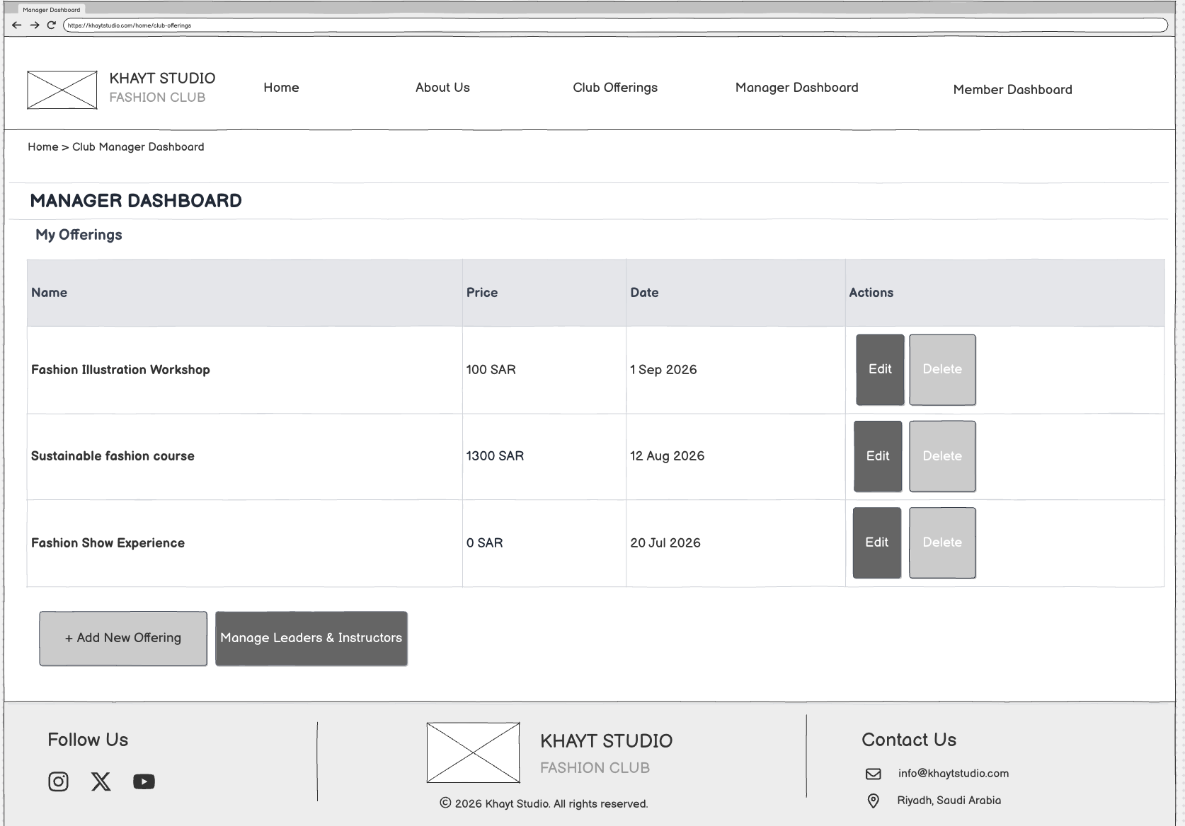
- Add a New Offering Page
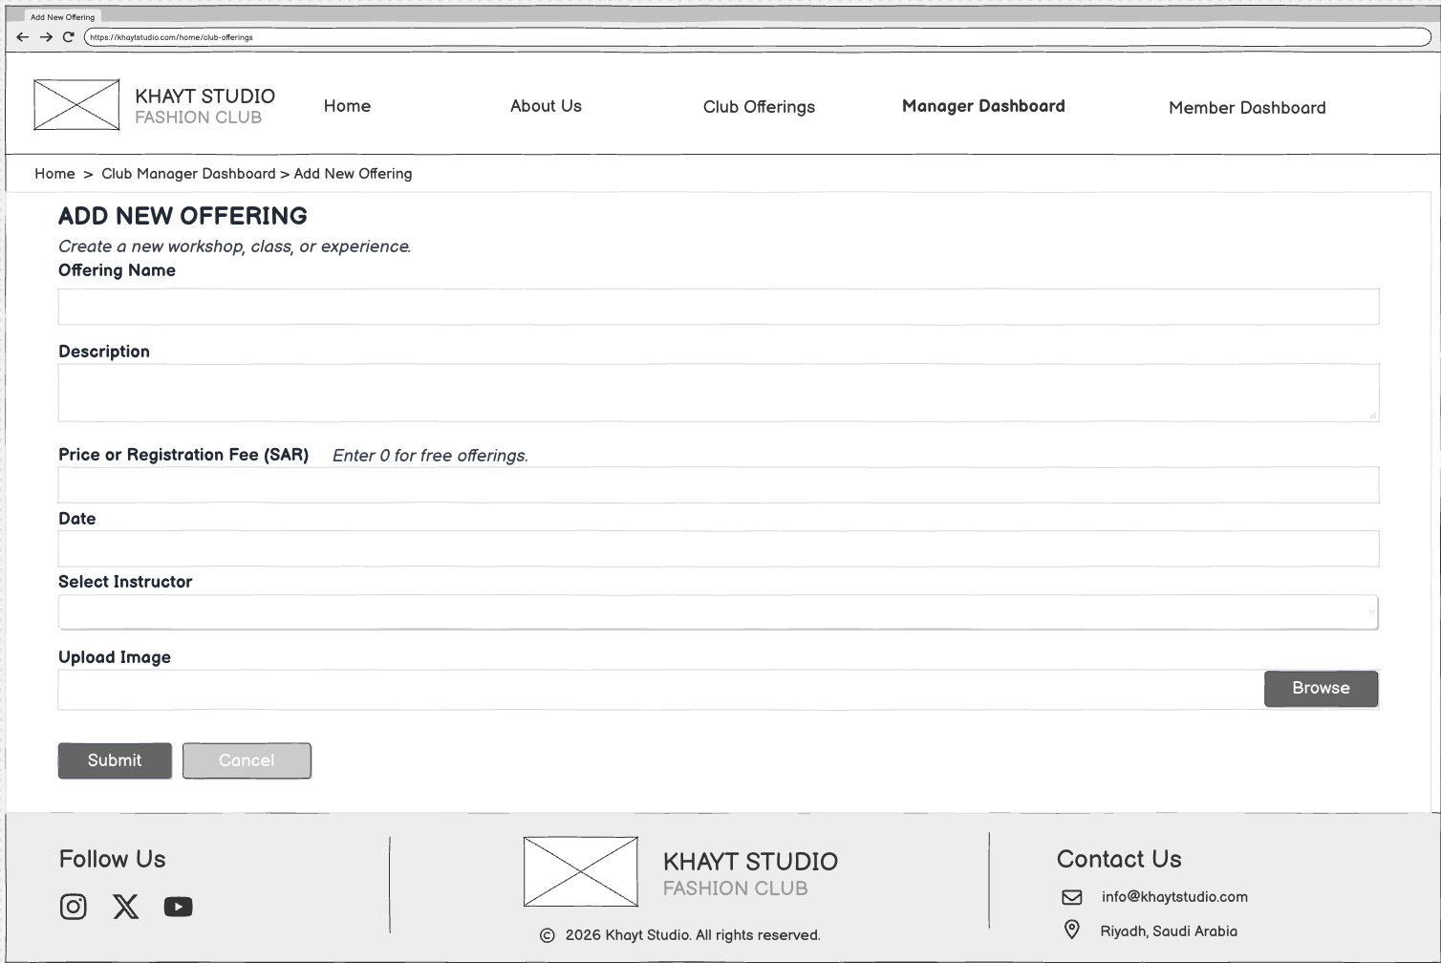

- Manage Activity Leaders and Instructors Page
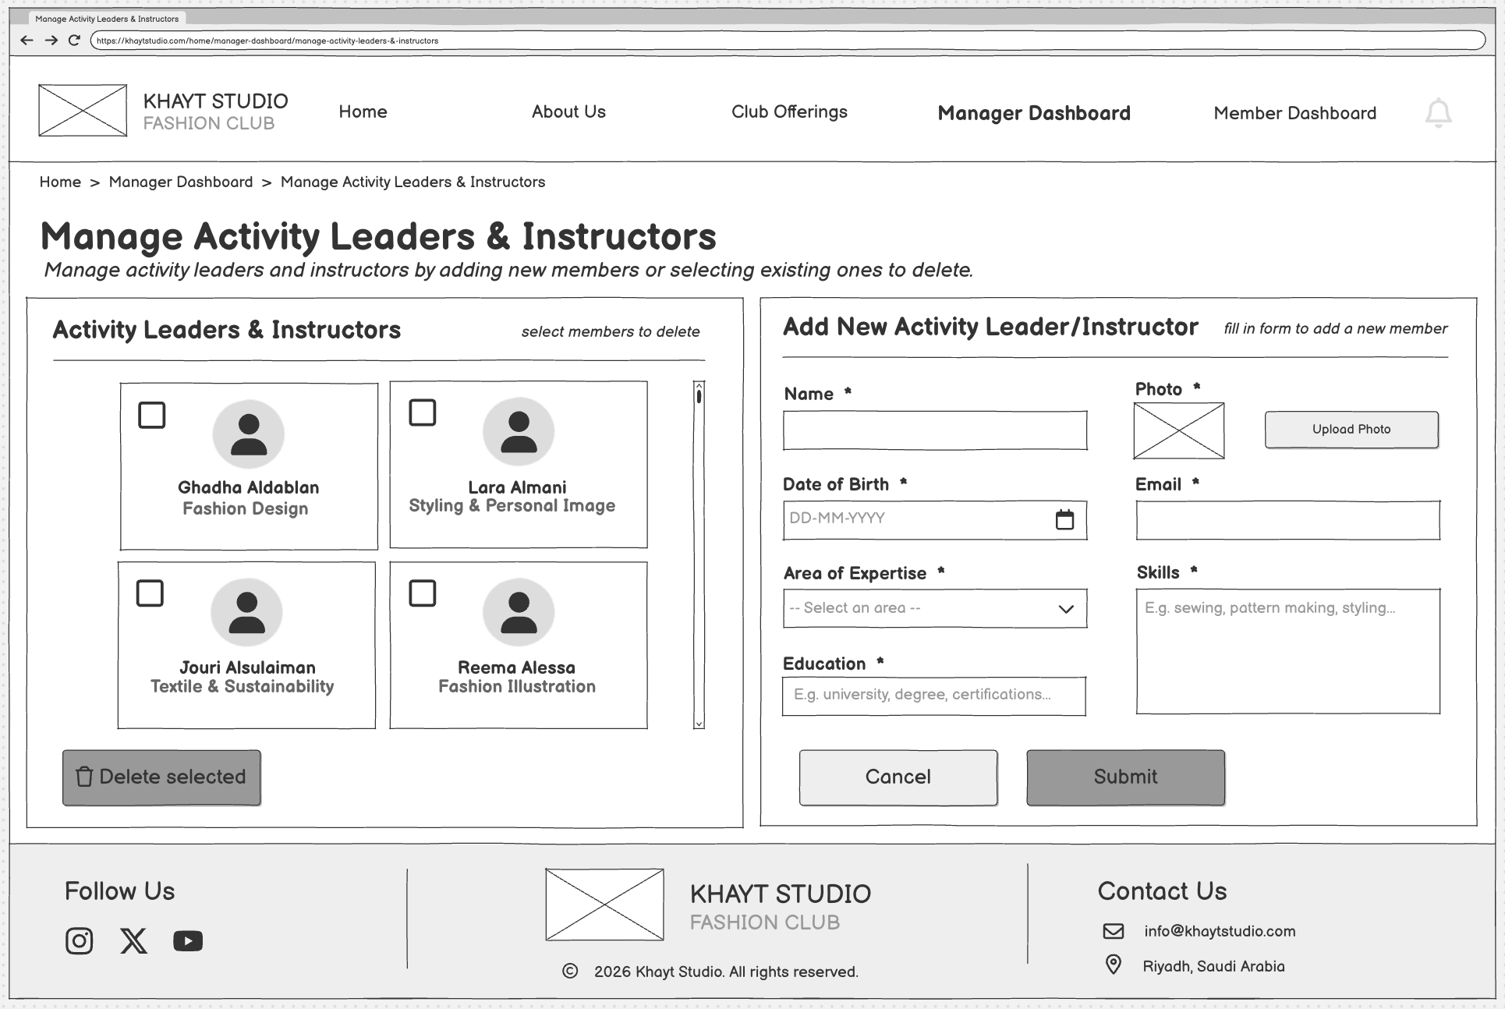

Part E — Generative AI Use
- Logo and Branding: Generative AI was used to explore and visualize logo concepts for Khayt Studio.
