Portfolio – Smart Parcel Sorting System

# Introduction

For this project, my group created a Smart Parcel Sorting System to help organize parcels based on how urgent they are needed. I was responsible for creating the codes for storing parcels using arrays and linked lists. I had to make sure that when parcels are added, they stay sorted by priority so the most important ones come first.

# My Contribution

I worked on two types of storage:  
- Array Storage: I used a simple array where each new parcel is inserted into the correct position based on its priority. The lower the number, the higher the priority.  
- Linked List Storage: I also created a linked list version, which allows parcels to be added dynamically without worrying about the size limit. Like the array, the linked list keeps parcels sorted by priority.

# Code Snapshots

array_storage.cpp output and linked_list_storage.cpp output :

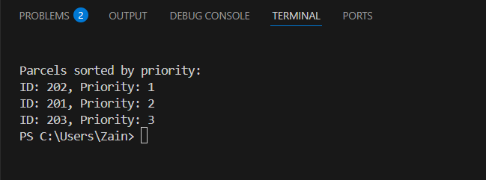

# Challenges and How I Solved Them

One of the challenges I faced was figuring out how to insert a parcel into the correct spot without having to sort the whole list again. For the array, I shifted elements to the right to make space. For the linked list, I had to carefully place new nodes while keeping the list sorted, which took me time to fully understand the concept of it.  
  
Another small challenge was making sure the first element was handled correctly when the array or list was empty.

# What I Learned

Working on this project helped me learn and understand the differences between arrays and linked lists. Arrays are faster for accessing parcels by index, but linked lists are better when you have many insertions and don't know the size in advance.