ER图

customer

purchase

Goods

include

Order information

数据库：coms

表：customer,goods,order_info

表结构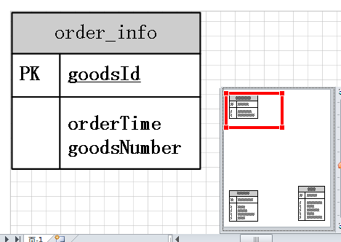

goodsId char(20) not null PRIMARY KEY,

orderTime datetime not null,

goodsNumber int not null,

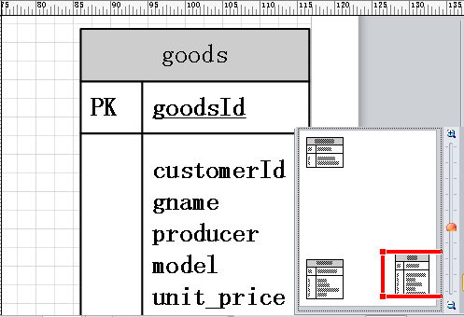

customerId char(20) not null,

goodsId char(20) not null PRIMARY KEY,

gname char(20) not null,

producer text not null,

model char(20) not null,

unit_price money not null,

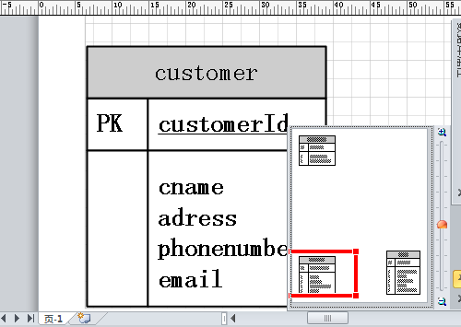

customerId char(20) not null PRIMARY KEY,

cname char(20) not null,

adress text not null,

phonenumber char(20) not null,

email text not null,

)