Visual Patterns Activity NAME ______________________
For each visual pattern, describe in words what you notice happening and then make a prediction for the unknown figure.
Question 1
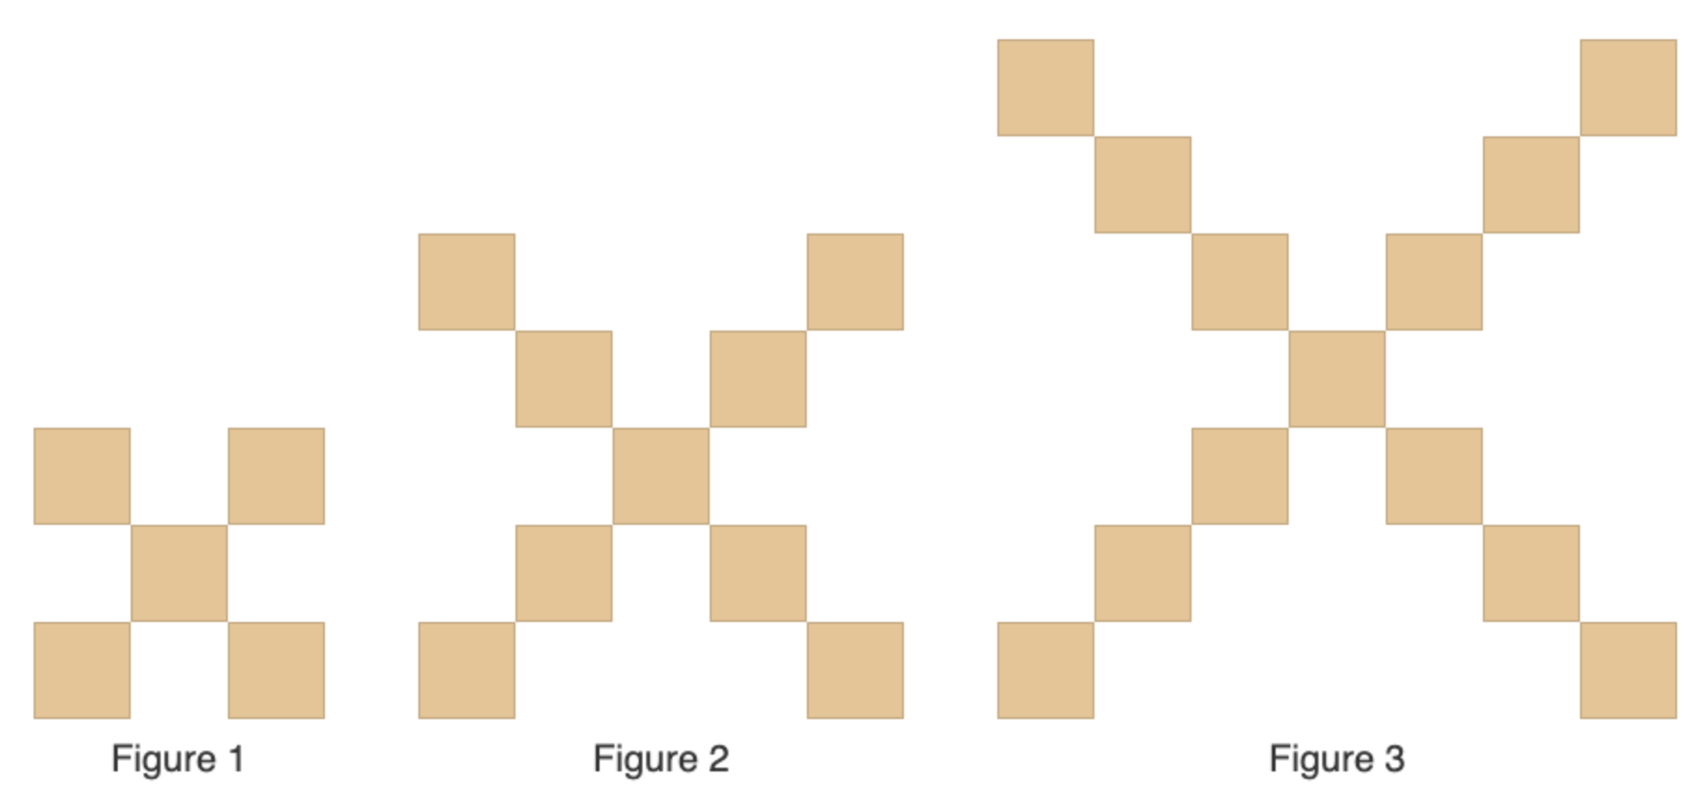 | - How are the figures changing in your own words  - How many squares would there be in figure 7?

Question 2
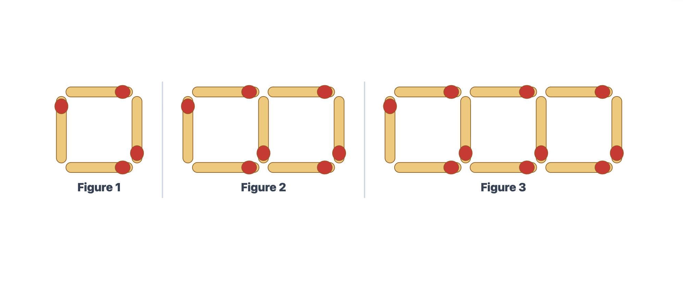 | - How are the figures changing in your own words  - How many matchsticks would there be in figure 11?

Question 3
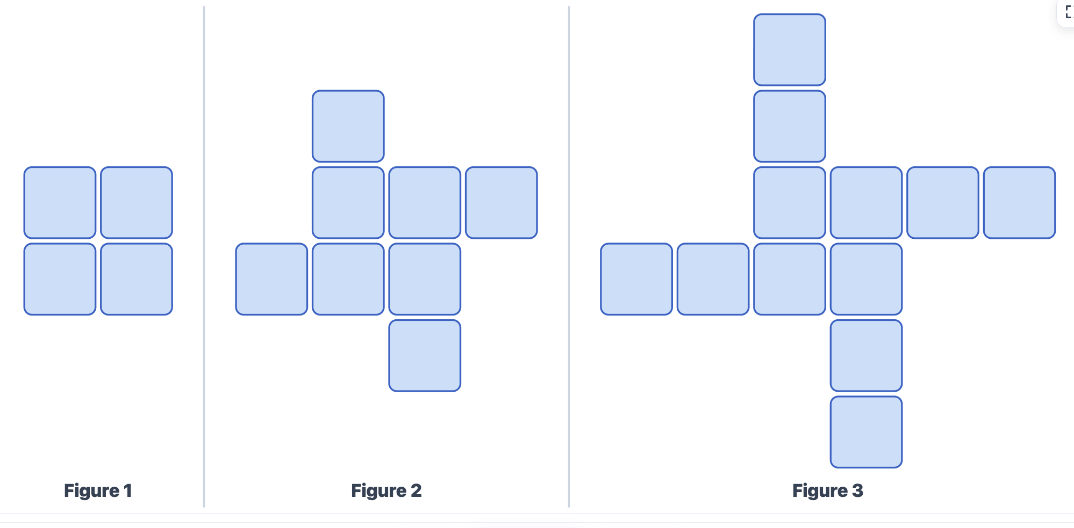 | - How are the figures changing in your own words  - How many squares would there be in figure 6?

Question 4
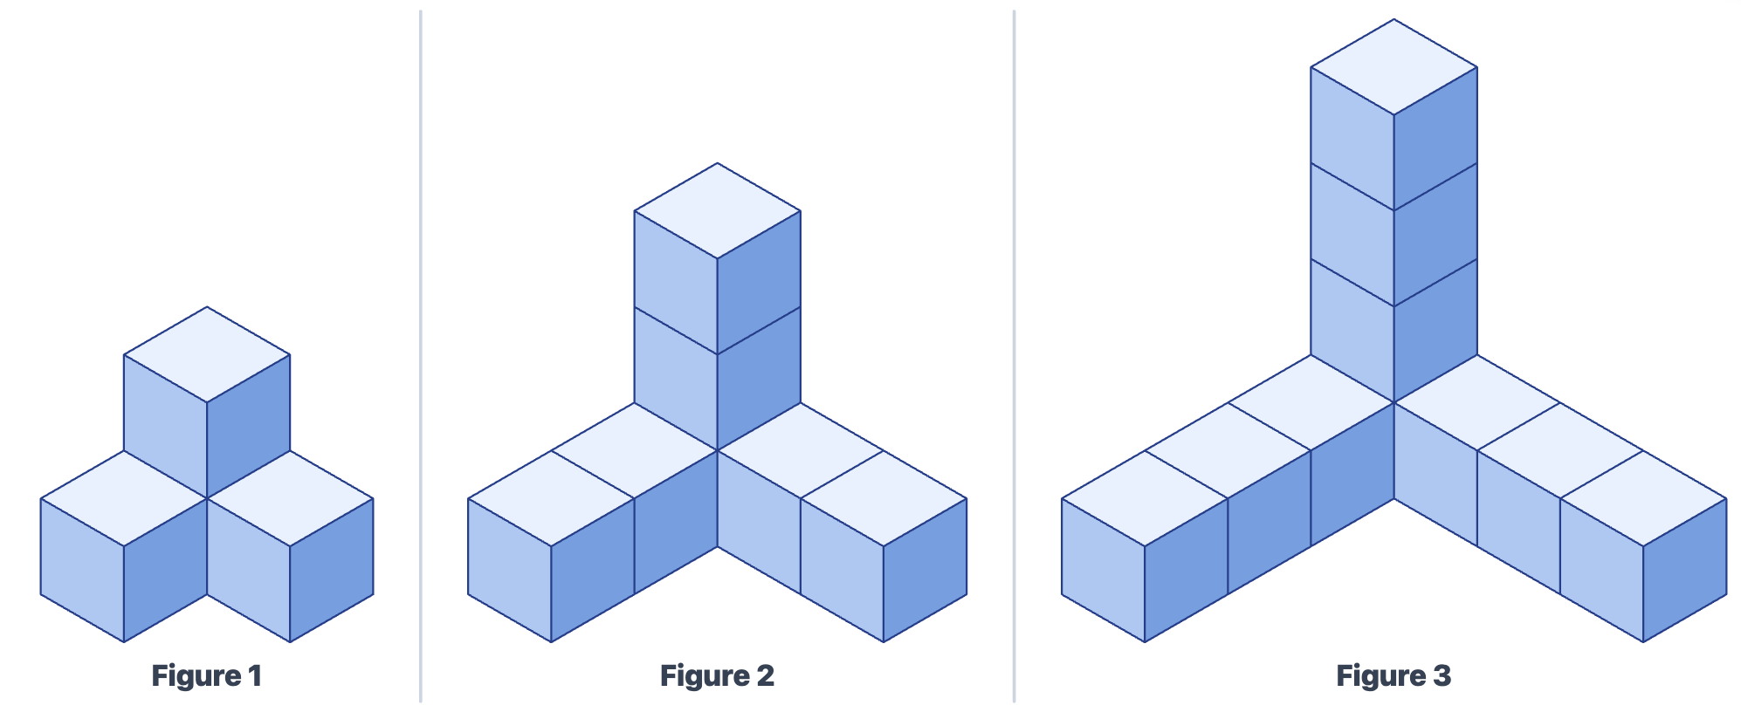 | - How are the figures changing in your own words  - How many cubes would there be in figure 12?

Question 5
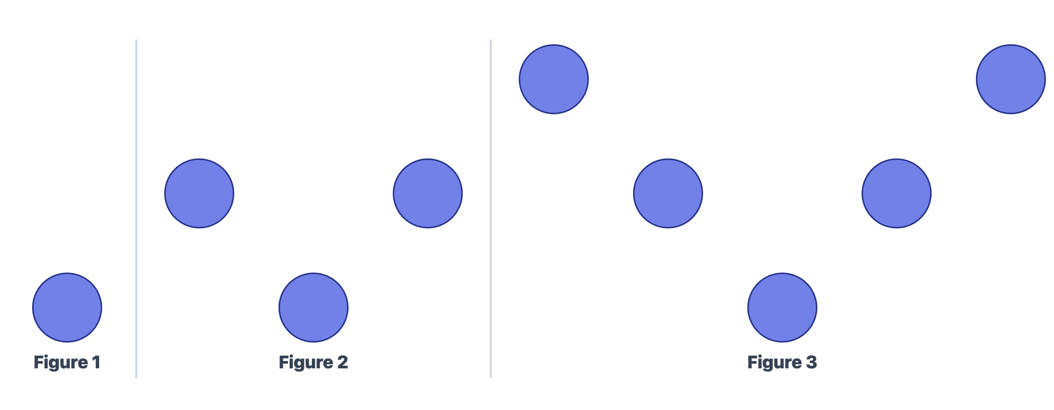 | - How are the figures changing in your own words  - How many circles would there be in figure 28?

*Challenge
Question 6
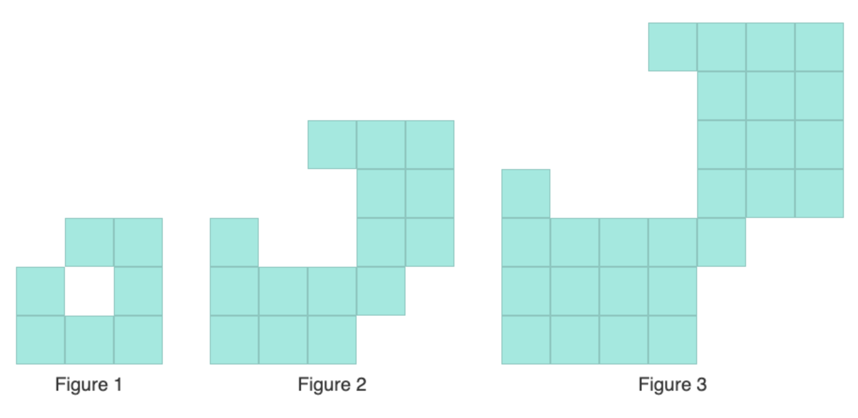 | - How are the figures changing in your own words  - How many squares would there be in figure 10?

