Created rails application in the home directory

- rails labtitan.com -d mysql
but we need to create rails application in separate folder and need to provide symbolic link.

- rails rails_app -d mysql

- ln -s ~/rails_app/public ~/labtitan.com/rails_app

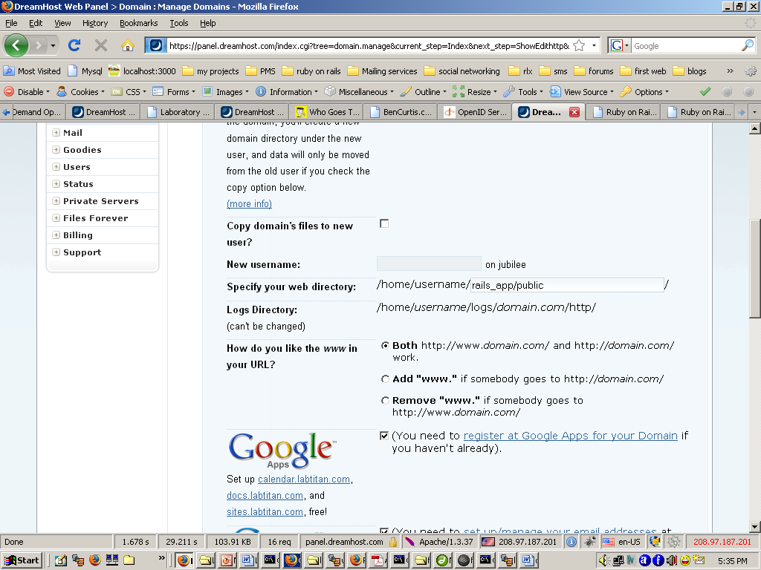

Specify your web directory: /home/username/ labtitan.com

To
Specify your web directory: /home/username/ rails_app/public

As shown above

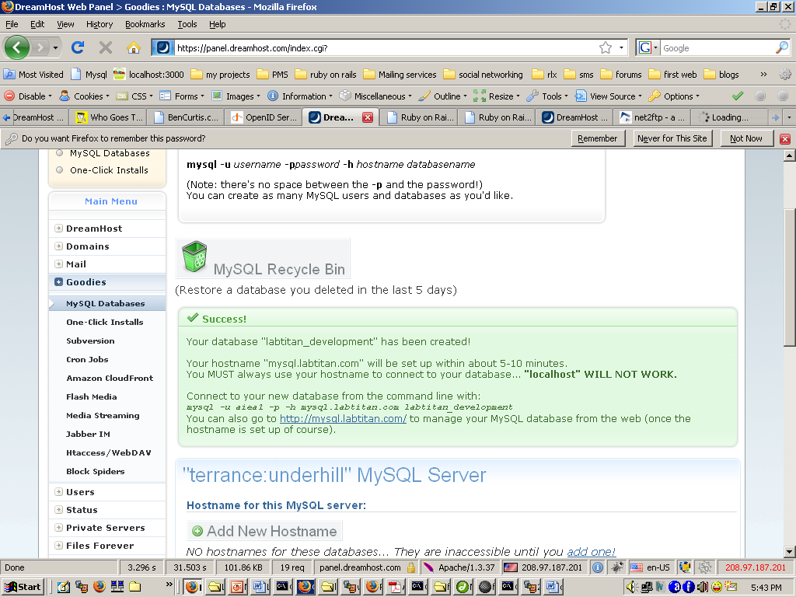

Create a sample controller demo

When you change the code you need to run the command
- touch tmp/restart.txt to restart passenger.

List of URL’s:

http://wiki.dreamhost.com/Passenger
http://wiki.dreamhost.com/index.php/Ruby_on_Rails
http://wiki.dreamhost.com/Passenger
http://wiki.dreamhost.com/Mod_security
http://rubydreams.dreamhosters.com/2009/05/running-an-application-using-passenger-mod_rails/

