**ESP2resso Scale PRO**

**PCB Assembly Guide (v3)**

**WIP**

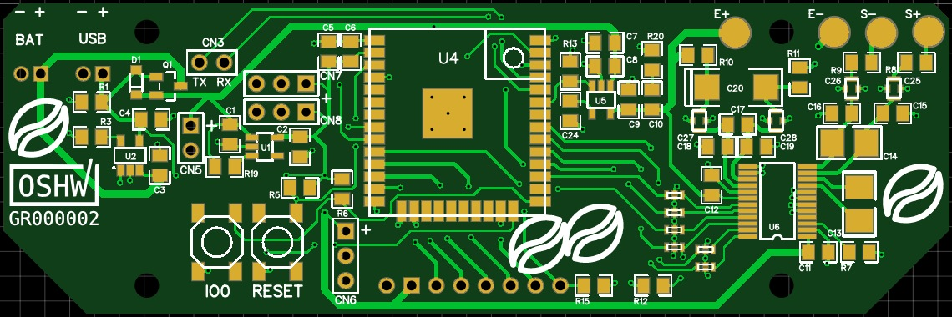

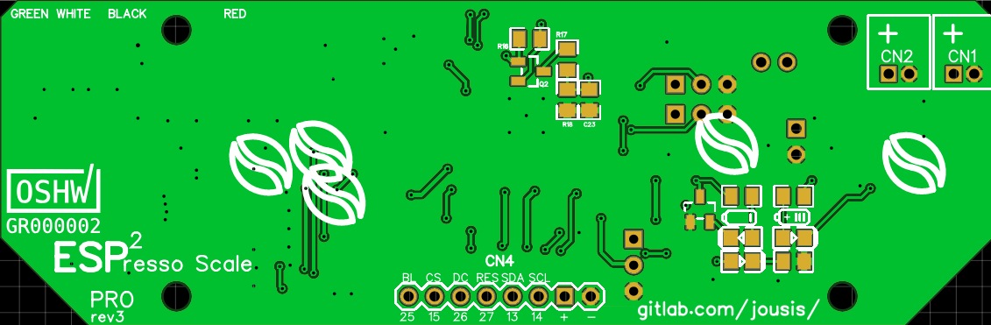

With a little care, you can easily hand solder all the components. No need for hot air.

If you want to minimize the cost, all components except the ADC can be replaced with cheaper alternatives. Try to avoid very cheap components in the analog section (RC filtering) or you might lose some accuracy/stability.

Why “espresso” scale?  
High resolution, high refresh rate needed during an espresso extraction. Apart from that, it is a normal scale.

Why “PRO”?

You can use any SPI (or I2C) screen (even TFT with backlight pin), slightly better RC filtering, speed/gain control of the ADC from the software, better separation of analog/digital tracks, power on/off of the second LDO.

**Section 1 – USB / Battery Input & charging**

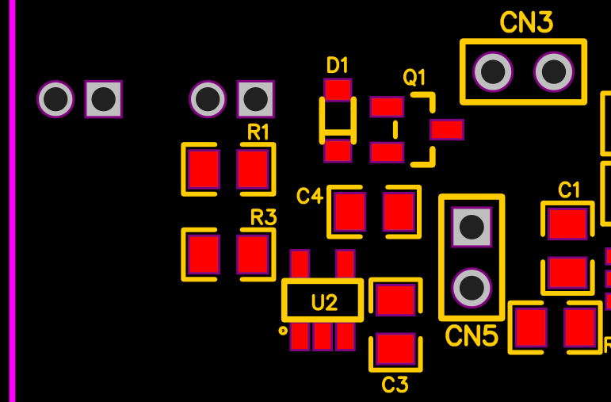

[Battery charging circuit design: Sparkfun ESP32 Thing](https://cdn.sparkfun.com/assets/learn_tutorials/5/0/7/esp32-thing-schematic.pdf)

If you don’t care about battery / battery charging you can connect DC+5V to CN5 and do not solder any of the parts shown above.

Please see the schematics for more info.

**Section 2 – LDO & MCU**

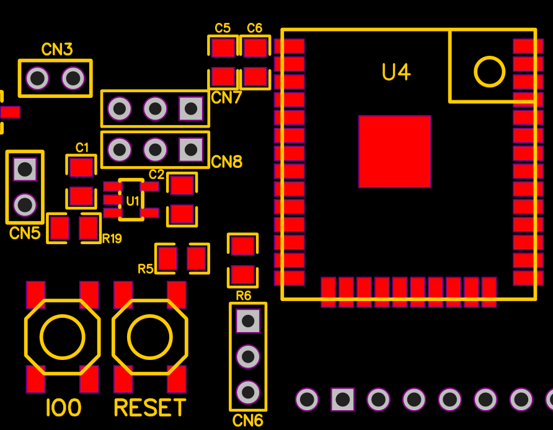

**LDO (U1)**

You can use any LDO pin-compatible with TLV75533PDBVR (SOT-23-5). You don’t need one with enable pin but if it has one, check its datasheet and:

* If it needs logic high for enable, solder R19 (100K). R19 goes to vin (C1).
* If it needs logic low solder a jumper cable from R19 right pad to GND of CN5.

CN5 is optional header, you can use it to give power to the LDO without having to connect the Section 1 part. Very handy for testing.

**MCU (U4)**

You can use any esp32 wroom with the same footprint (ESP32, ESP32D, ESP32U).  
Why module (wroom) and not barebones chip?  
Easier to solder, readily available, reasonable size.

**Programming**

The only way to program your MCU for the 1st time is through the serial connector on the bottom. There is no ftdi chip on the PCB. Afterwards, if you wish, you can setup an OTA method.

**Touch Input**

The middle pin of the three connectors CN6,CN7,CN8 goes to a touch pin of esp32 (T5,T8,T9). You can use them with internal capacitive methods if you prefer. Or…

**Regular buttons/ External digital IO touch modules**

CN6,CN7,CN8 provide an easy way to connect regular buttons using internal PULLUP/PULLDOWN or any external touch module with digital output. All three provide VCC(3.3V) / IO / GND.

**Section 3 – ADC / Load Cell**

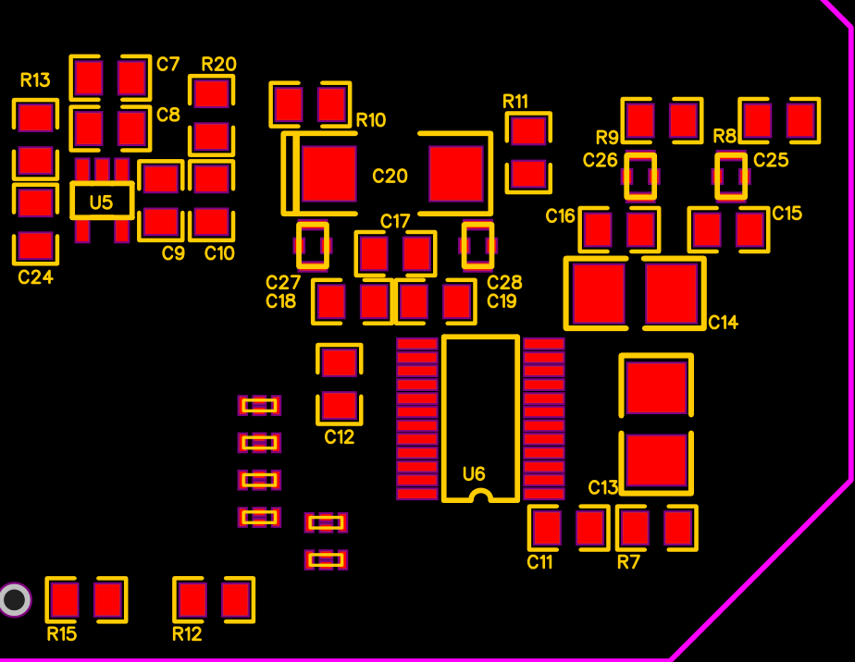

**Analog Voltage LDO**

U5 is the local LDO for the excitation voltage of the load cell (and reference voltage). Use high quality components on everything related to the analog circuit.

**R20**

Is there to add some resistance to C10 if you want to use MLCC and your LDO works better with some ESR (most). If you don’t want to use any R there (not even 0R?), solder bridge both pads.  
**Warning: C20 is not grounded. It goes to ground through R20.**

**C24**

Completely optional. Only if your LDO had a need/option for Cnr capacitor to reduce its output noise. Check datasheet for correct value.

**Comments on the analog LDO**

You don’t have to use any of them but since this is a very crucial part of the scale, I like to share my thoughts and experiments.

Disclaimer: I know there is a pattern in my project with a special brand (TI) but I am not in any way affiliated to them, everything was paid using my own money. I cannot deny though that I really like the quality and specs of their components.

**Option 1 – OK for battery use (BOM)**

TPS7A0533PDBVR

200mA **3.3V** with 210mV dropout and **1uA Iq while working (0.1A on shutdown)**. Good all around. You can use this LDO only with 5V input (max Input 5.5V). Place 0R on R20 or solder bridge the pads, leave C24 unpopulated.

I used this LDO with most of my tests, works well but it is nothing extraordinary. If your main use is battery, excitation voltage cannot go above 3.3V (maybe slightly) so 3.3V regulator is all we need.

**Option 2 – OK for battery use**

TLV75533PDBVR

500mA **3.3V** with 210mV dropout and **25uA Iq while working (0.1A on shutdown)**. Good all around. You can use this LDO only with 5V input (max Input 5.5V). Place 0R on R20 or solder bridge the pads, leave C24 unpopulated.

I used this LDO with most of my tests, works well but it is nothing extraordinary. If your main use is battery, excitation voltage cannot go above 3.3V (maybe slightly) so 3.3V regulator is all we need.

Note: you can use this LDO for both analog and digital, reducing the parts you will need to buy.

**Option 3 – OK for mixed use (DC / Battery)**

TPS76950DBVR

100mA **5V** with 70mV dropout, **17uA while working (1uA on shutdown)**. Its max input V is 10V so if you provide 7V+ input you will have 5V excitation voltage for our load cell. The same LDO will work fine on battery but if you don’t intend to provide DC input on the scale, prefer the TPS7A for its low Iq. Place 0R on R20 or solder bridge the pads, leave C24 unpopulated.

Advantages:

* Up to 5V excitation voltage (with 10V>Vin>7V) for increased accuracy
* Very low dropout voltage

Disadvantages:

* Works fine on battery due to its relatively low Iq but not as well as option1

**Option 4 – Low noise – mixed use**

TPS73643DBVR (4.3V) or TPS73633DBVR (3.3V)

400mA with 75mV dropout and **500uA** **ground current while working, 0.02uA on shutdown**. With C24 (0.01uF) this LDO has very low noise on output. The drawback is its very high ground current while working. For short periods on, large periods off (espresso), it is a viable option. Also note its impressive shutdown current (0.02uA). TPS73643DBVR is the optimal solution here for mixed use (battery/5V DC). You will get 4.3V excitation voltage while on DC for increased accuracy. Place 0R on R20 or solder bridge the pads.

Warning: check firmware options, this LDO needs LOW for enable and HIGH for disable.

Advantages:

* Up to 4.3V excitation voltage (max Vin 5.5V)
* Very low noise if you populate C24 (0.01uF)
* Very low shutdown current
* Very low dropout voltage
* 3.3V can be used as a main LDO as well, reducing the parts you need to buy (not recommended)

Disadvantages:

* Very high ground current while working.  
  Not recommended for prolonged use while on battery. Decrease light/deep sleep timeout on firmware (those two options shut down the ADC LDO).  
  Not recommended for use as main LDO (0.5mA consumption is a lot)
* Very expensive, low availability

**Option 5 – DC input only (<16V)**

LP2985-50DBVR (5V) – not tested yet

150mA with 280mV dropout and 850uA **ground current (0.01uA on shutdown).** Since we don’t mind about dropout and ground current, this LDO is a good option because of its low noise and stable operation with MLCC. Place 0R on R20 and 0.01uF capacitor on C24.

Warning: proposed main LDO cannot accept >5.5V. You will need to change it as well (see SPX3819M5-L-3-3)

Advantages:

* Up to 5V excitation voltage for increased accuracy
* Wide DC input voltage (<16V)
* Very low noise if you populate C24 (0.01uF)
* Very low shutdown current
* Good price (especially in quantity), good availability.

Disadvantages:

* Very high ground current while working

**ADC**

Compared to the HX711 used in almost all the cheap (and not) designs, ADS1232 from TI is very accurate and stable. Although much more expensive, for this type of scale it is an expense you will have to make. Even when heating it up it could manage 0.1g accuracy (has internal temp sensor). Kudos to TI for their awesome documentation and white papers. (notice: This project is in no way affiliated with TI)

Digital +3.3V comes from the main LDO, analog +3.3V from the local LDO. There is only one ground for both signals (analog/digital) but I tried to avoid any digital signal return path through the analog part of the ADC. Unfortunately, due to the size constraints and the large number of tracks needed for the LED segment controller, digital and analog tracks are relatively close together. That said, I tested the same design with separate analog ground (join under the ADC) and couldn’t find measurable difference.

**Notice: ADS1232 does not communicate using standard SPI. Please see my (or any other) library.**

**RC filtering**

Finally, I settled with the reference design and parts. The only exception is that I replaced the small 100pF PPS (ECH-U1C101GX5) with NP0 (GRM2165C1H101FA01D) caps to lower the cost a little.

**Why those tiny feed throughs?**

I cannot measure/see any difference with/without them, but TI knows best (they have them on the reference design). Run a jumper cable across if you don’t have them or even edit the pcb and remove them completely (if you can’t ask me – I can make a new revision).

**Bottom Layer**

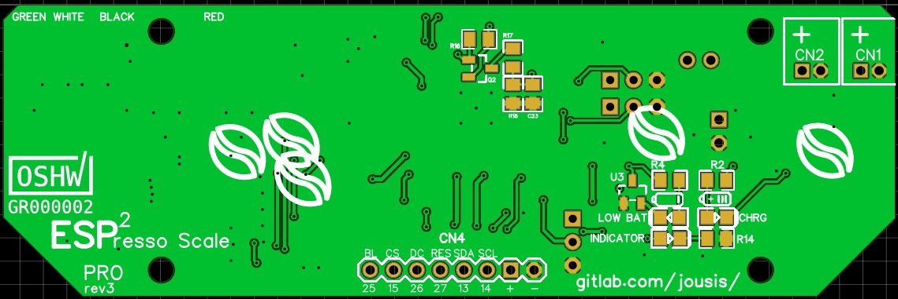

Battery warning (works also while on deep sleep) & LEDs

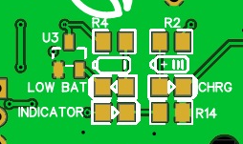

U3 is a simple voltage supervisor circuit that will light LED2 (LOW BAT) when LDO output is <2.99 volts. Use a low power LED because it might stay on for some time. Our MCU will die around 2.8V.

CHRG LED (LED1) is enabled when …you guessed it… battery is charging.

INDICATOR (LED3) is connected to mcu IO and you can use it in any way you like.

All leds are placed closely together so you can design a small “window” on your case. For the same reason, there are no indicators/names on the final pcb (silkscreen) apart from the two battery icons.

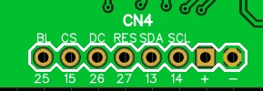

CN4 is for OLED/TFT screens and I have labeled the pins for your convenience.  
As is, you can connect the usual Chinese OLED modules (be careful of VCC/GND pins) and some TFT modules.

**PINS**

From left to right as you see on the picture above:

1. **Screen Backlight control (TFT) – IO25 – solder pulldown resistor R15 if you have a TFT**
2. **CS – IO15 (HSPI SS)**
3. **DC – IO26**
4. **RES – IO27**
5. **SDA – IO13 (HSPI MOSI)**
6. **SCL – IO14 (HSPI SCK)**
7. VCC
8. GND

Note: You must solder the R15 pulldown resistor next to the PWM pin if you want to shut down the backlight.

Tip:

In order to mount your display as close to the PCB as possible without soldering it directly to it, use 90 degree headers in a “Z” configuration.