Exploratory testing: <http://www.gatesnfences.com/index.html>, <https://libertyvan.com/LibertyVan/>

**Basic information:**

Test name: Research testing of site functionality and usability

Sites: <http://www.gatesnfences.com/index.html>, <https://libertyvan.com/LibertyVan/>

Browser: Firefox v115.0

Date: 16.08.2024.

Tester: Jovan Golic

Testing site Gates N Fences

**Objection:** Test the functionality of the main menu, contact form, and other key elements of the site. Identify any errors, inconsistencies, or problems in the user experience.

**Testing steps:**

* 1. Testing the main menu:
* Steps:

1. Open the site <http://www.gatesnfences.com/index.html> in Firefox;
2. Homepage loading time;
3. Click on every visible and displayed links, contact us, about us, faq, our policies, manufacturers, links, dealers application, side links for products.
4. On each open page check: a) did the page load correctly with no errors and redirects; 2) does the main menu remain functional and consistent
5. Click on every pictures if is clickable;
6. Check the search button;
7. Check the every products/services which is on the left side of the homepage;
8. Check the company’s logo basic information and click on each side bar links on the left side of the page;
9. Check the page which leads to payment and click on Add to Chart button;
10. On the payment page check if the logo’s for FedEx and U.S. Postal Service are clickable
11. Click on Fencing or Fencing_2 button, then Pool Fences which is on upper-right side of the screen, then scroll down and click on Colour Chart
12. Click on Links which is on the bottom on the homepage, then click on Link Partners, then click on Electronics, then on Small Business Phone Systems;
13. Click on Links which is on the bottom on the homepage, then click on Link Partners and check the Google search field which is on upper-left side;

* Expected result:

1. Homepage loading time is 1 to 5 seconds;
2. Each link in the main menu leads to the corresponding page without errors;
3. The main menu remains visible and functional on all pages;
4. Every clickable picture should open new page;
5. Search button should throw search result;
6. Every products/services link should be opened in new page;
7. Company’s logo information should be visible and well displayed
8. Payment page should be displayed;
9. Logo for FedEx should open FedEx page and logo for U.S. Postal Service should open U.S. Postal Service page;
10. Colour chart section should be opened with different colours depictions;
11. New page should be opened;
12. Google search field should throw some result;

* Actual result:

1. Homepage loading time is ~2 seconds;
2. Links on homepage such as: [**Miami Florida in Bird Road**](http://www.rrautorepairs.com/aboutus.html), [**www.rrautorepairs.com**](http://www.rrautorepairs), [**Tune-up**](http://www.rrautorepairs.com/Tune-ups/Tune-Ups.html)**,** [**Injection System**](http://www.rrautorepairs.com/Fuel-Injection-System/fuel-Injection-System.html)**,** [**CV Joints**](http://www.rrautorepairs.com/CV-Joints/CV-Joints.html), **Fuel,** [**hydroponics**](http://www.hydroponics-grow-light.com/HYDROPONICS/American-Hydroponics_Hydroponics_Hydroponics-System_Grow-Hydroponics.html)**,** [**hydroponics system**](http://www.hydroponics-grow-light.com/HYDROPONICS/Hydroponics-System_Hydroponics_Hydroponics-System_Hydroponics-Gardening_IndoorGardening.html)**,** [**advanced nutrients**](http://www.hydroponics-grow-light.com/HYDROPONICS-FERTILIZER-/Advanced-Nutrients_Advanced-Nutrients-Fertilizer_Advanced-Nutrients_Organic-Fertilizer_Hydroponics.html)**,** [**grow light**](http://www.hydroponics-grow-light.com/GROW-LIGHT/Grow-light-hood_hydroponics-grow-light_Indoor-grow-light-hoods_plant-grow-light_hydroponics.html) are unavailable;
3. 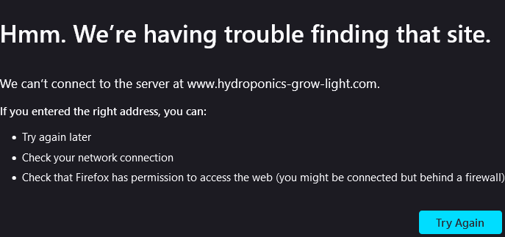
4. Not every clickable picture opens new page. These pictures are clickable, but opens to no one page
5. 
6. Search button doesn’t work, it throws 404 error;
7. 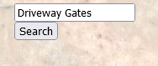
8. Company’s logo info on Driveway Gates, Modern Driveway Gates and Custom Driveway Gates button are not well displayed;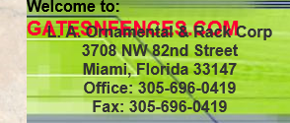
9. Payment page is displayed;
10. Pages for FedEx and U.S. Postal Service are clickable and is to open up;
11. Page with different colours are depicted;
12. Error is being displayed;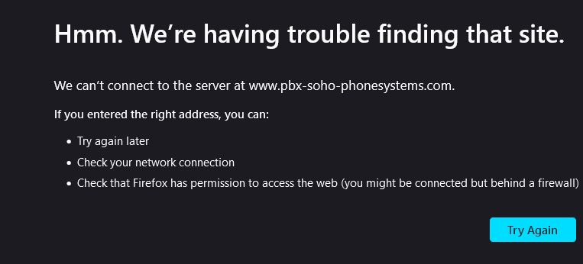
13. Google search field doesn’t work, it opens new page 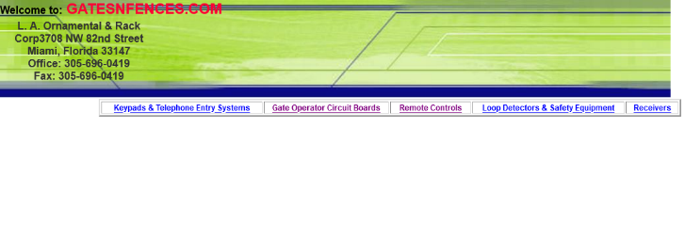

* Conclusions:

1. These links: [**Miami Florida in Bird Road**](http://www.rrautorepairs.com/aboutus.html), [**www.rrautorepairs.com**](http://www.rrautorepairs), [**Tune-up**](http://www.rrautorepairs.com/Tune-ups/Tune-Ups.html)**,** [**Injection System**](http://www.rrautorepairs.com/Fuel-Injection-System/fuel-Injection-System.html)**,** [**CV Joints**](http://www.rrautorepairs.com/CV-Joints/CV-Joints.html), **Fuel,** [**hydroponics**](http://www.hydroponics-grow-light.com/HYDROPONICS/American-Hydroponics_Hydroponics_Hydroponics-System_Grow-Hydroponics.html)**,** [**hydroponics system**](http://www.hydroponics-grow-light.com/HYDROPONICS/Hydroponics-System_Hydroponics_Hydroponics-System_Hydroponics-Gardening_IndoorGardening.html)**,** [**advanced nutrients**](http://www.hydroponics-grow-light.com/HYDROPONICS-FERTILIZER-/Advanced-Nutrients_Advanced-Nutrients-Fertilizer_Advanced-Nutrients_Organic-Fertilizer_Hydroponics.html)**,** [**grow light**](http://www.hydroponics-grow-light.com/GROW-LIGHT/Grow-light-hood_hydroponics-grow-light_Indoor-grow-light-hoods_plant-grow-light_hydroponics.html) should be fixed;
2. These three pictures should be either clickable and to lead to the new page or not;
3. Search field with search button on the homepage should be fixed;
4. Page which is lead to Small Business Phone Systems should be fixed;
5. Google search field should be fixed or removed;
   1. Testing the form:

* Step:

1. Go to site <http://www.gatesnfences.com/index.html>, scroll down to the Contact Us;
2. Fill in form and click on button submit;
3. Check if reset button exist;

* Expected result:

1. Contact Us page should be opened;
2. Form with data should be sent with some proper message like: “Data successfully sent”;
3. Reset button exists;

* Actual:

1. Contact Up page is opened and contains fields;
2. There are two buttons, submit and reset barely visible. 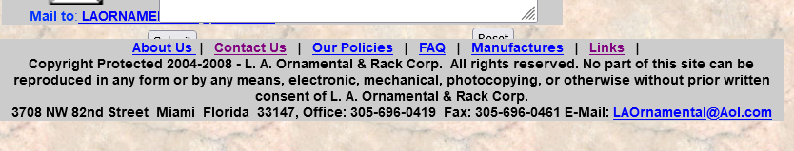 If you click on submit, pop-up emerges with message: Please enter a value for the "Width of Gate" field. That field cannot be found. Form fields are ambiguous and thrown on;
3. Reset button is barely visible and overlapped with footer;

* Conclusions:

1. Form should be fixed
2. Buttons such are submit and reset should be visible
3. Information such as About Us, Contact Us, Our Policies, FAQ, Links should be on the bottom of the page;
4. Instead of check-box fields it should be using radio;
5. Select field should be put;

Testing site Liberty Van

**Objections:** Test key site functionalities, including navigation, image gallery, and contact form. Identify any potential bugs and issues in the user experience.

**Testing steps:**

2.1. Testing the main menu:

* Steps:

1. Open the site <https://libertyvan.com/LibertyVan/> in Firefox;
2. Click on this link: [www.hosanna1.com/social/](http://www.hosanna1.com/social/)
3. Check every single link on that page;
4. Click on that link [**www.libertyvan.com**](http://www.libertyvan.com) which in on the lower-left side of the page;
5. Click on the link where it says CLICK HERE for PICS;
6. Click on this link: [**http://www.clipsyndicate.com/video/play/5137433**](http://www.clipsyndicate.com/video/play/5137433)
7. Click on these links: [**Stars & Stripes photo of Liberty Van at FreePAC in Dallas, TX**](https://libertyvan.com/LibertyVan/image/LVStarsStripesFreePAC072612newspaperT.jpg)
8. Click on this link: [great VIDEO they made of me and Freedom van IN ACTION](http://www.courier-journal.com/videonetwork/1770991245001/Fancy-Farm-2012?fb_action_ids=10151077399613726&fb_action_types=og.recommends&fb_source=aggregation&fb_aggregation_id=246965925417366)
9. Go to this link: [Front Page Sunday Metro Louisville Courier Journal](https://libertyvan.com/LibertyVan/image/freedomvan/FVmeLouisvilleCJSundayarticle-pic.jpg)
10. Go to this link: [www.americansmokersparty.com/Kentucky/](http://www.americansmokersparty.com/Kentucky/)
11. Go to [www.paypal.com/](https://www.paypal.com)

* Expected result:

1. Liberty Van site loading time is 1 to 5 seconds;
2. New page should be opened;
3. Every link on that page should work;
4. That link should be returning you to the main page;
5. New page with images should be opened;
6. New page should be opened containing video;
7. New page should be opened for each link;
8. New page should be opened;
9. Page should be opened;
10. Page should be opened;
11. PayPal page should be opened;

* Actual:

1. Liberty Van loading time is 1 second;
2. New page is opened containing links with various social media;
3. Every link on that page works which they are leading to different social media sites;
4. That link returns you to the main page;
5. New page is opened containing the error 404 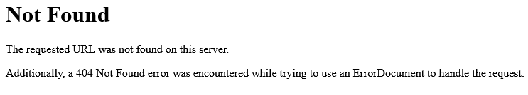
6. New page is opened with blank window;
7. New page is opened for each link containing 404 Not Found error;
8. This page contains 404 Not Found error: 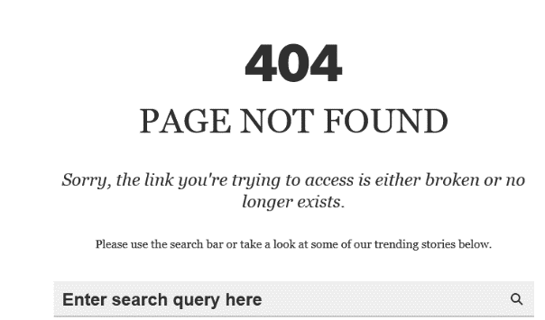
9. Error 404 occurred;
10. Page is opened, but it is loading the page
11. PayPal home page is displayed;

* Conclusions:

1. The pages containing 404 not found error should be deleted or should be redirected to the different pages;