VISOKA ŠKOLA STRUKOVNIH STUDIJA ZA INFORMACIONE I KOMUNIKACIONE TEHNOLOGIJE

INTERNET TEHNOLOGIJE

DOKUMENTACIJA

LINK SAJTA

Predmet: Web programiranje 1 Student: Kristina Mladenovic 5/19

Beograd, decembar 2021

Sadržaj

Uvod 3

Korišćeni programski jezici I tehnologije: 3

Opis funkcionalnosti 3

Template 3

Organizacija 4

Organizaciona šema 4

Svakoj stranici je moguće pristupiti sa svih stranica. 4

Mapa sajta 4

Stranice 5

Home 5

Men / Women 6

Contact 7

About 8

Author 8

Kodovi 9

HTML 9

Home 9

Men 11

Women 12

About 13

Contact 15

Author 17

CSS 19

JS 23

# Uvod

## Korišćeni programski jezici I tehnologije:

Html, Css, Bootstrap, JavaScript, JQuery, Owl JQuery plugin

## Opis funkcionalnosti

1. Dinamičko ispisivanje menija na svim stranama iz niza.
2. Hamburger dugme
3. Slajder na početnoj strani
4. Animacija za kamion na početnoj strani
5. Dinamičko ispisivanje iz nizova ‘Best Sellers’ na početnoj strani
6. Dinamičko ispisivanje vesti iz nizova na početnoj strani
7. Read more link na vestima
8. Animacija kada se klikne na korpu za svaki proizvod
9. Plug in za ispis tipova odeće na početnoj strani
10. Brojač na početnoj strani
11. Dinamičko ispisivanje footera na svim stranama
12. Ispisivanje proizvoda na stranam men i women
13. Hover prelaskom preko proizvoda
14. Validacija podataka iz forme na kontakt strani
15. ‘Back to top dugme’

## Template

Nije korišćen template, kod je samostalno pisan, ideja je preuzeta sa komercijalnih sajtova i template-a, za organizaciju i dizajn je koriscen bootstrap.

# Organizacija

## Organizaciona šema

## Svakoj stranici je moguće pristupiti sa svih stranica.

## Mapa sajta

////iskopirati sitemap

## Stranice

### Home

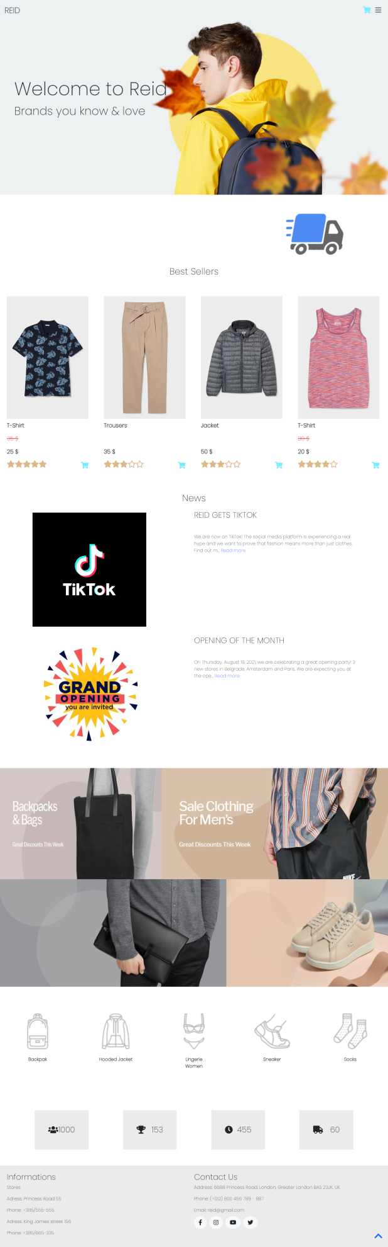

Na ovoj stranici nalaze se : dinamički meni koji se otvara klikom na hamburger dugme, slajder,kamion koji animacijom prelazi na drugu stranu, ispis najprodavanijih proizvoda, ispis vesti, ispis tipova odeće (owl plug in za povlačenje levo-desno) , brojač ( kada se dođe do tog dela strane kreće brojanje) I footer. Svi elementi koji se ponavljaju ispisuju se iz nizova. Klikom na link korpe pored proizvoda, korpa za taj proizvod menja boju, a korpa u hederu menja boju I okrene se za 360 stepeni. Strelica ‘Back to top’ se pojavljuje prilikom skrolovanja. Heder dobije pozadinku boju prilikom skrolovanja, ili kada se otvori. Kada se klikne na link ‘Read more’ na vestima, ispisuje se ceo tekst za tu vest. Prelaskom misem preko proizvoda, pojavljuje se senka za taj proizvod.

### Men / Women

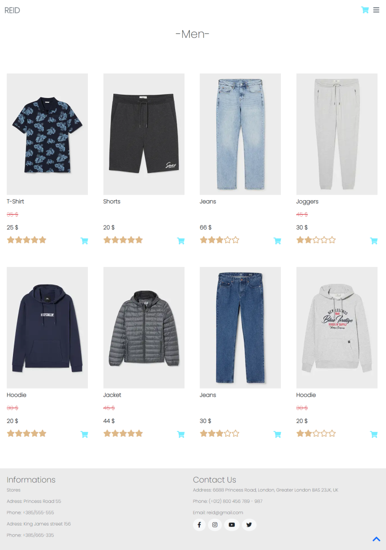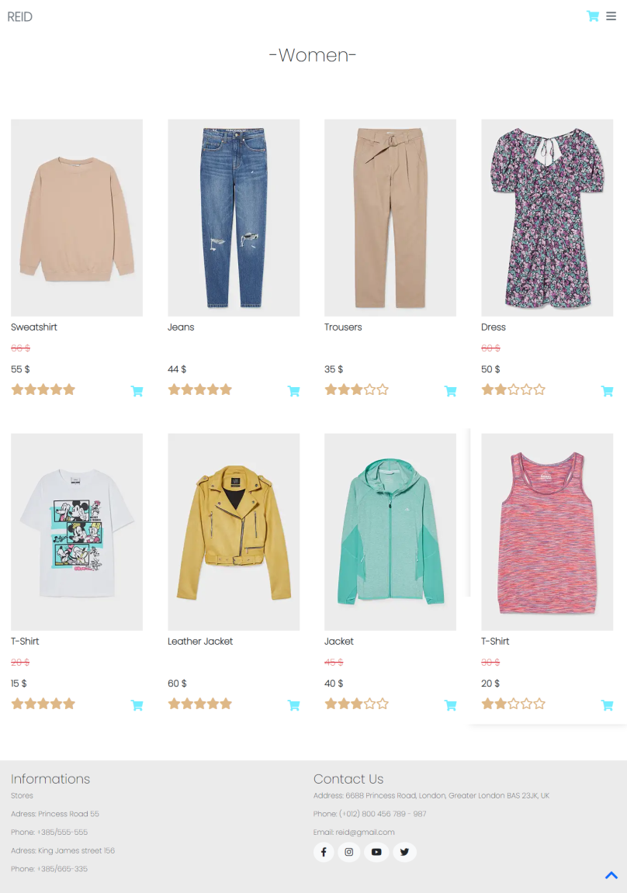

Na ovim stranicama nalaze se dinamički heder I footer, ispis proizvoda iz nizova (slika, naziv, stara cena ako je proizvod na sniženju, nova cena, ocean I link za korpu)

### Contact

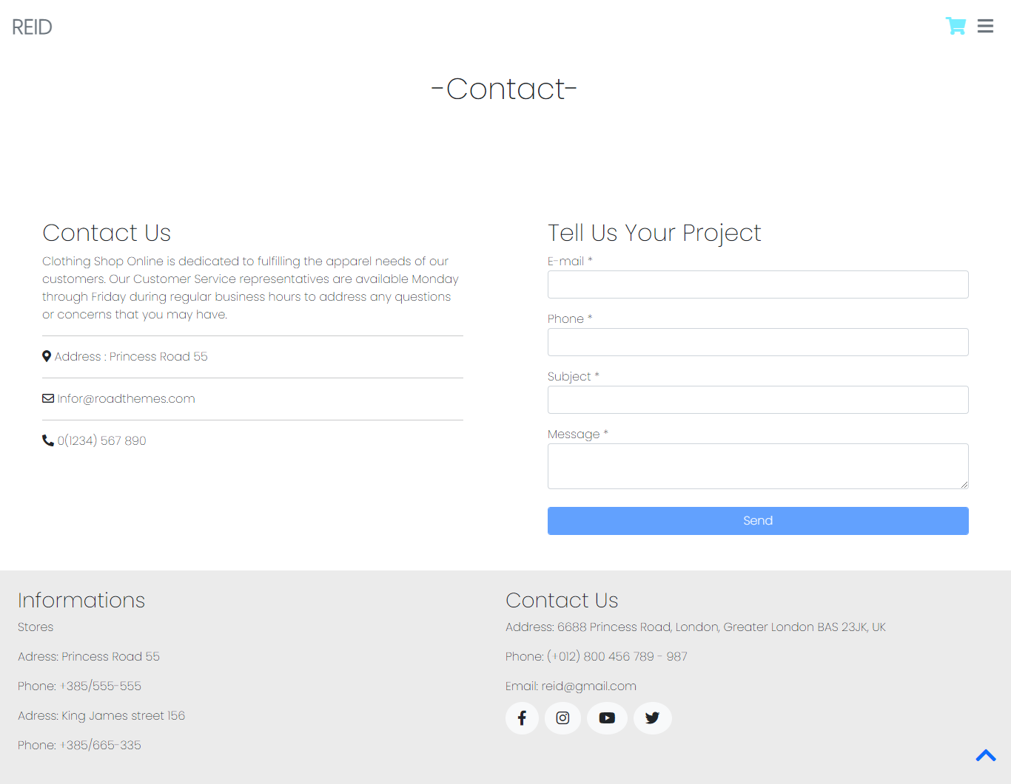

Na ovoj stranici su ispisani dinamički header I footer. Dugme za submit forme je disable-ovano sve dok se sva polja u formi ne popune pravilno. Kada se krene popunjavanje forme, ispisuju se odgovarajuće poruke kako popuniti formu. Ako je polje ispravno popuneno, poruka se sklanja I polje ima zelenu borduru, dok je neispravno, bordura je crvena. Kada se forma submituje, ispisuje se poruka da poruka uspešno poslata, a tekstovi iz forme se brišu.

### About

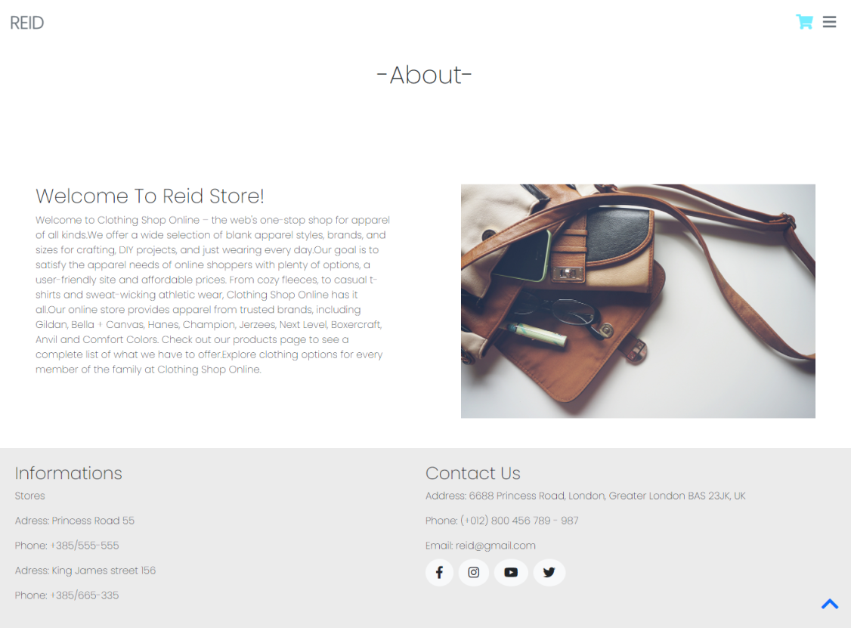

Na ovoj stranici prikazani su header,footer I statički tekst sa slikom.

### Author

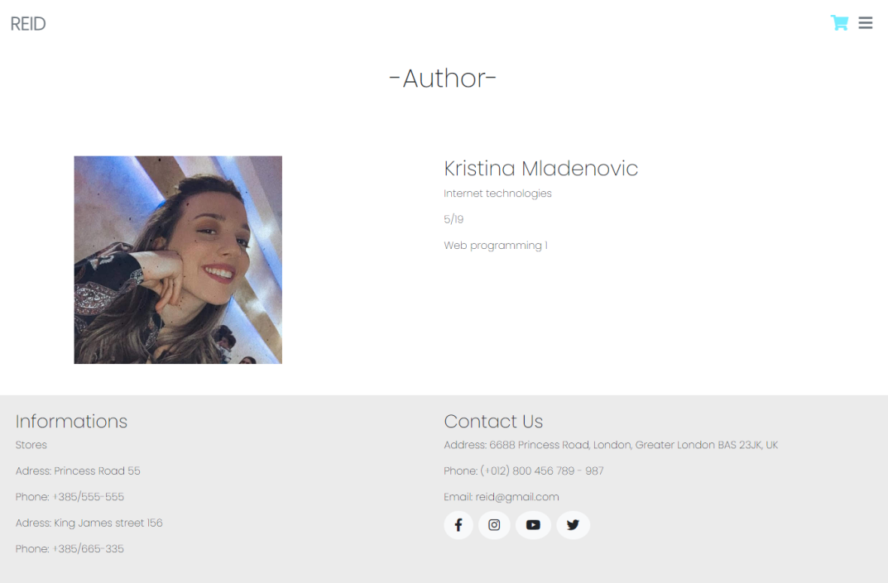

Na ovoj stranici prikazani su header,footer I statički tekst sa slikom.

# Kodovi

## HTML

### Home

<!DOCTYPE html>

<html lang="en">

<head>

    <meta charset="UTF-8">

    <meta http-equiv="X-UA-Compatible" content="IE=edge">

    <meta name="viewport" content="width=device-width, initial-scale=1.0">

    <link rel="stylesheet" href="OwlCarousel2-2.3.4/dist/assets/owl.carousel.min.css">

    <link href="https://cdn.jsdelivr.net/npm/bootstrap@5.0.2/dist/css/bootstrap.min.css" rel="stylesheet" integrity="sha384-EVSTQN3/azprG1Anm3QDgpJLIm9Nao0Yz1ztcQTwFspd3yD65VohhpuuCOmLASjC" crossorigin="anonymous">

    <link rel="preconnect" href="https://fonts.googleapis.com">

    <link rel="preconnect" href="https://fonts.gstatic.com" crossorigin>

    <link href="https://fonts.googleapis.com/css2?family=Poppins:wght@200&display=swap" rel="stylesheet">

    <link rel="stylesheet" href="https://cdnjs.cloudflare.com/ajax/libs/font-awesome/5.15.1/css/all.min.css">

    <link rel="stylesheet" href="assets/css/style.css">

    <title>Document</title>

    <link rel="shortcut icon" href="assets/images/favicon.ico" type="image/x-icon">

</head>

<body>

    <header id="header" class="d-flex justify-content-between flex-wrap p-3">

    </header>

    <div id="slider">

        <img id="sliderImage" class="img-fluid" src="assets/images/slider13.jpg" alt="Slider image">

        <div>

            <h1>Welcome to Reid</h1>

            <p class="fs-1">Brands you know & love </p>

        </div>

    </div>

    <div class="col-12 position-relative my-5">

        <div class="col-3 position-absolute left" id="sneakerAnimation">

            <img class="img-fluid" src="assets/images/patika2.png" alt="">

        </div>

    </div>

    <div id="best" class="bsHome">

        <h2 class="text-center">Best Sellers</h2>

        <div id="topProducts" class="d-flex justify-content-between flex-wrap my-4"></div>

    </div>

    <div id="news" class="my-5">

        <h2 class="text-center">News</h2>

        <div id="news-container" class="my-4 col-10 mx-auto">

        </div>

    </div>

    <div class="baner d-flex flex-wrap justify-content-center my-4">

        <img class="col-5 img-fluid" src="assets/images/banner10.jpg" alt="Baner image">

        <img class="col-7 img-fluid" src="assets/images/banner8.jpg" alt="Baner image">

        <img class="col-7 img-fluid" src="assets/images/banner11.jpg" alt="Baner image">

        <img class="col-5 img-fluid" src="assets/images/banner12.jpg" alt="Baner image">

    </div>

    <div id="categories" class="owl-carousel owl-theme my-2">

    </div>

    <div id="backToTop" class="d-none">

        <a href="#"><i class="fas fa-chevron-up fs-2"></i></a>

    </div>

    <div class="stats d-flex justify-content-between flex-wrap col-10 mx-auto my-5">

        <div class="col-5 col-md-2 p-5 d-flex justify-content-between align-items-center m-2">

            <i class="fas fa-users fs-3"></i> <span class="fs-3" id="users">0</span>

        </div>

        <div class="col-5 col-md-2 p-5 d-flex justify-content-between align-items-center m-2">

            <i class="fas fa-trophy fs-3"></i> <span class="fs-3" id="awards">0</span>

        </div>

        <div class="col-5 col-md-2 p-5 d-flex justify-content-between align-items-center m-2">

            <i class="fas fa-clock fs-3"></i> <span class="fs-3" id="hours">0</span>

        </div>

        <div class="col-5 col-md-2 p-5 d-flex justify-content-between align-items-center m-2">

            <i class="fas fa-truck fs-3"></i> <span class="fs-3" id="delivery">0</span>

        </div>

    </div>

    <script src="assets/js/jquery-3.4.1.min.js"></script>

    <script src="OwlCarousel2-2.3.4/src/js/owl.carousel.js"></script>

    <script src="assets/js/main.js" type="text/javascript"></script>

</body>

</html>

### Men

<!DOCTYPE html>

<html lang="en">

<head>

    <meta charset="UTF-8">

    <meta http-equiv="X-UA-Compatible" content="IE=edge">

    <meta name="viewport" content="width=device-width, initial-scale=1.0">

    <link href="https://cdn.jsdelivr.net/npm/bootstrap@5.0.2/dist/css/bootstrap.min.css" rel="stylesheet" integrity="sha384-EVSTQN3/azprG1Anm3QDgpJLIm9Nao0Yz1ztcQTwFspd3yD65VohhpuuCOmLASjC" crossorigin="anonymous">

    <link rel="preconnect" href="https://fonts.googleapis.com">

    <link rel="preconnect" href="https://fonts.gstatic.com" crossorigin>

    <link href="https://fonts.googleapis.com/css2?family=Poppins:wght@200&display=swap" rel="stylesheet">

    <link rel="stylesheet" href="https://cdnjs.cloudflare.com/ajax/libs/font-awesome/5.15.1/css/all.min.css">

    <link rel="stylesheet" href="assets/css/style.css">

    <title>Document</title>

    <link rel="shortcut icon" href="assets/images/favicon.ico" type="image/x-icon">

</head>

<body>

    <header id="header" class="d-flex justify-content-between flex-wrap p-3">

    </header>

    <div id="best" class="py-5">

        <h1 class="text-center py-5">Men</h1>

        <div id="topProducts" class="d-flex justify-content-between flex-wrap px- my-4"></div>

    </div>

    <div id="backToTop" class="d-none">

        <a href="#"><i class="fas fa-chevron-up fs-2"></i></a>

    </div>

    <script src="assets/js/jquery-3.4.1.min.js"></script>

    <script src="assets/js/main.js" type="text/javascript"></script>

</body>

</html>

### Women

<!DOCTYPE html>

<html lang="en">

<head>

    <meta charset="UTF-8">

    <meta http-equiv="X-UA-Compatible" content="IE=edge">

    <meta name="viewport" content="width=device-width, initial-scale=1.0">

    <link href="https://cdn.jsdelivr.net/npm/bootstrap@5.0.2/dist/css/bootstrap.min.css" rel="stylesheet" integrity="sha384-EVSTQN3/azprG1Anm3QDgpJLIm9Nao0Yz1ztcQTwFspd3yD65VohhpuuCOmLASjC" crossorigin="anonymous">

    <link rel="preconnect" href="https://fonts.googleapis.com">

    <link rel="preconnect" href="https://fonts.gstatic.com" crossorigin>

    <link href="https://fonts.googleapis.com/css2?family=Poppins:wght@200&display=swap" rel="stylesheet">

    <link rel="stylesheet" href="https://cdnjs.cloudflare.com/ajax/libs/font-awesome/5.15.1/css/all.min.css">

    <link rel="stylesheet" href="assets/css/style.css">

    <title>Document</title>

    <link rel="shortcut icon" href="assets/images/favicon.ico" type="image/x-icon">

</head>

<body>

    <header id="header" class="d-flex justify-content-between flex-wrap p-3">

    </header>

    <div id="best" class="py-5">

        <h1 class="text-center py-5">Women</h1>

        <div id="topProducts" class="d-flex justify-content-between flex-wrap px- my-4"></div>

    </div>

    <div id="backToTop" class="d-none">

        <a href="#"><i class="fas fa-chevron-up fs-2"></i></a>

    </div>

    <script src="assets/js/jquery-3.4.1.min.js"></script>

    <script src="assets/js/main.js" type="text/javascript"></script>

</body>

</html>

### About

<!DOCTYPE html>

<html lang="en">

<head>

    <meta charset="UTF-8">

    <meta http-equiv="X-UA-Compatible" content="IE=edge">

    <meta name="viewport" content="width=device-width, initial-scale=1.0">

    <link href="https://cdn.jsdelivr.net/npm/bootstrap@5.0.2/dist/css/bootstrap.min.css" rel="stylesheet" integrity="sha384-EVSTQN3/azprG1Anm3QDgpJLIm9Nao0Yz1ztcQTwFspd3yD65VohhpuuCOmLASjC" crossorigin="anonymous">

    <link rel="preconnect" href="https://fonts.googleapis.com">

    <link rel="preconnect" href="https://fonts.gstatic.com" crossorigin>

    <link href="https://fonts.googleapis.com/css2?family=Poppins:wght@200&display=swap" rel="stylesheet">

    <link rel="stylesheet" href="https://cdnjs.cloudflare.com/ajax/libs/font-awesome/5.15.1/css/all.min.css">

    <link rel="stylesheet" href="assets/css/style.css">

    <title>Document</title>

    <link rel="shortcut icon" href="assets/images/favicon.ico" type="image/x-icon">

</head>

<body>

    <header id="header" class="d-flex justify-content-between flex-wrap p-3">

    </header>

    <div id="best" class="py-5">

        <h1 class="text-center py-5">About</h1>

    </div>

    <div class="d-flex flex-wrap justify-content-around my-5 col-12">

        <div class="col-10 col-md-5">

            <h2>Welcome To Reid Store!</h2>

            <p>Welcome to Clothing Shop Online – the web's one-stop shop for apparel of all kinds.We offer a wide selection of blank apparel styles, brands, and sizes for crafting, DIY projects, and just wearing every day.Our goal is to satisfy the apparel needs of online shoppers with plenty of options, a user-friendly site and affordable prices. From cozy fleeces, to casual t-shirts and sweat-wicking athletic wear, Clothing Shop Online has it all.Our online store provides apparel from trusted brands, including Gildan, Bella + Canvas, Hanes, Champion, Jerzees, Next Level, Boxercraft, Anvil and Comfort Colors. Check out our products page to see a complete list of what we have to offer.Explore clothing options for every member of the family at Clothing Shop Online.</p>

        </div>

        <div class="col-10 col-md-5 mx">

            <img class="img-fluid" src="assets/images/about1.jpg" alt="Store about">

        </div>

    </div>

    <div id="backToTop" class="d-none">

        <a href="#"><i class="fas fa-chevron-up fs-2"></i></a>

    </div>

    <script src="assets/js/jquery-3.4.1.min.js"></script>

    <script src="assets/js/main.js" type="text/javascript"></script>

</body>

</html>

### Contact

<!DOCTYPE html>

<html lang="en">

<head>

    <meta charset="UTF-8">

    <meta http-equiv="X-UA-Compatible" content="IE=edge">

    <meta name="viewport" content="width=device-width, initial-scale=1.0">

    <link href="https://cdn.jsdelivr.net/npm/bootstrap@5.0.2/dist/css/bootstrap.min.css" rel="stylesheet" integrity="sha384-EVSTQN3/azprG1Anm3QDgpJLIm9Nao0Yz1ztcQTwFspd3yD65VohhpuuCOmLASjC" crossorigin="anonymous">

    <link rel="preconnect" href="https://fonts.googleapis.com">

    <link rel="preconnect" href="https://fonts.gstatic.com" crossorigin>

    <link href="https://fonts.googleapis.com/css2?family=Poppins:wght@200&display=swap" rel="stylesheet">

    <link rel="stylesheet" href="https://cdnjs.cloudflare.com/ajax/libs/font-awesome/5.15.1/css/all.min.css">

    <link rel="stylesheet" href="assets/css/style.css">

    <title>Document</title>

    <link rel="shortcut icon" href="assets/images/favicon.ico" type="image/x-icon">

</head>

<body>

    <header id="header" class="d-flex justify-content-between flex-wrap p-3">

    </header>

    <div id="best" class="py-5">

        <h1 class="text-center py-5">Contact</h1>

    </div>

    <div class="d-flex flex-wrap justify-content-around my-5 col-12">

        <div class="col-10 col-md-5">

           <h2>Contact Us</h2>

           <p>Clothing Shop Online is dedicated to fulfilling the apparel needs of our customers. Our Customer Service representatives are available Monday through Friday during regular business hours to address any questions or concerns that you may have.</p>

           <hr>

           <p><i class="fas fa-map-marker-alt"></i> Address : Princess Road 55</p>

           <hr>

           <p><i class="far fa-envelope"></i> Infor@roadthemes.com</p>

           <hr>

           <p><i class="fas fa-phone-alt"></i> 0(1234) 567 890</p>

        </div>

        <div class="col-10 col-md-5 mx">

            <h2>Tell Us Your Project</h2>

            <div class="col-12 mb-2">

                <label for="email">E-mail *</label>

                <input type="text" name="email" id="email" class="form-control">

                <p id="errEmail"></p>

            </div>

            <div class="col-12 mb-2">

                <label for="phone">Phone *</label>

                <input type="text" name="phone" id="phone" class="form-control">

                <p id="errPhone"></p>

            </div>

            <div class="col-12 mb-2">

                <label for="subject">Subject *</label>

                <input type="text" name="subject" id="subject" class="form-control">

                <p id="errSubject"></p>

            </div>

            <div class="col-12 mb-2">

                <label for="message">Message *</label>

                <textarea name="message" id="message" class="form-control"></textarea>

                <p id="errMessage"></p>

            </div>

            <div class="col-12 mt-4">

                <button id="btnSend" class="form-control btn btn-primary disabled">Send</button>

            </div>

            <p class="text-success d-none mt-4" id="messageSuccess">You have successfuly sent message!</p>

        </div>

    </div>

    <div id="backToTop" class="d-none">

        <a href="#"><i class="fas fa-chevron-up fs-2"></i></a>

    </div>

    <script src="assets/js/jquery-3.4.1.min.js"></script>

    <script src="assets/js/main.js" type="text/javascript"></script>

</body>

</html>

### Author

<!DOCTYPE html>

<html lang="en">

<head>

    <meta charset="UTF-8">

    <meta http-equiv="X-UA-Compatible" content="IE=edge">

    <meta name="viewport" content="width=device-width, initial-scale=1.0">

    <link href="https://cdn.jsdelivr.net/npm/bootstrap@5.0.2/dist/css/bootstrap.min.css" rel="stylesheet" integrity="sha384-EVSTQN3/azprG1Anm3QDgpJLIm9Nao0Yz1ztcQTwFspd3yD65VohhpuuCOmLASjC" crossorigin="anonymous">

    <link rel="preconnect" href="https://fonts.googleapis.com">

    <link rel="preconnect" href="https://fonts.gstatic.com" crossorigin>

    <link href="https://fonts.googleapis.com/css2?family=Poppins:wght@200&display=swap" rel="stylesheet">

    <link rel="stylesheet" href="https://cdnjs.cloudflare.com/ajax/libs/font-awesome/5.15.1/css/all.min.css">

    <link rel="stylesheet" href="assets/css/style.css">

    <title>Document</title>

    <link rel="shortcut icon" href="assets/images/favicon.ico" type="image/x-icon">

</head>

<body>

    <header id="header" class="d-flex justify-content-between flex-wrap p-3">

    </header>

    <div id="best" class="pt-5">

        <h1 class="text-center py-5">Author</h1>

    </div>

    <div class="d-flex flex-wrap justify-content-center my-5 col-12">

        <div class="col-10 col-md-5 mx">

            <img class="img-fluid" src="assets/images/profil.jpg" alt="Kristina Mladenovic">

        </div>

        <div class="col-10 col-md-5">

            <h2>Kristina Mladenovic</h2>

            <p>Internet technologies</p>

            <p>5/19</p>

            <p>Web programming 1</p>

        </div>

    </div>

    <div id="backToTop" class="d-none">

        <a href="#"><i class="fas fa-chevron-up fs-2"></i></a>

    </div>

    <script src="assets/js/jquery-3.4.1.min.js"></script>

    <script src="assets/js/main.js" type="text/javascript"></script>

</body>

</html>

## CSS

*{

    margin: 0px;

    padding: 0px;

    box-sizing: border-box;

}

body{

    font-family: 'Poppins', sans-serif;

}

header{

    width: 100%;

    position: fixed;

    transition-duration: 0.5s;

    z-index: 99;

}

nav{

    position: absolute;

    right: 0px;

    top: 59px;

    padding-right: 25px;

    transition-duration: 0.5s;

}

nav ul{

    list-style-type: none;

}

.headerColor{

    background-color: #fff;

    transition-duration: 0.5s;

}

#backToTop{

    position: fixed;

    right: 20px;

    bottom: 20px;

    z-index: 99;

}

.item{

    margin: 45px;

    padding: 25px;

}

footer{

    width: 100%;

    background-color: #ebebeb;

}

.product{

    position: relative;

    z-index: 80;

    padding: 20px 0px;

}

.product p{

    font-size: 20px;

}

.product .productName{

    font-weight: bold;

}

.product .fa-star{

    color: burlywood;

    font-size: 25px;

}

.card-position{

    position: absolute;

    z-index: 80;

    bottom: 20px;

    right: 30px;

}

.bsHome{

    margin-top: 250px;

}

#best h1::after{

    content: "-";

}

#best h1::before{

    content: "-";

}

.add-to-card,.card-up{

    color: #75edff;

}

.card-added{

    color: #0026ff;

    transition-duration: 0.5s;

}

.card-animation{

    transform: rotate(360deg);

    transition-duration: 0.5s;

}

#slider{

    position: relative;

}

#slider div{

    position: absolute;

    top: 40%;

    left: 50px;

}

#slider h1{

    font-size: 65px;

}

.stats div{

    background-color: #ebebeb;

}

/* #sneakerAnimation{

    animation-name: myAnimation;

    animation-iteration-count: infinite;

} */

.left{

    transform: rotateY(0deg);

}

.right{

    transform: rotateY(180deg);

}

.shadow{

    box-shadow: 0px 0px 10px #c2c2c2;

}

/* @keyframes myAnimation{

    0% {

        transform: rotateY(0deg);

        }

    100% {

        transform: rotateY(180deg);

        }

} */

@media screen and (max-width:800px){

    .item{

        margin: 20px;

        padding: 0px;

    }

    #slider h1{

        font-size: 30px;

    }

    #slider p{

        font-size: 20px!important;

    }

    .product .fa-star{

        font-size: 15px;

    }

    .card-position{

        font-size: 15px!important;

        right: 15px;

        bottom: 10px;

    }

    .product{

        padding: 0px 10px!important;

    }

    .bsHome{

        margin-top: 150px;

    }

}

@media screen and (max-width:500px){

    .item{

        margin: 5px;

    }

}

## JS

$(document).ready(function(){

    getHeader()

    getFooter()

})

$(window).scroll(function(){

    if(window.pageYOffset>50){

        $("header").addClass("headerColor")

        $("nav").addClass("headerColor")

        $("#backToTop").removeClass("d-none")

    }

    else{

        $("header").removeClass("headerColor")

        $("nav").removeClass("headerColor")

        $("#backToTop").addClass("d-none")

    }

})

$("#scroll a").click(function() {

    $("html, body").animate({ scrollTop: 0 }, "slow");

    return false;

});

function getHeader(){

    let print=''

    print+=`<div id="Logo"><a class="text-decoration-none fw-bold text-secondary text-uppercase fs-3" href="index.html">Reid</a></div>

            <div class="d-flex align-items-center">

                <a href="#" id="card"><i class="fas fa-shopping-cart fs-4 card-up mx-2"></i></a>

                <a href="#" id="hamburger" class="hamburger text-secondary"><i class="fas fa-bars fs-4 mx-2"></i></a>

            </div>`

    $('header').html(print)

    getMenu()

    $("#hamburger").click(showMenu)

}

function getMenu(){

    var menuNames=['Home','Men','Women','About','Contact','Author']

    var menuLinks=['index.html','men.html','women.html','about.html','contact.html','author.html']

    let print=''

    print+=`<nav class="col-12 d-none"><ul class="text-end">`

    for(let i=0;i<menuNames.length;i++){

        print+=`<li><a class="text-decoration-none text-uppercase fs-4" href="${menuLinks[i]}">${menuNames[i]}</a></li>`

    }

    print+=`</ul></nav>`

    document.getElementById("header").innerHTML+=print

}

function getFooter(){

    var footer=document.createElement("footer");

    footer.setAttribute("class","p-4 d-flex justify-content-between flex-wrap");

    $("body").append(footer)

    var footerInformations=document.createElement("div")

    var footerContact=document.createElement("div")

    footerInformations.setAttribute("class","col-10 col-md-6")

    footerContact.setAttribute("class","col-10 col-md-6")

    footer.append(footerInformations)

    footer.append(footerContact)

    footerInformations.innerHTML=`<h3>Informations</h3>

    <p>Stores</p>

    <p>Adress: Princess Road 55</p>

    <p>Phone: +385/555-555</p>

    <p>Adress: King James street 156</p>

    <p>Phone: +385/665-335</p>

    `

    footerContact.innerHTML=`<h3>Contact Us</h3>

    <p>Address: 6688 Princess Road, London, Greater London BAS 23JK, UK</p>

    <p>Phone: (+012) 800 456 789 - 987</p>

    <p>Email: reid@gmail.com</p>

    `

    var networks=['fa-facebook-f','fa-instagram','fa-youtube','fa-twitter']

    var networksLinks=['https://www.facebook.com','https://www.instagram.com','https://www.youtube.com','https://www.twitter.com/']

    for(let i=0;i<networks.length;i++){

        footerContact.innerHTML+=`<a target="_blank" class="px-3 py-2 me-2 rounded-circle bg-light border-1 text-dark fs-5" href="${networksLinks[i]}"><i class="fab ${networks[i]}"></i></a>`

    }

    footerContact.innerHTML+=`<br/><br/><a class="text-decoration-none text-dark" href="doc.pdf">Documentation</a>`

}

function showMenu(e){

    e.preventDefault()

    if($("nav").hasClass("d-none")){

        $("nav").removeClass("d-none")

        $("#hamburger").html(`<i class="fas fa-times fs-4 mx-2"></i>`)

        $("header").addClass("headerColor")

        $("nav").addClass("headerColor")

    }

    else{

        $("nav").addClass("d-none")

        $("#hamburger").html(`<i class="fas fa-bars fs-4 mx-2"></i>`)

        $("header").removeClass("headerColor")

        $("nav").removeClass("headerColor")

    }

}

let url=location.href;

function getSlider(){

    var slider=document.querySelector("#sliderImage");

    var imagesSrc=["slider13.jpg","slider14.jpg","slider15.jpg"];

    var i=0;

    function loadSlider(){

        slider.src="assets/images/"+imagesSrc[i];

        if(i<imagesSrc.length-1) i++;

        else i=0;

        setTimeout(loadSlider, 3000);

    };

    loadSlider();

}

function getCategories(){

    var categoriesImages=['shipping.png','shipping1.png','shipping2.png','shipping3.png','shipping4.png','shipping5.png']

    var categoryNames=['Backpak','Hooded Jacket','Lingerie Women','Sneaker','Socks','Clothing',]

let print=''

for(let i=0;i<categoriesImages.length;i++){

    print+=`<div class='item text-center'><img alt="Category" class="img-fluid" src='assets/images/${categoriesImages[i]}'/><p class="mt-4 fs-6 fw-bolder">${categoryNames[i]}</p></div>`

}

document.getElementById("categories").innerHTML+=print

$('.owl-carousel').owlCarousel({

    loop:true,

    margin:10,

    nav:true,

    responsive:{

        0:{

            items:1

        },

        60:{

            items:3

        },

        100:{

            items:5

        }

    }

})

}

///top products

var topProducts=['T-Shirt','Trousers','Jacket','T-Shirt']

var topProductsImages=['product9.webp','product3.webp','product14.webp','product8.webp']

var topProductsPrices=[25,35,50,20]

var topProductsOldPrices=[35,null,null,30]

var topProductRate=[5,3,3,4]

///men products

var menProducts=['T-Shirt','Shorts','Jeans','Joggers','Hoodie','Jacket','Jeans','Hoodie']

var menProductsImages=['product9.webp','product10.webp','product11.webp','product12.webp','product13.webp','product14.webp','product15.webp','product16.webp']

var menProductsPrices=[25,20,66,30,20,44,30,20]

var menProductsOldPrices=[35,null,null,45,30,45,null,30]

var menProductRate=[5,5,3,2,5,5,3,2]

///woman products

var womanProducts=['Sweatshirt','Jeans','Trousers ','Dress','T-Shirt','Leather Jacket','Jacket','T-Shirt']

var womanProductsImages=['product1.webp','product2.webp','product3.webp','product4.webp','product5.webp','product6.webp','product7.webp','product8.webp']

var womanProductsPrices=[55,44,35,50,15,60,40,20]

var womanProductsOldPrices=[66,null,null,60,20,null,45,30]

var womanProductRate=[5,5,3,2,5,5,3,2]

function printProducts(products,productsImages,productsPrices,oldPrices,productRate){

    let print=''

    for(let i=0;i<products.length;i++){

        print+=`<div class="col-6 col-md-3 px-4 my-3 product">

                <div class="my-2"><img class="img-fluid" src="assets/images/${productsImages[i]}"/></div>

                <p class="productName">${products[i]}</p>`

                if(oldPrices[i]!=null){

                    print+=`<p class="text-decoration-line-through me-5 text-danger">${oldPrices[i]} $</p>`

                }

                else{

                    print+=`<p>&nbsp;</p>`

                }

                print+=`<p class="fw-bolder">${productsPrices[i]} $</p>`

                for(let j=1;j<=5;j++){

                    if(j<=productRate[i]){

                        print+=`<i class="fas fa-star"></i>`

                    }

                    else{

                        print+=`<i class="far fa-star"></i>`

                    }

                }

                print+=`<a href="#" class="add-to-card"><i class="fas fa-shopping-cart card-position fs-4"></i></a>`

                print+=`</div>`

    }

    $("#topProducts").html(print)

    $(".add-to-card").click(addToCard)

    $(".product").hover(

        function(){

        $(this).addClass("shadow")

        },

        function(){

            $(this).removeClass("shadow")

        })

}

function addToCard(e){

    e.preventDefault()

    $(".card-up").addClass("card-added")

    if($(".card-up").hasClass("card-animation")){

        $(".card-up").removeClass("card-animation")

    }

    else{

        $(".card-up").addClass("card-animation")

    }

    $(this).addClass("card-added")

}

var newsTitle=['Reid gets tiktok','Opening of the month'];

var newsContent=['We are now on TikTok! The social media platform is experiencing a real hype and we want to prove that fashion means more than just clothes. Find out more here and become part of our community!','On Thursday, August 19, 2021, we are celebrating a great opening party! 3 new stores in Belgrade, Amsterdam and Paris. We are expecting you at the opening. Big discounts are waiting for you! Stores Locations : Belgrade - Bulevar Kralja Aleksandra 55, Amsterdam : Leidsestraat 7, Paris : 62 Rue Bonaparte']

var newsImage=['tiktok.png','opening.jpg']

function getNews(){

    let print=''

    for(let i=0;i<newsTitle.length;i++){

        print+=`<div class="col-12 my-4 d-flex justify-content-around flex-wrap">

                    <div class="col-10 col-md-6 my-2"><img class="img-fluid" src="assets/images/${newsImage[i]}" alt="${newsTitle[i]}"/></div>

                    <div class="col-10 col-md-6">

                        <h3 class="text-uppercase">${newsTitle[i]}</h3>

                        <p class="mt-5" data-id="${i}">${newsContent[i].substring(0,150)}... <a href="#" class="news-more text-decoration-none">Read more</a></p>

                    </div>

                </div>`

    }

    $("#news-container").html(print)

    $(".news-more").click(moreTextNews)

}

function moreTextNews(e){

    e.preventDefault()

    var text=$(this).parent()

    var clicked=$(this).parent().attr("data-id")

    text.html(newsContent[clicked])

}

function getNumbers(){

    $(window).scroll(function(){

        if(window.pageYOffset>3100){

            function tajmer(i,number,div){

                setInterval(() => {

                    if(i<=number){

                        $(div).html(i)

                    }

                    if(i>number){

                        clearInterval()

                    }

                    i++

                })

            }

            tajmer($("#users").text(),1000,"#users")

            tajmer($("#awards").text(),153,"#awards")

            tajmer($("#hours").text(),455,"#hours")

            tajmer($("#delivery").text(),60,"#delivery")

        }

    })

}

function getAnimatin(){

    setInterval(function(){

        $("#sneakerAnimation").animate({

            left: "75%"

        },5000).animate({

            left: "0%"

        },5000)

    })

    setInterval(function(){

        if($("#sneakerAnimation").hasClass("left")){

            $("#sneakerAnimation").addClass("right")

            $("#sneakerAnimation").removeClass("left")

        }

        else{

            $("#sneakerAnimation").addClass("left")

            $("#sneakerAnimation").removeClass("right")

        }

    },5000)

}

if(url.indexOf("index.html")!=-1){

    getSlider()

    getCategories()

    printProducts(topProducts,topProductsImages,topProductsPrices,topProductsOldPrices,topProductRate)

    getNews()

    getNumbers()

    getAnimatin()

}

if(url.indexOf("men.html")!=-1){

    printProducts(menProducts,menProductsImages,menProductsPrices,menProductsOldPrices,menProductRate)

}

if(url.indexOf("women.html")!=-1){

    printProducts(womanProducts,womanProductsImages,womanProductsPrices,womanProductsOldPrices,womanProductRate)

}

if(url.indexOf("contact.html")!=-1){

    $("#btnSend").click(function(){

        $("#messageSuccess").removeClass("d-none")

        $("input").val("")

        $("textarea").val("")

        document.getElementById("btnSend").classList.add("disabled")

        $("input").removeClass("border-success")

        $("textarea").removeClass("border-success")

    })

    var email=document.getElementById("email")

    var phone=document.getElementById("phone")

    var subject=document.getElementById("subject")

    var message=document.getElementById("message")

    var regEmail=/^\w+([\.-]?\w+)*@\w+([\.-]?\w+)*(\.\w{2,4})+$/;

    var regTelefon=/^06[012345679]\d{6,7}$/;

    var regSubject=/^[A-Z][a-z]{2,}(\s[a-z]{2,}){0,2}$/;

    var err=0;

    function emailCheck(){

        checkAll()

    }

    function subjectCheck(){

        checkAll()

    }

    function phoneCheck(){

        checkAll()

    }

    function messageCheck(){

        checkAll()

    }

    email.addEventListener("keyup",emailCheck)

    phone.addEventListener("keyup",phoneCheck)

    subject.addEventListener("keyup",subjectCheck)

    message.addEventListener("keyup",messageCheck)

}

function checkAll(){

    var err=0

    if(!regEmail.test(email.value)){

        document.getElementById("errEmail").innerHTML='E-mail eg. kristina@gmail.com or kristina.mladenovic.5.19@ict.edu.rs'

        $("#email").addClass("border-danger")

        $("#email").removeClass("border-success")

        err++

    }

    else{

        document.getElementById("errEmail").innerHTML=''

        $("#email").addClass("border-success")

        $("#email").removeClass("border-danger")

    }

    if(message.value.split(" ").length<10){

        document.getElementById("errMessage").innerHTML="Message has 10 words minimum"

        $("#message").addClass("border-danger")

        $("#message").removeClass("border-success")

        err++

    }

    else{

        document.getElementById("errMessage").innerHTML=""

        $("#message").addClass("border-success")

        $("#message").removeClass("border-danger")

    }

    if(!regTelefon.test(phone.value)){

        document.getElementById("errPhone").innerHTML='Phone format 06XXXXXXX(X)'

        $("#phone").addClass("border-danger")

        $("#phone").removeClass("border-success")

        err++

    }

    else{

        document.getElementById("errPhone").innerHTML=''

        $("#phone").addClass("border-success")

        $("#phone").removeClass("border-danger")

    }

    if(!regSubject.test(subject.value)){

        document.getElementById("errSubject").innerHTML='Subject has one word minimum with capital letter, maximum 3 words with lowercase. Every word has minimum 2 letters'

        $("#subject").addClass("border-danger")

        $("#subject").removeClass("border-success")

        err++

    }

    else{

        document.getElementById("errSubject").innerHTML=''

        $("#subject").addClass("border-success")

        $("#subject").removeClass("border-danger")

    }

    if(err==0){

        document.getElementById("btnSend").classList.remove("disabled")

    }

}