**Project: Development of a UAV for Wind Turbine Inspection Using Pixhawk Flight Controller**

**Petar Durdevic & Daniel Ortiz-Arroyo**

Project Description:

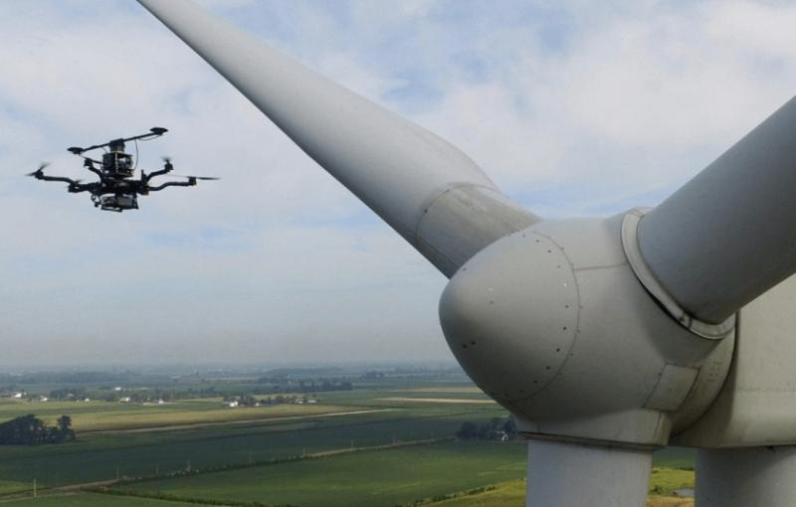The project involves the design and construction of an Unmanned Aerial Vehicle (UAV) equipped with a Pixhawk flight controller, with the primary objective of carrying and interfacing with various sensors for the inspection of wind turbines. Wind turbines require regular maintenance to ensure their longevity and operational efficiency. UAVs provide a flexible and efficient solution for scanning and inspecting these structures, particularly in hard-to-reach areas.

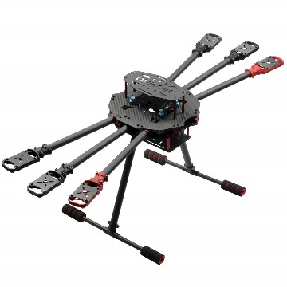The UAV will be designed to carry sensors that can include, but are not limited to, thermal cameras, LIDAR, and high-resolution optical cameras. These sensors will be used to detect potential issues such as blade damage, structural defects, or thermal anomalies in wind turbines. The project will also focus on integrating the sensors with the Pixhawk flight controller, ensuring seamless communication between the UAV and the sensors. To integrate these sensors, a microcontroller such as Jetson nano, Raspberry Pi, ESP32 or MSC32 could be used.

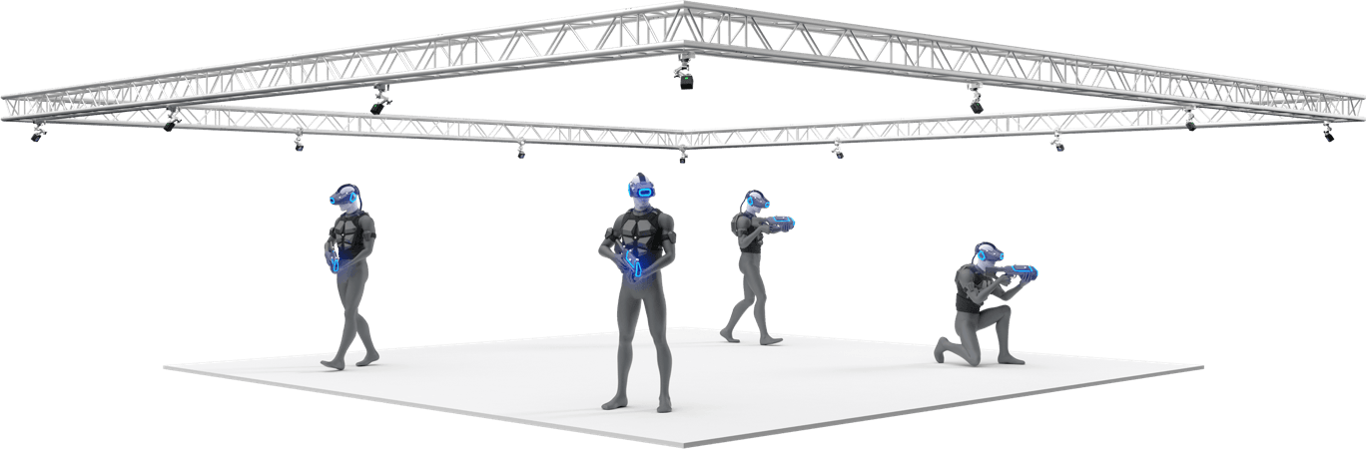Furthermore, the UAV will be programmed to execute specific flight paths as dictated by the scanning requirements of the sensors. These flight paths will be tested and refined in a controlled drone flight area, where the UAV’s performance will be monitored using an optical tracking system.

**Project Tasks:**

UAV Design and Construction: Build a UAV capable of carrying the necessary sensors and ensuring stable flight.

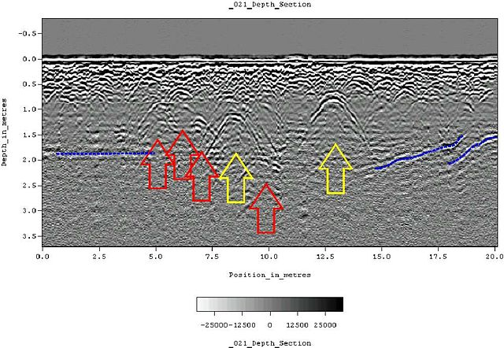Pixhawk Integration: Interface the Pixhawk flight controller with the UAV and the onboard sensors.

Sensor Integration: Develop the communication protocols between the Pixhawk and the various sensors.

Flight Path Programming: Implement autonomous flight capabilities that allow the UAV to follow predefined paths tailored to the scanning needs.

Testing and Validation: Conduct test flights in a drone flight area, using an optical tracking system to monitor and refine the UAV’s performance.

This project will provide hands-on experience in UAV construction, sensor integration, and autonomous flight programming, while addressing a real-world problem in the maintenance of renewable energy infrastructure.