CodeLogic: Data Flow Diagram — Level 0

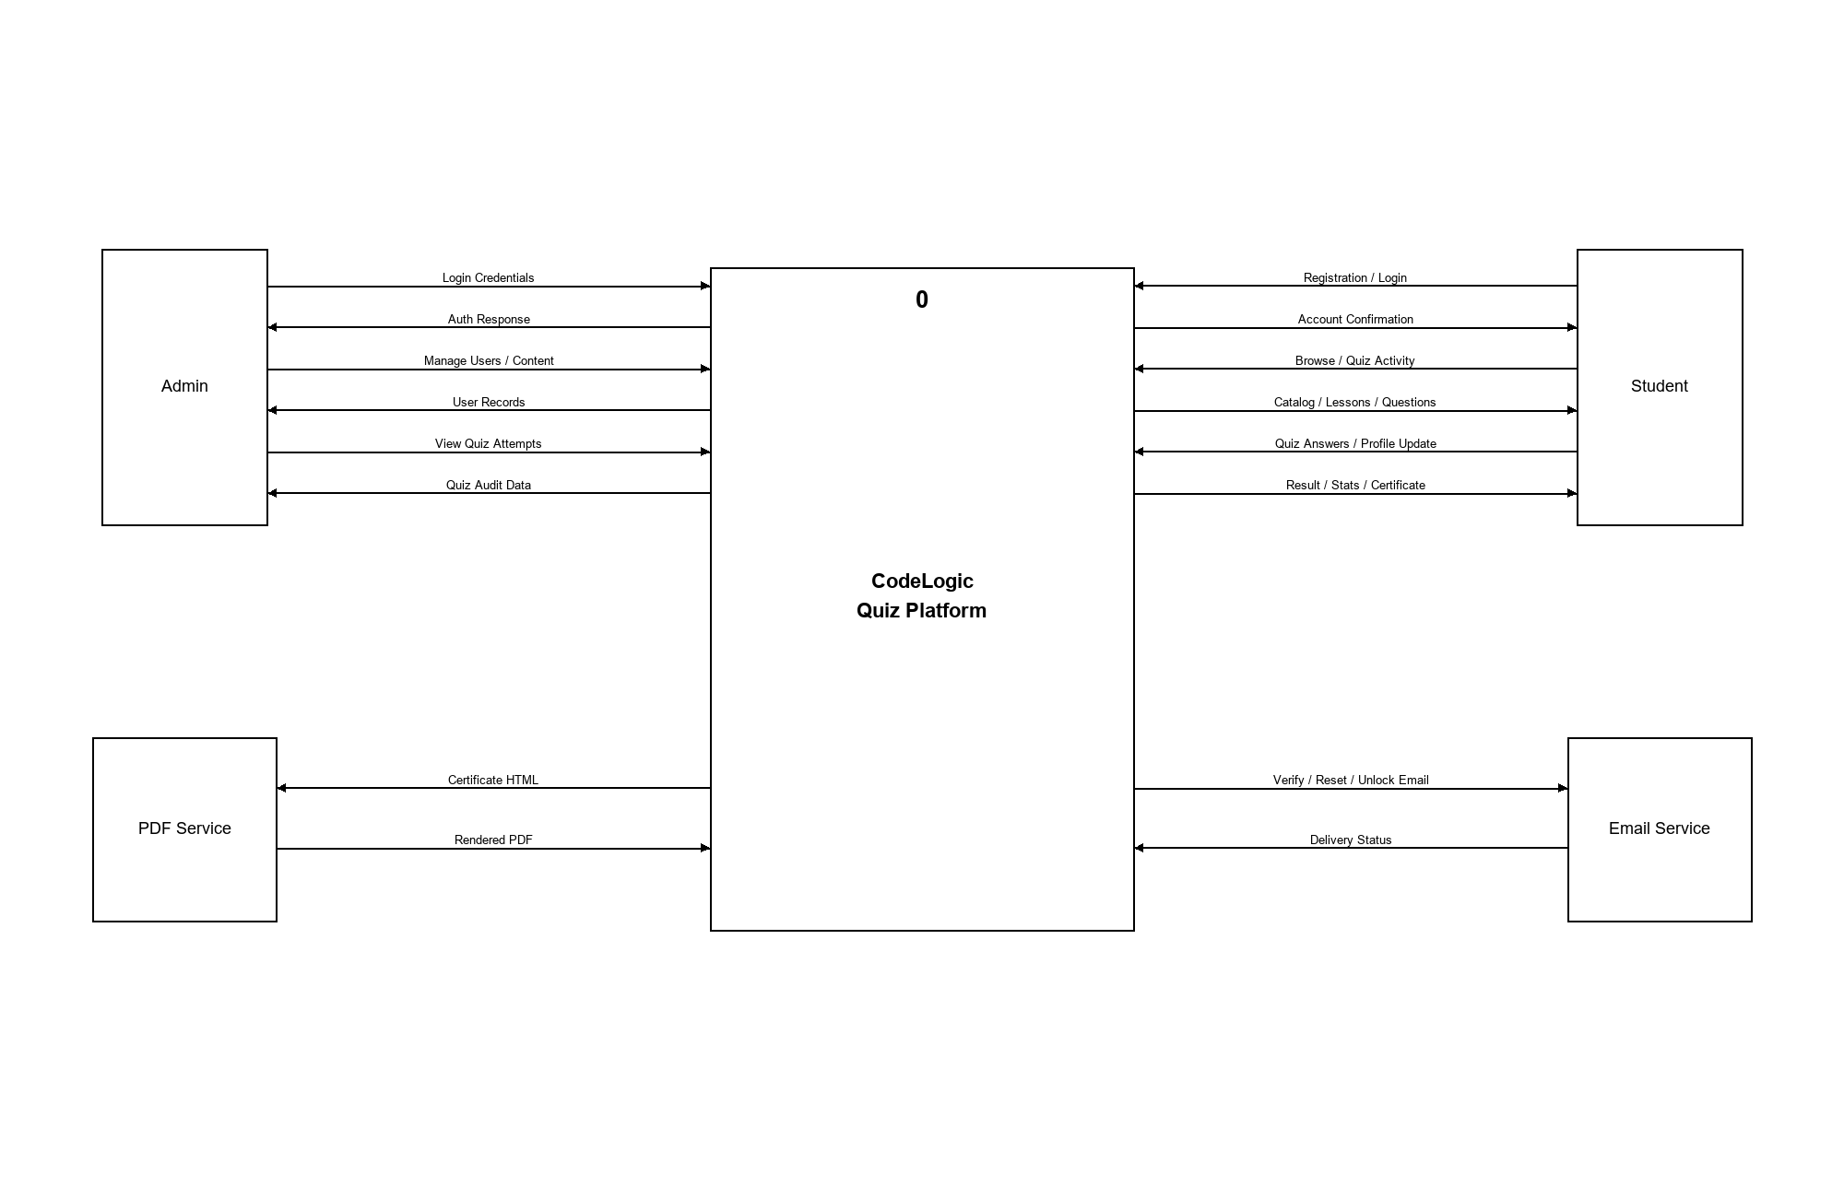
Figure 1 Level 0 Data Flow Diagram (Context Diagram) of the CodeLogic Quiz Platform

CodeLogic: Data Flow Diagram — Level 1

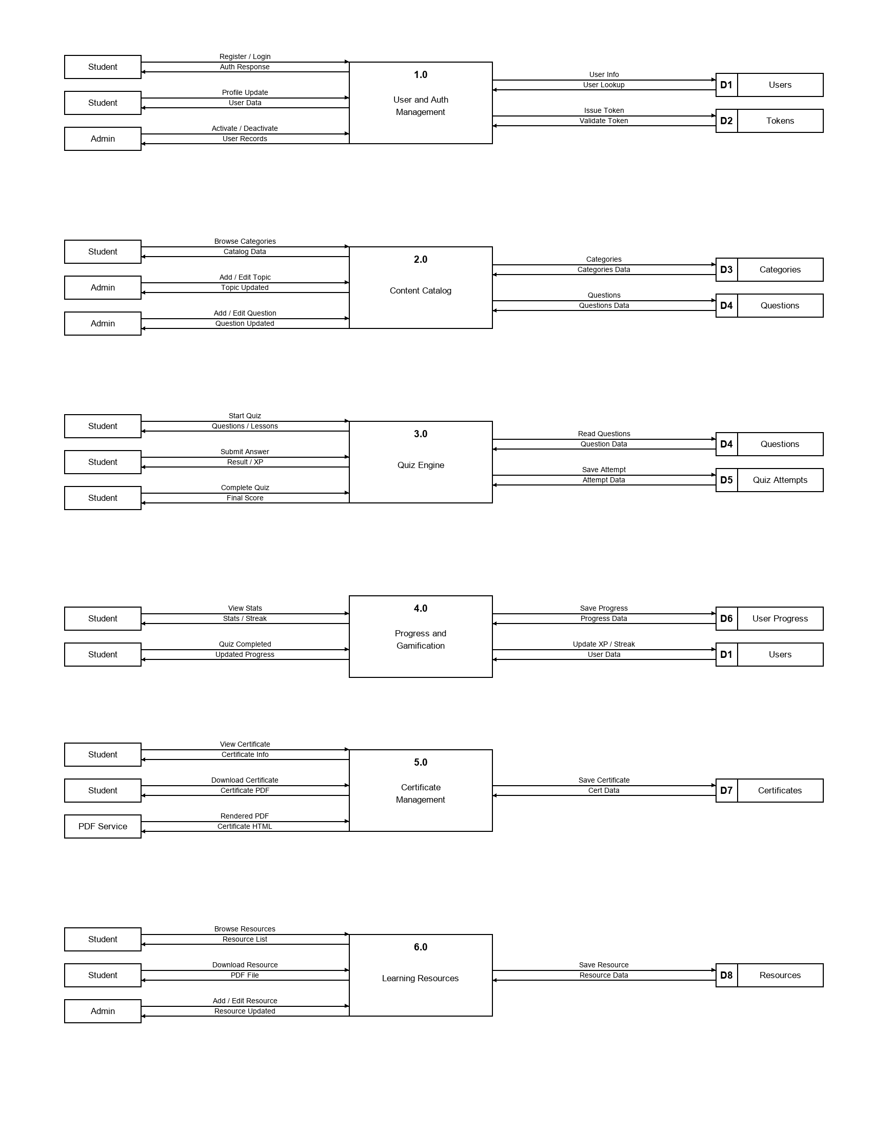
Figure 2 Level 1 Data Flow Diagram: User Auth, Content, Quiz Engine, Progress, Certificates, and Learning Resources

