CodeLogic: System Diagrams
Flowchart, Use Case Diagram, and Data Flow Diagrams

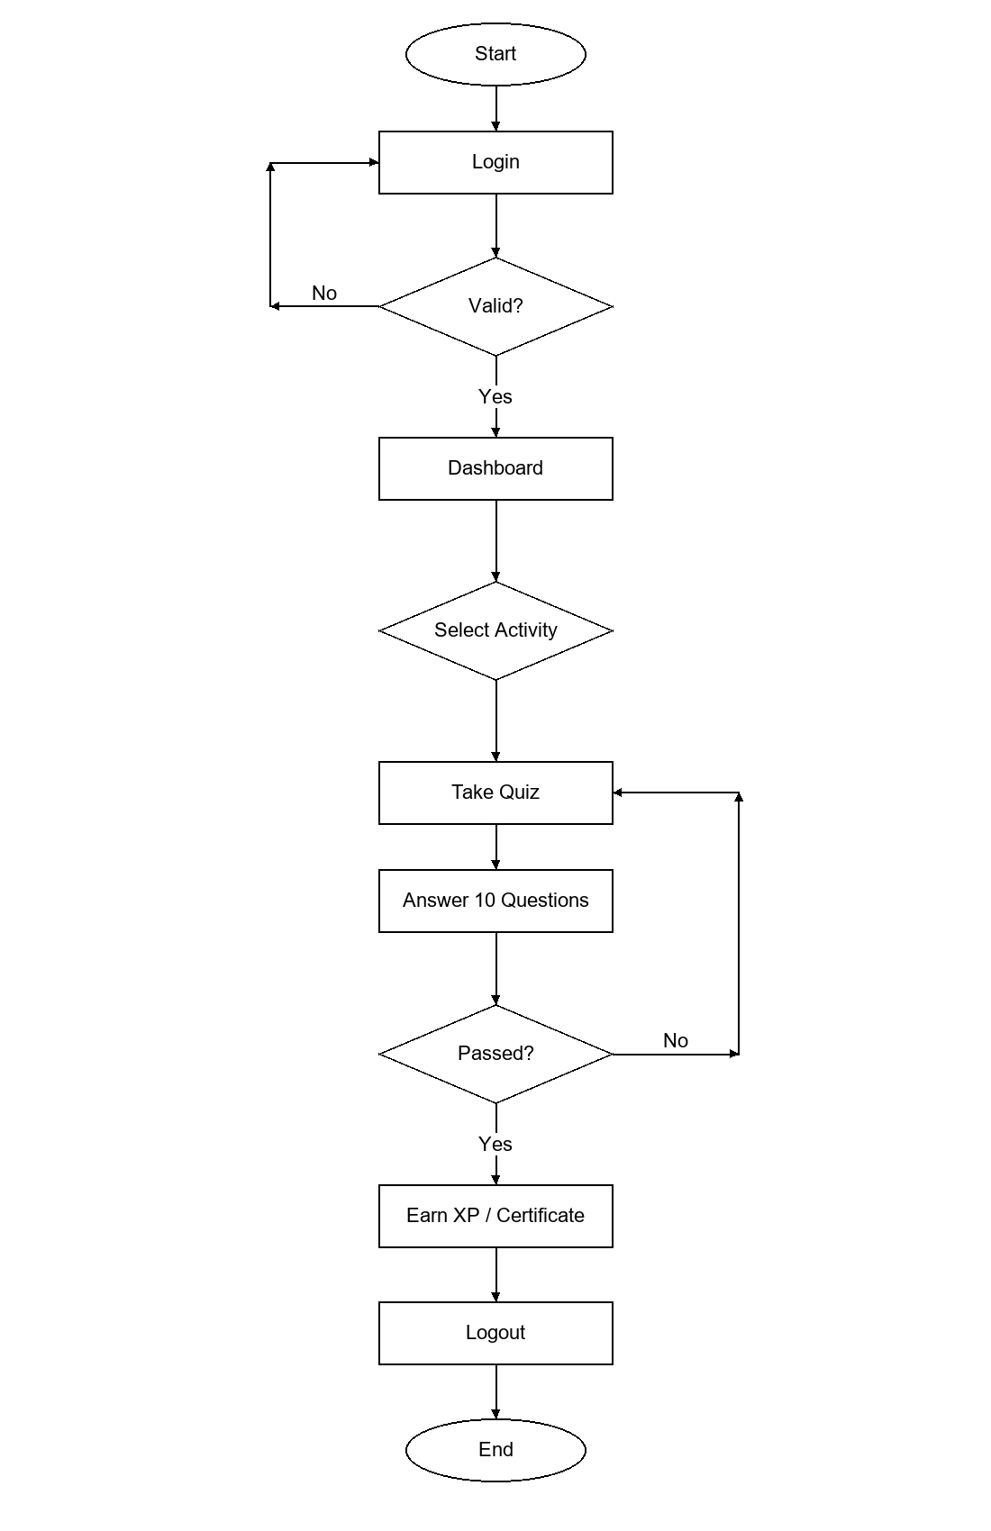
Figure 1 System Flowchart of the Student Side of CodeLogic

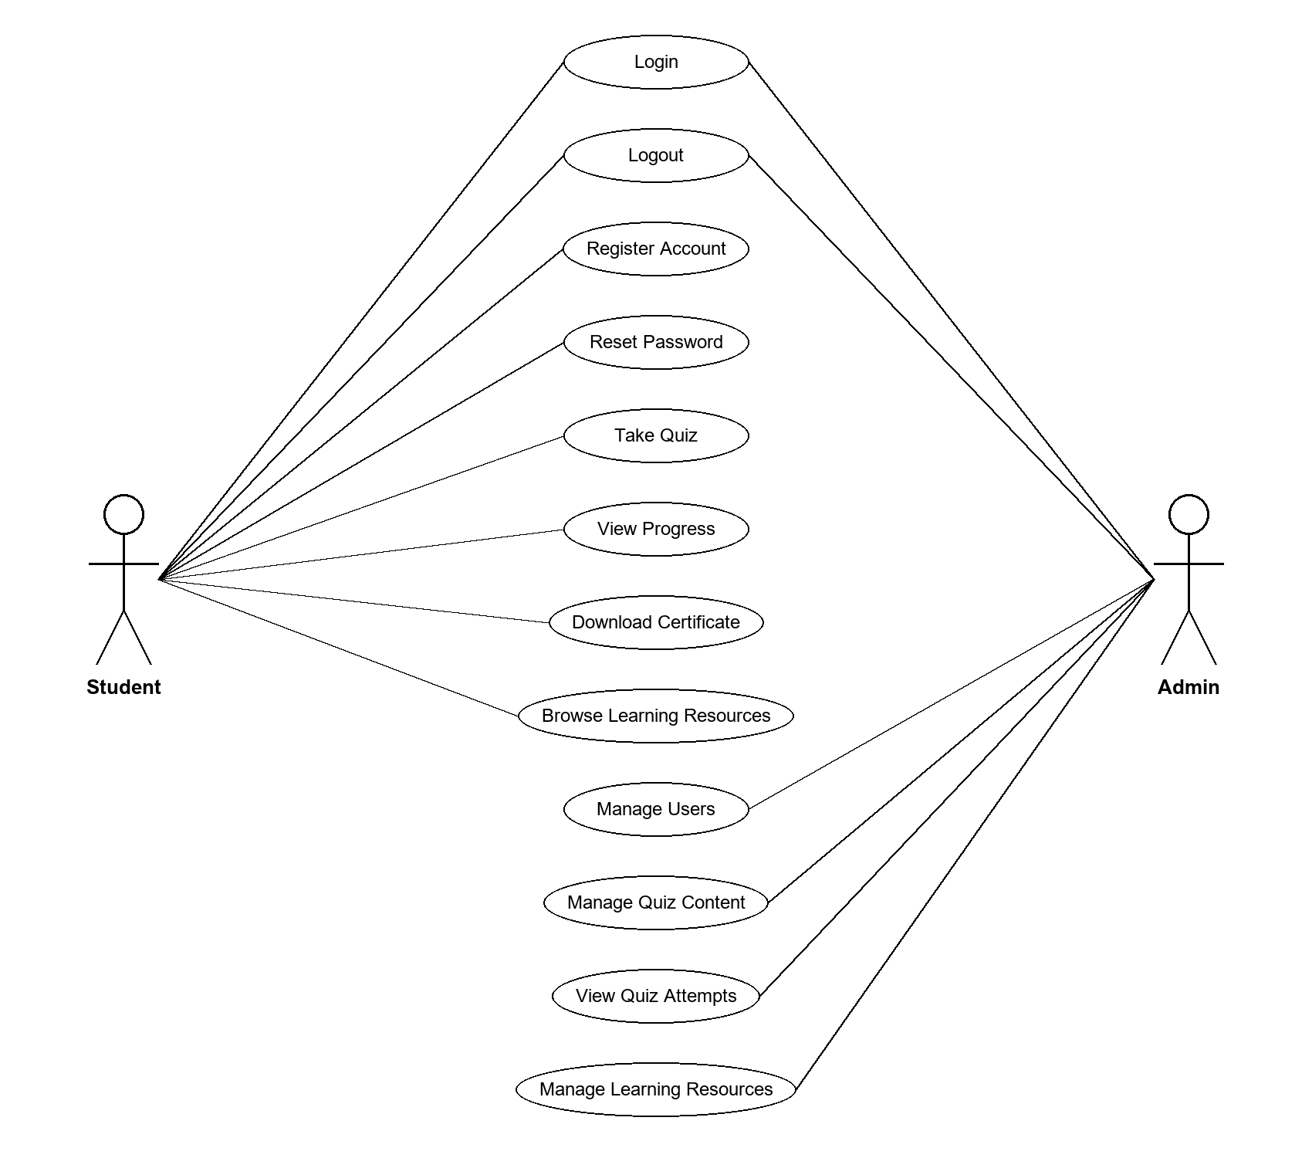
Figure 2 Use Case Diagram of the CodeLogic Quiz Platform

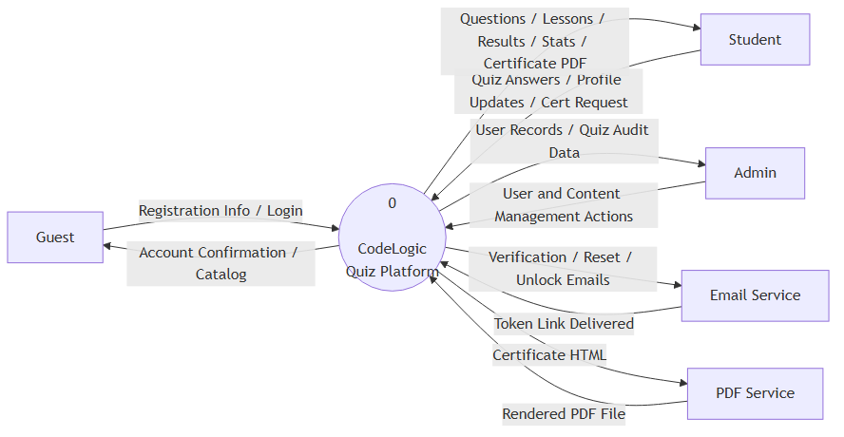
Figure 3 Level 0 Data Flow Diagram (Context Diagram) of the CodeLogic Quiz Platform

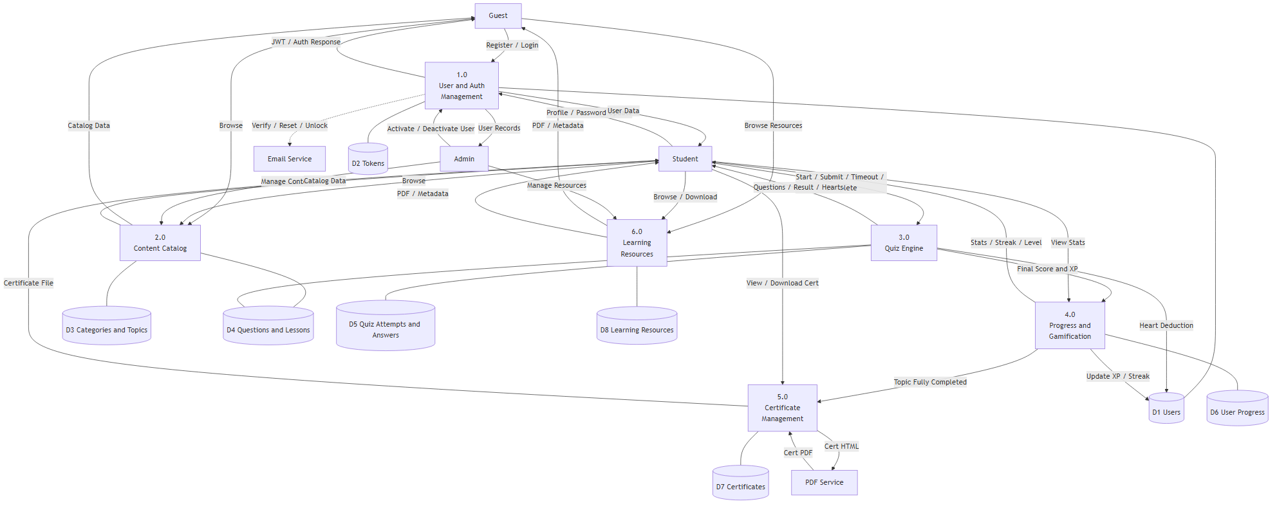
Figure 4 Level 1 Data Flow Diagram: User, Content, Quiz, Progress, Certificate, and Resource Management

