CodeLogic: Entity Relationship Diagram

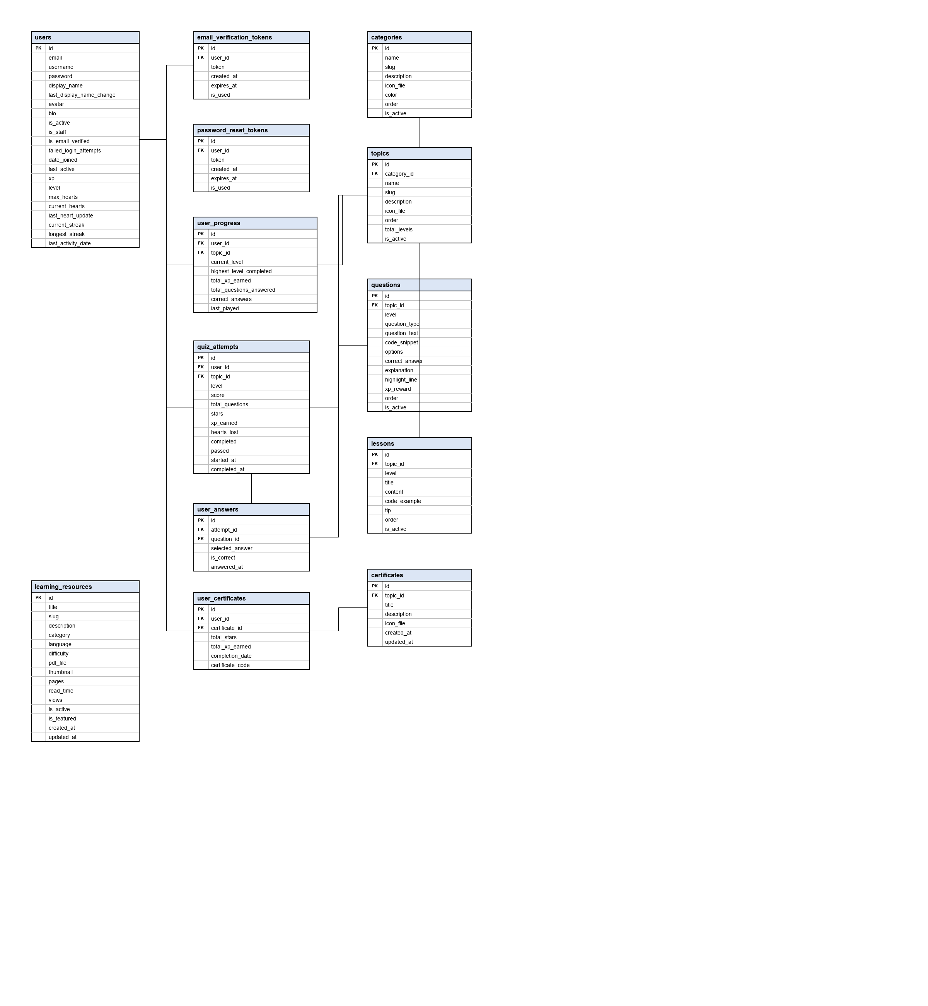
Figure 1 Entity Relationship Diagram of the CodeLogic Quiz Platform

