CodeLogic: System Flowchart

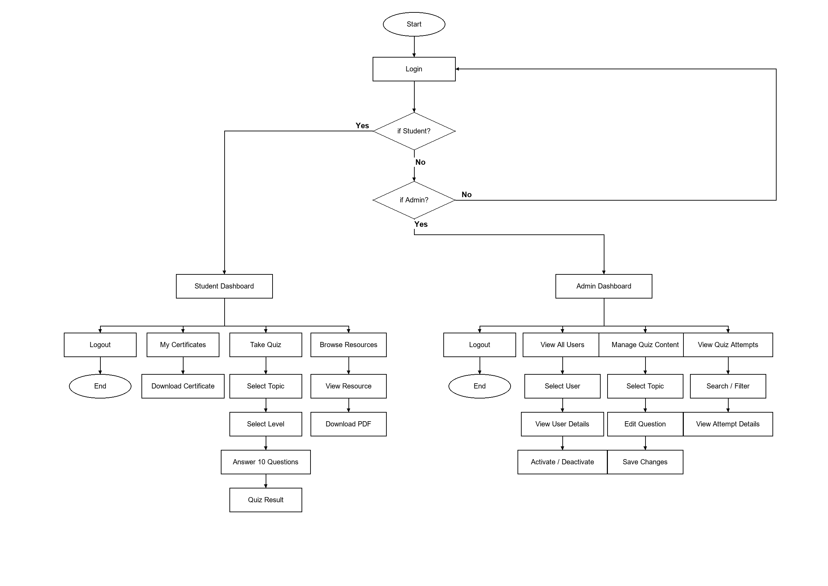
Figure 1 System Flowchart of the CodeLogic Quiz Platform

