Data Flow Diagram - Level 0

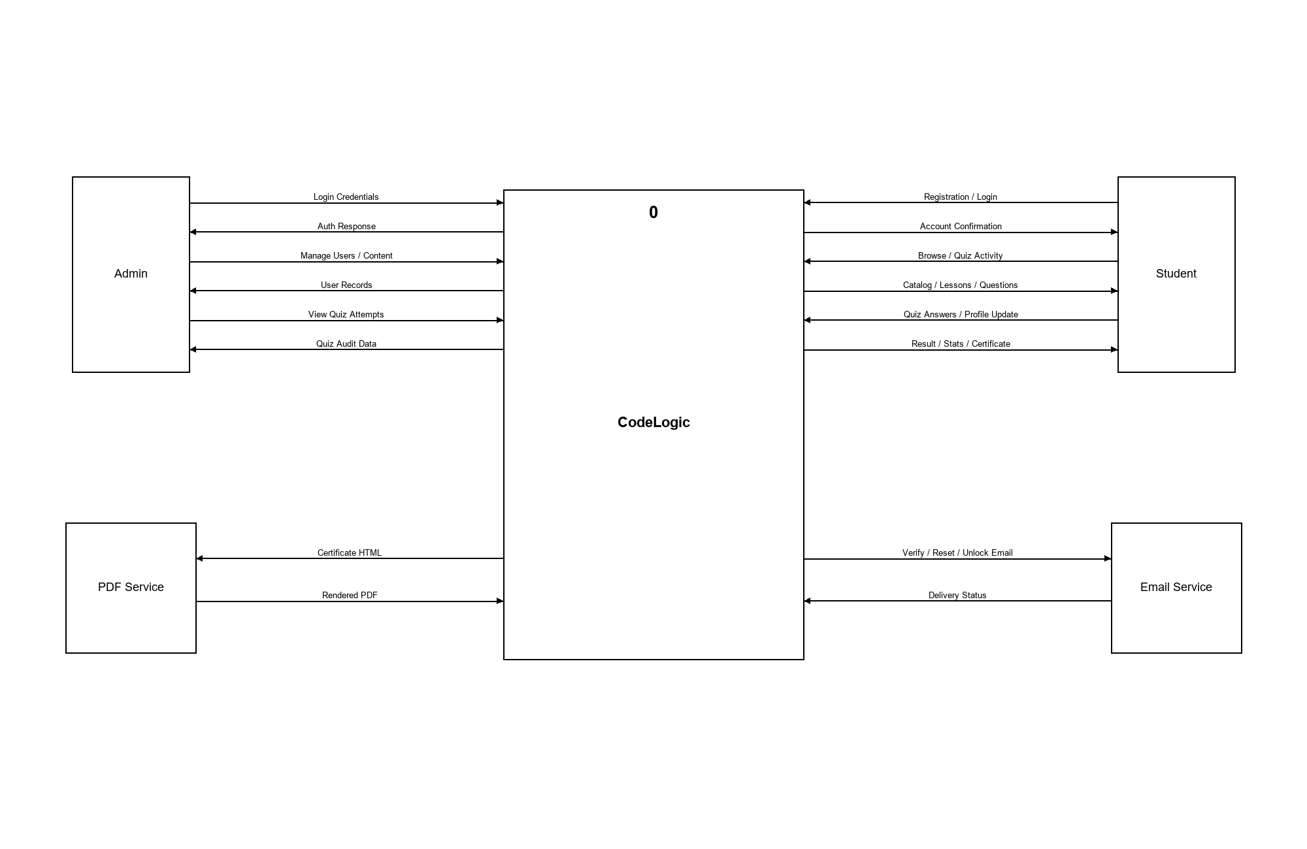

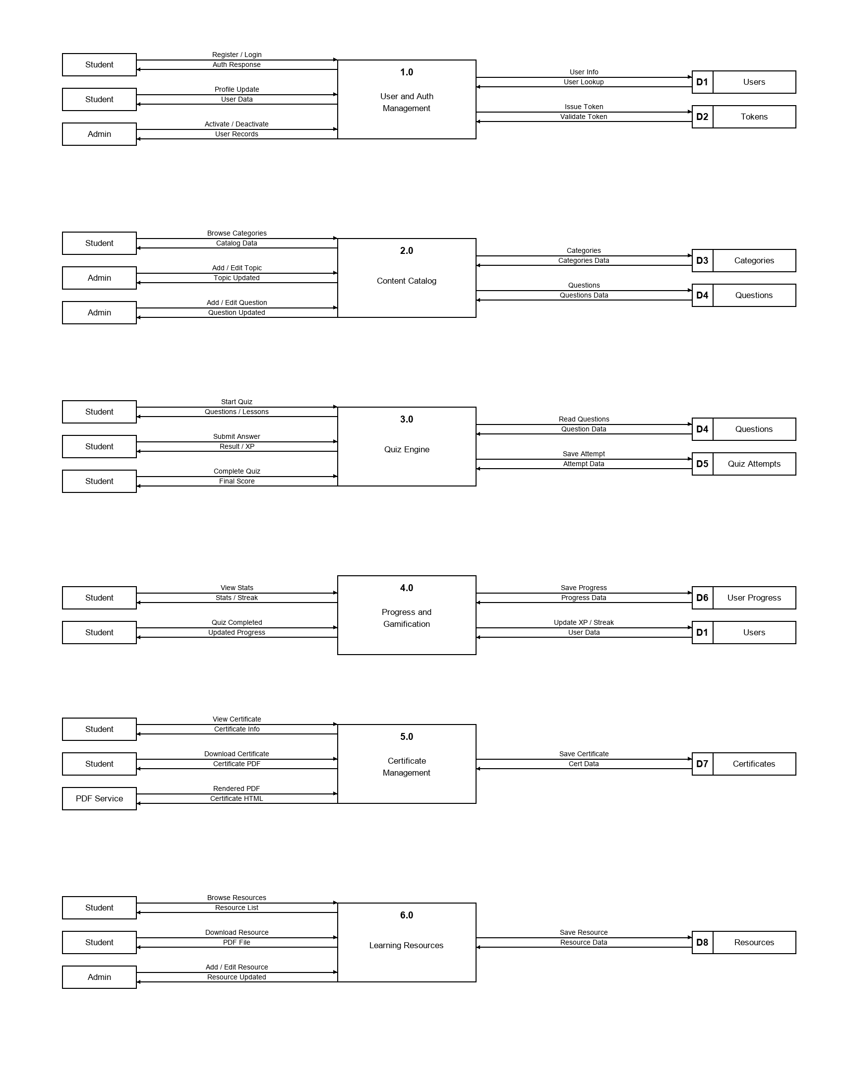
Data Flow Diagram - Level 1

