CodeLogic: Data Flow Diagram - Level 0
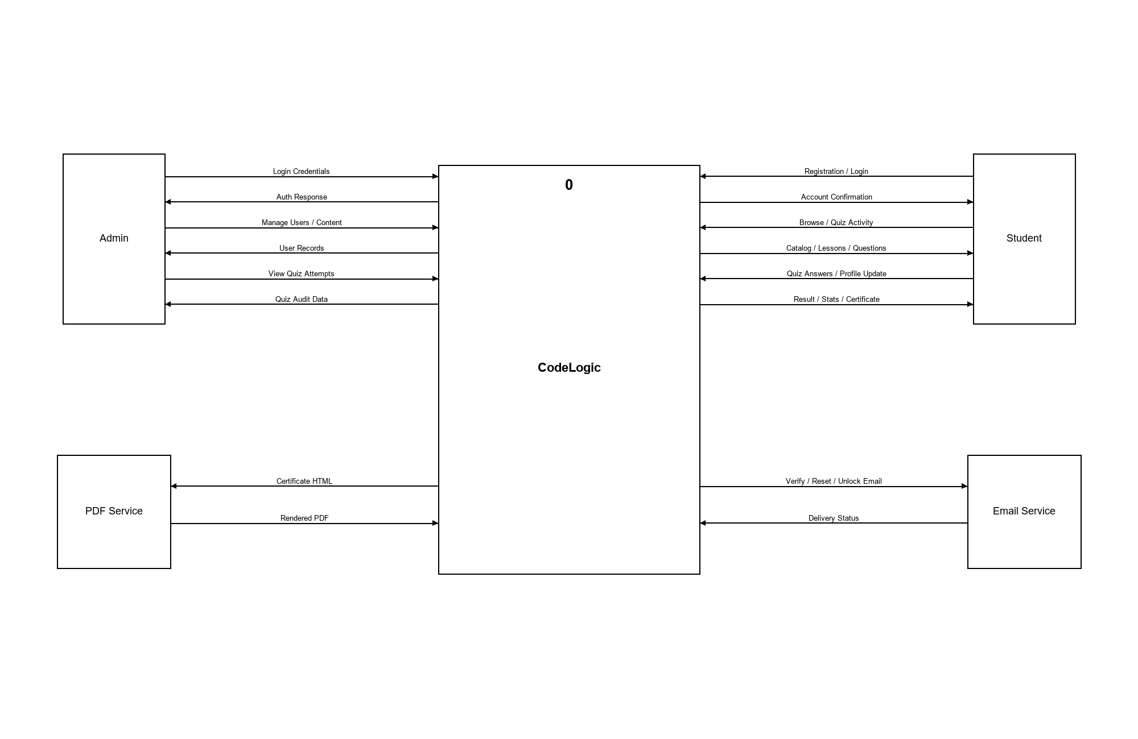
Figure 1. Level 0 Data Flow Diagram (Context Diagram) of the CodeLogic Quiz Platform showing the four external entities (Guest, Student, Admin, Email Service, PDF Service) and the high-level data flows into and out of the system.

CodeLogic: Data Flow Diagram - Level 1
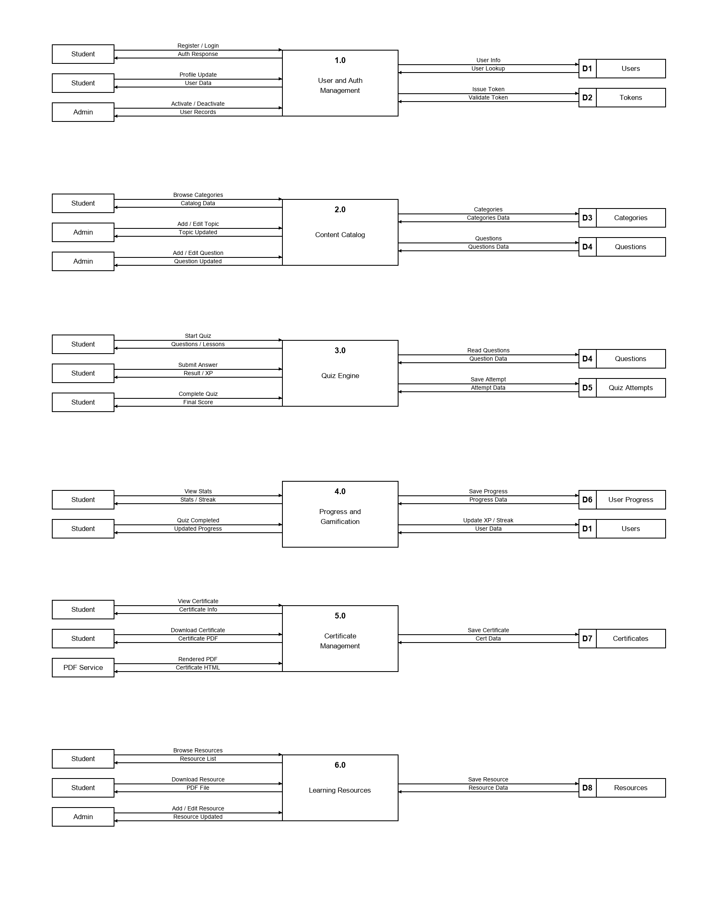
Figure 2. Level 1 Data Flow Diagram showing the six top-level processes of the CodeLogic platform (User & Auth Management, Content Catalog, Quiz Engine, Progress & Gamification, Certificate Management, and Learning Resources) and their primary data stores.

CodeLogic: Data Flow Diagram - Level 2
Process 1.0 - User & Auth Management
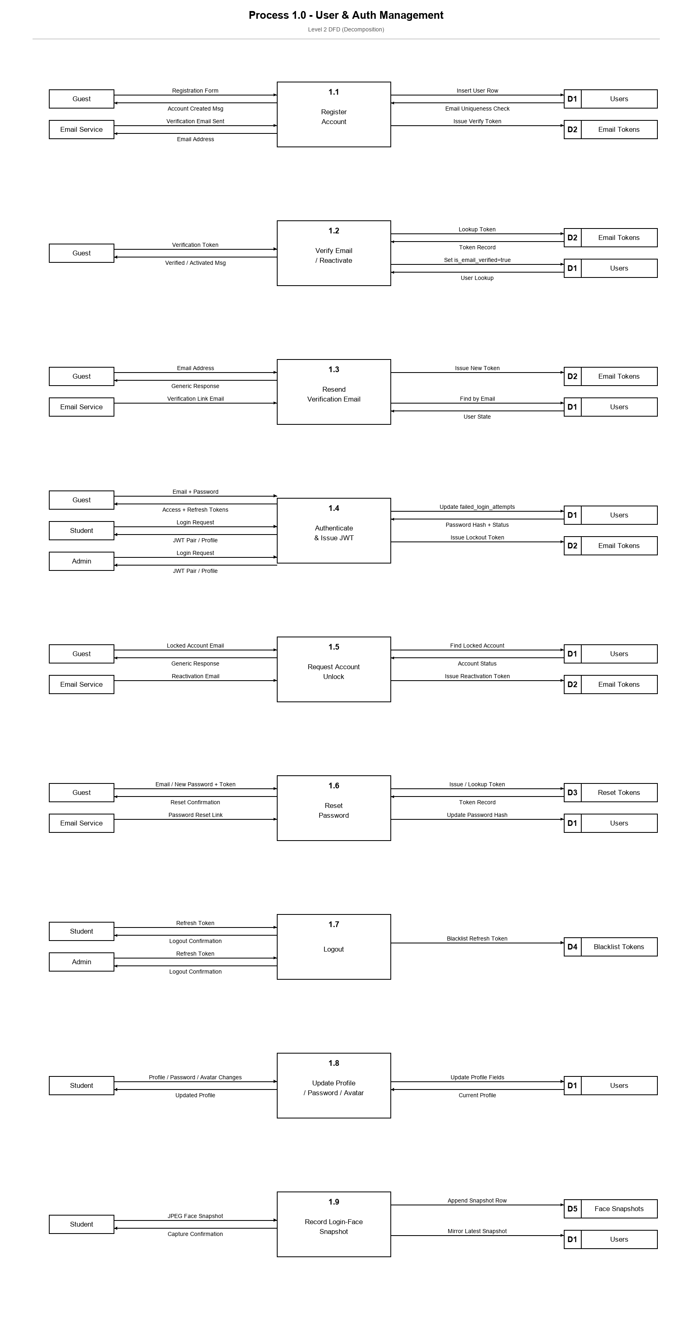
Figure 3. Level 2 decomposition of Process 1.0 (User & Auth Management). Shows the nine sub-processes that handle registration, email verification, login with lockout, account unlock, password reset, logout, profile / avatar / password updates, and the post-login face-snapshot capture.

CodeLogic: Data Flow Diagram - Level 2
Process 2.0 - Content Catalog
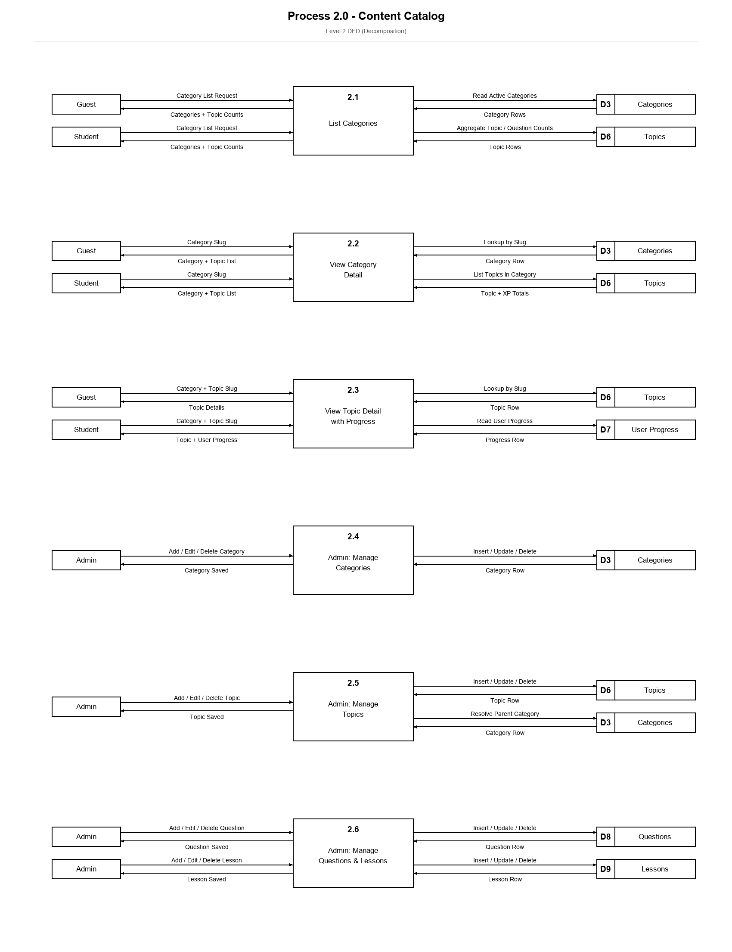
Figure 4. Level 2 decomposition of Process 2.0 (Content Catalog). Shows how guests and students browse categories, category details, and topic details (with per-user progress), and how admins manage categories, topics, questions, and lessons through the Django admin interface.

CodeLogic: Data Flow Diagram - Level 2
Process 3.0 - Quiz Engine
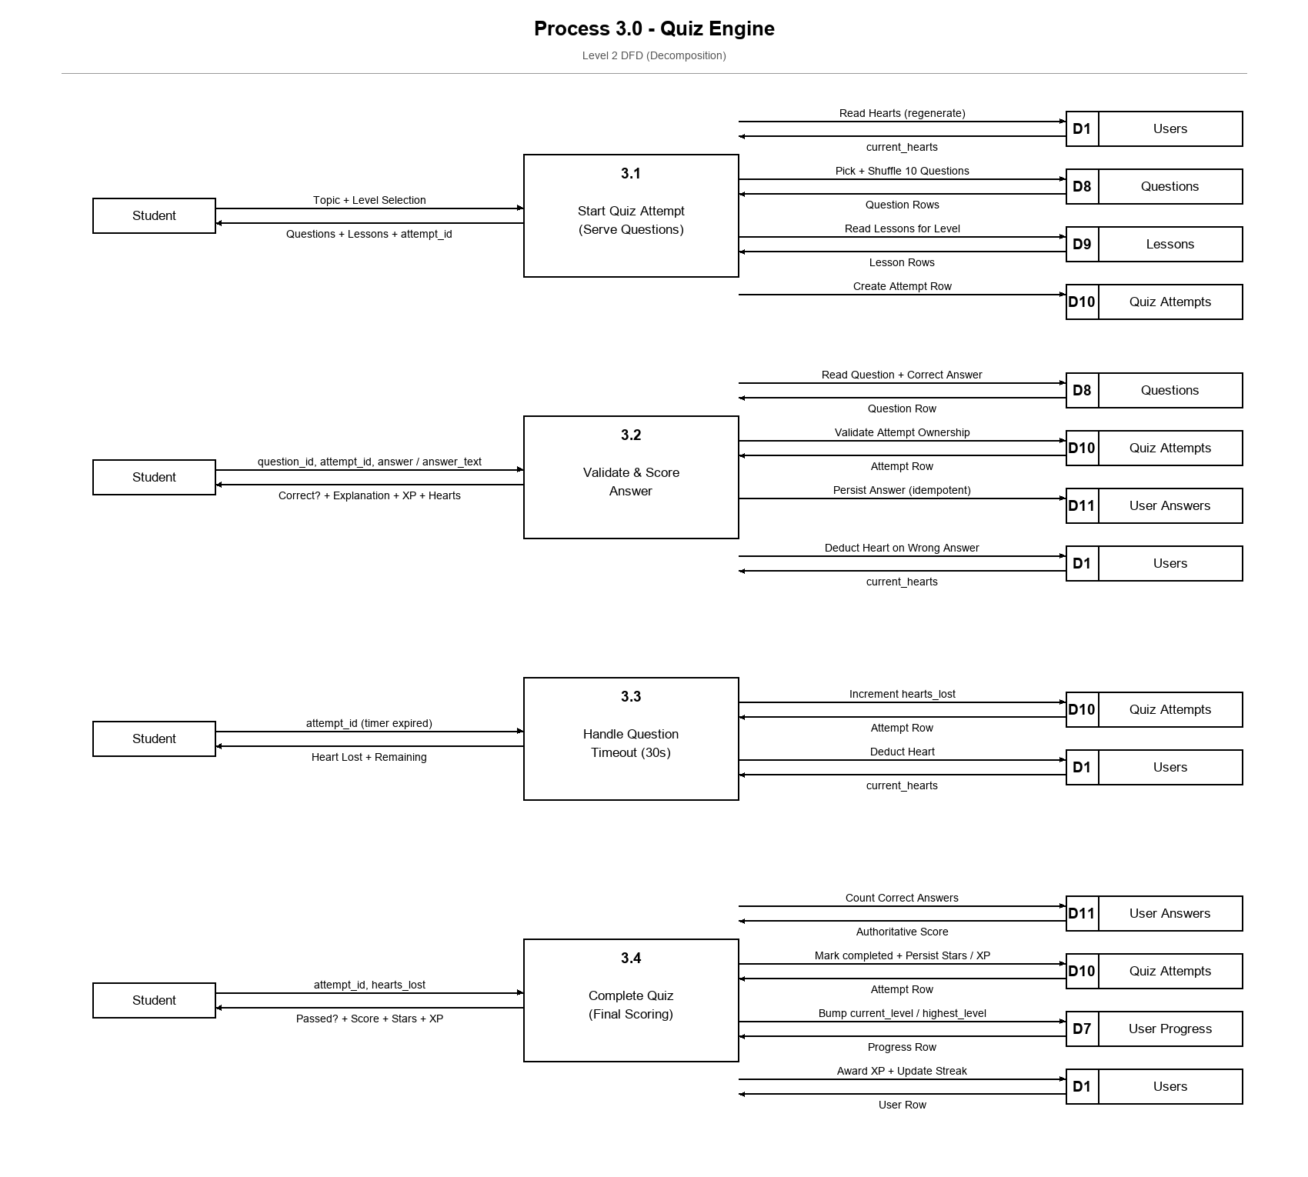
Figure 5. Level 2 decomposition of Process 3.0 (Quiz Engine). Shows the four sub-processes of the gameplay loop: starting an attempt (serving questions + lessons), validating and scoring each answer, handling the 30-second per-question timeout, and completing the quiz (final scoring + stars + XP).

CodeLogic: Data Flow Diagram - Level 2
Process 4.0 - Progress & Gamification
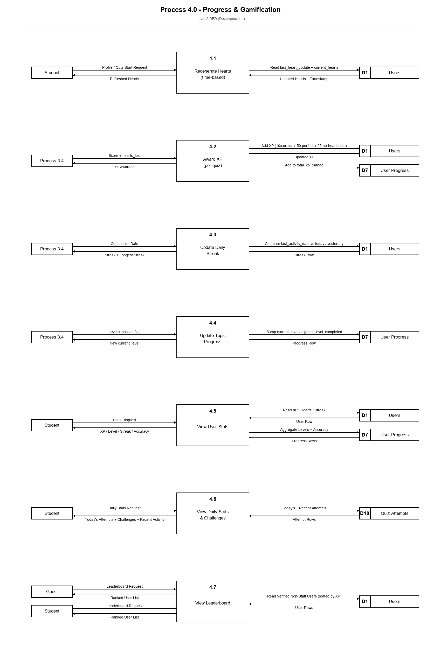
Figure 6. Level 2 decomposition of Process 4.0 (Progress & Gamification). Shows how hearts regenerate over time, how XP is awarded with bonuses, how the daily streak is recomputed, how per-topic progress is bumped, and the three read-only dashboards (user stats, daily stats / challenges, and leaderboard).

CodeLogic: Data Flow Diagram - Level 2
Process 5.0 - Certificate Management
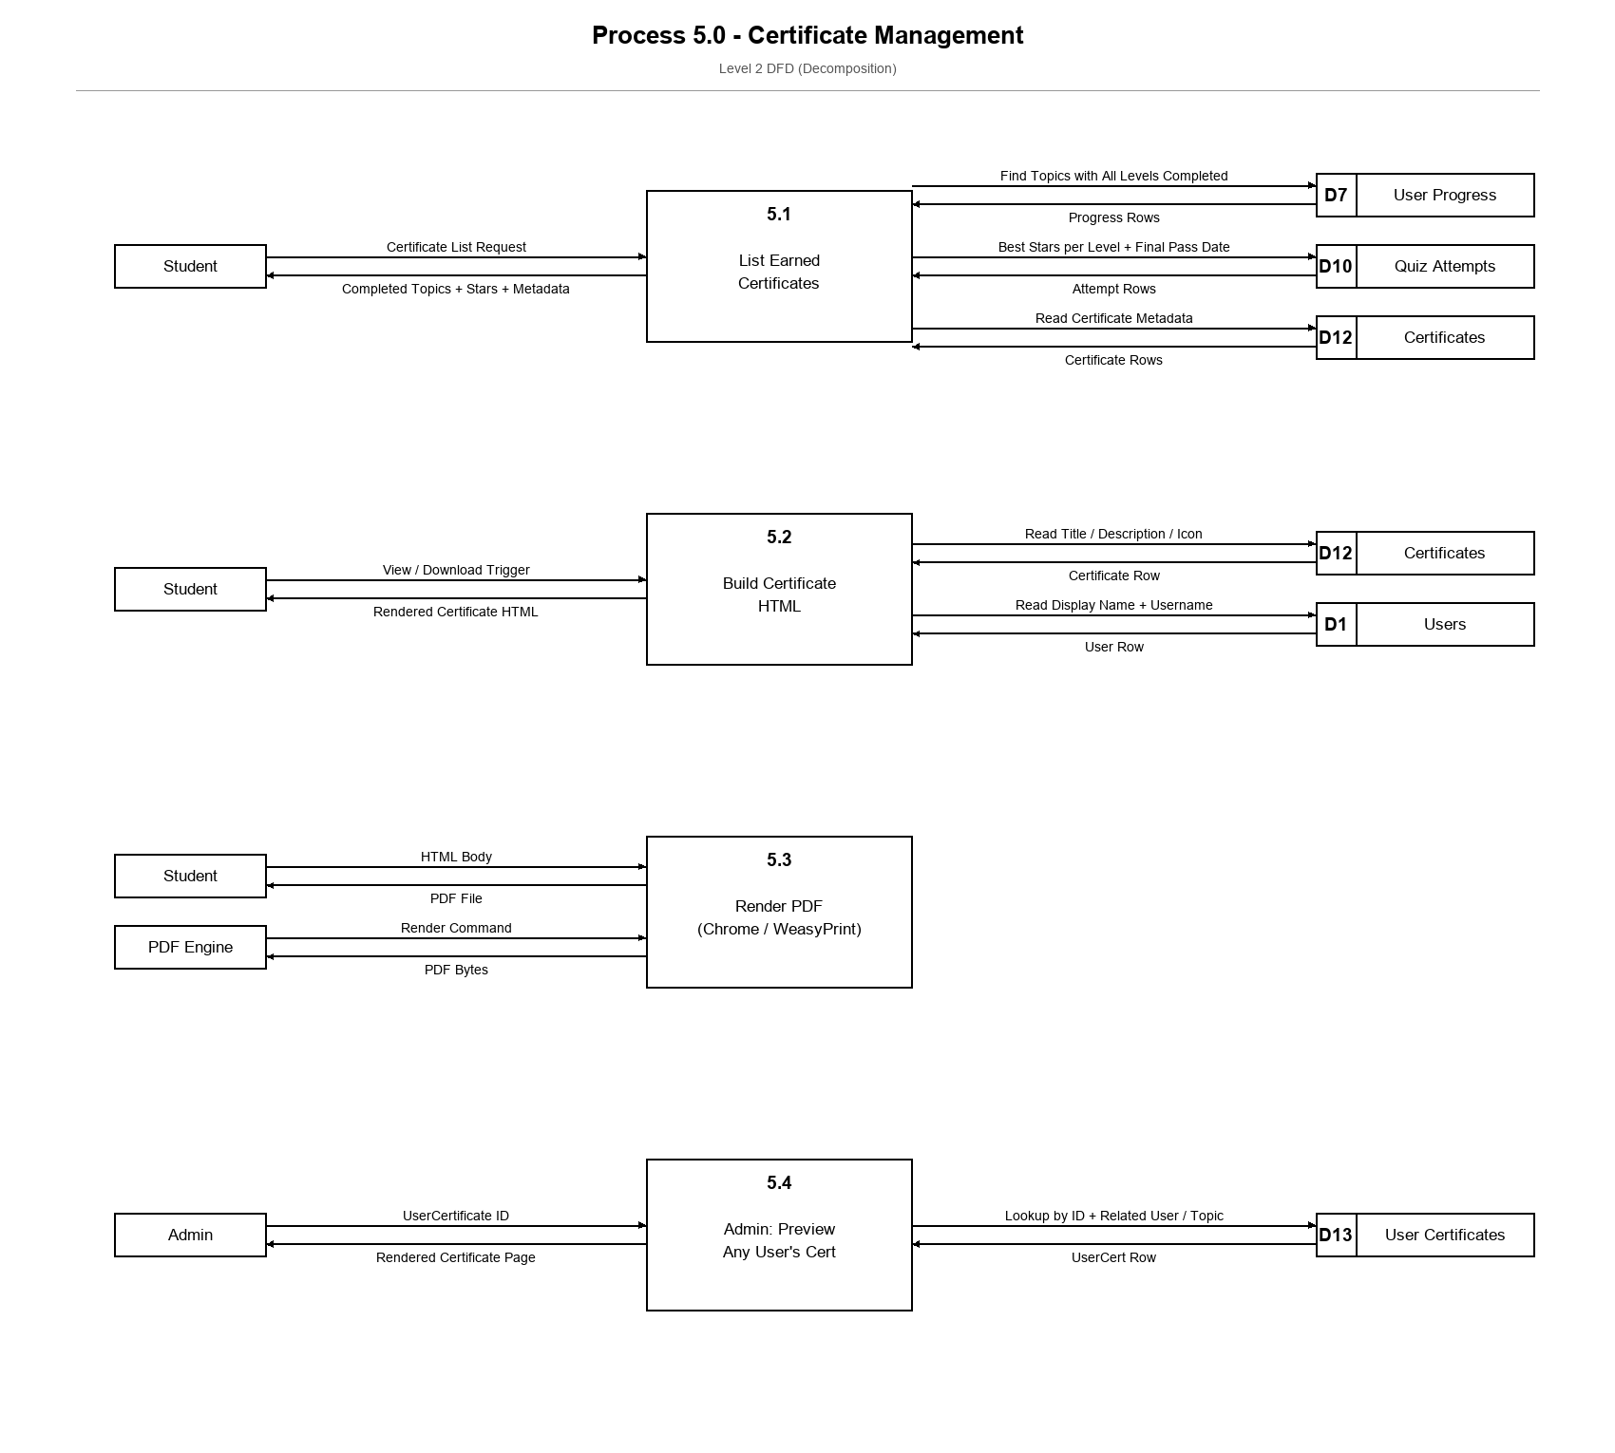
Figure 7. Level 2 decomposition of Process 5.0 (Certificate Management). Shows how a student's earned certificates are listed, how the certificate HTML is assembled, how it is rendered to PDF by either headless Chrome or WeasyPrint, and how admins can preview any user's certificate from the admin panel.

CodeLogic: Data Flow Diagram - Level 2
Process 6.0 - Learning Resources
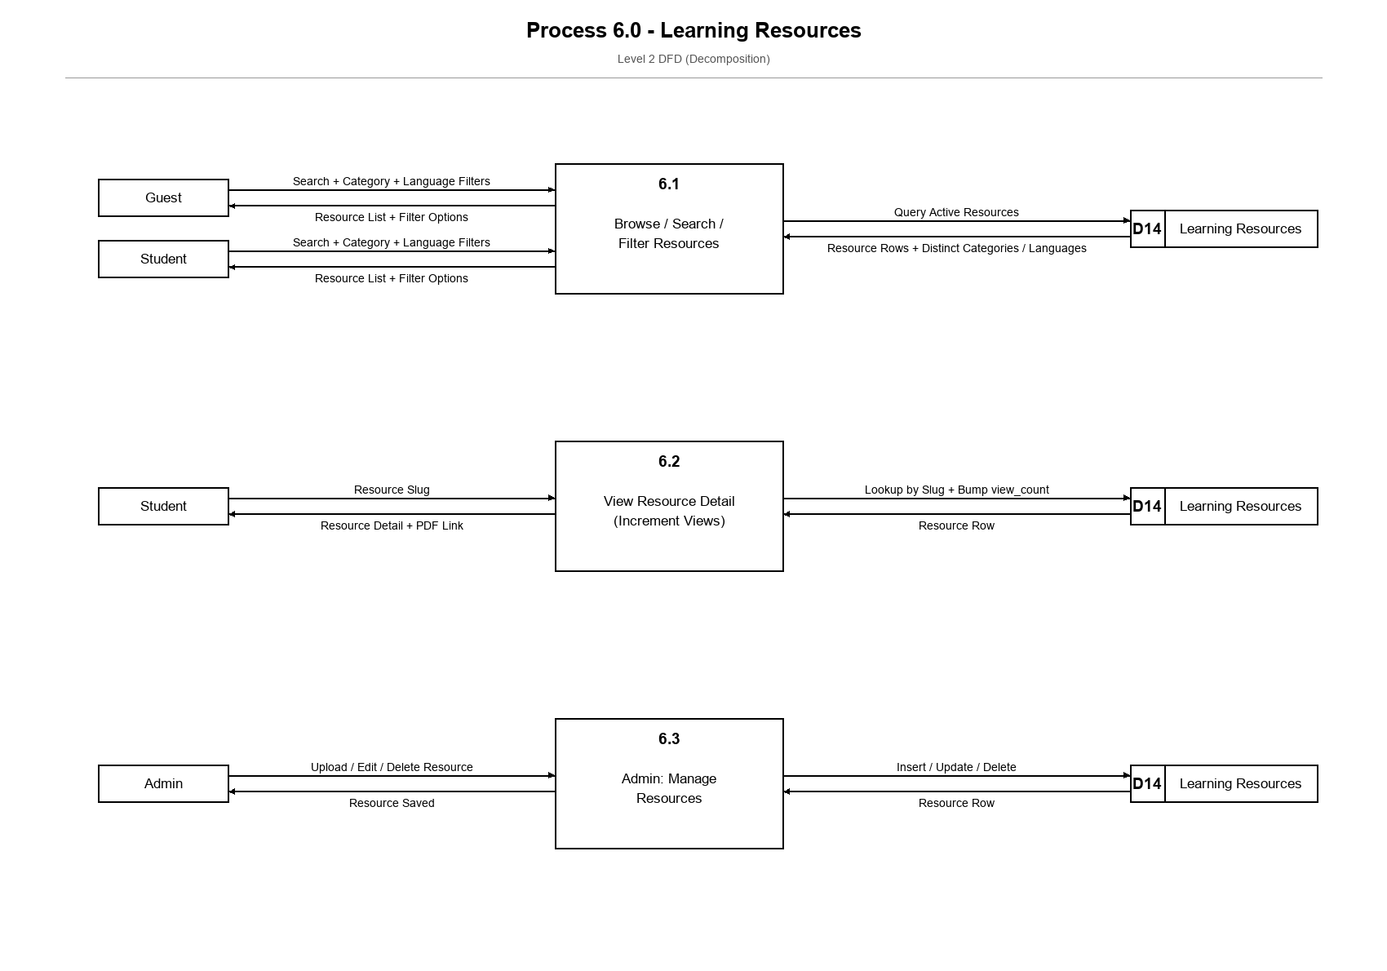
Figure 8. Level 2 decomposition of Process 6.0 (Learning Resources). Shows how guests and students browse, search, and filter the resource library, how a resource detail view increments its view counter, and how admins upload, edit, and remove resources.

