EELSMODEL tutorial

What you need to start:
- A well calibrated core loss EELS spectrum in either DM3 format or MSA format. This can be a single spectrum or a so-called spectrum image (1D or 2D). Note that the energy calibration of the core loss spectra is rather important to get the quantification right, so make sure during your experiment that eg. the zero loss is aligned before acquiring the core loss spectrum.
- A well calibrated low loss EELS spectrum in either DM3 or MSA format with the same energy dispersion as the core loss.
- Knowledge of all microscope parameters: acceleration voltage, collection angle, convergence angle. These parameters are best obtained from taking a diffraction pattern and calibration. Note: these are the most crucial parameters of your experiment, without these, you can not do a proper quantification.
- (Optionally) a ghost-spectrum. This is a core loss spectrum obtained with the sample removed. In an ideal spectrometer this gives no contribution at all, but depending on the setup and on the brand of microscope and spectrometer, there may be a considerable contribution from eg. reflection and X-ray generation leading to a rather pronounced ghost-spectrum. This can be taken into account by measuring this spectrum with a long exposure time and correcting it to the same exposure time as the core loss spectrum. If the ghost-spectrum is very noisy you could consider smoothing it a bit in DM if the spectrum is rather featureless.
- Noise properties of the detector in your EELS spectrometer. This is important to get the precision estimates on your parameters right as well as the acceptance levels. These parameters describe the noise behavior of your detector in terms of correlation and total noise per count. You get these by running the script which is located in the EELSMODEL distribution EELSMODEL\Noise_measure_script\measure_noise_properties_oversampling.s on your microscope. There are instructions written inside the script. The script will output a line of text in the results window of DM which should be copied as an extra line into the file EELSMODEL\release\detectors.txt. NOTE at the moment this script only works on 1k camera's. Need a bit of debugging to get it run on 2K cameras.. For more information on the noise behavior in EELSMODEL check out the paper describing the details [2]

Example 1 quantifying core loss spectra
In this example we will quantify the data from a so-called round-robin test where a set of labs within the ESTEEM project received a set of identical samples for testing the quantification of EELS. The first sample in this series is called A3 and contains a Boron and Nitrogen peak. As input we take the calibrated spectra with names:
Core loss: EELSMODEL\Examples\Round robin\T3_A3\region3\SI_HL2_cal.dm3
Low loss: EELSMODEL\Examples\Round robin\T3_A3\region3\LL_cal.msa
Ghost-spectrum: EELSMODEL\Examples\Round robin\T3_A3\region3\ BG_cal.msa
Note that these spectra a collection of 100 spectra taken on exactly the same region in the sample. This is nice to have to check for beam damage over time and also to check the standard deviation on the result as cimpared to the theoretical value that EELSMODEL will propose.

The experimental conditions were:
operator: Giovanni Bertoni
microscope: Jeol 3000F + GIF2000 1K camera
300kV, diffraction mode EELS, 2mm entrance aperture, 15 cm camera length
collection angle=4.12 mrad (obtained from pre-calibrated camera length and EELS entrance aperture)
convergence angle= 0.27 mrad (obtained from a diffraction patern and measuring the size of the diffraction discs due to beam convergence with respect to the 2mm entrance aperture)
aquisition time=0.2 s
200 spectra are recorded from the same region to check the variance due to noise. This gives also the opportunity to check that the specimen is not changing in time. Therefore it is a very good idea to take such large sets of spectra in case you want to do an accurate and precise quantification experiment.
The ghost-spectrum was recorded at 50s, smoothed afterwards and corrected to the 0.2 s aquisition time of the core losses.

starting EELSMODEL
Double click on the EELSMODEL icon on the desktop. If you have a core2duo or core2quad processor you may use the EELSMODEL_CORE2DUO icon for increased performance. Only do this if you really have one of these processor types, otherwise a hard crash will occur if you start fitting.

Loading the experimental data
Choose file/open DM3 and open the core loss spectrum
EELSMODEL\Examples\Round robin\T3_A3\region3\SI_HL2_cal.dm3
Choose file/open spectrum and open the low loss spectrum
EELSMODEL\Examples\Round robin\T3_A3\region3\LL_cal.msa
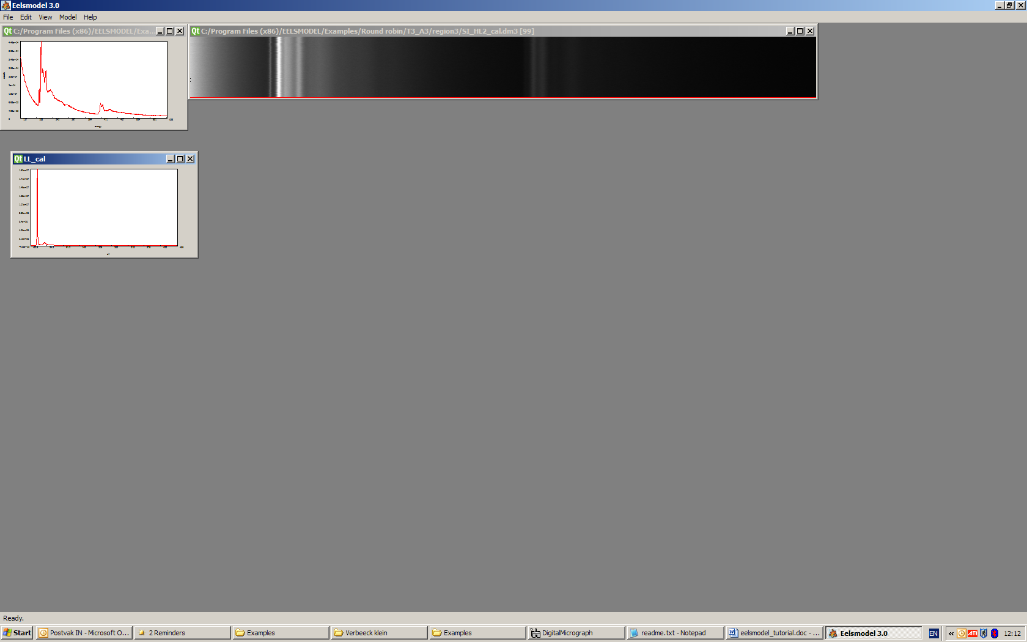

Creating a new model
make sure the core loss spectrum is frontmost (important, otherwise you might make a model of the low loss)
choose model/new model
to create an empty model, a new window appears containing your empty model in red and the experimental data in blue.
choose model/ component
to view a window with different model components to choose from
choose model/choose detector
and choose the "EMAT 3000F GIF2000 1k phosphor" detector as this was the setup we used to record the data.
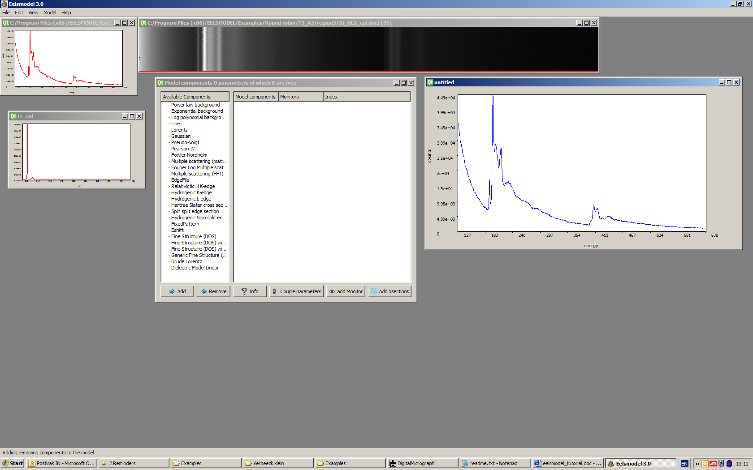

Choosing components to build up the model
Now we will build the model in a step by step way, by adding some of the many available components to the model. Each component has a set of parameters to set up

adding the background:
typically the first component in a model is the background (although the order doesn't really matter). In most cases you would choose a power law background but other options like epxonential, log polynomial, or linear are available as well.
choose "power law background" and "Add"
choose the selection tool in the upper left corner and drag a window over the spectrum in the region where you think is the background. Then right-click on the power law background in your model to make it adjust its parameters. (this feature is called auto-fit and gives a very good starting value for the parameters which helps a lot in the final fitting process in terms of convergence and speed. Not all components have this at the moment, so nothing might happen if you do this on another component type.)
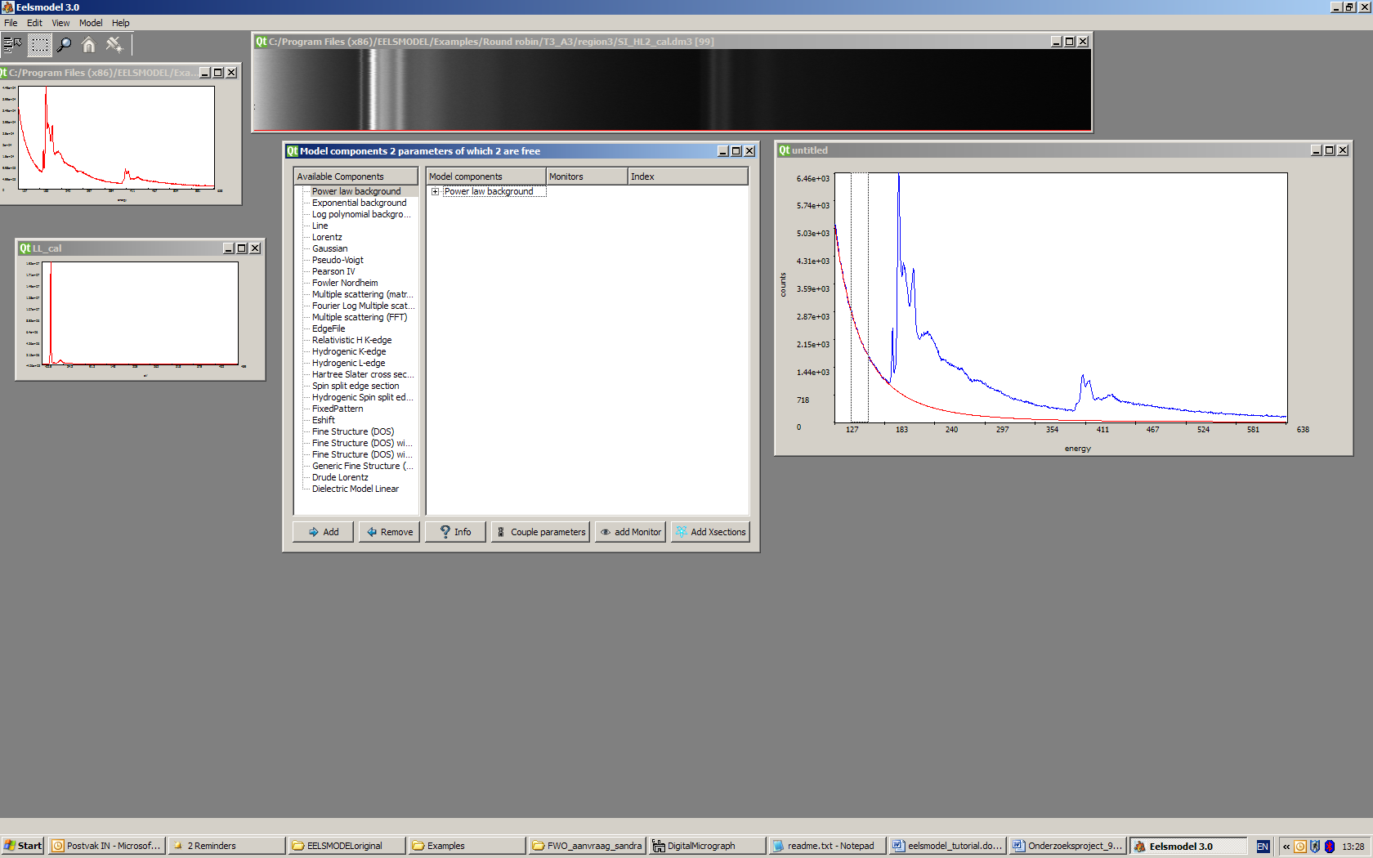
alternatively you can manually change the parameters of the power law (or of any other component) by clicking on the +sign in front of the component. This shows a list of parameters. Double clicking the parameters allows you to edit the values. You can lock parameters by right clicking on a parameter, a lock icon will apear. This means that in a fitting process this parameter will be treated a fixed.
You can also put boundaries on a parameter if you know it will be within a certain range. These boundaries can be a good idea since they keep the model within reasonable limits in case the fit would want to diverge because of bad starting conditions.
Try to set the limits on the r parameter of the power law background between 1 and 10.
Note: if you certainly know that a certain parameters is eg. positive, it is still a good idea to leave some room on the negative side to avoid that the fitter can never reach zero. As an example you can set the value for A to be bounded to -1 and +1e6 (the -1 avoids that the fitter would never be able to bring it to zero). Many cases where the fitter seems to be 'stuck' are because it wants to bring the parameters out of the range that was set, therefore use wide enough margins to describe the ranges for parameters to not interfere with the fitter algorithm.
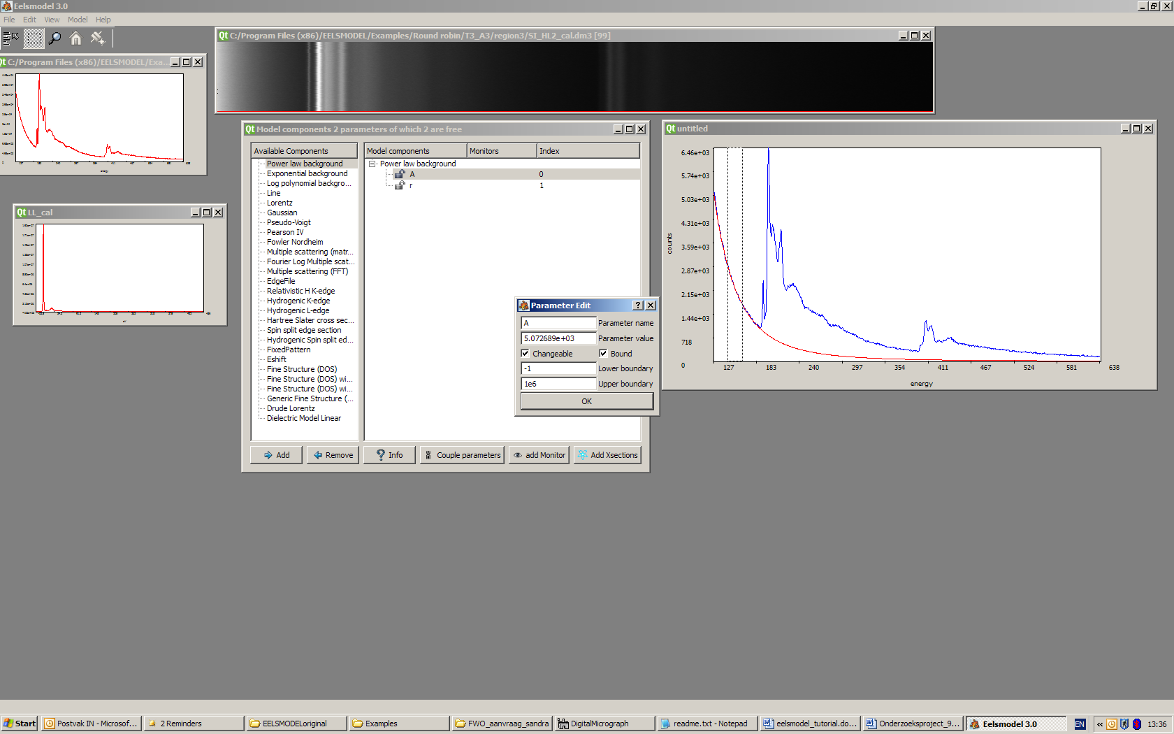

Adding the B and N core excitation edges
In case we are dealing with K or L edges there is a very easy way of adding these edges to the model by clicking on "add xsections". This opens a Mendeleev table where only those atoms are selectable which have a K or L edge within the range of your experimental spectrum.
Choose B and N, edit the values for collection and convergence angle and a realistic estimate of the energy resolution in your spectrum.
In our case we have: alpha=0.27 mrad, beta=4.12 mrad, 300kV and 1.5eV resolution
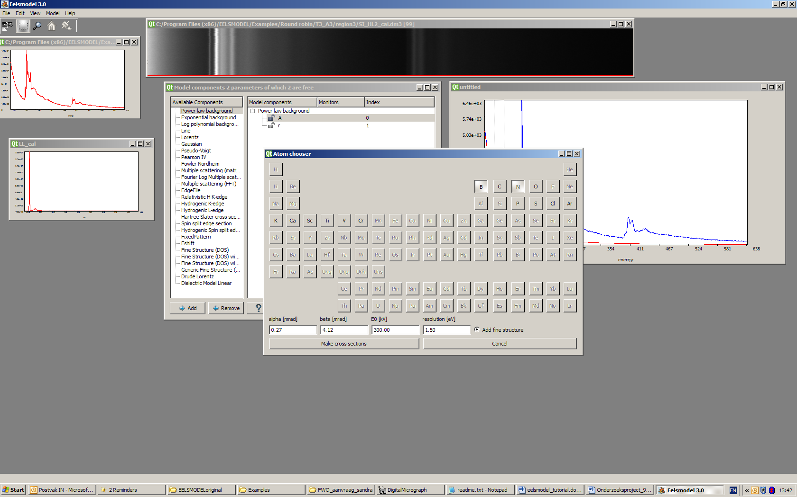
This procedure makes a few educated guessed about the size of the ELNES region and how many points will be needed in the modeling of the fine structure. You can later still change these parameters by hand. This procedure will use hydrogenic cross sections.
for now click "make xsections"
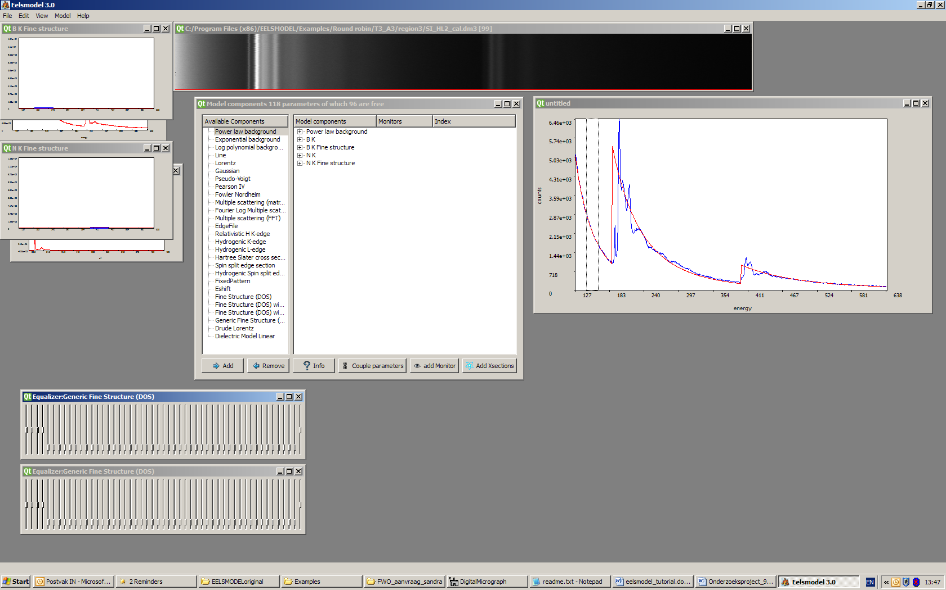
Two hydrogenic cross sections appeared each with their fine structure model for modeling the ELNES [4]. Each fine structure component also has a so called equaliser which allows the user to tune the values in an easy way.

Including multiple scattering
Next thing to do is including multiple scattering by convoluting the model with the low loss spectrum. Add the "multiple scattering (FFT)" component to the model making sure to click on the low loss spectrum when asked to make it front most [it should turn blue, it seems many people find this unexpected behaviour so I have to work on making this more natural]. Note that it is very important for the quantification to include multiple scattering and to make sure the low loss spectra are NOT SATURATED. Note the subtle change in shape of the B and N K-edges due to the inclusion of multiple scattering. If the collection and convergence angles are correctly given, the slope of the tails of the cross sections should nicely match your experiment.
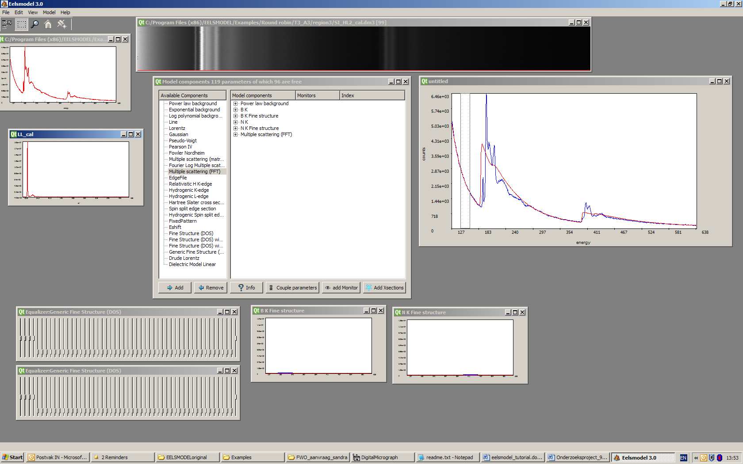
Its a good time now for saving the model that is already there, in order to avoid losing all your efforts when the program would crash or when the fitter would diverge to very bad parameter values.
Choose file/save project and give it a name ending with .mod

Doing a first fit
Choose model/fit and select either the "Levenberg Marquardt Poisson" or the "GSL least squares" (more robust but not optimised for Poisson noise). This brings a window with fitter parameters. Most of these parameters should be at a reasonable value but you can tweak them if you know what they mean...
To try a first fit, press "Do Itterations"
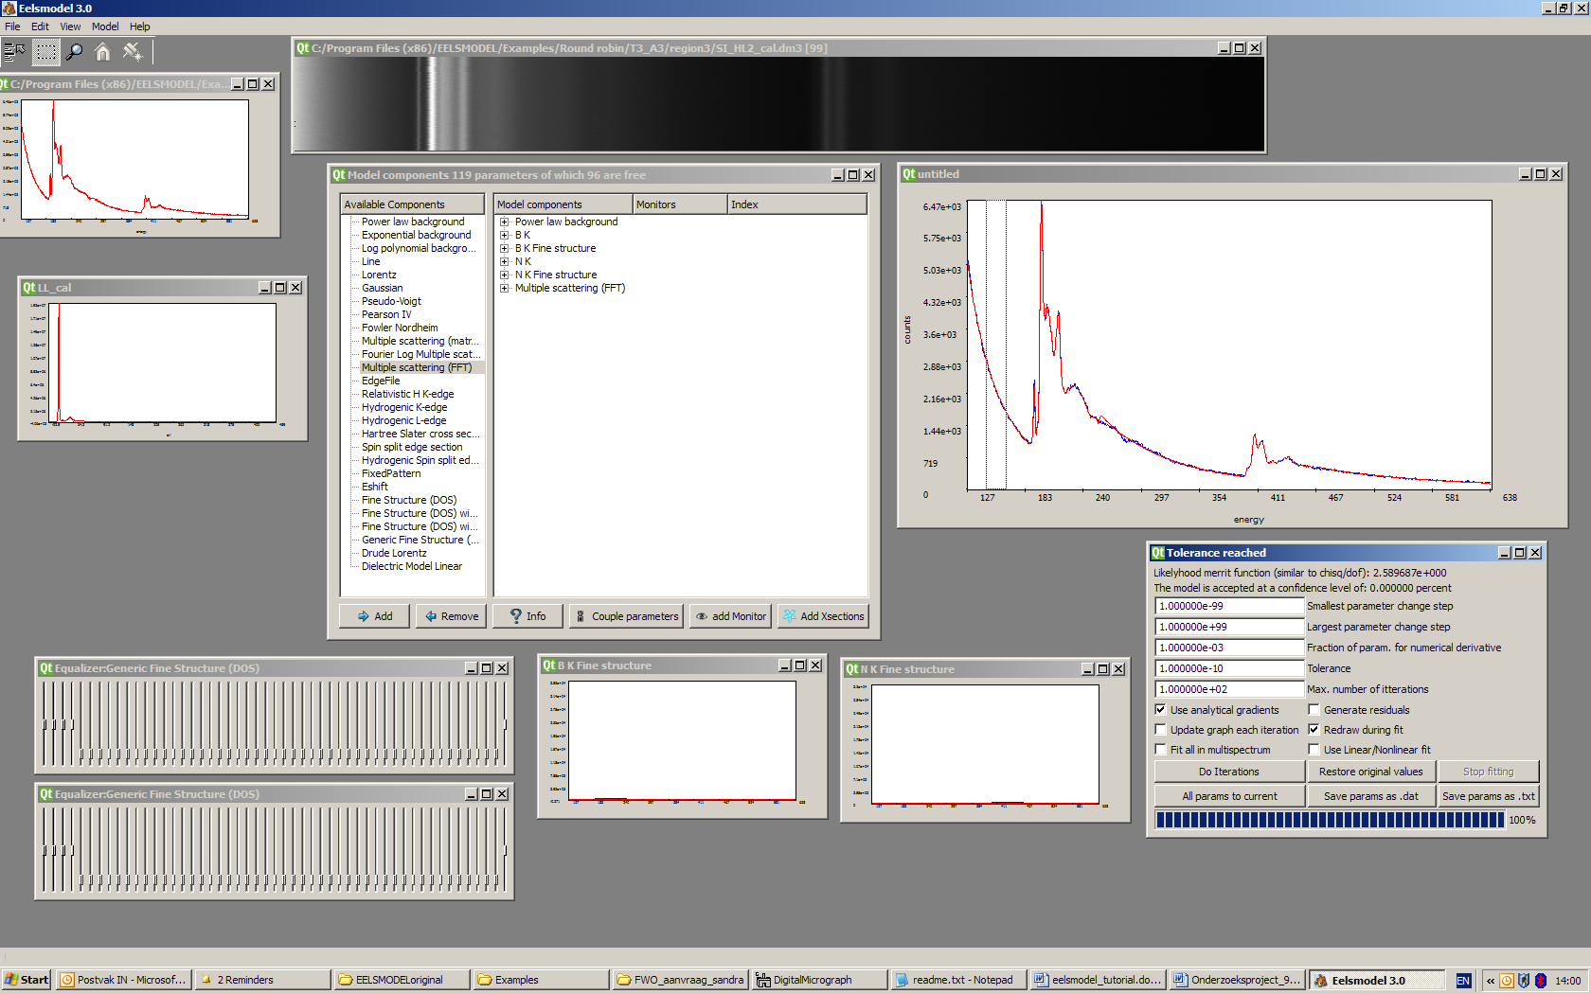
Which gives our first fitted result. How do we interpret decide now on the quality of this fit? and what is the B/N ratio that we obtained?
The quality of the fit can be read of from the fitter window under "Likelihood merrit function" for a good fit this should be close to 1.0. The next line "the model is accepted at a confidence level of 0.0 %" tells us that the model we made is not good enough to describe the experiment (should be higher than say 5% for an acceptable model, see also [5] for a discussion on the meaning of this acceptance test). And clearly we see differences by eye especially in the tail of the B K-edge which need to be taken into account.
We could check the B/N ratio now by comparing the strength parameters of the B and N K-edge. It is easier however to use the monitor tool [in the bottom of the component chooser window there is a button called "add monitor"]. Make sure you see the parameters of the B and N K-edge and click on the B-K edge "strength" parameter. The click on "add monitor", now the icon will change to an eye-icon. And click now on the N-K edge "strength" parameter. Then choose a ratio-monitor (for other reasons you might want to monitor eg the difference between 2 parameters). After doing this, a monitor line will appear behind the B-K-edge strength which tells you the B/N ratio as well as the estimated precision.
We have now a result of 0.954+-0.006
In principle we shouldn't trust this value since the model is not accepted.

Nevertheless, lets try to fit all spectra to get an idea on the variance of the output

Fit all the spectra: cross the box of “Fit all in multispectrum” of the fitting window. Click “Do Iterations”. It will start fitting the entire spectra image.
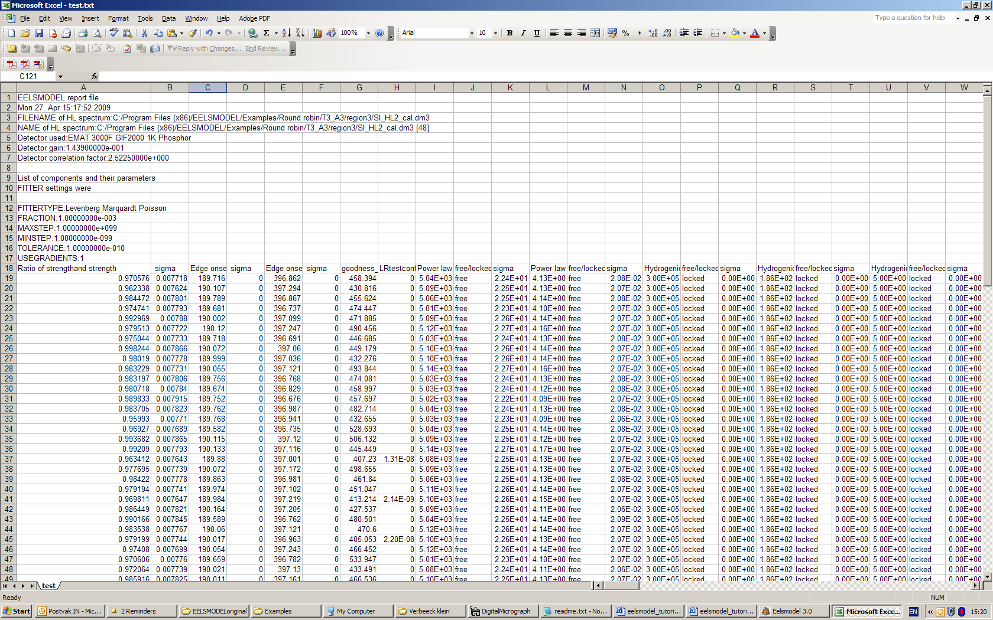

Save project and results: File—(1)save project. The model and all the parameters will be saved with extension “mod”. (2)Click “Save params as .txt” in the fitting window will save only the monitored results and parameters of each spectrum fitting.

Read the results: open the saved “.txt” file with office Excel. The spectrum data start from the 19th row. The first column (1) is the monitored ratio of B/N. The column with the caption “LRtestconfidence” (2) is the acceptance level.

You can now make averages and calculate standard deviations for your result. (we find average B/N ratio 0.953+-0.00699 while the theoretical prediction of error bar was 0.00656)

If everything behaved well, your estimated error bars should be almost the same as the real standard deviation in you experiment, assuming that the only thing that changes during recording was the noise.
If this does not fit, either your model is bad, your specimen is changing over time OR you don’t describe the noise correctly, pointing to a problem with the noise parameters of your detector.
In our case the model needs some improvements:

Improving the model fit
A few tricks can help to improve the fit to get an acceptable model.

The most obvious shortcoming of the model is in the B K-edge tail. This can be solved by extending the B K fine structure to improve its tail fitting: Right click the “Estop” under the “B K fine structure” in the component window. Change the parameter value to 300 eV. Then lock the parameter again by right clicking on it. “Do itteration” to fit。

First of all we need to exlude the very first and the very last pixels of the spectrum since there are edge artefacts of the multiple scattering convolution (should become atuomated in the future). Use the selection tool to mark the very first few pixels of the spectrum and choose in "edit\exlcude points" to exclude these points, the color of the spectrum will become light blue to mark that these points are no longer taken into account for the fitting process.
Do the same for the very last points of the spectra (say over 10 to 20eV from the end).
Redo the itterative fitting by "Do itterations" and you get a slightly better fit (only marginal improvement).

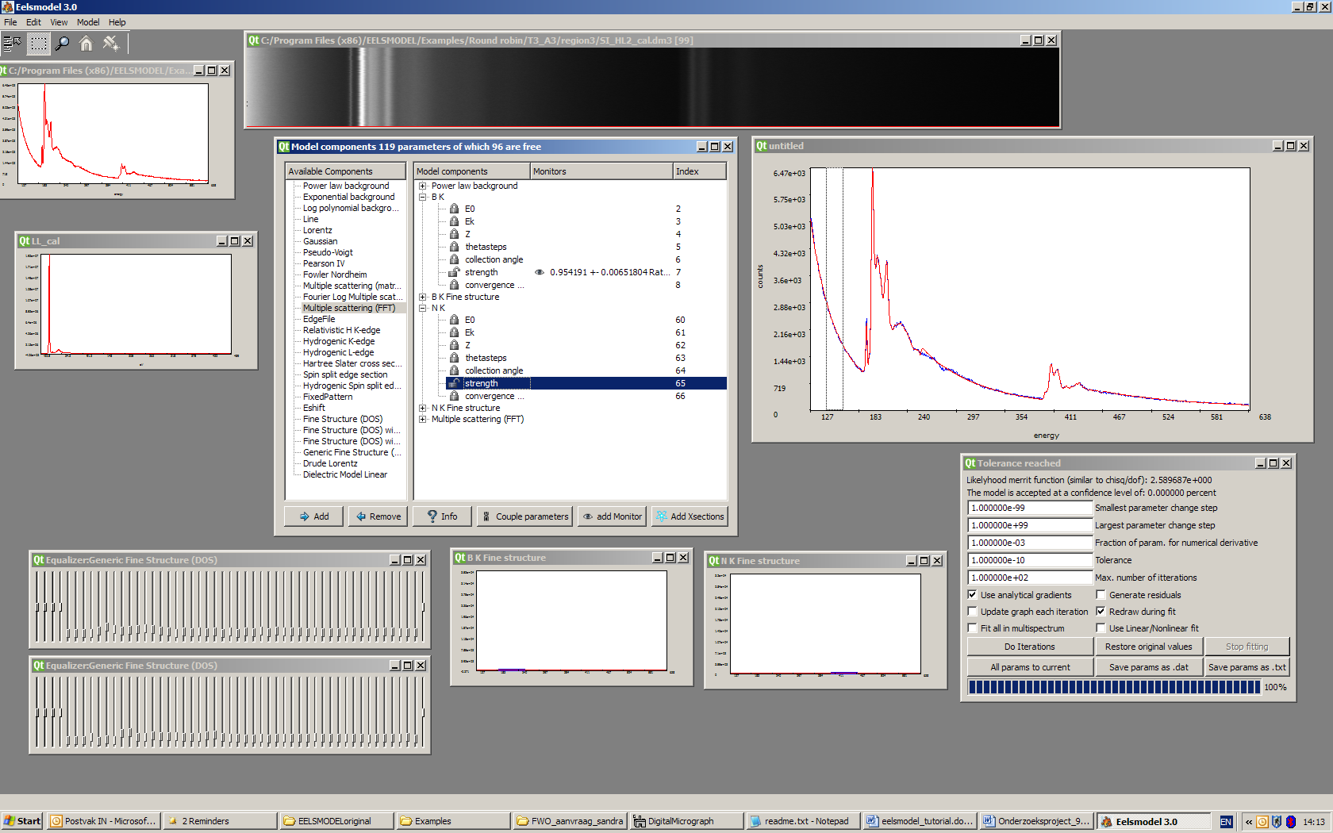
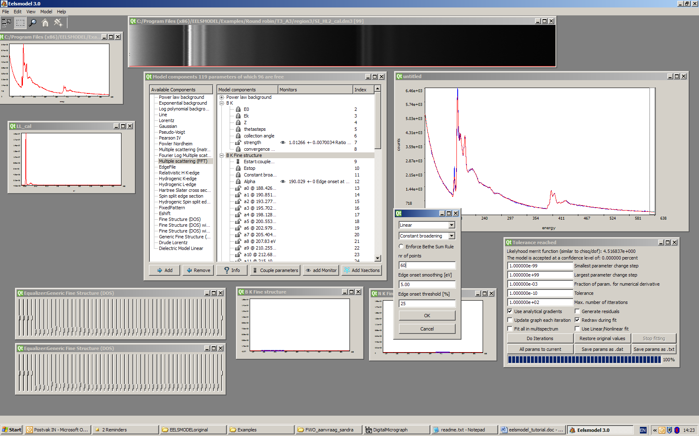
The amount of points describing the fine structure of B can also be increase to get a better fit of the fine features in the ELNES. This can be done by right clicking on the B K fine structure component, which opens a window where you can change some general parameters of the fine structure. Increase the number of points from 46 to 80 and redo the fit to see if it improves.

We can add the ghost-spectrum by opening it with file/open spectrum and selecting EELSMODEL\Examples\Round robin\T3_A3\region3\ BG_cal.msa. Then add a "fixed pattern" component to the model and take all parameters as. Redo the fit and see the improvement.

This way we have to keep trying to improve the fit. A possible improvement can be had by choosing linear broadening in the options of the B K fine structure. This makes sure that more points are avaiable close to the edge onset and less near the end of the ELNES region. Choose the parameter alpha=0.07 which controls how fast the lifetime broadening is decreasing the resolution for energies above the onset. Make sure this parameter is locked before fitting. NOTE that due to a bug in the current version (3.1.2) the estimated error bars are wrong if you choose this options. So use at your own risk...

Clearly, the better your spectra,the harder it will be for obtaining a good fit. This is logical since in low noise conditions, small deviations between model and experiment will become more apparent.

Fitting low loss spectra EELSMODEL (experimental)
- Click File→Open DM3 in the menu
open EELSMODEL\Examples\low_loss_diamond\diamond_no_bkg_deconv.dm3
(this is a BG removed and fourier log deconvolved spectrum of diamond)

- Click Model→New model, a window will show up. In this window, the blue curve is the experimental data and the red curve is the model fitting.
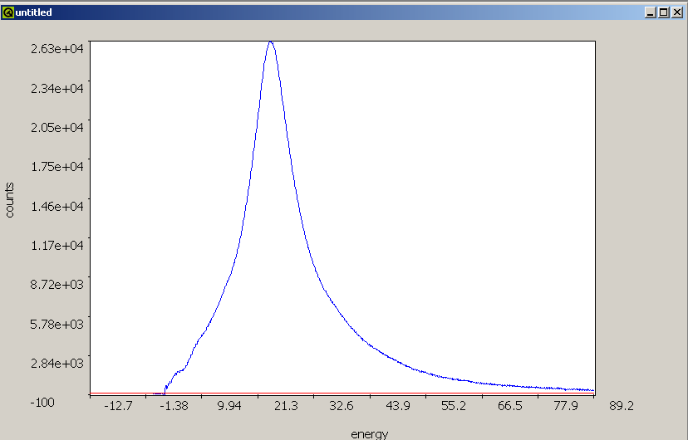

- Click Model→Component, the model components window will appear.

model components window
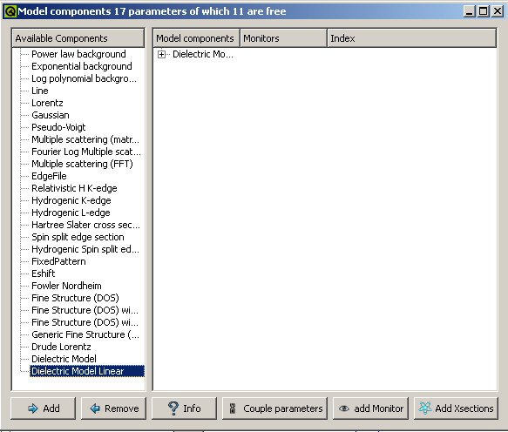

- Select this window, choose the dielectric model linear in the Available components box, click the Add icon, and then a series of dialog box will appear.

Number of points
This gives the number of point to fit the experimental spectra. The more points the better the fitting but the longer the computing time will be. Choose 10 to start, later we will increase.
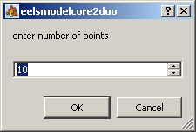

Eps0
Eps0 is dielectric constant at zero energy loss. It is related to the refractive index n. Eps0 = n² (here the material is diamond, n = 2.41, and then Eps0 = 5.84)

Strength
Change the lower boundary to 0.1 to avoid numerical problems, then adjust the parameter value in order to make the fitting curve has a comparable intensity with the experimental curve and then press OK.

E0
The acceleration voltage of the microscope, unit in eV. (the spectrum was recorded in CM30 with the accelerate voltage 3E5 eV.)

Absolute thickness
The thickness of the sample with the unit in meter. (the sample we use is about 50nm.) At the moment thickness plays no role in the calculation.

Thetamax
The value of the collection angle with unit in rad. (~ 20 mrad in this experimental setting)
Estop
The cutoff of energy scale. Normally set at an energy where the loss becomes negligible. Default setting is at the end of the recorded spectrum.

- After setting all the parameters, you’ll see three windows: the Epsilon1, the Epsilon2 and the Equalizer. The equalizer can be used to construct a good starting value for the fitter. Try to match the experiment as closely as possible by moving the sliders up and down.

- Click Model→Fit, a fitter chooser window will turn up. Choose a fitter and press OK (GSL fitter are used here because robustness of fitting is required).
Fitter chooser window
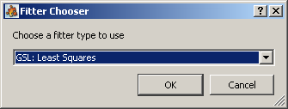

- After step 6, fitter option window will turn up, click the do iterations icon. After the tolerance reached check if the model fits the experiment well, if not do the iteration again.

Fitter option window
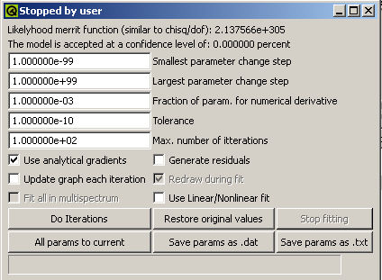

- Right clicking on the "dielectric model linear" component shows some options. You can select relativistic correction and fit again to see how much difference the relativistic correction makes (compare the dielectric function with an without and try to understand why they are so different for diamond). You can also choose different output options eg. showing n,K instead of eps1 and eps2. NOTE: don't use Kroeger formula at this point (v 3.1.2) since it doesn't work. You can also increase the number of points here to get a better fit with experiment (higher resolution) at the expense of longer computing time and possibly more noise.
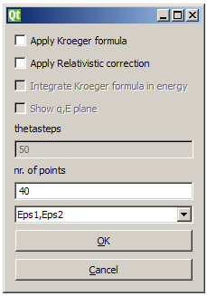
next figure is a comparison with the optically measured dielectric function for diamond to compare your result with, do you note any differences? Why? 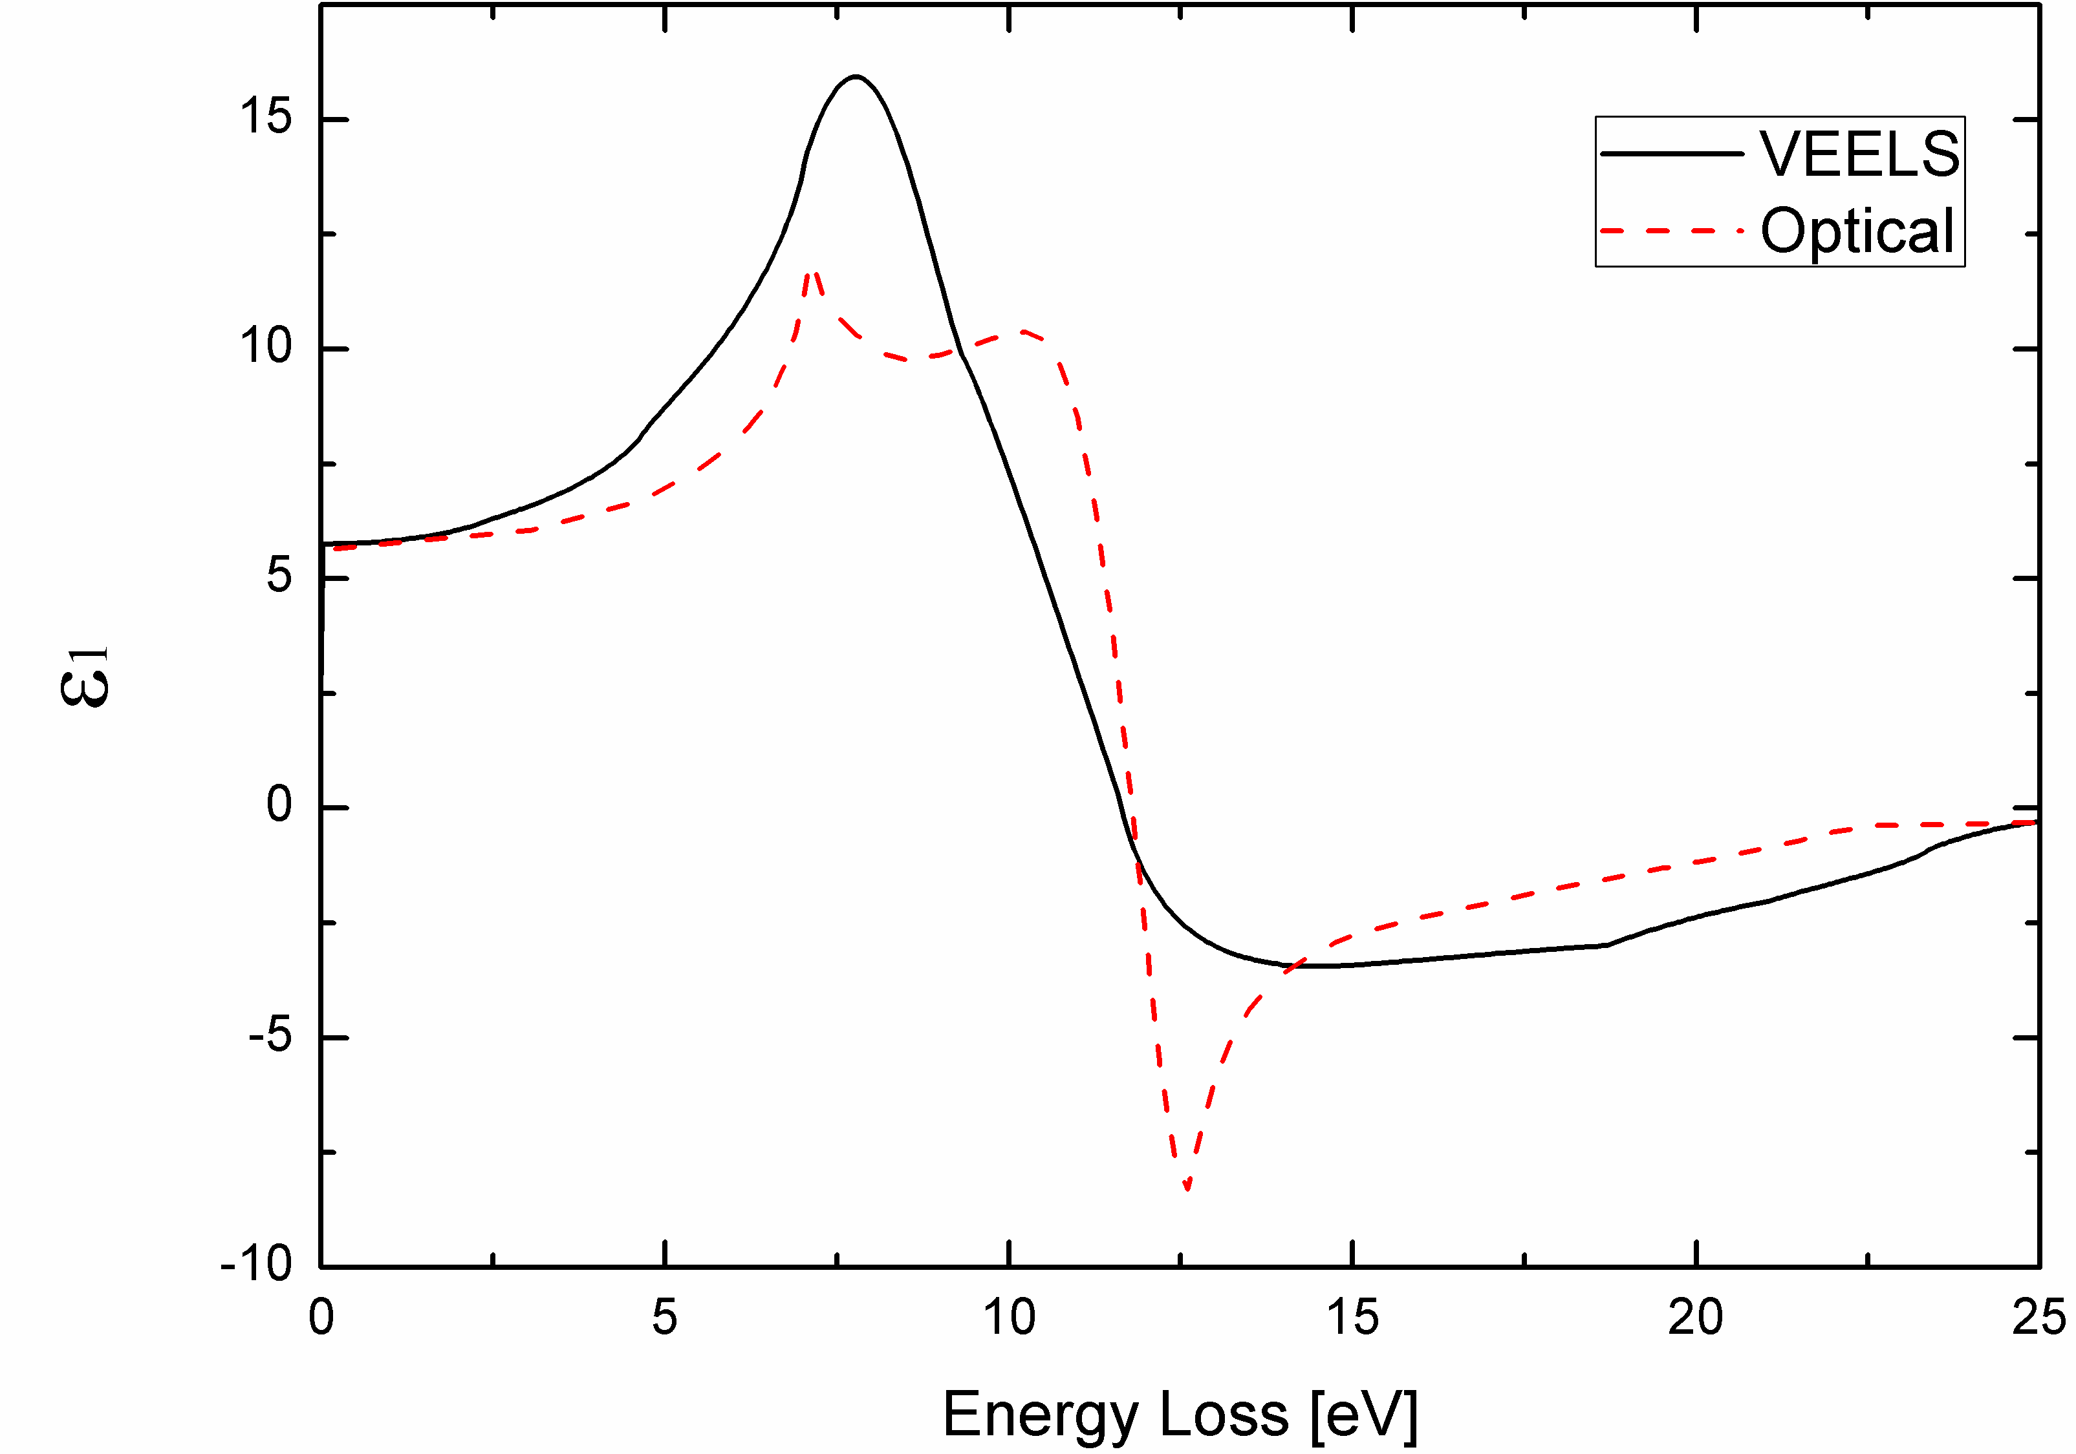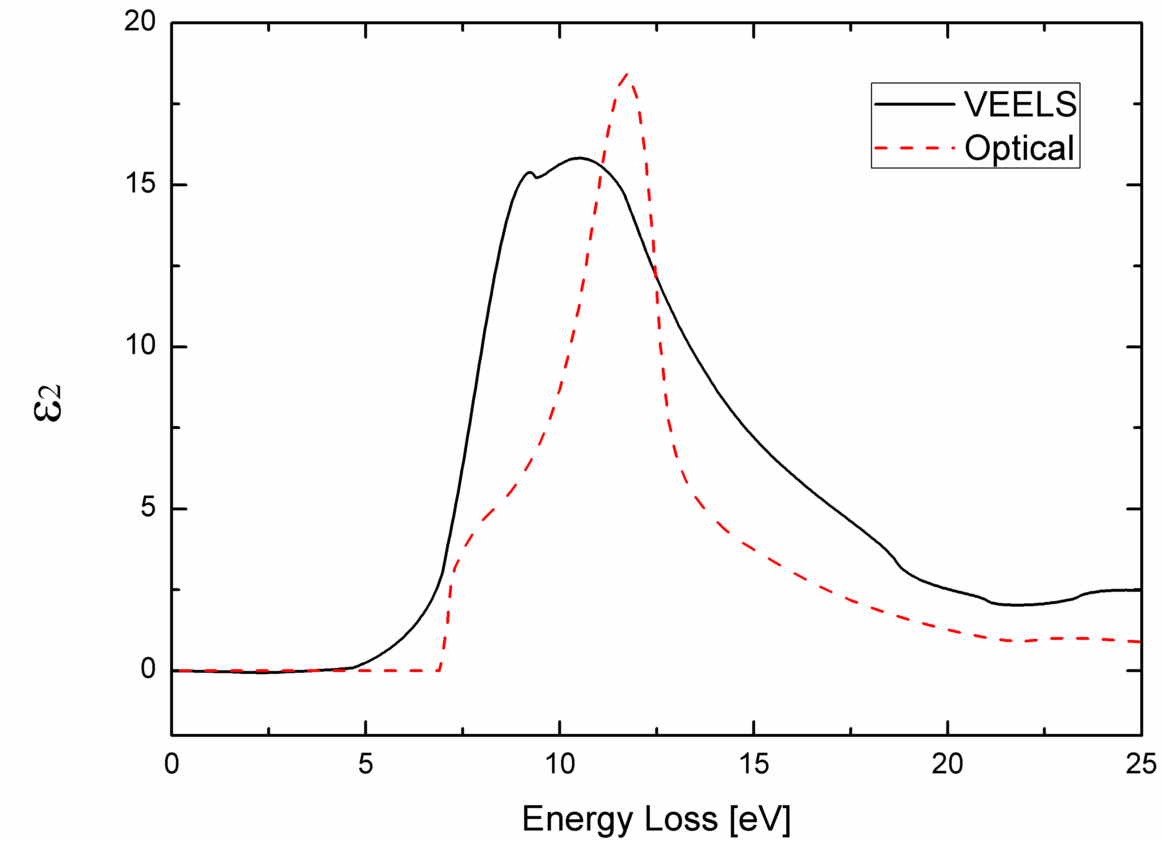

References
- Verbeeck, J. & Bertoni, G. (2008), 'Model-based quantification of EELS: is standardless quantification possible?', Microchim Acta 161(3-4), 439-443. {impact factor: 1.959 (2007)}
- Verbeeck, J. & Bertoni, G. (2008), 'Model-based quantification of EELS spectra: Treating the effect of correlated noise', Ultramicroscopy 108(2), 74-83. {impact factor: 1.996 (2007)}
- Bertoni, G. & Verbeeck, J. (2008), 'Accuracy and precision in model based EELS quantification', Ultramicroscopy 108 (8), 782-790. {impact factor: 1.996 (2007)}
- Verbeeck, J.; Van Aert, S. & Bertoni, G. (2006), 'Model based quantification of electron energy loss spectroscopy: including the fine structure', Ultramicroscopy 106(11-12), 976-980. {impact factor: 1.706 (2006)}
- Verbeeck, J. & Van Aert, S. (2004), 'Model based quantification of EELS spectra', Ultramicroscopy 101(2-4), 207-224. {impact factor: 2.215 (2004)}

