EXAM-REAL ESTATE DATA
JOVIA BULYABA
2026-05-06
#LOAD LIBRARIES
library(ggplot2)
## Warning: package 'ggplot2' was built under R version 4.5.3
library(dplyr)
## Warning: package 'dplyr' was built under R version 4.5.3
##
## Attaching package: 'dplyr'
## The following objects are masked from 'package:stats':
##
## filter, lag
## The following objects are masked from 'package:base':
##
## intersect, setdiff, setequal, union
#LOOK AT DATA
list.files()
## [1] "Custom Office Templates" "desktop.ini"
## [3] "FINAL-REAL-ESTATE.Rmd" "FINAL-REAL ESTATE.Rmd"
## [5] "inclass -week7.R" "My Music"
## [7] "My Pictures" "My Tableau Repository"
## [9] "My Videos" "myData.RData"
## [11] "Real estate.csv" "SUPPLY CHAIN PROJECT"
## [13] "Utilities.csv" "wine dataset plot.png"
df <-read.csv("Real estate.csv")
head(df)
## No X1.transaction.date X2.house.age X3.distance.to.the.nearest.MRT.station
## 1 1 2012.917 32.0 84.87882
## 2 2 2012.917 19.5 306.59470
## 3 3 2013.583 13.3 561.98450
## 4 4 2013.500 13.3 561.98450
## 5 5 2012.833 5.0 390.56840
## 6 6 2012.667 7.1 2175.03000
## X4.number.of.convenience.stores X5.latitude X6.longitude
## 1 10 24.98298 121.5402
## 2 9 24.98034 121.5395
## 3 5 24.98746 121.5439
## 4 5 24.98746 121.5439
## 5 5 24.97937 121.5425
## 6 3 24.96305 121.5125
## Y.house.price.of.unit.area
## 1 37.9
## 2 42.2
## 3 47.3
## 4 54.8
## 5 43.1
## 6 32.1
summary(df)
## No X1.transaction.date X2.house.age
## Min. : 1.0 Min. :2013 Min. : 0.000
## 1st Qu.:104.2 1st Qu.:2013 1st Qu.: 9.025
## Median :207.5 Median :2013 Median :16.100
## Mean :207.5 Mean :2013 Mean :17.713
## 3rd Qu.:310.8 3rd Qu.:2013 3rd Qu.:28.150
## Max. :414.0 Max. :2014 Max. :43.800
## X3.distance.to.the.nearest.MRT.station X4.number.of.convenience.stores
## Min. : 23.38 Min. : 0.000
## 1st Qu.: 289.32 1st Qu.: 1.000
## Median : 492.23 Median : 4.000
## Mean :1083.89 Mean : 4.094
## 3rd Qu.:1454.28 3rd Qu.: 6.000
## Max. :6488.02 Max. :10.000
## X5.latitude X6.longitude Y.house.price.of.unit.area
## Min. :24.93 Min. :121.5 Min. : 7.60
## 1st Qu.:24.96 1st Qu.:121.5 1st Qu.: 27.70
## Median :24.97 Median :121.5 Median : 38.45
## Mean :24.97 Mean :121.5 Mean : 37.98
## 3rd Qu.:24.98 3rd Qu.:121.5 3rd Qu.: 46.60
## Max. :25.01 Max. :121.6 Max. :117.50
#check for missing values
sum(is.na(df))
## [1] 0
boxplot(df$X3.distance.to.the.nearest.MRT.station,main = "Distance to MRT",ylab = "Distance")
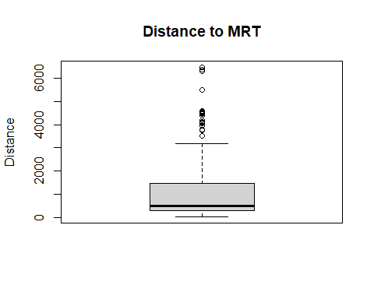
# Calculate Q1, Q3 and IQR
Q1 <- quantile(df$X3.distance.to.the.nearest.MRT.station, 0.25)
Q3 <- quantile(df$X3.distance.to.the.nearest.MRT.station, 0.75)
IQR_val <- Q3 - Q1
# Remove outliers
df_clean <- df %>%
filter(X3.distance.to.the.nearest.MRT.station < Q3 + 1.5 * IQR_val)
# how many rows we have now
nrow(df_clean)
## [1] 377
ggplot(df_clean, aes(x = X3.distance.to.the.nearest.MRT.station,
y = Y.house.price.of.unit.area)) +
geom_point(color = "blue") +
labs(title = "Distance to MRT vs House Price",
x = "Distance to MRT Station",
y = "House Price per Unit Area")
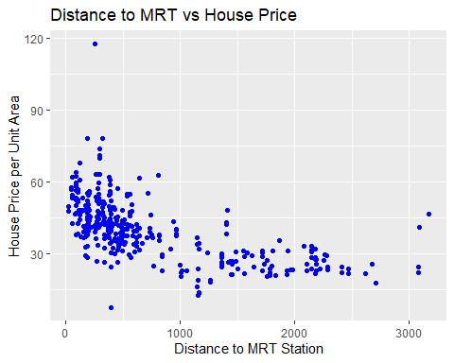
#building the model
model <- lm(Y.house.price.of.unit.area ~ X3.distance.to.the.nearest.MRT.station,
data = df_clean)
# See the results
summary(model)
##
## Call:
## lm(formula = Y.house.price.of.unit.area ~ X3.distance.to.the.nearest.MRT.station,
## data = df_clean)
##
## Residuals:
## Min 1Q Median 3Q Max
## -36.348 -5.365 -0.879 5.164 71.971
##
## Coefficients:
## Estimate Std. Error t value Pr(>|t|)
## (Intercept) 48.3679746 0.7444468 64.97 <2e-16
## X3.distance.to.the.nearest.MRT.station -0.0112380 0.0007213 -15.58 <2e-16
##
## (Intercept) ***
## X3.distance.to.the.nearest.MRT.station ***
## ---
## Signif. codes: 0 '***' 0.001 '**' 0.01 '*' 0.05 '.' 0.1 ' ' 1
##
## Residual standard error: 9.841 on 375 degrees of freedom
## Multiple R-squared: 0.393, Adjusted R-squared: 0.3914
## F-statistic: 242.8 on 1 and 375 DF, p-value: < 2.2e-16
#ADDING REGRESSION
ggplot(df_clean, aes(x = X3.distance.to.the.nearest.MRT.station,
y = Y.house.price.of.unit.area)) +
geom_point(color = "blue") +
geom_smooth(method = "lm", color = "red", se = FALSE) +
labs(title = "Distance to MRT vs House Price",
x = "Distance to MRT Station",
y = "House Price per Unit Area")
## `geom_smooth()` using formula = 'y ~ x'
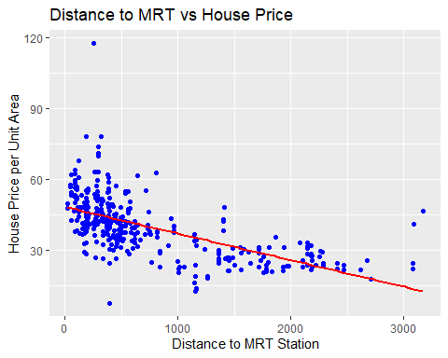

## Summary of my Findings
In this project, i used simple linear regression to predict house prices
based on distance to the nearest MRT station. After removing outliers and
cleaning the data, the model produced the following regression equation:

**Price = 48.37 - 0.0112 × Distance to MRT**

This confirms a negative relationship between distance and price so the further
a house is from an MRT station, the lower its price. The R-squared value of
0.393 indicates that distance to the MRT station explains approximately 39%
of the variation in house prices. While this is a reasonable result for a
single variable model, the remaining 61% is likely influenced by other factors
such as house age and number of nearby convenience stores. Overall, proximity
to public transportation proved to be a statistically significant predictor
of real estate prices.

LIFE EXPECTANCY
JOVIA BULYABA
2026-05-06
list.files()
## [1] "Custom Office Templates" "desktop.ini"
## [3] "FINAL-REAL-ESTATE.docx" "FINAL-REAL ESTATE.Rmd"
## [5] "inclass -week7.R" "Life-Expectancy.Rmd"
## [7] "Life-Expectancy_files" "Life Expectancy Data.csv"
## [9] "Life Expectancy.Rmd" "My Music"
## [11] "My Pictures" "My Tableau Repository"
## [13] "My Videos" "myData.RData"
## [15] "Real estate.csv" "SUPPLY CHAIN PROJECT"
## [17] "Utilities.csv" "wine dataset plot.png"
df <- read.csv("Life Expectancy Data.csv")
head(df)
## Country Year Status Life.expectancy Adult.Mortality infant.deaths
## 1 Afghanistan 2015 Developing 65.0 263 62
## 2 Afghanistan 2014 Developing 59.9 271 64
## 3 Afghanistan 2013 Developing 59.9 268 66
## 4 Afghanistan 2012 Developing 59.5 272 69
## 5 Afghanistan 2011 Developing 59.2 275 71
## 6 Afghanistan 2010 Developing 58.8 279 74
## Alcohol percentage.expenditure Hepatitis.B Measles BMI under.five.deaths
## 1 0.01 71.279624 65 1154 19.1 83
## 2 0.01 73.523582 62 492 18.6 86
## 3 0.01 73.219243 64 430 18.1 89
## 4 0.01 78.184215 67 2787 17.6 93
## 5 0.01 7.097109 68 3013 17.2 97
## 6 0.01 79.679367 66 1989 16.7 102
## Polio Total.expenditure Diphtheria HIV.AIDS GDP Population
## 1 6 8.16 65 0.1 584.25921 33736494
## 2 58 8.18 62 0.1 612.69651 327582
## 3 62 8.13 64 0.1 631.74498 31731688
## 4 67 8.52 67 0.1 669.95900 3696958
## 5 68 7.87 68 0.1 63.53723 2978599
## 6 66 9.20 66 0.1 553.32894 2883167
## thinness..1.19.years thinness.5.9.years Income.composition.of.resources
## 1 17.2 17.3 0.479
## 2 17.5 17.5 0.476
## 3 17.7 17.7 0.470
## 4 17.9 18.0 0.463
## 5 18.2 18.2 0.454
## 6 18.4 18.4 0.448
## Schooling
## 1 10.1
## 2 10.0
## 3 9.9
## 4 9.8
## 5 9.5
## 6 9.2
str(df)
## 'data.frame': 2938 obs. of 22 variables:
## $ Country : chr "Afghanistan" "Afghanistan" "Afghanistan" "Afghanistan" ...
## $ Year : int 2015 2014 2013 2012 2011 2010 2009 2008 2007 2006 ...
## $ Status : chr "Developing" "Developing" "Developing" "Developing" ...
## $ Life.expectancy : num 65 59.9 59.9 59.5 59.2 58.8 58.6 58.1 57.5 57.3 ...
## $ Adult.Mortality : int 263 271 268 272 275 279 281 287 295 295 ...
## $ infant.deaths : int 62 64 66 69 71 74 77 80 82 84 ...
## $ Alcohol : num 0.01 0.01 0.01 0.01 0.01 0.01 0.01 0.03 0.02 0.03 ...
## $ percentage.expenditure : num 71.3 73.5 73.2 78.2 7.1 ...
## $ Hepatitis.B : int 65 62 64 67 68 66 63 64 63 64 ...
## $ Measles : int 1154 492 430 2787 3013 1989 2861 1599 1141 1990 ...
## $ BMI : num 19.1 18.6 18.1 17.6 17.2 16.7 16.2 15.7 15.2 14.7 ...
## $ under.five.deaths : int 83 86 89 93 97 102 106 110 113 116 ...
## $ Polio : int 6 58 62 67 68 66 63 64 63 58 ...
## $ Total.expenditure : num 8.16 8.18 8.13 8.52 7.87 9.2 9.42 8.33 6.73 7.43 ...
## $ Diphtheria : int 65 62 64 67 68 66 63 64 63 58 ...
## $ HIV.AIDS : num 0.1 0.1 0.1 0.1 0.1 0.1 0.1 0.1 0.1 0.1 ...
## $ GDP : num 584.3 612.7 631.7 670 63.5 ...
## $ Population : num 33736494 327582 31731688 3696958 2978599 ...
## $ thinness..1.19.years : num 17.2 17.5 17.7 17.9 18.2 18.4 18.6 18.8 19 19.2 ...
## $ thinness.5.9.years : num 17.3 17.5 17.7 18 18.2 18.4 18.7 18.9 19.1 19.3 ...
## $ Income.composition.of.resources: num 0.479 0.476 0.47 0.463 0.454 0.448 0.434 0.433 0.415 0.405 ...
## $ Schooling : num 10.1 10 9.9 9.8 9.5 9.2 8.9 8.7 8.4 8.1 ...
summary(df)
## Country Year Status Life.expectancy
## Length:2938 Min. :2000 Length:2938 Min. :36.30
## Class :character 1st Qu.:2004 Class :character 1st Qu.:63.10
## Mode :character Median :2008 Mode :character Median :72.10
## Mean :2008 Mean :69.22
## 3rd Qu.:2012 3rd Qu.:75.70
## Max. :2015 Max. :89.00
## NA's :10
## Adult.Mortality infant.deaths Alcohol percentage.expenditure
## Min. : 1.0 Min. : 0.0 Min. : 0.0100 Min. : 0.000
## 1st Qu.: 74.0 1st Qu.: 0.0 1st Qu.: 0.8775 1st Qu.: 4.685
## Median :144.0 Median : 3.0 Median : 3.7550 Median : 64.913
## Mean :164.8 Mean : 30.3 Mean : 4.6029 Mean : 738.251
## 3rd Qu.:228.0 3rd Qu.: 22.0 3rd Qu.: 7.7025 3rd Qu.: 441.534
## Max. :723.0 Max. :1800.0 Max. :17.8700 Max. :19479.912
## NA's :10 NA's :194
## Hepatitis.B Measles BMI under.five.deaths
## Min. : 1.00 Min. : 0.0 Min. : 1.00 Min. : 0.00
## 1st Qu.:77.00 1st Qu.: 0.0 1st Qu.:19.30 1st Qu.: 0.00
## Median :92.00 Median : 17.0 Median :43.50 Median : 4.00
## Mean :80.94 Mean : 2419.6 Mean :38.32 Mean : 42.04
## 3rd Qu.:97.00 3rd Qu.: 360.2 3rd Qu.:56.20 3rd Qu.: 28.00
## Max. :99.00 Max. :212183.0 Max. :87.30 Max. :2500.00
## NA's :553 NA's :34
## Polio Total.expenditure Diphtheria HIV.AIDS
## Min. : 3.00 Min. : 0.370 Min. : 2.00 Min. : 0.100
## 1st Qu.:78.00 1st Qu.: 4.260 1st Qu.:78.00 1st Qu.: 0.100
## Median :93.00 Median : 5.755 Median :93.00 Median : 0.100
## Mean :82.55 Mean : 5.938 Mean :82.32 Mean : 1.742
## 3rd Qu.:97.00 3rd Qu.: 7.492 3rd Qu.:97.00 3rd Qu.: 0.800
## Max. :99.00 Max. :17.600 Max. :99.00 Max. :50.600
## NA's :19 NA's :226 NA's :19
## GDP Population thinness..1.19.years
## Min. :1.681e+00 Min. :3.400e+01 Min. : 0.10
## 1st Qu.:4.639e+02 1st Qu.:1.958e+05 1st Qu.: 1.60
## Median :1.767e+03 Median :1.387e+06 Median : 3.30
## Mean :7.483e+03 Mean :1.275e+07 Mean : 4.84
## 3rd Qu.:5.911e+03 3rd Qu.:7.420e+06 3rd Qu.: 7.20
## Max. :1.192e+05 Max. :1.294e+09 Max. :27.70
## NA's :448 NA's :652 NA's :34
## thinness.5.9.years Income.composition.of.resources Schooling
## Min. : 0.10 Min. :0.0000 Min. : 0.00
## 1st Qu.: 1.50 1st Qu.:0.4930 1st Qu.:10.10
## Median : 3.30 Median :0.6770 Median :12.30
## Mean : 4.87 Mean :0.6276 Mean :11.99
## 3rd Qu.: 7.20 3rd Qu.:0.7790 3rd Qu.:14.30
## Max. :28.60 Max. :0.9480 Max. :20.70
## NA's :34 NA's :167 NA's :163
#LOAD PACKAGES
library(ggplot2)
## Warning: package 'ggplot2' was built under R version 4.5.3
library(dplyr)
## Warning: package 'dplyr' was built under R version 4.5.3
##
## Attaching package: 'dplyr'
## The following objects are masked from 'package:stats':
##
## filter, lag
## The following objects are masked from 'package:base':
##
## intersect, setdiff, setequal, union
##MISSING VALUES
sum(is.na(df))
## [1] 2563
#REMOVE MISSING VALUES
df_clean <- na.omit(df)
nrow(df_clean)
## [1] 1649
#CONVERT TO BINARY
# Convert Status to binary (0 and 1)
df_clean$Status <- ifelse(df_clean$Status == "Developed", 1, 0)
# Check it worked
table(df_clean$Status)
##
## 0 1
## 1407 242
#VISUALIZATION
ggplot(df_clean, aes(x = factor(Status), y = Adult.Mortality,
fill = factor(Status))) +
geom_boxplot() +
labs(title = "Adult Mortality by Country Status",
x = "Status (0 = Developing, 1 = Developed)",
y = "Adult Mortality") +
scale_fill_manual(values = c("red", "blue"),
labels = c("Developing", "Developed"))
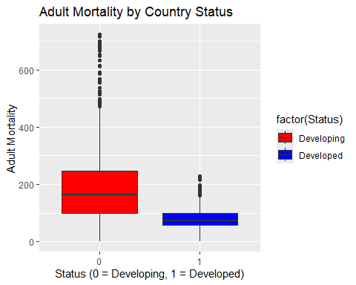 # CALCULATE Q1.Q3,IQR - REMOVING OUTLIERS
Q1 <- quantile(df_clean$Adult.Mortality, 0.25)
Q3 <- quantile(df_clean$Adult.Mortality, 0.75)
IQR_val <- Q3 - Q1
# Remove outliers
df_clean <- df_clean %>%
filter(Adult.Mortality < Q3 + 1.5 * IQR_val &
Adult.Mortality > Q1 - 1.5 * IQR_val)
# Check rows remaining
nrow(df_clean)
## [1] 1595
#MODEL TRAINING
model <- glm(Status ~ Adult.Mortality,data=df_clean,family= binomial)
summary(model)
##
## Call:
## glm(formula = Status ~ Adult.Mortality, family = binomial, data = df_clean)
##
## Coefficients:
## Estimate Std. Error z value Pr(>|z|)
## (Intercept) -0.401274 0.118690 -3.381 0.000723 ***
## Adult.Mortality -0.010900 0.000985 -11.066 < 2e-16 ***
## ---
## Signif. codes: 0 '***' 0.001 '**' 0.01 '*' 0.05 '.' 0.1 ' ' 1
##
## (Dispersion parameter for binomial family taken to be 1)
##
## Null deviance: 1357.9 on 1594 degrees of freedom
## Residual deviance: 1194.8 on 1593 degrees of freedom
## AIC: 1198.8
##
## Number of Fisher Scoring iterations: 5
ggplot(df_clean, aes(x = Adult.Mortality, y = Status)) +
geom_point(color = "blue", alpha = 0.3) +
geom_smooth(method = "glm",
method.args = list(family = binomial),
color = "red", se = FALSE) +
labs(title = "Logistic Regression: Adult Mortality vs Status",
x = "Adult Mortality",
y = "Probability of Being Developed (1)")
## `geom_smooth()` using formula = 'y ~ x'
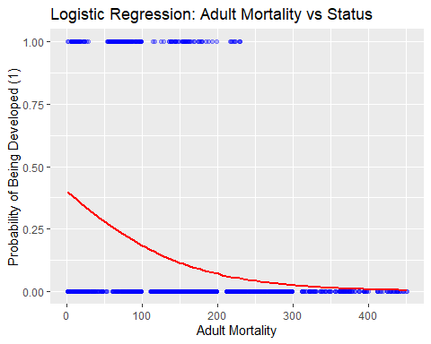

Summary of Findings
In this project ,I used logistic regression to predict whether a country is developed or developing based on adult mortality rates. MY dependent variable was Status and our independent variable was Adult Mortality.
After removing missing values and outliers on both sides, we were left with 1595 clean rows. The model produced the following equation:
log(p/1-p) = -0.4013 + (-0.0109) × Adult Mortality
The negative coefficient confirms that as adult mortality increases, the probability of a country being developed decreases. The logistic curve started high on the left where mortality is low, dropped steeply as mortality increased, and flattened at both ends since probability can never go above 1 or below 0. Overall adult mortality proved to be a statistically significant predictor of a country's development status.

WORD CLOUD
JOVIA BULYABA
2026-05-07
#run libraries
library(readxl)
## Warning: package 'readxl' was built under R version 4.5.3
library(tidytext)
## Warning: package 'tidytext' was built under R version 4.5.3
library(wordcloud)
## Warning: package 'wordcloud' was built under R version 4.5.3
## Loading required package: RColorBrewer
library(syuzhet)
## Warning: package 'syuzhet' was built under R version 4.5.3
library(reshape2)
## Warning: package 'reshape2' was built under R version 4.5.3
library(dplyr)
## Warning: package 'dplyr' was built under R version 4.5.3
##
## Attaching package: 'dplyr'
## The following objects are masked from 'package:stats':
##
## filter, lag
## The following objects are masked from 'package:base':
##
## intersect, setdiff, setequal, union
library(ggplot2)
## Warning: package 'ggplot2' was built under R version 4.5.3
list.files()
## [1] "Custom Office Templates" "desktop.ini"
## [3] "FINAL-REAL-ESTATE.docx" "FINAL-REAL ESTATE.Rmd"
## [5] "inclass -week7.R" "Life-Expectancy.docx"
## [7] "Life Expectancy Data.csv" "Life Expectancy.Rmd"
## [9] "My Music" "My Pictures"
## [11] "My Tableau Repository" "My Videos"
## [13] "myData.RData" "Real estate.csv"
## [15] "SUPPLY CHAIN PROJECT" "Utilities.csv"
## [17] "wine dataset plot.png" "WORD-CLOUD.Rmd"
## [19] "WORD CLOUD .csv" "WORD CLOUD CSV.csv"
## [21] "WORD CLOUD.Rmd"
df <- read.csv( "WORD CLOUD .csv")
head(df)

## X Clothing.ID Age Title
## 1 0 767 33
## 2 1 1080 34
## 3 2 1077 60 Some major design flaws
## 4 3 1049 50 My favorite buy! WORD CLOUD
JOVIA BULYABA
2026-05-07
#run libraries
library(readxl)
## Warning: package 'readxl' was built under R version 4.5.3
library(tidytext)
## Warning: package 'tidytext' was built under R version 4.5.3
library(wordcloud)
## Warning: package 'wordcloud' was built under R version 4.5.3
## Loading required package: RColorBrewer
library(syuzhet)
## Warning: package 'syuzhet' was built under R version 4.5.3
library(reshape2)
## Warning: package 'reshape2' was built under R version 4.5.3
library(dplyr)
## Warning: package 'dplyr' was built under R version 4.5.3
##
## Attaching package: 'dplyr'
## The following objects are masked from 'package:stats':
##
## filter, lag
## The following objects are masked from 'package:base':
##
## intersect, setdiff, setequal, union
library(ggplot2)
## Warning: package 'ggplot2' was built under R version 4.5.3
list.files()
## [1] "Custom Office Templates" "desktop.ini"
## [3] "FINAL-REAL-ESTATE.docx" "FINAL-REAL ESTATE.Rmd"
## [5] "inclass -week7.R" "Life-Expectancy.docx"
## [7] "Life Expectancy Data.csv" "Life Expectancy.Rmd"
## [9] "My Music" "My Pictures"
## [11] "My Tableau Repository" "My Videos"
## [13] "myData.RData" "Real estate.csv"
## [15] "SUPPLY CHAIN PROJECT" "Utilities.csv"
## [17] "wine dataset plot.png" "WORD-CLOUD.Rmd"
## [19] "WORD CLOUD .csv" "WORD CLOUD CSV.csv"
## [21] "WORD CLOUD.Rmd"
df <- read.csv( "WORD CLOUD .csv")
head(df)
## X Clothing.ID Age Title
## 1 0 767 33
## 2 1 1080 34
## 3 2 1077 60 Some major design flaws
## 4 3 1049 50 My favorite buy!
## 5 4 847 47 Flattering shirt
## 6 5 1080 49 Not for the very petite
## Review.Text
## 1 Absolutely wonderful - silky and sexy and comfortable
## 2 Love this dress! it's sooo pretty. i happened to find it in a store, and i'm glad i did bc i never would have ordered it online bc it's petite. i bought a petite and am 5'8". i love the length on me- hits just a little below the knee. would definitely be a true midi on someone who is truly petite.
## 3 I had such high hopes for this dress and really wanted it to work for me. i initially ordered the petite small (my usual size) but i found this to be outrageously small. so small in fact that i could not zip it up! i reordered it in petite medium, which was just ok. overall, the top half was comfortable and fit nicely, but the bottom half had a very tight under layer and several somewhat cheap (net) over layers. imo, a major design flaw was the net over layer sewn directly into the zipper - it c
## 4 I love, love, love this jumpsuit. it's fun, flirty, and fabulous! every time i wear it, i get nothing but great compliments!
## 5 This shirt is very flattering to all due to the adjustable front tie. it is the perfect length to wear with leggings and it is sleeveless so it pairs well with any cardigan. love this shirt!!!
## 6 I love tracy reese dresses, but this one is not for the very petite. i am just under 5 feet tall and usually wear a 0p in this brand. this dress was very pretty out of the package but its a lot of dress. the skirt is long and very full so it overwhelmed my small frame. not a stranger to alterations, shortening and narrowing the skirt would take away from the embellishment of the garment. i love the color and the idea of the style but it just did not work on me. i returned this dress.
## Rating Recommended.IND Positive.Feedback.Count Division.Name Department.Name
## 1 4 1 0 Initmates Intimate
## 2 5 1 4 General Dresses
## 3 3 0 0 General Dresses
## 4 5 1 0 General Petite Bottoms
## 5 5 1 6 General Tops
## 6 2 0 4 General Dresses
## Class.Name
## 1 Intimates
## 2 Dresses
## 3 Dresses
## 4 Pants
## 5 Blouses
## 6 Dresses
#MISSING VALUES
sum(is.na(df))
## [1] 0
#REMOVE STOP WORDS/CLEAN
df_tokens <- df %>%
unnest_tokens(word, `Review.Text`) %>%
anti_join(stop_words)
## Joining with `by = join_by(word)`
nrow(df_tokens)
## [1] 472675
#sentiment analysis
sentiment_scores <- df_tokens %>%
inner_join(get_sentiments("bing"))
## Joining with `by = join_by(word)`
## Warning in inner_join(., get_sentiments("bing")): Detected an unexpected many-to-many relationship between `x` and `y`.
## ℹ Row 22603 of `x` matches multiple rows in `y`.
## ℹ Row 3857 of `y` matches multiple rows in `x`.
## ℹ If a many-to-many relationship is expected, set `relationship =
## "many-to-many"` to silence this warning.
# Count positive vs negative
sentiment_summary <- sentiment_scores %>%
count(sentiment)
print(sentiment_summary)
## sentiment n
## 1 negative 24341
## 2 positive 74333
#visualizAtion
ggplot(sentiment_summary, aes(x = sentiment, y = n, fill = sentiment)) +
geom_bar(stat = "identity") +
scale_fill_manual(values = c("negative" = "red", "positive" = "green")) +
labs(title = "Sentiment Analysis of Clothing Reviews",
x = "Sentiment",
y = "Word Count")
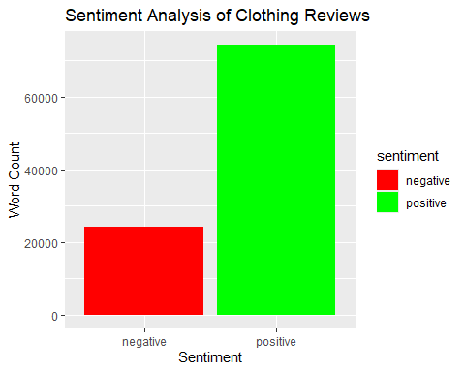 #WORD CLOUD
word_counts <- df_tokens %>%
count(word, sort = TRUE)
# Generate word cloud
wordcloud(words = word_counts$word,
freq = word_counts$n,
min.freq = 50,
max.words = 100,
colors = brewer.pal(8, "Dark2"))
## Warning in wordcloud(words = word_counts$word, freq = word_counts$n, min.freq =
## 50, : dress could not be fit on page. It will not be plotted.
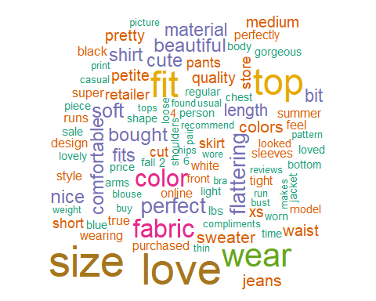 ## Get emotion scores
# sample of 5000 words
set.seed(123)
sample_words <- df_tokens %>%
sample_n(5000)
# n emotion analysis on smaller sample
emotions <- get_nrc_sentiment(sample_words$word)
emotion_summary <- colSums(emotions)
emotion_df <- data.frame(
emotion = names(emotion_summary),
count = emotion_summary
)
print(emotion_df)
## emotion count
## anger anger 101
## anticipation anticipation 343
## disgust disgust 77
## fear fear 76
## joy joy 393
## sadness sadness 175
## surprise surprise 116
## trust trust 415
## negative negative 343
## positive positive 745
#BAR CHART VISUALIZATION
ggplot(emotion_df, aes(x = reorder(emotion, -count),
y = count, fill = emotion)) +
geom_bar(stat = "identity") +
labs(title = "Emotion Recognition in Clothing Reviews",
x = "Emotion",
y = "Count") +
theme(axis.text.x = element_text(angle = 45, hjust = 1))
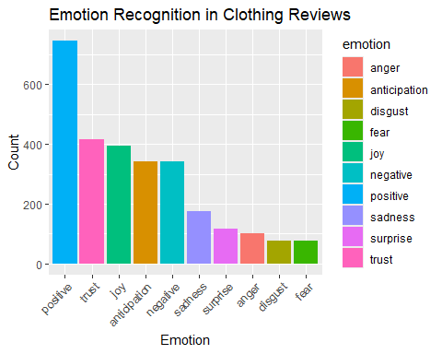
#Summary of Findings
Using the Women’s Clothing E-Commerce Reviews dataset, sentiment analysis revealed that 75% of customer reviews were positive compared to 25% negative. The word cloud highlighted “dress”, “love” and “size” as the most frequently mentioned words. Emotion recognition showed that trust and positive sentiment dominated, followed by joy and anticipation, while negative emotions like anger and disgust were minimal. Overall customers are highly satisfied with their purchases and trust the brand.
## 5 4 847 47 Flattering shirt
## 6 5 1080 49 Not for the very petite
## Review.Text
## 1 Absolutely wonderful - silky and sexy and comfortable
## 2 Love this dress! it's sooo pretty. i happened to find it in a store, and i'm glad i did bc i never would have ordered it online bc it's petite. i bought a petite and am 5'8". i love the length on me- hits just a little below the knee. would definitely be a true midi on someone who is truly petite.
## 3 I had such high hopes for this dress and really wanted it to work for me. i initially ordered the petite small (my usual size) but i found this to be outrageously small. so small in fact that i could not zip it up! i reordered it in petite medium, which was just ok. overall, the top half was comfortable and fit nicely, but the bottom half had a very tight under layer and several somewhat cheap (net) over layers. imo, a major design flaw was the net over layer sewn directly into the zipper - it c
## 4 I love, love, love this jumpsuit. it's fun, flirty, and fabulous! every time i wear it, i get nothing but great compliments!
## 5 This shirt is very flattering to all due to the adjustable front tie. it is the perfect length to wear with leggings and it is sleeveless so it pairs well with any cardigan. love this shirt!!!
## 6 I love tracy reese dresses, but this one is not for the very petite. i am just under 5 feet tall and usually wear a 0p in this brand. this dress was very pretty out of the package but its a lot of dress. the skirt is long and very full so it overwhelmed my small frame. not a stranger to alterations, shortening and narrowing the skirt would take away from the embellishment of the garment. i love the color and the idea of the style but it just did not work on me. i returned this dress.
## Rating Recommended.IND Positive.Feedback.Count Division.Name Department.Name
## 1 4 1 0 Initmates Intimate
## 2 5 1 4 General Dresses
## 3 3 0 0 General Dresses
## 4 5 1 0 General Petite Bottoms
## 5 5 1 6 General Tops
## 6 2 0 4 General Dresses
## Class.Name
## 1 Intimates
## 2 Dresses
## 3 Dresses
## 4 Pants
## 5 Blouses
## 6 Dresses
#MISSING VALUES
sum(is.na(df))
## [1] 0
#REMOVE STOP WORDS/CLEAN
df_tokens <- df %>%
unnest_tokens(word, `Review.Text`) %>%
anti_join(stop_words)
## Joining with `by = join_by(word)`
nrow(df_tokens)
## [1] 472675
#sentiment analysis
sentiment_scores <- df_tokens %>%
inner_join(get_sentiments("bing"))
## Joining with `by = join_by(word)`
## Warning in inner_join(., get_sentiments("bing")): Detected an unexpected many-to-many relationship between `x` and `y`.
## ℹ Row 22603 of `x` matches multiple rows in `y`.
## ℹ Row 3857 of `y` matches multiple rows in `x`.
## ℹ If a many-to-many relationship is expected, set `relationship =
## "many-to-many"` to silence this warning.
# Count positive vs negative
sentiment_summary <- sentiment_scores %>%
count(sentiment)
print(sentiment_summary)
## sentiment n
## 1 negative 24341
## 2 positive 74333
#visualizAtion
ggplot(sentiment_summary, aes(x = sentiment, y = n, fill = sentiment)) +
geom_bar(stat = "identity") +
scale_fill_manual(values = c("negative" = "red", "positive" = "green")) +
labs(title = "Sentiment Analysis of Clothing Reviews",
x = "Sentiment",
y = "Word Count")
 ##WORD CLOUD
word_counts <- df_tokens %>%
count(word, sort = TRUE)
# Generate word cloud
wordcloud(words = word_counts$word,
freq = word_counts$n,
min.freq = 50,
max.words = 100,
colors = brewer.pal(8, "Dark2"))
## Warning in wordcloud(words = word_counts$word, freq = word_counts$n, min.freq =
## 50, : dress could not be fit on page. It will not be plotted.
 ## Get emotion scores
# sample of 5000 words
set.seed(123)
sample_words <- df_tokens %>%
sample_n(5000)
# n emotion analysis on smaller sample
emotions <- get_nrc_sentiment(sample_words$word)
emotion_summary <- colSums(emotions)
emotion_df <- data.frame(
emotion = names(emotion_summary),
count = emotion_summary
)
print(emotion_df)
## emotion count
## anger anger 101
## anticipation anticipation 343
## disgust disgust 77
## fear fear 76
## joy joy 393
## sadness sadness 175
## surprise surprise 116
## trust trust 415
## negative negative 343
## positive positive 745
#BAR CHART VISUALIZATION
ggplot(emotion_df, aes(x = reorder(emotion, -count),
y = count, fill = emotion)) +
geom_bar(stat = "identity") +
labs(title = "Emotion Recognition in Clothing Reviews",
x = "Emotion",
y = "Count") +
theme(axis.text.x = element_text(angle = 45, hjust = 1))

#Summary of Findings
Using the Women’s Clothing E-Commerce Reviews dataset, sentiment analysis revealed that 75% of customer reviews were positive compared to 25% negative. The word cloud highlighted “dress”, “love” and “size” as the most frequently mentioned words. Emotion recognition showed that trust and positive sentiment dominated, followed by joy and anticipation, while negative emotions like anger and disgust were minimal. Overall customers are highly satisfied with their purchases and trust the brand.

