WORD CLOUD
JOVIA BULYABA
2026-05-07
#run libraries
library(readxl)
## Warning: package 'readxl' was built under R version 4.5.3
library(tidytext)
## Warning: package 'tidytext' was built under R version 4.5.3
library(wordcloud)
## Warning: package 'wordcloud' was built under R version 4.5.3
## Loading required package: RColorBrewer
library(syuzhet)
## Warning: package 'syuzhet' was built under R version 4.5.3
library(reshape2)
## Warning: package 'reshape2' was built under R version 4.5.3
library(dplyr)
## Warning: package 'dplyr' was built under R version 4.5.3
##
## Attaching package: 'dplyr'
## The following objects are masked from 'package:stats':
##
## filter, lag
## The following objects are masked from 'package:base':
##
## intersect, setdiff, setequal, union
library(ggplot2)
## Warning: package 'ggplot2' was built under R version 4.5.3
list.files()
## [1] "Custom Office Templates" "desktop.ini"
## [3] "FINAL-REAL-ESTATE.docx" "FINAL-REAL ESTATE.Rmd"
## [5] "inclass -week7.R" "Life-Expectancy.docx"
## [7] "Life Expectancy Data.csv" "Life Expectancy.Rmd"
## [9] "My Music" "My Pictures"
## [11] "My Tableau Repository" "My Videos"
## [13] "myData.RData" "Real estate.csv"
## [15] "SUPPLY CHAIN PROJECT" "Utilities.csv"
## [17] "wine dataset plot.png" "WORD-CLOUD.Rmd"
## [19] "WORD CLOUD .csv" "WORD CLOUD CSV.csv"
## [21] "WORD CLOUD.Rmd"
df <- read.csv( "WORD CLOUD .csv")
head(df)
## X Clothing.ID Age Title
## 1 0 767 33
## 2 1 1080 34
## 3 2 1077 60 Some major design flaws
## 4 3 1049 50 My favorite buy!
## 5 4 847 47 Flattering shirt
## 6 5 1080 49 Not for the very petite
## Review.Text
## 1 Absolutely wonderful - silky and sexy and comfortable
## 2 Love this dress! it's sooo pretty. i happened to find it in a store, and i'm glad i did bc i never would have ordered it online bc it's petite. i bought a petite and am 5'8". i love the length on me- hits just a little below the knee. would definitely be a true midi on someone who is truly petite.
## 3 I had such high hopes for this dress and really wanted it to work for me. i initially ordered the petite small (my usual size) but i found this to be outrageously small. so small in fact that i could not zip it up! i reordered it in petite medium, which was just ok. overall, the top half was comfortable and fit nicely, but the bottom half had a very tight under layer and several somewhat cheap (net) over layers. imo, a major design flaw was the net over layer sewn directly into the zipper - it c
## 4 I love, love, love this jumpsuit. it's fun, flirty, and fabulous! every time i wear it, i get nothing but great compliments!
## 5 This shirt is very flattering to all due to the adjustable front tie. it is the perfect length to wear with leggings and it is sleeveless so it pairs well with any cardigan. love this shirt!!!
## 6 I love tracy reese dresses, but this one is not for the very petite. i am just under 5 feet tall and usually wear a 0p in this brand. this dress was very pretty out of the package but its a lot of dress. the skirt is long and very full so it overwhelmed my small frame. not a stranger to alterations, shortening and narrowing the skirt would take away from the embellishment of the garment. i love the color and the idea of the style but it just did not work on me. i returned this dress.
## Rating Recommended.IND Positive.Feedback.Count Division.Name Department.Name
## 1 4 1 0 Initmates Intimate
## 2 5 1 4 General Dresses
## 3 3 0 0 General Dresses
## 4 5 1 0 General Petite Bottoms
## 5 5 1 6 General Tops
## 6 2 0 4 General Dresses
## Class.Name
## 1 Intimates
## 2 Dresses
## 3 Dresses
## 4 Pants
## 5 Blouses
## 6 Dresses
#MISSING VALUES
sum(is.na(df))
## [1] 0
#REMOVE STOP WORDS/CLEAN
df_tokens <- df %>%
unnest_tokens(word, `Review.Text`) %>%
anti_join(stop_words)
## Joining with `by = join_by(word)`
nrow(df_tokens)
## [1] 472675
#sentiment analysis
sentiment_scores <- df_tokens %>%
inner_join(get_sentiments("bing"))
## Joining with `by = join_by(word)`
## Warning in inner_join(., get_sentiments("bing")): Detected an unexpected many-to-many relationship between `x` and `y`.
## ℹ Row 22603 of `x` matches multiple rows in `y`.
## ℹ Row 3857 of `y` matches multiple rows in `x`.
## ℹ If a many-to-many relationship is expected, set `relationship =
## "many-to-many"` to silence this warning.
# Count positive vs negative
sentiment_summary <- sentiment_scores %>%
count(sentiment)
print(sentiment_summary)
## sentiment n
## 1 negative 24341
## 2 positive 74333
#visualizAtion
ggplot(sentiment_summary, aes(x = sentiment, y = n, fill = sentiment)) +
geom_bar(stat = "identity") +
scale_fill_manual(values = c("negative" = "red", "positive" = "green")) +
labs(title = "Sentiment Analysis of Clothing Reviews",
x = "Sentiment",
y = "Word Count")
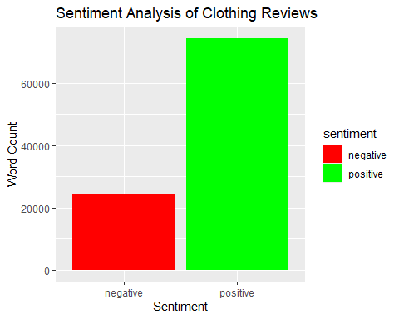 #WORD CLOUD
word_counts <- df_tokens %>%
count(word, sort = TRUE)
# Generate word cloud
wordcloud(words = word_counts$word,
freq = word_counts$n,
min.freq = 50,
max.words = 100,
colors = brewer.pal(8, "Dark2"))
## Warning in wordcloud(words = word_counts$word, freq = word_counts$n, min.freq =
## 50, : dress could not be fit on page. It will not be plotted.
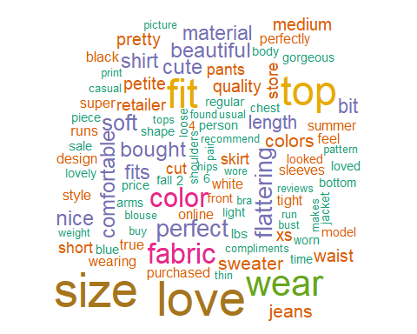 ## Get emotion scores
# sample of 5000 words
set.seed(123)
sample_words <- df_tokens %>%
sample_n(5000)
# n emotion analysis on smaller sample
emotions <- get_nrc_sentiment(sample_words$word)
emotion_summary <- colSums(emotions)
emotion_df <- data.frame(
emotion = names(emotion_summary),
count = emotion_summary
)
print(emotion_df)
## emotion count
## anger anger 101
## anticipation anticipation 343
## disgust disgust 77
## fear fear 76
## joy joy 393
## sadness sadness 175
## surprise surprise 116
## trust trust 415
## negative negative 343
## positive positive 745
#BAR CHART VISUALIZATION
ggplot(emotion_df, aes(x = reorder(emotion, -count),
y = count, fill = emotion)) +
geom_bar(stat = "identity") +
labs(title = "Emotion Recognition in Clothing Reviews",
x = "Emotion",
y = "Count") +
theme(axis.text.x = element_text(angle = 45, hjust = 1))
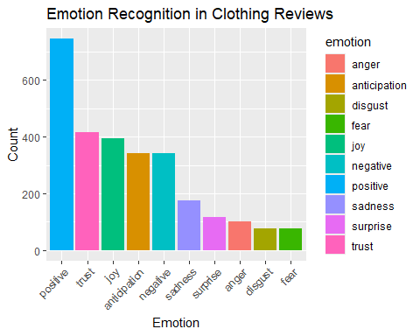
#Summary of Findings
Using the Women’s Clothing E-Commerce Reviews dataset, sentiment analysis revealed that 75% of customer reviews were positive compared to 25% negative. The word cloud highlighted “dress”, “love” and “size” as the most frequently mentioned words. Emotion recognition showed that trust and positive sentiment dominated, followed by joy and anticipation, while negative emotions like anger and disgust were minimal. Overall customers are highly satisfied with their purchases and trust the brand.

