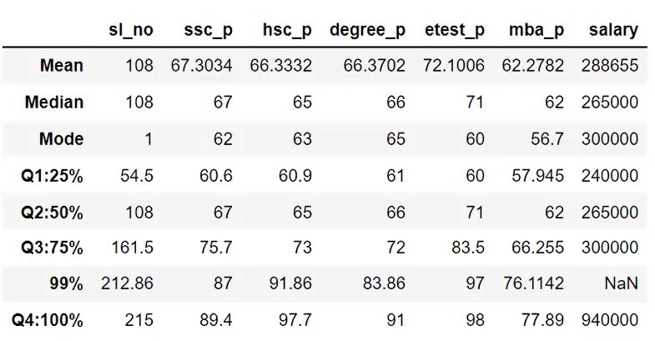

Mean:

1. What is the overall performance of the candidates in SSLC? 67
2. What is the overall performance of the candidates in HSC? 66
3. What is the overall performance of the candidates in Degree? 66
4. What is the overall performance of the candidates in entrance exam? 72
5. What is the overall performance of the candidates in MBA? 62
6. What is the overall average salary of the candidates for the above criteria? 288655

Median: (the middle value in a dataset when the data is arranged in ascending order without considering outliers)

1. What is the average score of the candidates in SSLC? 67
2. What is the average score of the candidates in HSC? 65
3. What is the average score of the candidates in Degree? 66
4. What is the average score of the candidates in entrance test? 71
5. What is the average score of the candidates in MBA? 62
6. What is the average salary of candidates? 265000

Mode: Highest repeating value in dataset.

1. What is the most common mark obtained by many of the candidates in SSLC? 62
2. What is the most common mark obtained by many of the candidates in HSC? 63
3. What is the most common mark obtained by many of the candidates in Degree? 65
4. What is the most common score obtained by many of the candidates in entrance? 60
5. What is the most common mark obtained by many of the candidates in MBA? 56.7
6. What is the most common salary earned by many of the candidates? 300000

Percentile:

1. What is the range of SSLC score?
   1. 25% of candidates have scored within 60.6
   2. 50 % of candidates have scored within 67.
   3. 75 % of candidates have scored within 75.7.
   4. 99 % of candidates have scored within 87.
   5. What is the maximum score obtained? 89.4.
2. What is the range of HSC score?
   1. 25% of candidates have scored within 60.9
   2. 50 % of candidates have scored within 65.
   3. 75 % of candidates have scored within 73.
   4. 99 % of candidates have scored within 91.86.
   5. What is the maximum score obtained? 97.7.
3. What is the range of degree mark?
   1. 25% of candidates have scored within 61
   2. 50 % of candidates have scored within 66.
   3. 75 % of candidates have scored within 72.
   4. 99 % of candidates have scored within 83.86.
   5. What is the maximum score obtained? 91.
4. What is the range of entrance test score?
   1. 25% of candidates have scored within 60.
   2. 50 % of candidates have scored within 71.
   3. 75 % of candidates have scored within 83.5.
   4. 99 % of candidates have scored within 97.
   5. What is the maximum score obtained? 98.
5. What is the range of MBA score?
   1. 25% of candidates have scored within 57
   2. 50 % of candidates have scored within 62.
   3. 75 % of candidates have scored within 66.
   4. 99 % of candidates have scored within 76.
   5. What is the maximum score obtained? 77.
6. What is the range of salary earned?
   1. Salary of 25% of candidates is below or equal to 240000
   2. Salary of 50% of candidates is below or equal to 265000
   3. Salary of 75% of candidates is below or equal to 300000
   4. Maximum salary of candidates is 940000.