1. Command for searching pattern line by line in any document with an example.

Ans: grep -n "pattern" filename

Example:

~cat >bobb.txt

Hello Im Ankur Dubey

I study in NITT MCA Department

My hobbies are playing cricket volleyball and chess.

I love travelling,photgrapgy, coding and study story books.

I want to be placed in a nice company from where i can learn a lot of things.

I am hard working, confident in my work and put all efforts to to whatever I start.

~grep -n "I" bobb.txt

2:I study in NITT MCA Department

3:My hobbies are playing cricket volleyball and chess.

4:I love travelling,photgrapgy, coding and study story books.

5:I want to be placed in a nice company from where i can learn a lot of things.

6:I am hard working, confident in my work and put all efforts to to whatever I start.

2.What all permissions are there in LINUX. State all permissions and different way of changing permissions.

Ans. There are three kind of permissions in LINUX.

a.Read (r)

b.Write (w)

c.Execute (x)

There are 3 users to a particular file to which we provide permissions.

Others Users and Group.

to check the permission we use command : ls -l filename

To change the permission we have two methods: 1.Symbollic 2.Octal numbers

In symbollic we use + sign to add permission and - to remove along with the user and the permissions, Eg: $chmod o+wx,u-x,g=rx testfile ,It will give other permission to write and execute, and remove permision from user to execute and group to only read and execute.

In Octal number represtation we use ocatl numbers to add or remove $chmod 743 testfile,7 is to provide all permision to other, 4 is read to user and 3 is wx to group.

3.Create a folder name OSOC and inside that another folder Inductions and now create a file task.txt, inside Inductions with some contents. Now copy into another folder Workshop in OSOC.

Ans:~mkdir OSOC

OSOC~mkdir Inductions

OSOC~mkdir Workshop

OSOC~cd Inductions

OSOC/Induction~ cat > task.txt

>This is my OSOC Induction task File. I wanted to be part of the club because i wanted to contribute to open souce. It will lead to reduce human effort and make things available easily.

OSOC/Induction~ cp task.txt ../Workshop/file.txt

OSOC/Induction~cd ../

OSOC/~ cd Workshop

OSOC/Workshop/~ ls

file.txt

4.I want to check whether my system is connected to any network or not, give an appropriate command for that.

Ans. We can use ping command.

5.How to change password for another user in Linux?

Ans: Firstly we need to login as root /admin

the , type, passwd username

or sudo passwd username

Enter new unix password:

Retypr the password:

Password changed successfully.

6.Write shell script to sort an array. Input should be taken from User.

Ans:

vi touch.sh

#!/ bin / bash

echo Enter how many Elements

read n

echo "Enter array elements: "

for((i=0;i<n;i++))

do

read a[$i]

done

for((i=0;i<n;i++))

do

for((j=$i;j<n;j++))

do

if[{$a[$j]} -gt ${a[$j]}]

then

temp=${a[$i]}

a[$i]=a[$j]

a[$i]=temp

fi

done

done

}

echo "The sorted array is:"

for((i=0;i<n;i++))

do

echo${a[i]}

done

esc: w

esc: wq

chmod +x sort.sh

./sort.sh

7.Using shell script write a program to reverse the string.

vi reverse.sh

#!/ bin / bash

read -p "enter string to reverse" string

len=$

{

#string

}

for((i=$len-1;i>=0;i--))

do

reverse="$reverse${string:$i:1}"

done

echo "$reverse"

esc: w

esc: wq

chmod +x reverse.sh

./reverse.sh

enter the string ankur

String after reverse is rukna.

8.What is concept of Branching? How it is useful ?Explain with working examples.

Ans: Branches are pointers to a specific commit.

Branches are of two types: Local Branches,Remote-tracking branches. There is always a master branch which contains all the codes. Suppose we want some changes but not sure to add to master branch or not, then we make another branch. Once we are sure to add those code we merge the local branch into master branch.

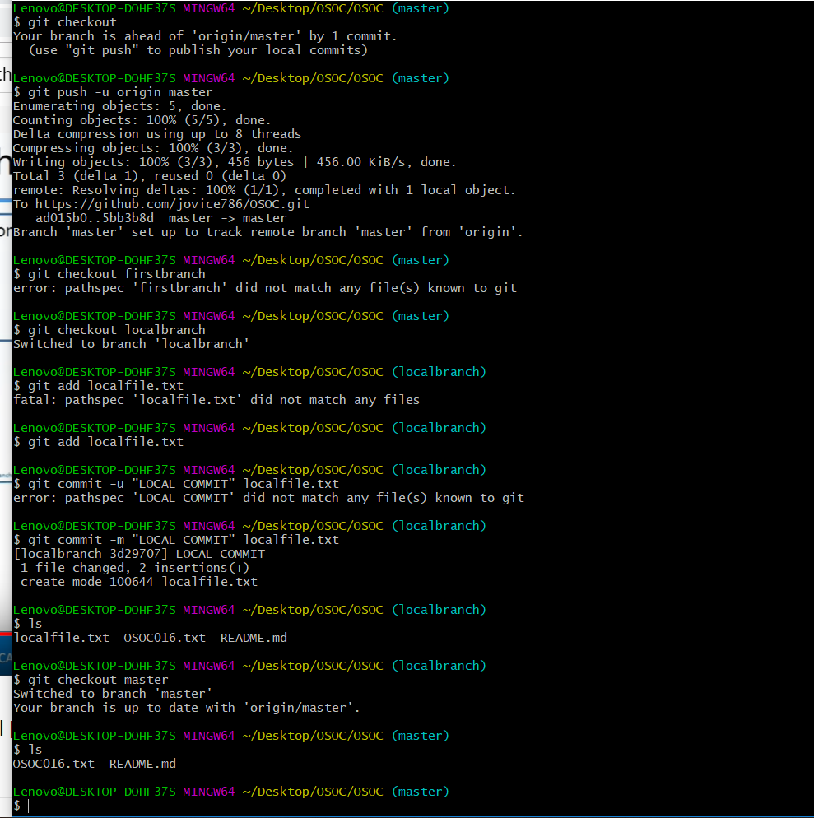

9.What is push,pull,commit??Explain with examples.

Ans: Commit: The git commit command captures a snapshot of the project's currently staged changes. Committed snapshots can be thought of as “safe” versions of a project—Git will never change them unless you explicitly ask it to. Prior to the execution of git commit, The git add command is used to promote or 'stage' changes to the project that will be stored in a commit

Push:The git push command is used to upload local repository content to a remote repository. Pushing is how you transfer commits from your local repository to a remote repo.

Pull:The git pull command is used to fetch and download content from a remote repository and immediately update the local repository to match that content.

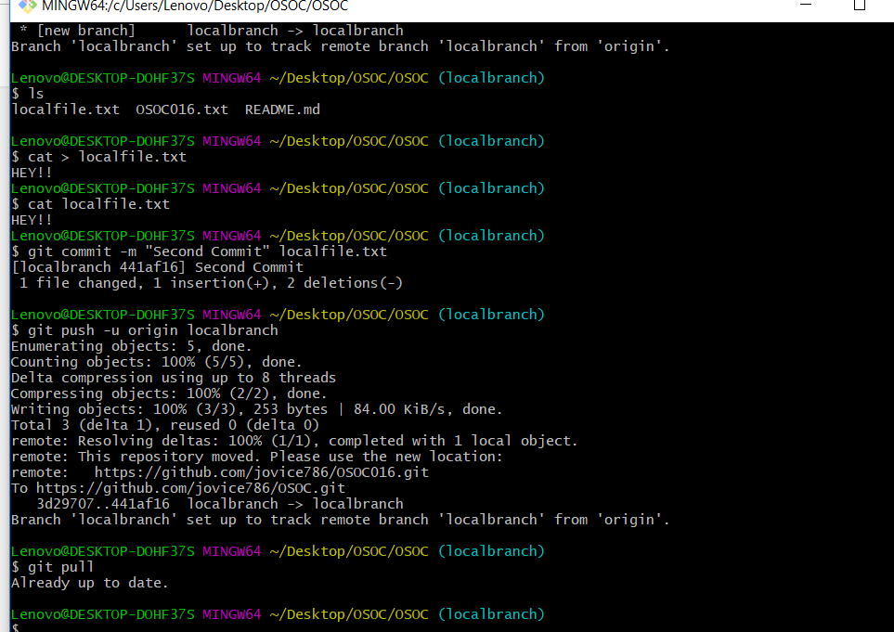

10.How we can restore a file after the commit with an example.

Ans: Step 1: git log

Step 2:git log filename to get the hash value of commit you want to revert

Step 3: git revert hash value.

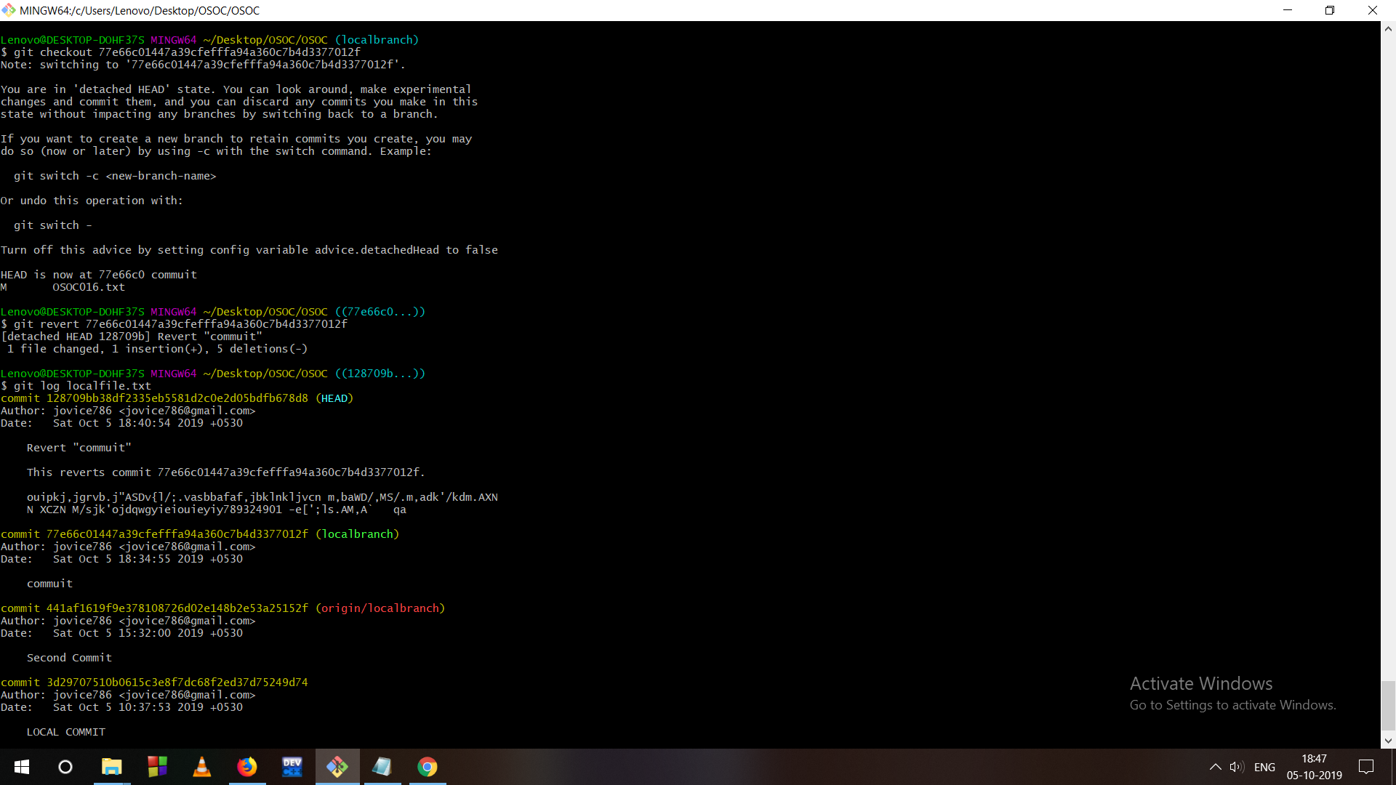

11. How to preview the changes before you have made before applying merging commands?

Ans:

13.What is git stash stack??how to write workingg on stash stack top???

Ans : stashing:git stash temporarily shelves (or stashes) changes you've made to your working copy so you can work on something else, and then come back and re-apply them later on. Stashing is handy if you need to quickly switch context and work on something else, but you're mid-way through a code change and aren't quite ready to commit.