Public single-cell datasets of human adipose tissue: control vs type 2 diabetes
Dataset selection, verification and quality control: progress report
Prepared by: [Your name] | For: [Line manager] | Date: 29 October 2026 | Project repository: Literature-Review-for-Control-Vs-Stressed-Adipose-Tissues (branch claude/sweet-feynman-1r4mhz)

1. Summary
The aim was to find a public single-cell dataset that meets four criteria: (1) human adipose tissue, (2) control vs type 2 diabetes (T2D), (3) more than 10,000 cells, and (4) endothelial cells. Two candidate datasets were checked in depth, one of them using real data processed in Google Colab.
Recommendation: use GSE268904 as the primary dataset. It is verified to have 131,641 nuclei from 14 people (human subcutaneous fat) and contains endothelial cells. Its T2D arm is small (3 people), so T2D comparisons are exploratory. GSE278526 (BioProject PRJNA1167724) is a useful second dataset with a balanced obese vs obese+T2D design (5 vs 5 pooled people), but its donors and cell counts are not yet verified.
Criterion | GSE268904 (verified on real data) | GSE278526 / PRJNA1167724 (not yet run on real data)
Human adipose tissue | Met: subcutaneous fat, 14 people | Met: omental and subcutaneous fat stromal cells
Control vs T2D | Partly: 3 obese diabetic vs 7 obese vs 4 lean | Met in design: obese without vs with T2D, 5 people each (pooled); no lean control
More than 10,000 cells | Met: 131,641 nuclei | Not verified (a third-party analysis reports 32,851 cells after QC)
Endothelial cells | Present; about 24,070 estimated (range 9,380 to 38,452 by rule); not formally annotated | Present per the authors; third-party annotation found 1,223; not verified

2. Objective and method
Dataset metadata were read from the NCBI GEO series and sample records and the BioProject page. Where the count data could be processed, this was done by R code run by the author in Google Colab, because the files (about 1 GB) exceed the upload limit of the assistant and several data hosts are blocked in its working environment. Numbers marked as estimates come from marker-gene rules, not from a laboratory or cluster-based cell-type annotation.

3. Candidate datasets considered
Accession | Design (from GEO) | Assessment
GSE268904 | Subcutaneous adipose, single-nucleus RNA-seq, 14 people: lean 4, obese 7, obese diabetic 3 (Aarhus University) | Best fit. Processed in full (Section 4).
GSE278526 (PRJNA1167724) | Omental and subcutaneous adipose stromal cells, single-cell RNA-seq, obese with and without T2D (10 people sequenced, 4 pooled libraries) | Second choice. Assessed (Section 5).
GSE342773 | Visceral adipose, 21 adults: lean 8, obese 5, obese+T2D 8, single-nucleus RNA-seq | Promising but unpublished; endothelial content and cell counts not verified.
GSE249089 (METSIM) | Subcutaneous adipose, 84 participants, single-nucleus RNA-seq | Large, but T2D labels per participant unverified and raw files withheld for privacy.

4. GSE268904: results on the real data

4.1 Dataset
Human deep subcutaneous fat from patients undergoing abdominal surgery (University Medical Center Göttingen). Nuclei were isolated and sequenced with 10x Genomics 3' v3.1. Type 2 diabetes was defined by a history of the disease plus antidiabetic medication. The study is published (PubMed 41040169, Nature Metabolism 2026) and reports a larger atlas of about 70,000 vascular cells from 65 people that also includes seven public datasets; only the 14 people above are in this GEO series.

4.2 Cell counts (verified)
Group | People | Nuclei | Estimated endothelial (specific rule) | Average % endothelial per person
Lean | 4 | 37,418 | 5,762 | 21%
Obese, no diabetes | 7 | 58,141 | 13,211 | 25%
Obese with T2D | 3 | 36,082 | 5,097 | 18%
All | 14 | 131,641 | 24,070 | 22%

- All 14 samples were read; every nucleus is accounted for (131,641 barcodes, none dropped). Five individual samples each exceed 10,000 nuclei. The more-than-10,000-cells criterion is met.
- Every nucleus has at least 500 detected RNA molecules; the median is 1,569 genes per nucleus.
- Sequencing depth is similar across groups (4.75 billion read pairs in total).

4.3 Endothelial cells (estimated)
Endothelial cells are not labelled in the raw data. They were estimated from marker genes. The count depends strongly on how strict the rule is:
Rule | Estimated endothelial nuclei
All of PECAM1, VWF and CLDN5 detected (strictest) | 9,380
At least 5 of 6 core markers | 14,829
At least 4 of 6 core markers | 27,679
At least 3 of 6 core markers (loosest) | 38,452
Specific rule used in the summary (at least 3 markers, blood-vessel signal is the top cell family and at least twice any other) | 24,070

The count is probably above 10,000 overall, but this is not established: the looser rules are inflated by stray RNA in the sample, and the strictest rule gives slightly under 10,000. The T2D arm alone has about 5,100 (specific rule) to 6,200 (at least 4 markers) endothelial nuclei from 3 people. Per-person endothelial share ranges widely (about 5% to 41%), so group averages should be treated with care.
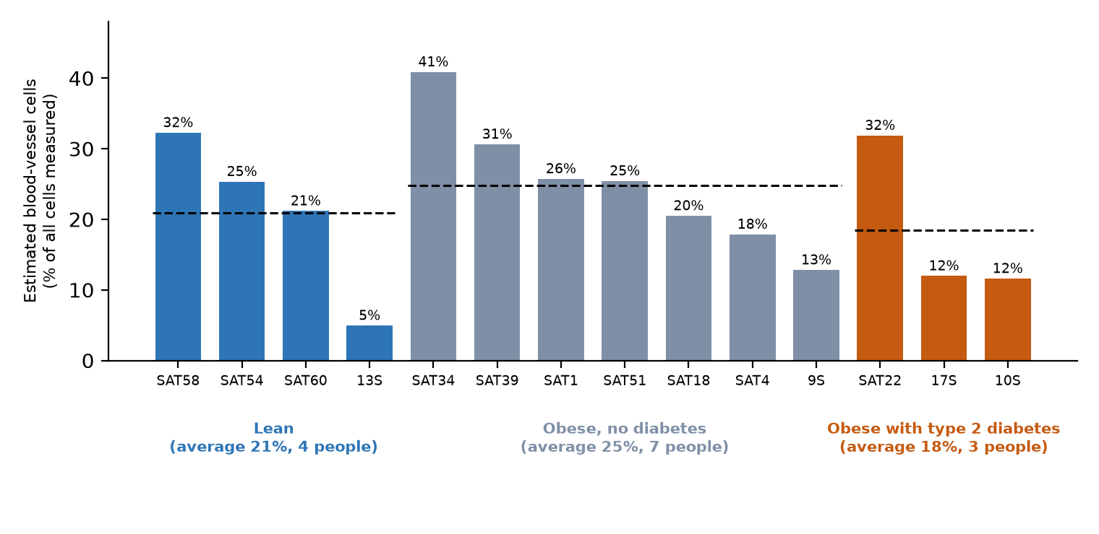
Figure 1. Estimated endothelial cells as a percentage of cells measured, by person (dashed line = group average).

5. GSE278526 / PRJNA1167724: assessment
This is the BioProject behind GSE278526. Fifty-eight people with obesity were recruited, with or without type 2 diabetes. Paired omental (visceral) and subcutaneous fat from 10 of them was sequenced as single cells, using only the stromal vascular fraction (the non-fat-storing cells: fibroblast-like cells, endothelial cells, pericytes and immune cells).
- Design: four libraries (omental or subcutaneous, each for obese without and obese with T2D). The five people in each group were pooled into one library, so people can only be separated if the separate cell-metadata file contains a donor label. This file has not been read.
- Positives: a balanced 5 vs 5 diabetes contrast; the authors report that omental endothelial cells show an inflammatory, lipid-overload profile in T2D.
- Concerns: no lean control; group is confounded with library; donors may not be identifiable; SNPs were removed from the alignment files, so people cannot be separated by genotype; instrument information in the record is inconsistent (NovaSeq 6000 vs NextSeq 500).
- Cell counts: not stated in GEO. A third-party re-analysis on GitHub (husseinkamal22/adipose-obesity-t2d-scrna) reports 43,887 barcodes before QC and 32,851 cells after, with 1,223 endothelial cells (51, 457, 474, 241 per library) and 24.7% of cells left unannotated. It is descriptive only (one library per group) and also states that the deposited metadata file labels tissue opposite to the GEO records. These claims were reviewed but could not be verified independently.
A processing script and Colab notebook were written for this dataset (Section 7). They have been tested on a synthetic copy of the archive but not yet run on the real files.

6. Limitations and risks
- Small T2D group in GSE268904: only 3 people. Any T2D comparison is exploratory and cannot support a claim of difference.
- Obesity vs diabetes is confounded: the obese and diabetic groups have BMI about 50, the lean group about 23. Differences may reflect body weight and not diabetes.
- Endothelial counts are marker-based estimates, not a formal cell-type annotation. The range across rules is wide (9,380 to 38,452).
- Cells are not independent people: the effective sample size is the number of donors (14 in GSE268904), not the number of cells. Statistical testing should be done at donor level (pseudobulk).
- GSE278526 is unverified: donor labels, cell counts and the tissue-label discrepancy have not been checked against the real files.
- Access: several data hosts (NCBI file server, PMC, bioRxiv) are blocked in the assistant's working environment, so data processing relied on Colab runs by the author.

7. Tools and outputs produced
All code is in the project repository. Scripts were written in R as requested.
Item | Purpose | Status
notebooks/GSE268904_colab_qc.ipynb; scripts/GSE268904_extract.R | Extract the archive, inventory files with checksums, compute per-nucleus QC, marker-based endothelial calls; write one consolidated CSV | Run on the real data; results in Section 4
GSE268904_barcodes_clean.csv and GSE268904_summary_clean.csv | Null-free tables: 131,641 rows x 51 columns (one per nucleus) and 18 summary rows x 31 columns | Produced from the real run
GSE268904_summary_for_readers.xlsx; GSE268904_one_page_summary.pdf | Plain-language workbook and a one-page chart summary for non-technical readers | Produced
notebooks/GSE278526_colab.ipynb; scripts/GSE278526_extract.R | Same approach for GSE278526, plus an automatic four-criteria check and a readable Excel summary | Tested on synthetic data only
docs/gse268904_verification.md; docs/gse278526_verification.md | Written criterion cross-checks with sources | Complete (counts updated)

8. Recommended next steps
- Run the GSE278526 notebook on the real archive and the metadata file; confirm donor labels, cell counts and the tissue-label discrepancy.
- Replace marker rules with a proper annotation for GSE268904: cluster the nuclei (Seurat section of the notebook) and name the clusters, to obtain a defensible endothelial count and to check the 10,000 target.
- Increase the number of T2D donors: evaluate the 65-donor atlas from the published study and GSE342773 (8 obese+T2D donors), once their data location and endothelial content are verified.
- Plan donor-level statistics: pseudobulk analysis per person with BMI, age, sex and batch as covariates, and report effect sizes with false discovery rate control.
- Request network access to the NCBI file server and related hosts for the assistant's environment if it should process data directly.

Appendix: key terms in plain language
Term | Meaning
Single-cell / single-nucleus RNA-seq | Measures which genes are active in each individual cell (or cell nucleus).
Barcode | A short DNA tag that marks one cell or nucleus; one barcode = one row in the data.
Features file / genes | The list of genes measured (36,601 in GSE268904).
Matrix file | The counts of every gene in every nucleus.
UMI | A molecule tag; total UMIs = how many RNA molecules were counted in a nucleus.
Endothelial cell | The thin cells lining the inside of blood vessels; they pass nutrients and insulin into tissue and form new vessels.
Pericyte | Support cells wrapped around small blood vessels that stabilise them and control blood flow.
Stromal vascular fraction | The non-fat-storing cells of adipose tissue: fibroblast-like, endothelial, pericyte, immune and progenitor cells.
Marker gene | A gene that is characteristically active in one cell type (for example PECAM1, VWF and CLDN5 in endothelial cells).
endo_specific | A strict yes/no call: at least 3 of 6 blood-vessel genes are active, and blood-vessel genes are the cell's strongest signal, at least twice any other cell family.
SRX / SRR / spots | SRA identifiers: SRX = one sequencing experiment, SRR = one run (the read file), spots = read pairs (not cells).
Pseudobulk | Adding up a person's cells so each person counts once in the statistics (avoids treating thousands of cells as independent).

