Lelis, Joverich A.

BSIT-1A1

I.

1. Router is a hardware device that allows you to connect **several computers** and **other devices** to a single Internet connection.
2. Wireless modern alternative to router.
3. Cloud are **convenience** and **reliability**
4. Cable service It uses a broadband connection and can be faster than both dial-up and DSL service.
5. Digital subscriber line connects to the Internet **via a phone line** but does not require you to have a landline at home.
6. Data connection/3G.4G.5G service is most commonly used with mobile phones, and it connects **wirelessly** through your ISP's network.
7. File Storage store all types of information in the cloud, including files and email.

8-9.Upload several photos to a cloud-based photo service like Flicker or iCloud Photos

10. Facebook an online **profile** and interact with your **friends**

II.

1. What are the types of Internet Service?
2. Dial
3. Digital subscriber line
4. Cable
5. Sattelite
6. 3G and 4G
7. Draw how to set-up a WiFi Network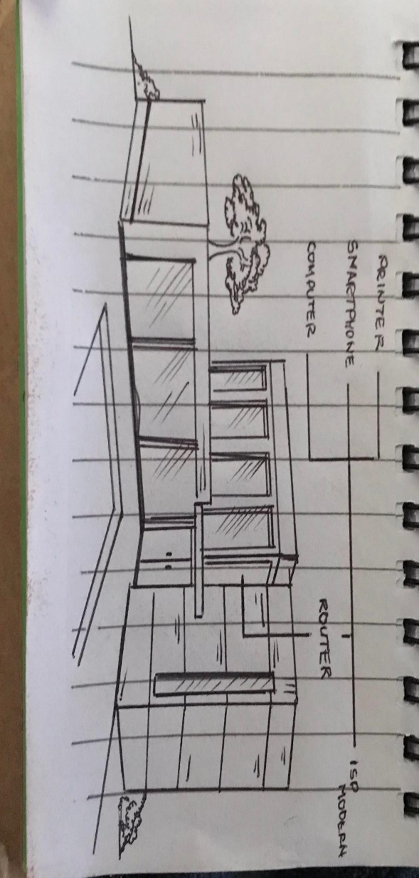
8. three example of cloud storage or web cloud storage.

1. Apple (iCloud)

2. Amazon (Amazon Web Services )

3. Google and Dropbox.