Lelis, Joverich A.

BSIT-1A1

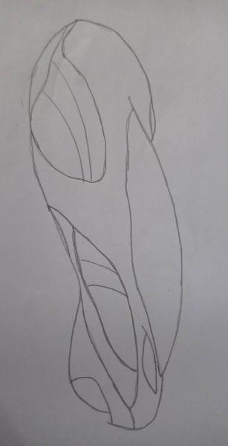

This is a Futuristic car, this is what I thought because I like to travel, but the capabilities of this futuristic car is that the energy it uses is electricity and it also has the ability to produce electricity because it is also solar. This futuristic car is an Artificial Intelligence programmed with the ability to communicate with its owner through voice speech or how it is programmed it is like a living car. This futuristic car is floating and it has no wheels because it only floats because it has control over the gravity it is placed on. So this futuristic car is not only available on land but also in the air. This car can also be driven without an owner because it can also be remotely controlled by the owner.