GRIEFYARD WORKS BUILT ENVIRONMENT HH-BP-2026-01

COMPANY ARCHITECTURE AND OPERATING BLUEPRINT
Honorary
Homes
The work becomes the way home.
CONSTRUCTION EDUCATION PROPERTY RECOVERY HOUSING ACCESS
HEADQUARTERS Vermont REGIONS Vermont, Maine, Baltimore EDITION September 2026

REGISTER OF CONTENTS
Contents
PART I | The Company | 00 The Blueprint in Brief
 |  | 01 Company Definition
 |  | 02 The New Category
 |  | 03 The Honorary Loop
 |  | 04 Enterprise Architecture
 |  | 05 Parent and Founder
PART II | Operations | 06 Regional Operating Model
 |  | 07 Honorary Build
 |  | 08 Vacant Bone
PART III | People and Skill | 09 Honorary Field School
 |  | 10 Earned Ground Apprenticeship System
 |  | 11 State Line Remote Entry
PART IV | Housing and Ownership | 12 Keyline, First Key, and Quiet Key
PART V | Institution | 13 Partnership System
 |  | 14 Business and Revenue Model
 |  | 15 Governance and Risk Boundaries
PART VI | Identity | 16 Brand System
 |  | 17 Core Company Copy
PART VII | Execution | 18 Launch Sequence and Measures
 |  | 19 Decisions Required
 |  | 20 Website Phase
 |  | A Implementation References

HOW TO READ THIS BLUEPRINT
Parts I and II define the company and its field operations. Parts III and IV set out the people and housing systems that make Honorary Homes a different kind of builder. Parts V through VII cover the institutional controls, the identity, and the order in which the company goes live.
Every operating claim in this document is written to match real capacity. Where a program, partner, or credential is pending, the text says so.

PART I
The Company
What Honorary Homes is, the category it creates, and the single operating model every division serves.
00 The Blueprint in Brief
01 Company Definition
02 The New Category
03 The Honorary Loop
04 Enterprise Architecture
05 Parent and Founder
SECTION 00 THE COMPANY

The Blueprint in Brief
Honorary Homes is the built-environment operating company of Griefyard Works. It builds, rehabilitates, and maintains homes and commercial property. It sells practical construction education. It employs and advances apprentices. It recovers distressed buildings and returns them to use. It opens governed routes to stable housing and, in time, ownership.
Each of these is a business line with its own customers, revenue, and standards. Together they form one operating system, and that system is the company's advantage. No competitor in its markets connects the classroom, the jobsite, the property, and the front door under one set of rules.
The work becomes the way home.
MASTER LINE
HONORARY HOMES IS  A construction company with commercial discipline and licensed leadership  A paid employer that builds skill through supervised field work  A developer that returns distressed buildings to productive use  A housing access operator under separate, protective governance | HONORARY HOMES IS NOT  A charity with a construction side program  A training business that sells promises of placement  A shelter, clinical service, or crisis program  A landlord that ties a person's housing to their job

Five Operating Principles
1 | REVENUE FIRST | Client construction funds crews, supervision, and equipment. The mission is carried by how the work is done, not by dependence on subsidy.
2 | SEPARATE DOORS | Employment, education, and housing each carry their own agreement. Leaving one never collapses a person's rights in another.
3 | CLAIMS FOLLOW CAPACITY | No partner, credential, placement, or housing outcome is published until it is real, signed, and authorized.
4 | SUPERVISION BEFORE PARTICIPATION | Apprentices join live work only when scope, safety planning, insurance, and qualified supervision permit it.
5 | DIGNITY WITHOUT DISCLOSURE | No one is required to share personal history in order to be hired, taught, or housed.
SECTION 01 THE COMPANY

Company Definition
Honorary Homes is a vertically integrated construction, education, property recovery, and housing access company headquartered in Vermont and operating through regional partnerships in Maine and Baltimore. The company serves residential and commercial clients, sells practical construction courses, develops paid apprenticeship pathways, restores distressed properties through its Vacant Bone division, and connects qualified participants to independent housing and homeownership pathways.
Griefyard Works is the parent company. Honorary Homes is its built-environment operating company: the place where systems thinking, workforce access, property redevelopment, and housing stability become physical work.
Honorary Homes connects the classroom, the jobsite, the property, and the front door.
COMPANY LEDGER
PARENT COMPANY | Griefyard Works
OPERATING COMPANY | Honorary Homes
HEADQUARTERS | Vermont
REGIONAL NETWORK | Vermont, Maine, and Baltimore
PRIMARY MARKETS | Residential construction, commercial construction, rehabilitation, adaptive reuse, education, workforce development, and housing pathways
SIGNATURE ASSET ARM | Vacant Bone, the distressed-property recovery division
SIGNATURE OPERATING LOOP | Learn, Earn, Build, Live, Own, Mentor
PUBLIC ENDORSEMENT | Honorary Homes, a Griefyard Works company
SECTION 02 THE COMPANY

The New Category
Honorary Homes does not present itself as a contractor with a charitable side program. Its advantage comes from running several functions as one disciplined system, where the output of each division is the input of the next.
FUNCTION | WHAT IT PRODUCES | WHAT IT FEEDS
Client construction | Revenue, field capacity, and a live jobsite | Paid work for crews and supervised hours for apprentices
Courses | Prepared entrants and education revenue | A qualified candidate pool for Earned Ground
Apprenticeships | Paid experience and documented skill | Crews for client work and Vacant Bone projects
Vacant Bone | Recovered properties and asset value | Housing inventory, rental income, and training sites
Keyline housing | Placement and relocation capacity | Stability that keeps workers in the trade
Ownership pathways | A credible route to a home | Graduates who return as mentors and leaders

The result is a company that earns commercial revenue, develops real assets, trains workers, and produces measurable housing outcomes without turning participants into marketing material. That combination is rare, and it is defensible because it is operationally difficult to copy.
POSITIONING TEST
If a client, a lender, and a state workforce agency each read the same description of Honorary Homes, each should recognize a serious counterpart. The company is written for all three at once.
SECTION 03 THE COMPANY

The Honorary Loop
The Honorary Loop is the central operating model. It gives every division a defined role and prevents the course, apprenticeship, construction, property, and housing programs from drifting into disconnected projects.
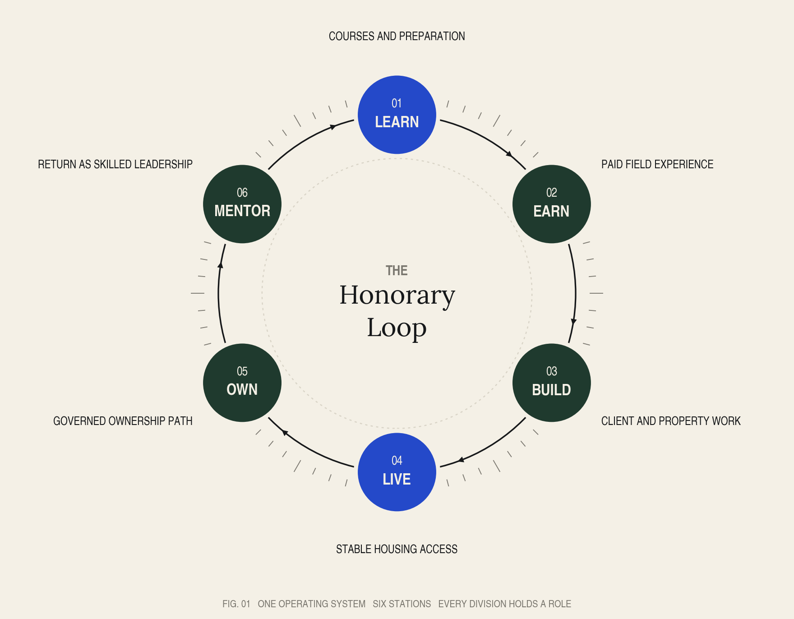
01 | LEARN | A participant begins with an entry course, a partner-college class, a work-readiness program, or a pre-apprenticeship module.
02 | EARN | Qualified participants enter paid employment or a registered apprenticeship pathway with supervision and progressive skill development.
03 | BUILD | Apprentices work on real residential, commercial, and Vacant Bone projects under licensed and experienced professionals.
04 | LIVE | Participants who need relocation or stability may access independent housing through the Keyline Housing Network, subject to availability and separate eligibility rules.
05 | OWN | Eligible apprentices and survivor participants may enter carefully governed homeownership pathways that use independent counseling and consumer protections.
06 | MENTOR | Experienced graduates return as journey workers, crew leaders, instructors, property operators, or employer partners.
SECTION 04 THE COMPANY

Enterprise Architecture
The public brand stays simple: Honorary Homes. Beneath it, named divisions give each audience a correct point of entry. A homeowner, a learner, an apprentice, a lender, and a housing participant should each find their door without passing through anyone else's.
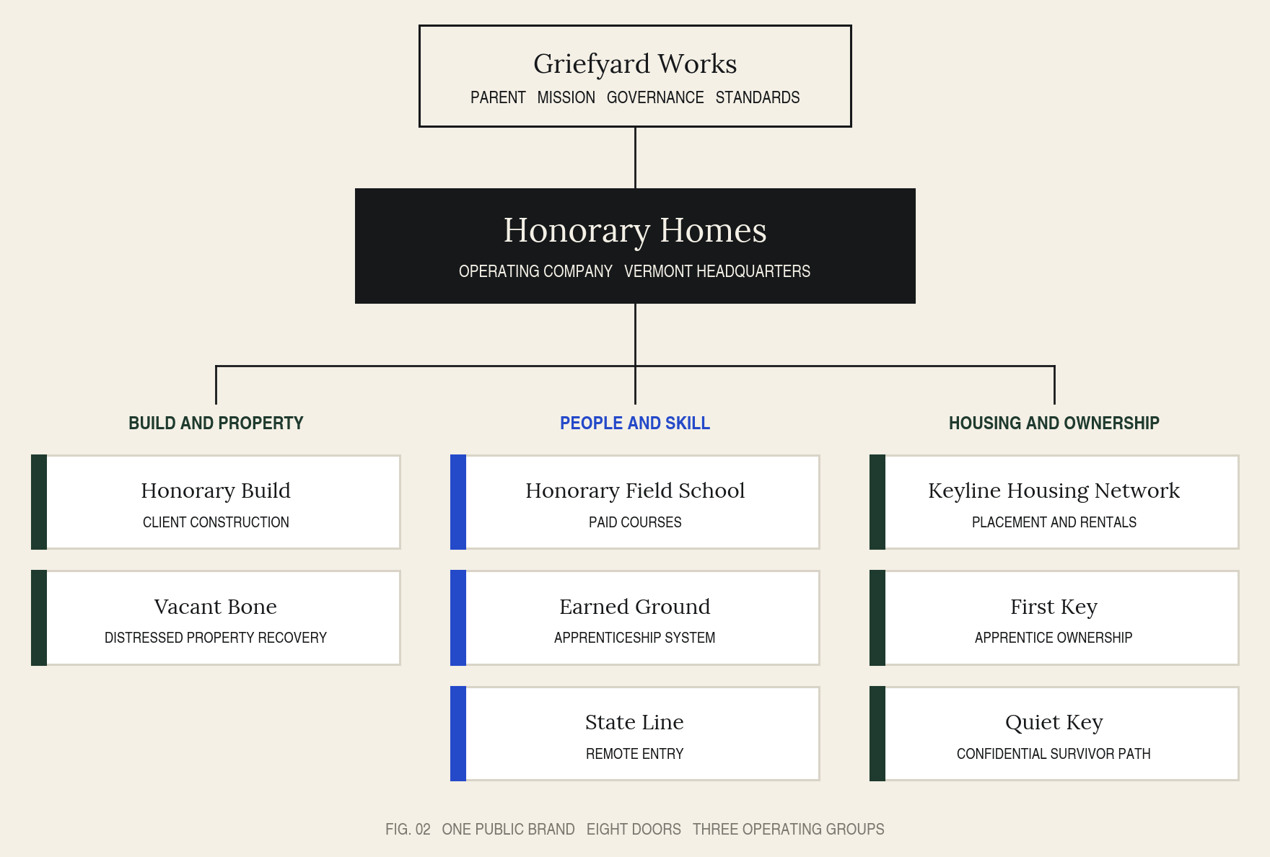
DIVISION | ROLE | PRIMARY CUSTOMER OR PARTICIPANT
Honorary Build | Residential and commercial construction, renovation, repair, maintenance, and owner services | Homeowners, businesses, developers, institutions, municipalities, and nonprofits
Vacant Bone | Acquisition, stabilization, rehabilitation, adaptive reuse, and return of distressed property to productive use | Property owners, investors, communities, housing partners, and hospitality operators
Honorary Field School | Paid courses, related technical instruction, employer training, and college-aligned learning | New entrants, career changers, students, employers, and partner institutions
Earned Ground | Pre-apprenticeship, registered apprenticeship, mentorship, and field progression | Apprentices and employer partners
State Line | Remote entry program linking out-of-state learners to coursework, local labs, employers, and relocation support | Learners outside the three core regions
Keyline Housing Network | Company-controlled and partner housing for placement, relocation, rentals, and ownership preparation | Eligible workers, apprentices, and referred participants
First Key | Apprentice homeownership pathway with separate housing and employment agreements | Qualified apprentices and graduates
Quiet Key | Confidential survivor housing and ownership pathway delivered with specialist partners | Eligible survivors of sexual assault and domestic violence
SECTION 05 THE COMPANY

Parent and Founder

Relationship to Griefyard Works
Griefyard Works provides the parent strategy, survivor-informed governance, institutional relationships, and systems perspective. Honorary Homes delivers construction, training, property development, and housing operations. Griefyard Works sets the standard; Honorary Homes carries it into the physical environment.
The connection appears as an endorsement, not a crowded co-brand. The approved form is: Honorary Homes, a Griefyard Works company.
GRIEFYARD WORKS HOLDS | Mission, brand standards, shared services, and survivor-informed accountability
HONORARY HOMES HOLDS | Construction, education, apprenticeship, property recovery, and housing operations
SHARED | Governance review, partner standards, and the language rules in Section 16

The Founder Standard
Founder history explains the company's standards. It does not become the product. Public language may state that a healthcare professional with lived experience of housing instability, violence, and institutional systems created Honorary Homes after seeing how strongly the built environment affects dignity, privacy, safety, and the ability to begin again.
DISCLOSURE RULE
Detailed trauma disclosure is never required from the founder, apprentices, employees, or housing participants. The company earns trust through the quality and terms of its work, not through personal testimony.

PART II
Operations
One operating standard across three regions, a client construction business, and a division built to recover what others abandon.
06 Regional Operating Model
07 Honorary Build
08 Vacant Bone
SECTION 06 OPERATIONS

Regional Operating Model
Honorary Homes applies one operating standard across three distinct regional contexts. Each hub requires local licensed supervision, employer relationships, education partners, housing partners, and a defined property pipeline. Specific institutions are named in public materials only after an agreement is signed.
REGION | OPERATING EMPHASIS | PARTNERSHIP PRIORITIES
Vermont headquarters | Residential rehabilitation, weatherization, rural housing, small commercial work, the apprenticeship pilot, and the first Vacant Bone portfolio | Vermont Department of Labor, technical centers, colleges, contractors, municipalities, and housing organizations
Maine field region | Residential and mixed-use rehabilitation, property preservation, hospitality and vacation-rental property work, and rural and small-city trade access | Maine Department of Labor, community colleges, contractors, housing providers, and property owners
Baltimore partnership hub | Urban residential and commercial rehabilitation, rowhouse and neighborhood property recovery, and youth and adult apprenticeship partnerships | Maryland Department of Labor, Baltimore colleges and schools, contractors, developers, and housing and community partners

REGIONAL CLAIM STANDARD
Baltimore is presented as a partnership hub, and as a company office only once staffing, licenses, insurance, housing agreements, and active project capacity are in place. The same threshold applies to any future state.
SECTION 07 OPERATIONS

Honorary Build
Honorary Build is the primary client-services division and the first face of the company. It gives Honorary Homes commercial credibility and produces the work volume required to employ crews, train apprentices, and sustain property development. Every other division depends on its reliability.
Built work for homes, commerce, and public life.

Residential Services
- Whole-home renovation and rehabilitation
- Kitchen, bathroom, flooring, finish, and exterior projects
- Weatherization, energy efficiency, and property preservation
- New residential construction and additions
- Rental turnover, maintenance, and owner representation
- Accessibility, privacy, sound control, and survivor-informed residential improvements

Commercial and Institutional Services
- Tenant improvements and small commercial buildouts
- Office, retail, hospitality, and community-space rehabilitation
- Multifamily and mixed-use renovation
- Facilities repair, maintenance, and capital improvement work
- Shelter, supportive-housing, nonprofit, and behavioral-health facility improvements
- Preconstruction planning and resident-informed facility review with licensed project partners

CLIENT PROTECTION
Apprentices participate in client work only when the scope, supervision, insurance, client agreement, and safety plan allow it. A client project is never an unsupervised training exercise.
SECTION 08 OPERATIONS

Vacant Bone
Vacant Bone is the distressed-property recovery division of Honorary Homes. It acquires, receives, or partners on vacant, neglected, tax-distressed, damaged, and underused buildings. It stabilizes the structure, designs an economically sound second use, and returns the property to occupancy.
A building can lose its use without losing its future.

Eligible Property Outcomes
OUTCOME | USE CASE | COMMERCIAL LOGIC
Primary home | Sale or lease to an owner-occupant or household | Restores housing supply and creates sale or rental revenue
First Key home | Lease-purchase or ownership preparation for an eligible apprentice | Creates a governed worker-to-owner pathway
Quiet Key home | Confidential survivor housing or ownership pathway through qualified partners | Creates protected access while keeping housing separate from employment
Long-term rental | Workforce, family, or general rental housing | Produces recurring income and preserves local occupancy
Vacation rental | Responsibly selected hospitality property | Produces operating revenue where local rules and community conditions support the use
Commercial reuse | Retail, office, studio, workshop, training, or community space | Returns an underused asset to economic activity
Partner disposition | Rehabilitated property transferred to a housing or community partner | Supports contracted, financed, or mission-aligned redevelopment

The Property Registry
Every Vacant Bone property carries a public project record once confidentiality and safety review is complete. The registry makes the work legible, gives lenders and partners a verifiable history, and prevents vague claims about impact.
VACANT BONE PROPERTY REGISTRY SPECIMEN RECORD
PROJECT CODE | HH-VB-VT-0001
ACQUISITION CONDITION | Vacant. Active water intrusion. Unsafe rear stair.
SCOPE | Structural stabilization, building envelope, mechanical systems, interiors.
APPRENTICE PARTICIPATION | Approved tasks and supervised hours only.
FINAL USE | Long-term residence.
STATUS | SECURED IN REHABILITATION OCCUPIED
MEASURED RESULT | Units returned, training hours logged, energy performance, occupancy date.

Operating Sequence
01 | RESOLVE | Confirm ownership, access, liens, code status, environmental questions, financing, and authority to act before any design or demolition.
02 | STABILIZE | Secure the building, stop active water or weather exposure, address urgent hazards, and document existing conditions.
03 | UNDERWRITE | Select a viable final use, develop the full scope, test the budget, and identify licensed work, permits, partners, and apprentice-safe tasks.
04 | REHABILITATE | Sequence professional construction and supervised learning so quality, schedule, and safety remain accountable.
05 | RETURN | Place the property into its approved use, publish the measured project record, and hold reserves for the next operating cycle.

PART III
People and Skill
A course business, a paid apprenticeship engine, and a distributed entry route for learners beyond the three regions.
09 Honorary Field School
10 Earned Ground Apprenticeship System
11 State Line Remote Entry
SECTION 09 PEOPLE AND SKILL

Honorary Field School
Honorary Field School is the education and course business. It sells practical learning to individuals, employers, colleges, housing organizations, and partner programs. Course revenue funds curriculum, instructors, learner equipment, and entry into field opportunities.
Learn the work before the work asks for you.
COURSE LEVEL | SAMPLE COURSES | RESULT
Entry | Construction Is a Language; Tools Without Guessing; Jobsite Readiness; Reading the Room and the Plan | Learner understands roles, hazards, tools, expectations, and trade pathways
Core skills | Measure and Layout; Wall Systems; Drywall and Finish; Paint as a System; Flooring Foundations; Property Turnover | Learner completes assessed practice in a partner lab or supervised setting
Property recovery | How Buildings Fail; Distressed Property Triage; Weather and Water; Scope Before Demo; Rehabilitation Sequencing | Learner can observe, document, and escalate building conditions
Commercial readiness | Commercial Site Conduct; Documentation and Change Orders; Quality Control; Working Around Occupied Spaces | Learner is prepared for structured employer and institutional environments
Leadership | Mentoring on a Live Site; Crew Communication; Estimating Basics; Client Boundaries; From Apprentice to Lead | Experienced worker is prepared for supervision and instruction

Course Commerce Model
- Individual course purchases for independent learners
- Cohort tuition for live or hybrid programs
- Employer licenses for crew training
- College and workforce contracts for customized curriculum
- Related technical instruction delivered under approved apprenticeship agreements
- Scholarship seats purchased by public, philanthropic, or employer partners
- Assessment and lab fees where hands-on verification is required

CREDENTIAL CLAIMS
A course is never marketed as a license, certification, apprenticeship, or job guarantee unless the issuing authority has approved that exact claim.
Online learning prepares a person for the field. It does not replace hands-on practice, site-specific safety training, licensed work, or supervised skill verification.
SECTION 10 PEOPLE AND SKILL

Earned Ground Apprenticeship System
Earned Ground is the workforce engine. It welcomes first-time workers, adult career changers, students, rural residents, people returning to work, survivors, veterans, and others who have been excluded from ordinary entry routes. Selection standards remain job-related, transparent, accessible, and consistent with equal employment requirements.
Paid skill built in the field.
A Registered Apprenticeship is paid employment that combines structured on-the-job learning, mentorship, related classroom instruction, progressive wages, and a recognized credential. Honorary Homes uses the term Registered Apprenticeship only after its program is approved, or when participants are enrolled through an approved sponsor. Until then, the company operates clearly labeled courses, lawful work-based learning, and pre-apprenticeship programs with direct-entry partner relationships. [1] [2] [3] [4]
STAGE | PARTICIPANT EXPERIENCE | COMPANY OBLIGATION
Explore | Orientation, trade sampling, career mapping, and review of barriers and supports | Accurate expectations and no promise of placement
Prepare | Coursework, safety foundations, tool familiarity, and basic assessments | Qualified instructors, accessible delivery, and documented results
Enter | Application, interview, work eligibility, and matching to a sponsor or employer | Fair selection and written employment terms
Earn | Paid work, progressive competencies, related instruction, and mentorship | Wages, supervision, safety, records, feedback, and reasonable accommodation
Advance | Higher-skill assignments, credential progress, and leadership preparation | Transparent progression and wage standards
Return | Mentor, instructor, crew lead, contractor, or partner employer role | Professional development and clearly defined authority

Apprentice Protections
- Paid employment for registered apprentices, with no relabeling of ordinary labor as unpaid training
- A named supervisor and a documented learning plan for every field placement
- Hazard training before hazardous work, and job-specific training beyond a general safety card [5]
- Written wage, progression, attendance, grievance, discipline, and completion standards
- Equal opportunity, reasonable accommodation, and confidential support pathways
- No requirement to disclose trauma, disability, housing instability, justice involvement, or personal history beyond lawful job and support questions
- Separate employment, education, and housing agreements, so leaving one program never automatically erases rights in another
SECTION 11 PEOPLE AND SKILL

State Line Remote Entry
State Line serves people who want to enter construction but live outside Vermont, Maine, or Baltimore. It combines online preparation with local hands-on verification, employer matching, and optional relocation support. It is a distributed entry system, not a remote substitute for trade practice.
01 | REMOTE FOUNDATION | Learners complete jobsite culture, safety foundations, trade vocabulary, math, tools, documentation, and career-selection coursework online.
02 | LOCAL VERIFICATION | A vetted contractor, technical school, community college, union, lab, or training partner verifies hands-on competencies.
03 | EMPLOYER BRIDGE | Honorary Homes or a regional partner interviews qualified participants for employment, pre-apprenticeship, or a registered sponsor opportunity.
04 | HOUSING BRIDGE | When relocation is required, Keyline may identify partner housing or company-controlled units. Availability and eligibility are confirmed independently of admission.
05 | REGIONAL HANDOFF | Learners stay with a local employer or relocate into a core region with clear wage, housing, and training terms.

STATE LINE CLAIM STANDARD
Public language never implies national job placement, guaranteed housing, transferable licensing, or college credit unless a written agreement covers the learner's state and program.

PART IV
Housing and Ownership
Housing that supports the work without depending on it, and ownership that is earned under rules a participant can trust.
12 Keyline, First Key, and Quiet Key
SECTION 12 HOUSING AND OWNERSHIP

Keyline, First Key, and Quiet Key

Keyline Housing Network
The Keyline Housing Network combines company-controlled units with independent housing partners. It supports temporary relocation, workforce housing, long-term rentals, and homeownership preparation. Housing remains a separately governed service, so an apprentice is never forced to keep a job to avoid immediate displacement.

First Key
A governed path from work to ownership.
First Key is the apprentice housing-to-ownership pathway. Eligible apprentices and graduates may rent a qualified Honorary Homes or partner property while completing financial preparation and working toward a conventional purchase.
The preferred model uses clear leases, independently documented purchase options or savings credits, third-party escrow where appropriate, independent legal review, and HUD-approved housing counseling. Contract-for-deed arrangements require heightened legal review, because federal consumer authorities identify serious risks when ownership, repairs, taxes, insurance, default, and accumulated payments are unclear. [7] [8]

Quiet Key
Confidential housing access with room to become permanent.
Quiet Key is a separate, confidential housing and homeownership pathway for people affected by sexual assault, domestic violence, dating violence, stalking, or trafficking. It is delivered with qualified survivor-service and housing partners. The program may offer flexible documentation, confidential communications, safety-aware property selection, rental access, homeownership counseling, and longer preparation timelines. [9]
SCOPE OF QUIET KEY
Quiet Key is not a shelter, a clinical service, or a crisis program. Advocacy and safety planning remain with qualified specialist partners.

Nonnegotiable Housing Safeguards
- Independent lease or purchase documents that do not depend on continued employment
- A clear purchase price or valuation method, with defined payment credits, repair duties, taxes, insurance, default rights, and refund treatment
- Independent legal review and access to a HUD-approved housing counselor before any purchase commitment [7]
- No automatic forfeiture of earned savings or purchase credits because a participant leaves employment
- Fair housing review across marketing, eligibility, screening, accommodations, and property assignment [6]
- Confidential survivor referrals, with no public identification of participant status or protected property locations
- A written grievance and appeal process handled outside the participant's direct employment chain
- Separate data systems for employment, education, and sensitive housing records

PART V
Institution
The partnerships, revenue lines, and controls that let the company scale without compromising its terms.
13 Partnership System
14 Business and Revenue Model
15 Governance and Risk Boundaries
SECTION 13 INSTITUTION

Partnership System
Honorary Homes enters partnerships with a defined exchange of value. A logo wall is not a partnership. Every relationship requires a written purpose, named owners, participant capacity, data boundaries, funding terms, and a review date.
PARTNER TYPE | HONORARY HOMES PROVIDES | THE PARTNER PROVIDES
State workforce agency | Employer demand, occupation design, placements, and performance data | Registration guidance, candidate pipeline, grants, workforce funding, and compliance support
College or technical school | Live project context, employer input, instructors, and work experience | Related instruction, labs, credit review, faculty, and learner support
Contractor or trade employer | Prepared candidates, shared standards, curriculum, and a project pipeline | W-2 employment, journey-level supervision, wages, and field progression
Housing organization | Rehabilitation capacity, property pipeline, maintenance, and participant coordination | Units, referrals, counseling, subsidies, tenant support, and compliance
Municipality or land bank | Property assessment, redevelopment plans, and workforce outcomes | Property access, approvals, local coordination, and eligible incentives
Survivor-service partner | Construction and housing capacity within strict boundaries | Confidential referral, advocacy, safety planning, and survivor-centered policy review
Lender or CDFI | A qualified property and participant pipeline with rehabilitation documentation | Acquisition, construction, mortgage, matched-savings, or small-business capital

INSTITUTIONAL CLAIM STANDARD
The company may say it is building or seeking partnerships in Vermont, Maine, and Baltimore. It may say it works with state, college, housing, or employer partners only when at least one relevant agreement is active.
Named logos, endorsements, credentials, college credit, guaranteed interviews, funding, and placement outcomes require written authorization.
SECTION 14 INSTITUTION

Business and Revenue Model
The company becomes durable when no single program carries the entire mission. Construction creates operating cash flow. Courses create scalable education revenue. Vacant Bone creates property value and recurring assets. Partner contracts fund cohorts and supportive services. Housing produces rent, sale proceeds, or development fees under separate governance.
REVENUE LINE | PAYER | USE WITHIN THE SYSTEM
Residential and commercial construction | Private, institutional, public, and nonprofit clients | Core payroll, supervision, equipment, overhead, and field capacity
Property rehabilitation and development | Property owners, buyers, investors, lenders, and public partners | Acquisition, construction, sale, lease, and portfolio growth
Course sales | Individuals, employers, colleges, and workforce partners | Curriculum, instructors, platform, equipment, and learner preparation
Apprenticeship and training contracts | Employers, workforce agencies, and education partners | Mentors, related instruction, records, and supportive services
Rental and hospitality operations | Tenants and guests | Property operations, reserves, debt service, and future rehabilitation
Maintenance and facilities contracts | Owners, institutions, and housing partners | Recurring revenue and graduate employment
Eligible grants and incentives | Public and philanthropic sources | Program development, equipment, access supports, and evaluation

TWO DISCIPLINES
Grants accelerate, they do not subsidize. Grant funding expands access and infrastructure. It never conceals an unprofitable core business.
Hospitality follows a use test. Vacation-rental development follows local law, housing-market conditions, and a documented property-use test, so it never undermines the company's housing purpose.
SECTION 15 INSTITUTION

Governance and Risk Boundaries
The following structure is recommended for review by construction, employment, housing, tax, education, and consumer-finance counsel in each operating state.
FUNCTION | RECOMMENDED CONTROL
Parent governance | Griefyard Works owns the mission, brand standards, shared services, and survivor-informed accountability
Construction operations | Honorary Homes uses properly licensed, insured, and locally qualified construction leadership
Individual properties | Separate project entities are used where counsel recommends them, to isolate property, lending, and operating risk
Apprenticeship | Honorary Homes registers as a sponsor, or partners formally with approved sponsors, in each state
Education | Clear terms, refunds, outcomes, instructor qualifications, and credential claims for every paid course
Housing | Separate screening, leases, counseling, records, grievance process, and legal review
Survivor pathway | Confidential specialist referrals, with advocacy and safety planning held by qualified partners
Data | Public marketing data kept separate from employment, education, housing, and survivor-related records

Nonclinical Boundary
WHAT HONORARY HOMES DOES NOT PROVIDE
Honorary Homes provides construction, education, employment, property development, and housing pathways. It does not provide therapy, crisis response, victim advocacy, safety planning, legal advice, mortgage counseling, or emergency shelter. Qualified partners retain those responsibilities.

PART VI
Identity
An unfamiliar institution with practical authority: part construction ledger, part field school, part property archive.
16 Brand System
17 Core Company Copy
SECTION 16 IDENTITY

Brand System
The brand reads as an institution with practical authority: part construction ledger, part field school, part property archive. It must not resemble a charity campaign, a generic contractor, a rustic Vermont builder, or a technology startup.

Master Language
MASTER LINE | THE WORK BECOMES THE WAY HOME
COMPANY DESCRIPTOR | Construction. Education. Property Recovery. Housing Access.
PARENT ENDORSEMENT | A Griefyard Works Company
HONORARY BUILD | Built work for homes, commerce, and public life
VACANT BONE | Distressed property returned to use
FIELD SCHOOL | Learn the work before the work asks for you
EARNED GROUND | Paid skill built in the field
FIRST KEY | A governed path from work to ownership
QUIET KEY | Confidential housing access with room to become permanent

Palette
#F4F0E6 | #16181A | #1F3A2E | #D9D4C7 | #2449C9
Bone paper  GROUND AND PAPER | Registry black  TYPE AND RECORDS | Vermont pine  AUTHORITY AND STRUCTURE | Weathered limestone  RULES AND FIELDS | Survey cobalt  SINGLE DIGITAL ACCENT

Visual Direction
SYSTEM | DIRECTION
Typography | A condensed technical sans for records and navigation, paired with a serious serif for statements and long reading
Graphic language | Survey marks, property IDs, deed fields, inspection notes, material labels, measurements, and restoration status
Photography | Real weather, real job sites, real material wear, honest light, and people shown as skilled participants rather than recipients
Motion | Slow registry reveals, plan layers, measured before-and-after transitions, and progress states rather than glossy construction animation
Logo behavior | A restrained Honorary Homes wordmark with the Griefyard Works endorsement. No roofline, hammer, hard hat, heart, or key icon.

Language Rules
- Describe work, terms, and outcomes precisely. Avoid savior language and motivational slogans that replace information.
- Never describe apprentices, survivors, renters, or former residents of distressed properties as broken, rescued, or given a second chance.
- Never use founder trauma as proof that the company can guarantee safety or understand every survivor.
- Present apprentices as employees and developing professionals. Present learners as customers and participants with agency.
- Use before-and-after property content to document construction, never to expose former residents or ridicule a neighborhood.
- Label pilot, proposed, pending, registered, accredited, partnered, and guaranteed claims accurately.
SECTION 17 IDENTITY

Core Company Copy
Approved copy for proposals, partner packets, the website, and press. Each block may be used as written.
PRIMARY COMPANY DESCRIPTION
APPROVED TEXT
Honorary Homes is a Vermont-based construction, education, property recovery, and housing access company operating through regional partnerships in Maine and Baltimore. We build and rehabilitate homes, commercial spaces, rental properties, hospitality projects, and community facilities. Through Honorary Field School and Earned Ground, we sell practical courses and create supervised pathways into the construction trades. Vacant Bone, our distressed-property division, returns neglected buildings to useful life as homes, rentals, places of business, and carefully selected hospitality properties. Honorary Homes is a Griefyard Works company.

FOUNDER DESCRIPTION
APPROVED TEXT
Honorary Homes was founded by a healthcare professional whose lived experience revealed how deeply buildings, housing systems, and institutional decisions shape a person's stability. That background informs the company's standards for dignity, privacy, control, and practical access. The company turns those standards into construction work, trade education, property redevelopment, and housing pathways, without making anyone's history a requirement for participation.

VACANT BONE DESCRIPTION
APPROVED TEXT
Vacant Bone is the distressed-property recovery division of Honorary Homes. We acquire or partner on vacant, damaged, neglected, and underused buildings, stabilize them, and design a viable return to occupancy. Each property is assigned a registry record that tracks its condition, scope, final use, training participation, and measured result.

APPRENTICESHIP DESCRIPTION
APPROVED TEXT
Earned Ground connects instruction to paid field experience. Apprentices learn alongside qualified professionals, complete structured on-the-job learning, receive mentorship, and progress through documented competencies. Honorary Homes operates through registered programs or approved sponsor partnerships wherever it uses the Registered Apprenticeship designation.

PARTNER DESCRIPTION
APPROVED TEXT
Honorary Homes works with public agencies, colleges, technical schools, contractors, developers, municipalities, housing organizations, lenders, and survivor-service partners to connect construction demand with education, employment, property recovery, and housing access. Every partnership defines the work, capacity, participant protections, data boundaries, and expected results in writing.

PART VII
Execution
The order in which the company goes live, the measures that prove it works, and the decisions that must be made first.
18 Launch Sequence and Measures
19 Decisions Required
20 Website Phase
A Implementation References
SECTION 18 EXECUTION

Launch Sequence and Measures
The company launches in controlled layers. The brand may describe the complete system from the first day, while every operating claim remains tied to actual capacity. No stage opens until the proof required by the stage before it is in hand.
STAGE | OPERATING PRIORITY | PROOF REQUIRED BEFORE EXPANSION
One | Vermont company setup, licensed construction leadership, first paid courses, and initial employer and education agreements | Insurance, contracts, course terms, a safety system, and qualified supervision
Two | Honorary Build client work and the first Earned Ground cohort | Reliable project delivery, wages, training records, mentor capacity, and apprentice protections
Three | First Vacant Bone property and Keyline housing agreements | Property underwriting, financing, legal entities, housing policy, and partner capacity
Four | Maine and Baltimore regional delivery | Local licenses, staffing, signed partners, active projects, housing options, and a state apprenticeship path
Five | First Key and Quiet Key pilots | Independent counseling, consumer-finance and fair housing review, property inventory, and a grievance system
Six | State Line expansion and multi-state course licensing | A local verification network, employer partners, clear state-by-state claims, and data controls

Measures That Matter
AREA | CORE MEASURES
Construction | On-time delivery, safety record, quality callbacks, gross margin, and repeat clients
Learning | Enrollment, completion, lab verification, cost per learner, and course-to-field conversion
Apprenticeship | Paid placements, retention, wage progression, competencies, and credential completion
Properties | Buildings stabilized, units returned, final uses, development cost, and occupancy
Housing | Placements, housing retention, counseling completion, ownership conversions, and grievances resolved
Partnerships | Active agreements, funded seats, employer capacity, college alignment, and partner renewal
SECTION 19 EXECUTION

Decisions Required
The following decisions must be settled before website design begins. Each is recorded as open until the founder confirms it in writing.
NO. | DECISION | WHAT MUST BE SETTLED | INPUT FROM | STATUS
01 | Legal name | Confirm the legal name, and whether Honorary Homes will carry a broader legal descriptor such as Construction Development and Trades Institute. | Counsel | OPEN
02 | Partnership status | Confirm which Vermont, Maine, and Baltimore partnerships are signed, pending, or targets. | Founder | OPEN
03 | Apprenticeship route | Decide whether Honorary Homes will sponsor a Registered Apprenticeship or partner with existing sponsors in each region. | State labor departments | OPEN
04 | First courses | Select the first three paid courses and identify instructors and hands-on verification partners. | Founder | OPEN
05 | Vacant Bone profile | Define the first property profile and acquisition criteria. | Founder and lender | OPEN
06 | First Key model | Choose the financial model only after housing and consumer-finance counsel review. | Counsel | OPEN
07 | Quiet Key partners | Identify survivor-service and HUD-approved housing counseling partners. | Founder | OPEN
08 | Application access | Define which applications are public and which use private referral or invitation workflows. | Founder | OPEN
SECTION 20 EXECUTION

Website Phase
The website is designed only after this company architecture is approved. Its first job is to separate the five primary audiences so each reaches the correct door at once.
AUDIENCE | ENTRY | PRIMARY ACTION
Construction clients | Honorary Build | Request a project consultation
Property partners | Vacant Bone | Submit a property or partnership inquiry
Learners | Honorary Field School and State Line | Purchase or enroll in a course
Apprenticeship candidates | Earned Ground | Apply for an open cohort
Institutional partners | Partnerships | Request a partnership conversation

Housing pathways require a quieter, privacy-aware entry that does not sit in primary navigation. The site should make the company feel singular while keeping every application, course sale, project inquiry, and partnership claim operationally accurate.
The website phase follows the accepted Webflow direction and develops the visual system, page architecture, conversion flows, course commerce, application logic, regional content, the Vacant Bone property registry, and private operational handoffs as a separate deliverable.
SECTION A APPENDIX

Implementation References
These public references informed the program safeguards in this blueprint. Requirements, funding, and agency procedures must be rechecked in each state before launch.
[1] | Registered Apprenticeship Program  APPRENTICESHIP.GOV  Defines paid work, mentorship, progressive wages, instruction, and a recognized credential.  https://www.apprenticeship.gov/employers/registered-apprenticeship-program
[2] | Vermont Registered Apprenticeship  VERMONT DEPARTMENT OF LABOR  State program and sponsor development resources.  https://labor.vermont.gov/workforce-development/apprenticeship
[3] | Maine Apprenticeship Program  MAINE DEPARTMENT OF LABOR  State apprenticeship and employer resources.  https://www.maine.gov/labor/apprenticeship/
[4] | Office of Apprenticeship  MARYLAND DEPARTMENT OF LABOR  Registered and youth apprenticeship resources for Maryland employers and participants.  https://labor.maryland.gov/employment/appr/
[5] | Training  OCCUPATIONAL SAFETY AND HEALTH ADMINISTRATION  Employer responsibility for hazard and job-specific safety training.  https://www.osha.gov/training
[6] | Housing Discrimination Under the Fair Housing Act  U.S. DEPARTMENT OF HOUSING AND URBAN DEVELOPMENT  Federal fair housing overview for renting, buying, mortgages, and housing services.  https://www.hud.gov/helping-americans/fair-housing-act-overview
[7] | Housing Counseling  U.S. DEPARTMENT OF HOUSING AND URBAN DEVELOPMENT  HUD participating housing counseling and homeownership support.  https://www.hud.gov/stat/sfh/housing-counseling
[8] | What Is a Contract for Deed  CONSUMER FINANCIAL PROTECTION BUREAU  Consumer risks and federal protection considerations for seller-financed home purchases.  https://www.consumerfinance.gov/ask-cfpb/what-is-a-contract-for-deed-en-2149/
[9] | Your Rights Under the Violence Against Women Act  U.S. DEPARTMENT OF HOUSING AND URBAN DEVELOPMENT  Housing protections for survivors in covered programs.  https://www.hud.gov/hud-partners/fair-housing-vawa

THE WORK BECOMES THE WAY HOME
Honorary Homes, a Griefyard Works company

