Q1. What kind of variable is single_trial? (vector, string, etc.)

vector

Q2. How big is it?

1x41

Q3. Cut and paste the labelled raster plot into your Word document.

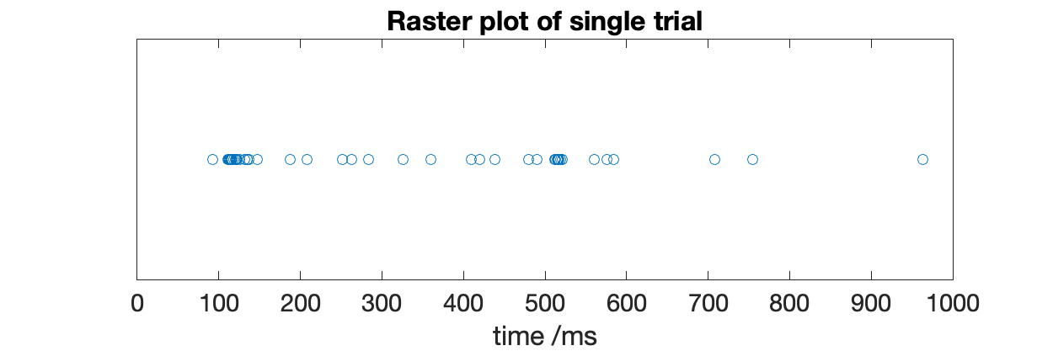

Q4. Cut and paste the labelled histogram into your Word document.

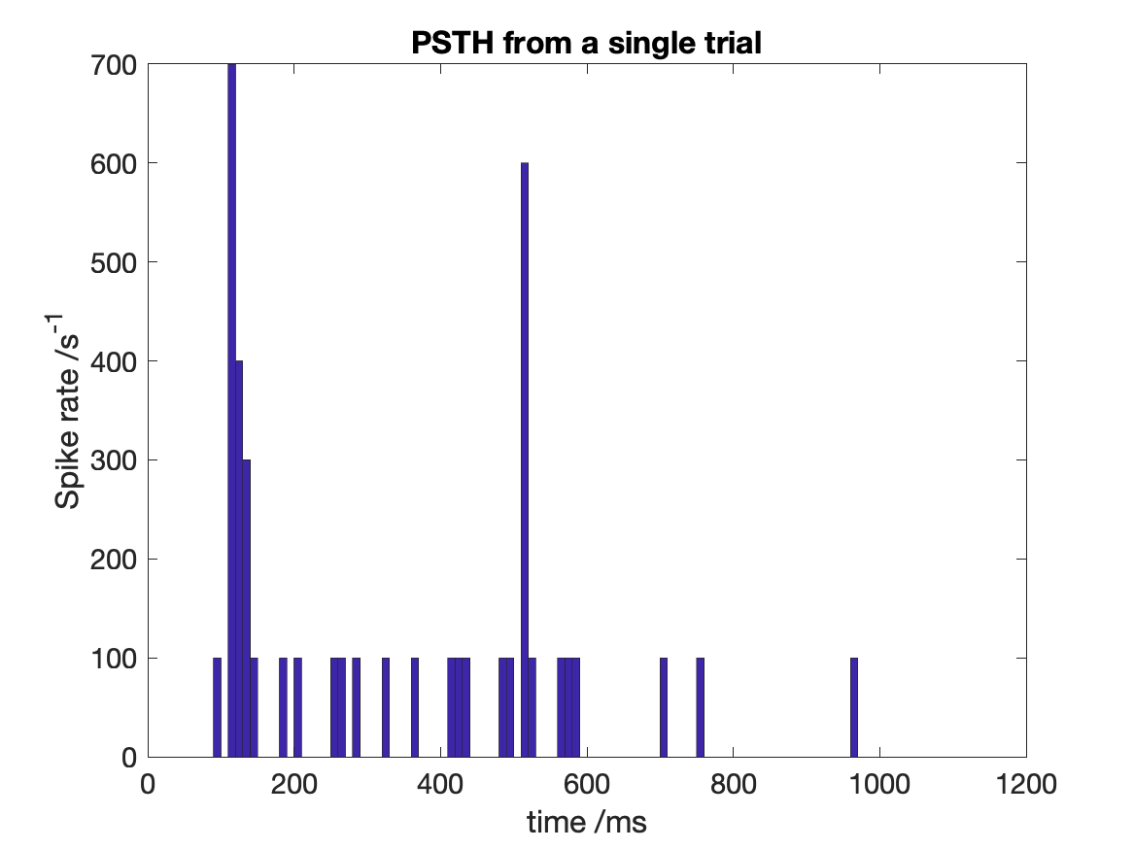

Q5. Knowing that the stimulus onset was at 100ms, what was the response latency of the neuron, i.e. the time that the first peak in spiking occurred?

???

Q6. What was the maximum response rate of the neuron, in spikes/second?

700

Q7. Paste the figure into your Word document.

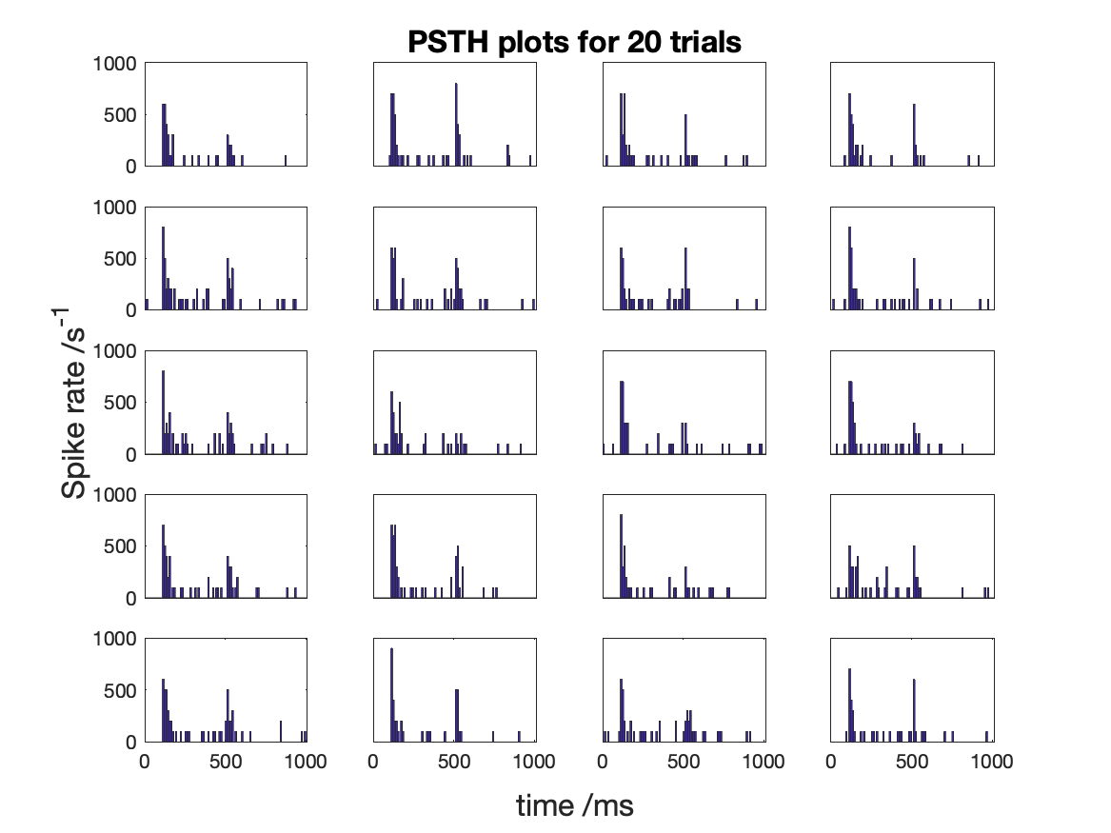

Q8. Paste the figure into your Word document. What does each graph represent now?

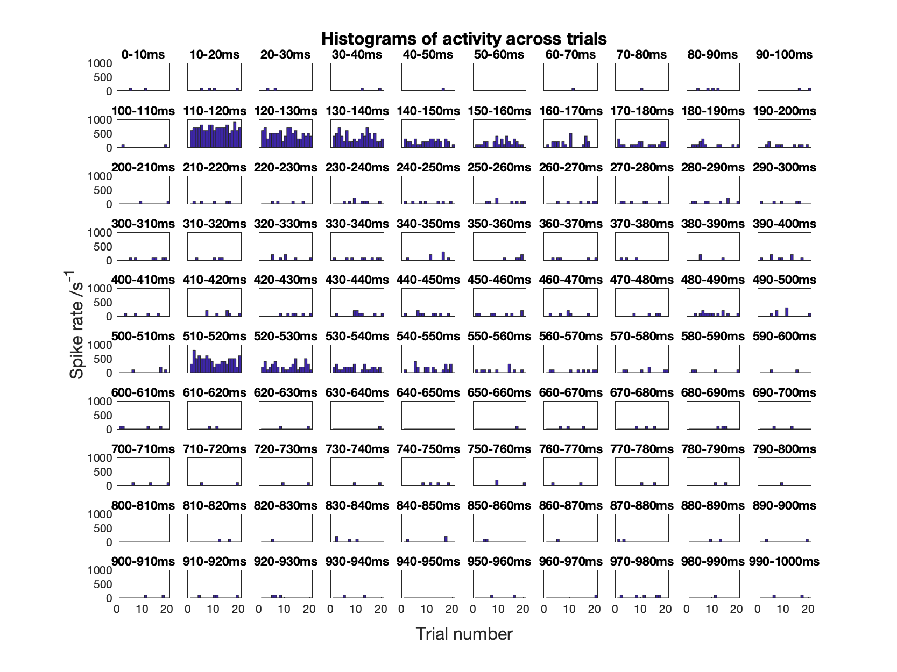
Firing activity across trials at a particular timepoint/time-bin

Q9. Label your axes, give your figure a title and paste it into your Word document.

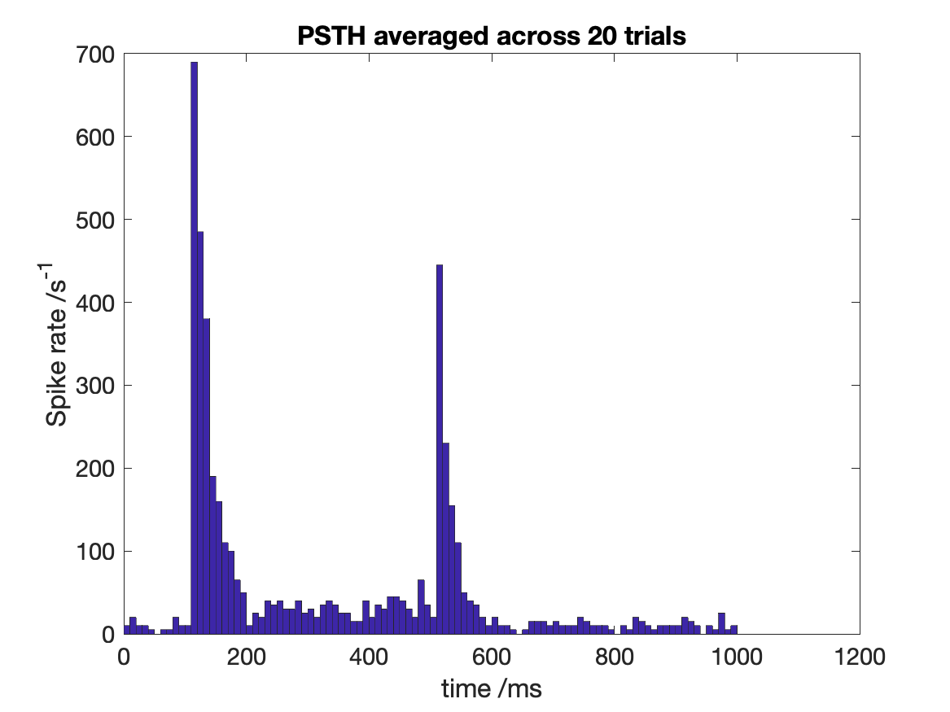

Q10. Label your axes, give your figure a title and paste it into your Word document.

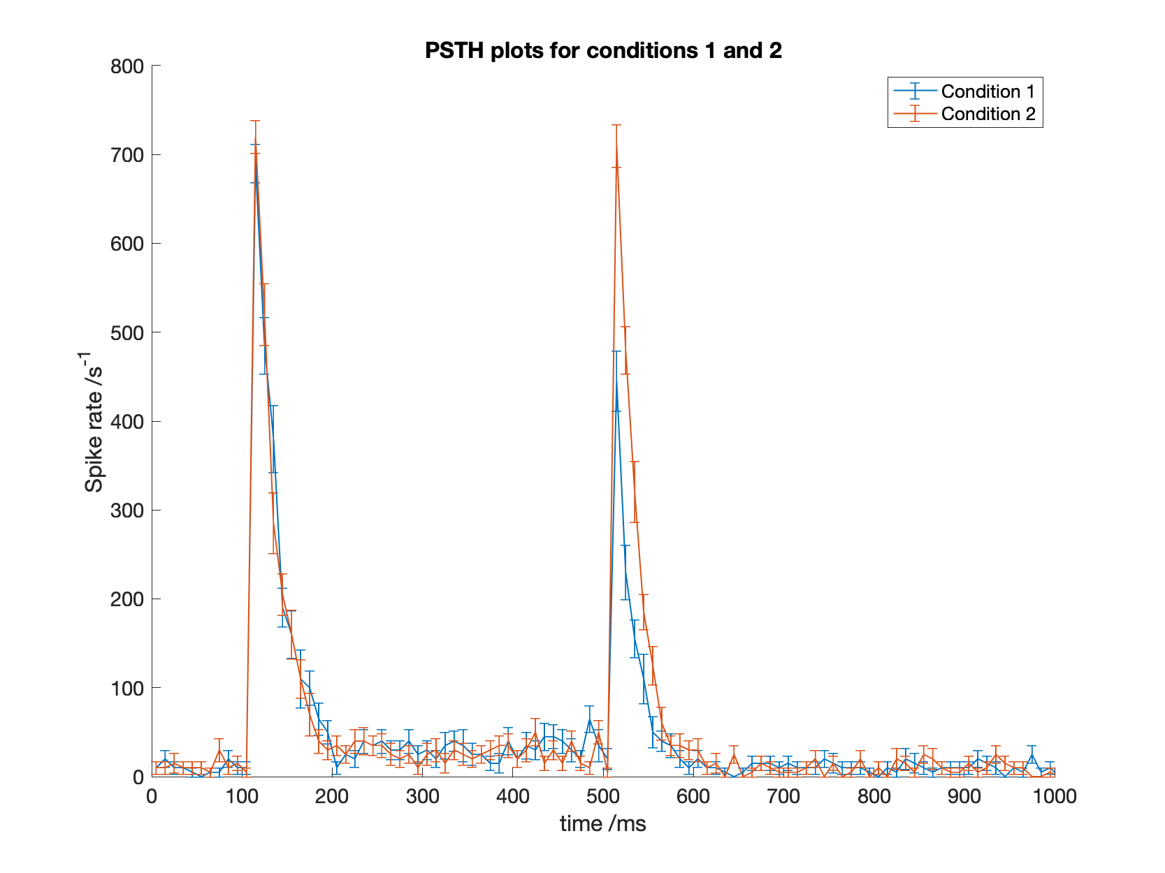

Q11. Are the responses of the neuron different in the two conditions? At what time are the responses most different?

3. To confirm the above, you can do a t-test. Set a variable equal to the column of condition1 that corresponds to the time where the responses are most different. Do the same for condition2. Now use ttest2() to perform a t-test on these data with a significance level of 0.01.

Q12. Are the responses significantly different at P<0.01? What about P<0.001?

Q13. Label your axes, give your figure a title and paste it into your Word document.

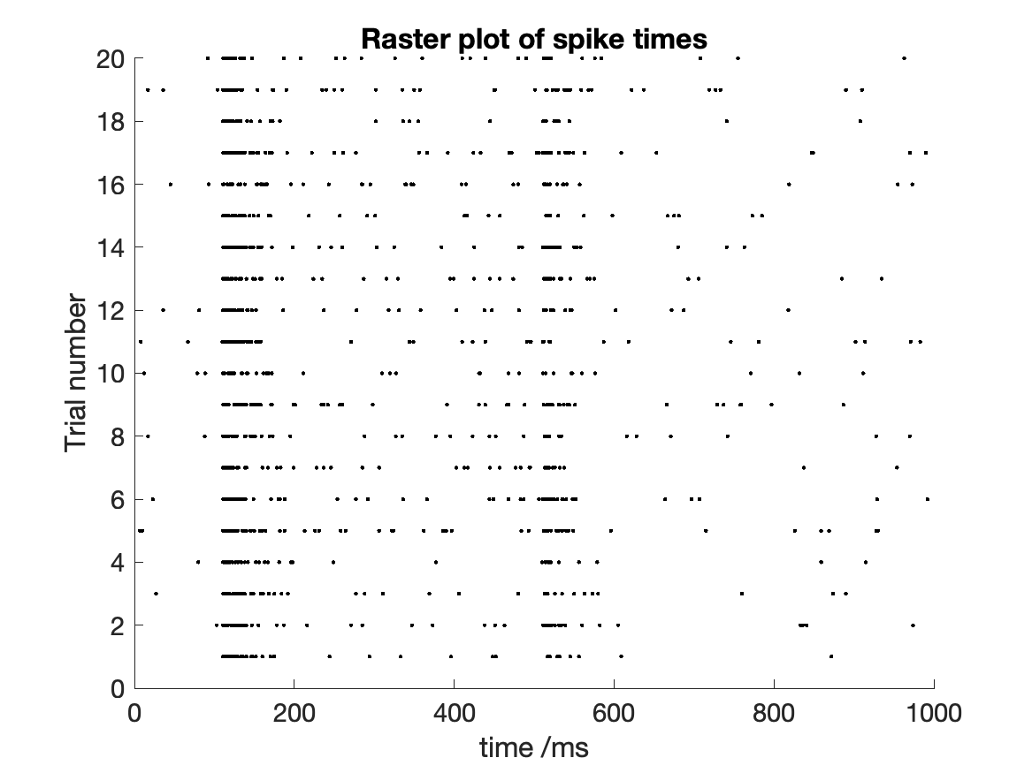

Q14. Label your axes, give your figure a title and paste it into your Word document.

