Name: Nava, Gweaneth Charm Lavee D. Block:22-ITE-03 Date: April 24, 2026

MongoDB
Async Flow Exercise

Lab Instructions:

Step 1: Understanding Synchronous Execution
Subtask 1.1: Write Basic Sync Code Description: Write simple console.log statements.
Example:
console.log("A");
console.log("B");
console.log("C");

CODE & OUTPUT:
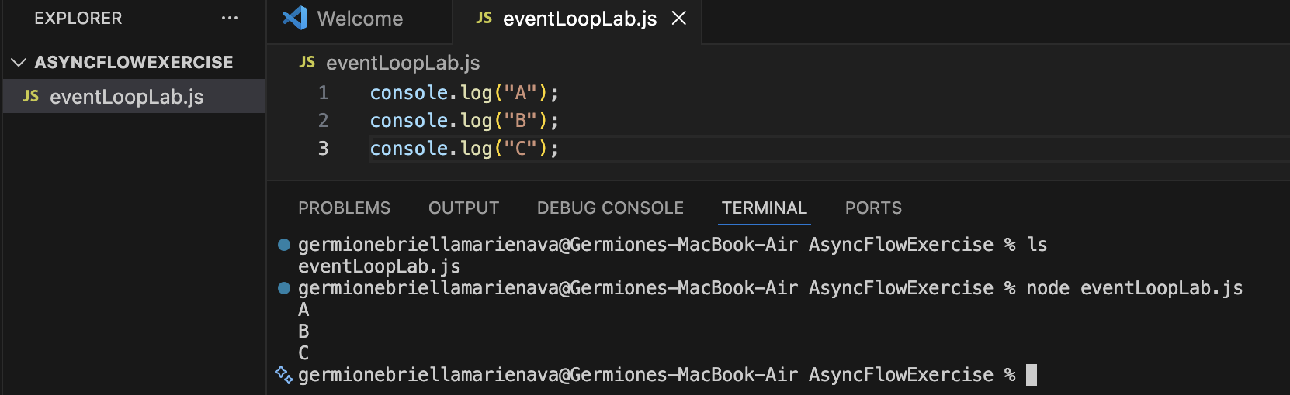

Step 2: Introduction to setTimeout (Macrotask)
Subtask 2.1: Basic setTimeout Example Description: Add setTimeout with 0ms delay.
Example:
console.log("Start");
setTimeout(() => { console.log("Timeout"); }, 0);
console.log("End");

CODE & OUTPUT:
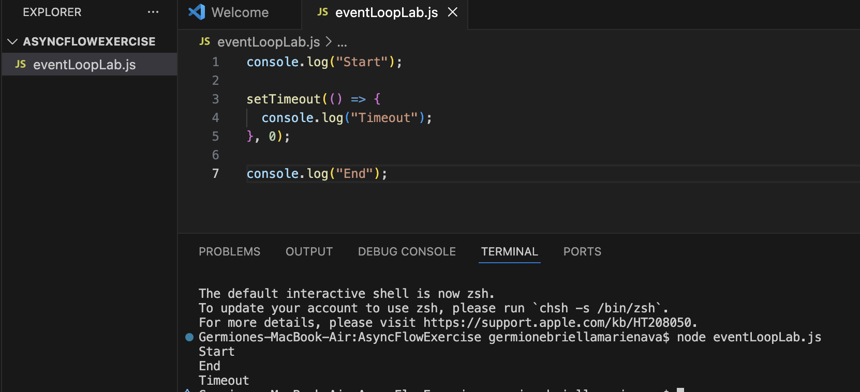
Step 3: Introduction to Promises (Microtask)
Subtask 3.1: Basic Promise Example Description: Use Promise.resolve() with .then()
Example:
console.log("Start");
Promise.resolve().then(() => { console.log("Promise"); });
console.log("End");

CODE & OUTPUT:
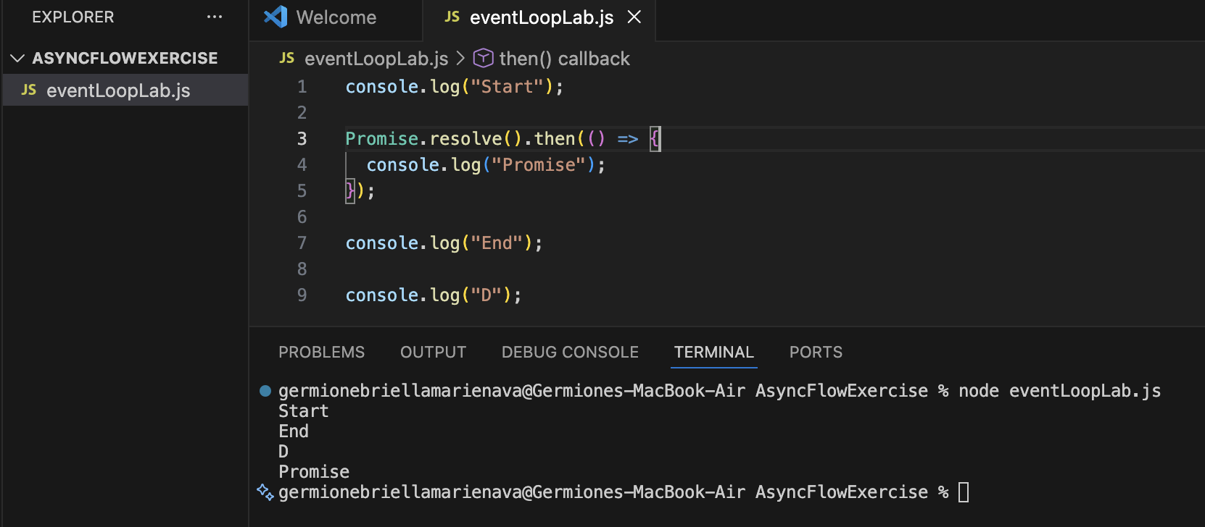

Step 4: Microtask vs Macrotask Comparison
Subtask 4.1: Combine Promise & setTimeout Description: Write code including both Promise and setTimeout.
Example:
console.log("Start"); setTimeout(() => { console.log("Timeout"); }, 0);
Promise.resolve().then(() => { console.log("Promise"); }); c
onsole.log("End");

CODE & OUTPUT:
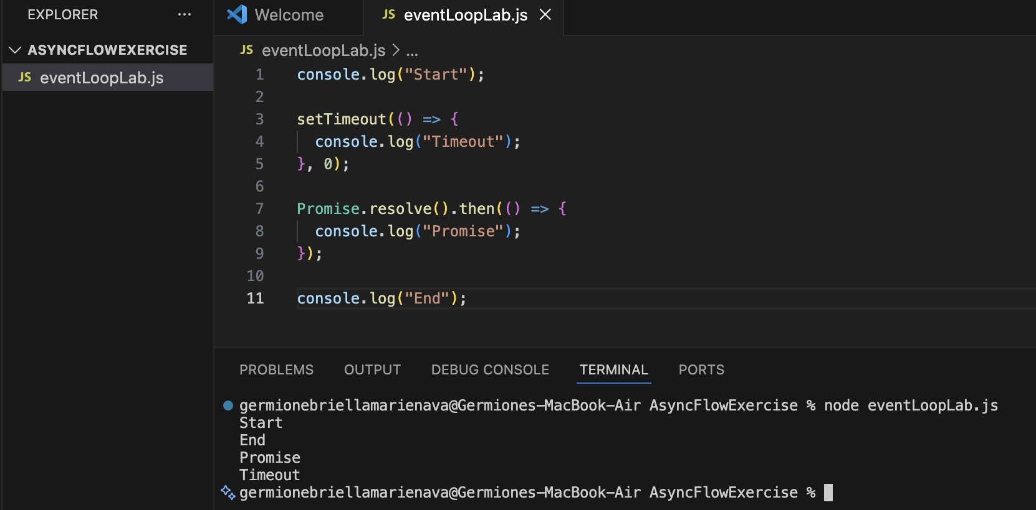

Step 5: Async/Await Flow
Subtask 5.1: Create Async Function Description: Use async function with await Promise.
Example:
async function test() { console.log("1");
await Promise.resolve(); console.log("2"); } console.log("3"); test();
console.log("4");

CODE & OUTPUT:
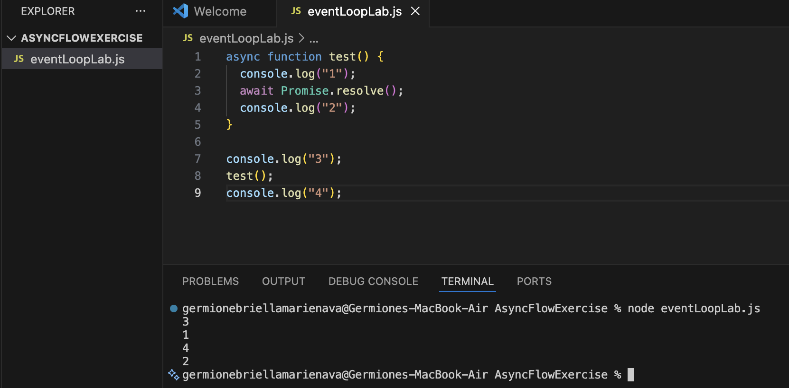

Step 6: Advanced Flow Challenge
Subtask 6.1: Predict the Output Description:
Analyze the following code:
console.log("A"); setTimeout(() => { console.log("B"); }, 0);
Promise.resolve().then(() => { console.log("C"); });
console.log("D");

CODE & OUTPUT:
