
Singapore Institute of Technology - University of Glasgow
Joint Degree in Computing Science Degree Programme

CSC3102 Integrated Work Study Programme

[CSC3102] IWSP End-of-Trimester Report Declaration Form

Please complete the following form and attached it to each IWSP End-of-Trimester Report submitted.

IWSP Period: 01 SEP 2025 to 10 APR 2026
Assessment Trimester: Final Trimester
IWSP Organization: Wilmar International Limited

Declaration of Conformity

Work Supervisor Details & Declaration:
Name: Rain Ha Haw Ing
Designation: Analytic & BI Lead
Department: IT Department
Email Address: rain.hahawing@sg.wilmar-intl.com
Contact Number: +65 91822803

I hereby acknowledge that I have read and understood the contents of the IWSP End-of-Trimester Report, and deem the contents appropriate for release to the Singapore Institute of Technology and the University of Glasgow for use in the assessment of the candidate.

Date: 06 APR 2026

Student Particulars & Declaration:
Name: Joween Ang
Student ID: 2301093
Email Address: 2301093@sit.singaporetech.edu.sg
Contact Number: +65 92341035

I hereby acknowledge that I have engaged and discussed with my Work Supervisor on the contents of the IWSP End-of-Trimester Report and have sought approval for the release of the report to the Singapore Institute of Technology and the University of Glasgow.

Date: 06 APR 2026

Academic Supervisor Details:
Name: Muhamed Fauzi Bin Abbas
Designation: Professor
Institution: Singapore Institute of Technology
Email Address: fauzi.abbas@singaporetech.edu.sg

END OF IWSP END-OF-TRIMESTER REPORT DECLARATION FORM


Singapore Institute of Technology - University of Glasgow
Joint Degree in Computing Science Degree Programme

[CSC3102] IWSP End-of-Trimester Report
Wilmar International Limited

For Final Trimester from 01 SEP 2025 to 10 APR 2026

Joween Ang
Student ID: 2301093
Student GUID: 2957833A
Work Supervisor: Rain Ha Haw Ing

Academic Supervisor: Muhamed Fauzi Bin Abbas

Submitted as part of the requirement for CSC3002 Integrated Work Study Programme (IWSP)

[CSC3102] IWSP End-of-Trimester Report for the Period of
01 SEP 2025 to 10 APR 2026

Table of Contents

A. Declaration of Conformity 1
A.1 Work Supervisor Details & Declaration: 1
A.2 Student Particulars & Declaration: 2
A.3 Academic Supervisor Details: 2
1. Abstract 2
2. Introduction 2
2.1 Company Background 2
2.2 Scope of Work 2
2.3 Problem Definition 3
3. Analysis, Solutions and Results 3
3.1 Core Project: PMO Resource Utilisation Dashboard 3
3.1.1 Requirements and Design 3
3.1.2 Technical Implementation 5
3.1.3 Delivery and Business Impact 6
3.2 Strategic Digital Enablement 7
3.2.1 Power BI Self-Service Governance Framework 7
3.2.2 Tableau Community Advocacy 8
3.2.3 IT Data Portal UX Design 9
3.2.4 Operational BI Contributions 10
4. Reflections 11
4.1 Technical Skills Attained 11
4.2 Soft Skills Developed 11
4.3 Application of Classroom Learning 12
4.4 Lessons Learnt 12
4.5 Constructive Suggestions for IWSP Improvement 13
4.6 Career Preparation 13
5. Conclusions 14
5.1 Key Achievements 14
5.2 Future Recommendations 14
6. References 15

Abstract
This report documents my Integrated Work Study Programme at Wilmar International Limited's Data & Analytics team. My core project was end-to-end delivery of the SG-240575 PMO (Project Management Office) Resource Utilisation Dashboard, where I served as Tableau developer, business analyst, functional designer, and UAT coordinator. The dashboard automated a manual reporting process, eliminating approximately 25-30 hours of monthly work previously spent consolidating OutSystems and Excel data. Beyond this project, I contributed to three strategic initiatives: co-authoring enterprise-wide Power BI governance guidelines to enable safe self-service analytics, creating a weekly "Tableau Tip of the Week" series, fostering community learning and advocacy, and leading UX design in Figma for the IT Data Portal SharePoint modernization. This report details my technical contributions, business impact, and reflects on applying computing science principles to solve real-world problems while developing professional competencies essential for my career.

Introduction

2.1 Company Background

Wilmar International Limited is a global agribusiness group headquartered in Singapore, with over 1,000 manufacturing plants across more than 50 countries. The company manages the entire agricultural value chain from oil palm cultivation to consumer products. The Information Technology division plays a critical role in enabling Wilmar's global operations, with the Data & Analytics team specifically tasked with transforming the organization into a data-driven enterprise through modern business intelligence platforms, cloud data infrastructure, and digital literacy initiatives.

During my IWSP placement, I was embedded within the Data & Analytics team under supervision of Rain Ha Haw Ing, BI Lead. This period coincided with Wilmar's accelerated digital transformation agenda, characterized by modernizing enterprise reporting and democratizing analytics through self-service tools.

2.2 Scope of Work

My role as Business Intelligence Intern spanned the entire analytics value chain from data engineering to dashboard development, UX design, governance, and community building. I was entrusted with delivering the PMO Resource Utilisation Dashboard as my core project, requiring me to function as Tableau developer, business analyst, functional designer, and UAT coordinator. Beyond this, my scope extended to three strategic initiatives: co-authoring Power BI governance guidelines, creating a Tableau community advocacy programme, and leading UX design for the IT Data Portal SharePoint revamp. Operationally, I managed Power BI license requests, processed Jira tickets, and supported UAT for team deliverables.

2.3 Problem Definition

The PMO Reporting Challenge

Prior to this project, the Project Management Office (PMO) at Wilmar faced a chronic operational inefficiency. The PMO team was responsible for monthly reporting on resource utilization, productivity and chargeability across staff. This process required manually extracting data from OutSystems and CSV files, consolidating them in Excel with complex pivot tables and VLOOKUPs, and reformatting the results into PowerPoint slides for management presentation. This manual workflow consumed approximately 25-30 person-hours per month - effectively 3-4 full working days dedicated solely to report compilation. Beyond labor cost, the process was reactive, error-prone, non-scalable, and offered no drill-down capability for stakeholders.

The Broader Digital Enablement Gap

Beyond the immediate PMO challenge, Wilmar's IT leadership identified three strategic gaps that my contributions would address:

- Self-Service Analytics Without Governance: Employees and business users were building Power BI dashboards without centralized standards, creating risks of inconsistent metrics, report sprawl, and potential data exposure.
- Low Tableau Adoption: Despite significant investment in Tableau enterprise licensing, many employees were unaware of its capabilities or intimidated by the learning curve, with no sustained channel for knowledge sharing.
- Poor Discoverability of Data Assets: Wilmar's SharePoint-based IT portal made it difficult for employees to find certified datasets, approved reports, and data owners, creating friction in the data discovery process.

Analysis, Solutions and Results

3.1 Core Project: PMO Resource Utilisation Dashboard

The culmination of my internship was the end-to-end delivery of the SG-240575 PMO Resource Utilisation Dashboard - a project that integrated all the skills I had developed and delivered tangible business value through complete automation of a previously manual reporting process.

3.1.1 Requirements and Design

Stakeholder Engagement and Requirements Synthesis

I led multiple requirements gathering sessions with PMO stakeholders. Drawing upon business analysis best practices (Nicholas, 2021), I proactively designed and implemented an Excel Business Analyst Requirements Template, which was subsequently adopted team wide. Using it, I systematically captured current state pain points, desired capabilities, specific KPIs, user personas, and technical constraints.

Below is a sample of the Business Analyst Requirements Template excel file:

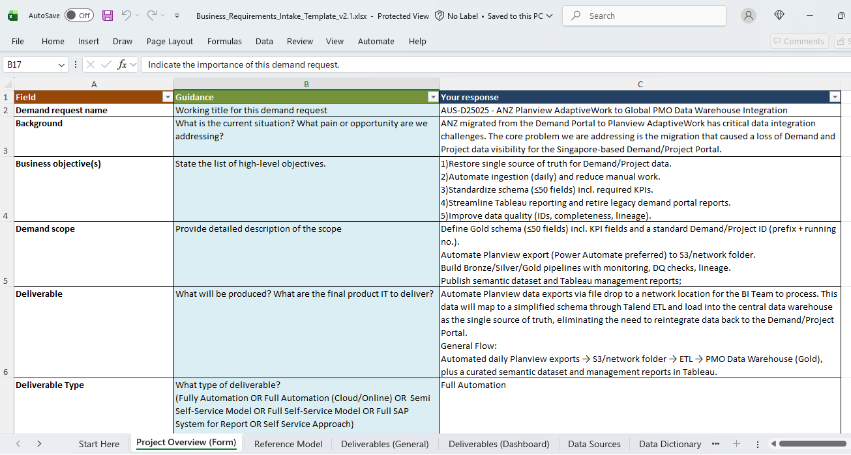

Figure 1: Business Analyst Requirements Template

Functional Design Specification

I authored the complete Functional Design Specification, a formal document that served as the single source of truth for development.

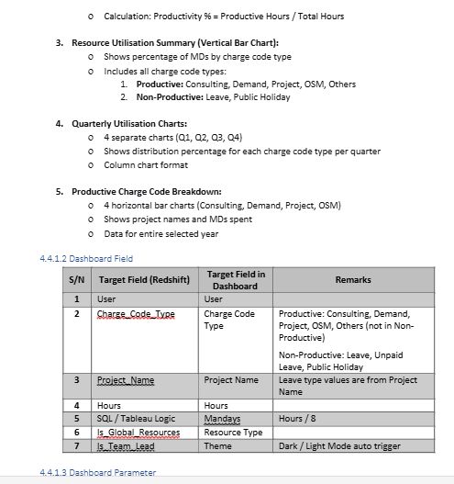

Figure 2: Functional Design Specification for PMO Dashboard

3.1.2 Technical Implementation

Data Pipeline and Engineering

Below is the complete data pipeline architecture supporting the dashboard

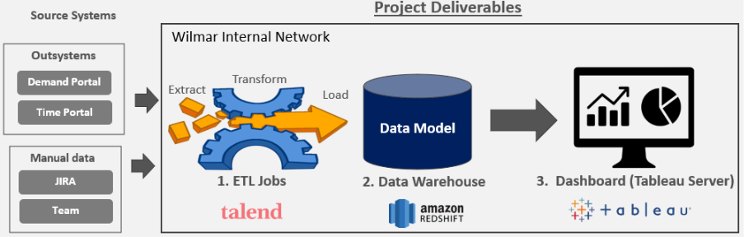

Figure 3: Data Pipeline Architecture

- Raw Data - Bronze Layer - Gold Layer Materialized Views: Authored complex SQL scripts to create business-ready materialized views in Amazon Redshift using Talend ETL, by joining timesheet entries, employee master data, project information, and charge code classifications from outsystem and manual data source. These views aggregated data at daily and quarterly grains with pre-calculated metrics for optimal query performance.

Dashboard Development

Below shows the PMO Resource Utilisation Dashboard that was built:

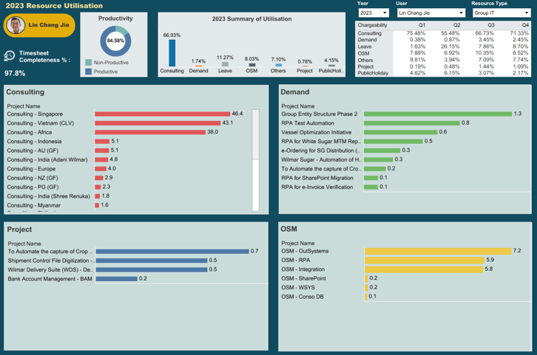

Figure 4: PMO Dashboard (Team Lead View – Dark Mode)
As the Tableau developer, I built the entire workbook from scratch:

- Data Connection: Configured scheduled Tableau extracts from Redshift with incremental refresh strategy, maintaining sub-3-second load times
- Calculated Fields: Authored approximately 30 calculated fields implementing business logic for productivity classification, quarterly chargeability percentages, dynamic titles, role-based theming, and quarter-over-quarter change indicators
- Interactive Navigation: Implemented dashboard actions for double-click drill-down and custom button navigation (Next, Back, Home) with parameter-based filter persistence across all sheets
- Tooltip Enhancement: Custom-designed every tooltip to display full, untruncated project names and precise MD values - addressing a key usability pain point identified during UAT

3.1.3 Delivery and Business Impact

User Acceptance Testing and Deployment

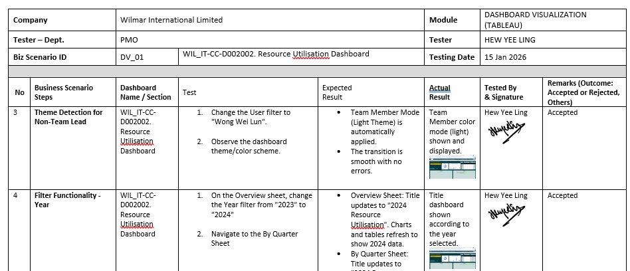

Figure 5: User Acceptance Testing for PMO Dashboard
I authored a comprehensive UAT test plan with test cases across functional, performance, usability, security, and compatibility categories. The UAT was conducted with one PMO team member, who executed test cases against documented expected results. Following successful validation, the dashboard was deployed to Tableau Server production.

Post-Deployment Enhancement

After one week of real-world usage, PMO users requested enhancements. I documented each with business justification, triggered formal change requests, implemented cascading Resource Type filters and quarter-over-quarter comparisons, and completed a second UAT cycle.
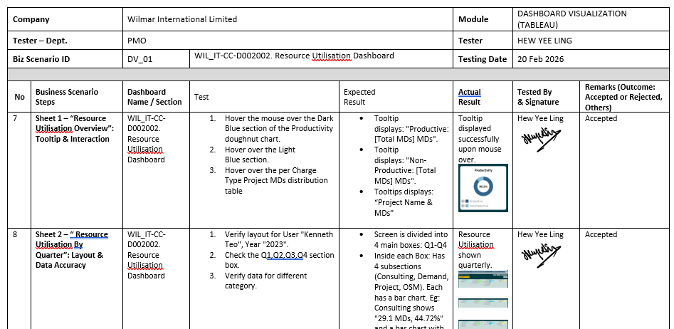

Figure 6: User Acceptance Testing Round 2 for PMO Dashboard
Quantitative Impact

Table 1: Quantitative Impact on PMO
Metric | Before | After | Improvement
Monthly reporting time | 25-30 hours | <1 hour | 96% reduction  (~300 hours saved annually)
Report latency | +15 days | +1 day | 94% faster
Manual data handling steps | 12+ steps | 0 steps | Fully automated
Data sources | 3-5 files | 1 source | Centralized

For the PMO team, this project was transformative. Analysts shifted from being "report producers", spending days on data wrangling to "insight analysts" focusing on trend identification and strategic recommendations. The elimination of manual Excel manipulations removed anxiety about formula errors before management presentations.

3.2 Strategic Digital Enablement

Parallel to the PMO dashboard project, I contributed to three strategic initiatives addressing Wilmar's broader digital transformation goals.

3.2.1 Power BI Self-Service Governance Framework

Context: As Wilmar encouraged employees to develop digital skills, there was rapid proliferation of Power BI dashboards created by individual business users. While democratization was strategically desirable, it introduced risks: multiple versions of truth, unmanaged data sources, no naming conventions, and potential security exposure. Two critical gaps needed addressing: (1) governance for self-service analytics, and (2) standardized guidance for implementing Row-Level Security (RLS) to ensure proper data access controls.

My Contribution: I researched the best industry practices, studying Microsoft's Power BI adoption framework (Microsoft, 2024), Gartner's augmented analytics governance recommendations, and peer organization case studies, and co-authored an enterprise guideline document that integrated both governance and security guidance, covering:

- Power BI Pro & Fabric Workspace Governance - Defined workspace structures, ownership models, and lifecycle management to prevent sprawl.
- Power BI Development Guidelines - Established version control, development-to-production promotion workflows, and peer review practices.
- Licensing & JIRA Workflow - Outlined a clear process for Power BI license requests, including required approvals and JIRA-based tracking to streamline access management.
- Data Source Certification, Naming Conventions, Publication Workflows, and RLS Implementation - Authored key sections to ensure consistency and security across self-service initiatives.

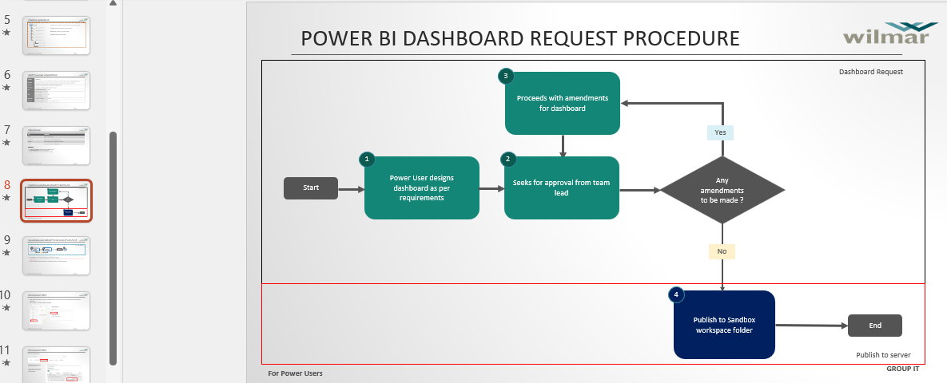

Figure 7: Power BI Self-Service Governance Guidelines
Outcome: The Power BI Self-Service Governance Guidelines v1.0 were formally adopted by Wilmar's BI. The document became the foundational reference for all self-service analytics initiatives, enabling employees to build their own dashboards confidently while maintaining data integrity and security. The integrated RLS and licensing guidance ensured proper access controls and governance scaled effectively alongside adoption.

3.2.2 Tableau Community Advocacy

Context: Despite significant investment in Tableau enterprise licensing, many employees were unaware of the tool's capabilities or intimidated by its learning curve. The team needed a sustained, low-friction method to build capability and foster community.

My Contribution: I initiated and single-handedly maintained a weekly "Tableau Tip of the Week" series on Wilmar's Viva Engage platform throughout my entire internship – covering full spectrum of Tableau proficiency such as parameters, LOD expressions, performance optimization, and dashboard best practices.

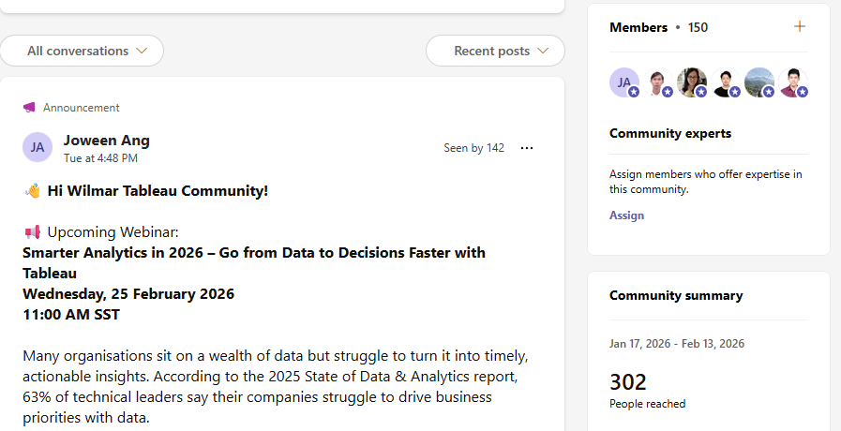

Figure 8: Weekly Tableau Tip Series on Viva Engage
Outcome: The series consistently reached 300+ employees weekly, positioning the Data & Analytics team as an enablement centre and demonstrating that peer-to-peer learning effectively complements formal training.

3.2.3 IT Data Portal UX Design

Context: Wilmar IT initiated a company-wide modernization of its SharePoint portals. My team was responsible for redesigning the IT Data Portal - the primary gateway for employees to discover certified datasets, published dashboards, and data documentation.

My Contribution: I volunteered to lead the UX design effort, using Figma to create wireframes and interactive prototypes. This was my first professional UX design project:

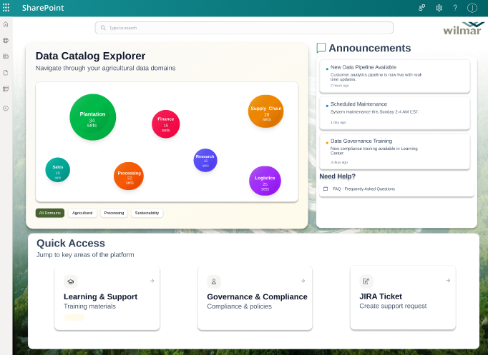

Figure 9: IT Data Portal UX Design
- Requirements Gathering: Conducted stakeholder discussions to identify pain points in the existing portal, including difficulty finding datasets, unclear ownership, and poor user experience.

- Information Architecture: Mapped user journeys for common scenarios and designed navigation structures organized by business domain, data type, and certification status.

- Wireframing and Prototyping: Developed three major design iterations - evolving from a dense list view to a card-based grid layout with featured dashboards, and finally to a refined interface with browse-by-category navigation and rich metadata cards.

- Feedback and Iteration: Presented prototypes to stakeholders including the Head of IT through multiple review cycles, incorporating feedback on terminology, layout, colour scheme, and functionality.

Outcome: My Figma prototypes were formally handed off to the SharePoint development team for implementation. The designs established a user-centred blueprint for making Wilmar's data assets more discoverable, understandable, and accessible.

3.2.4 Operational BI Contributions

Throughout my internship, I maintained consistent operational responsibilities:
- Power BI License Management: Maintained the user license list, transitioned tracking from Excel to shared environment, and processed Jira license request tickets.
- User Acceptance Testing: Conducted UAT for User Listing dashboard, validating licensing data across multiple sources
- Security Implementation: Drawing from Microsoft's official documentation on Row-Level Security (Microsoft, 2025), I researched and shared with my team about Power BI data access control patterns, gaining hands-on experience with both static and dynamic RLS implementation.

3.3 Results and Business Impact

Table 2: Overview of Contributions
Initiative | Key Contribution | Impact
PMO Resource Utilisation Dashboard | End-to-end development and deployment | 25-30 hours/month saved (~300 hours saved annually); 96% reporting time reduction; PMO role transformation from producer to analyst
Requirements Template | Designed and implemented team standard | 25% reduction in project initiation time; adopted by entire BI team
Power BI Governance | Co-authored enterprise framework | Adopted as BI standard; enabled safe self-service analytics
Tableau Viva Engage | Created and maintained weekly content | 300+ weekly reach; increased Tableau understanding within the community
IT Data Portal UX | Led Figma design and prototyping | 3 major iterations; handoff to dev team; improved data discoverability and UX

Reflections

4.1 Technical Skills Attained

Data Engineering & ETL
- Talend Cloud: Designed and scheduled production ETL jobs; configured materialized view refresh workflows
- AWS Stack: Working knowledge of S3 for data lake storage and Redshift for data warehousing
- Advanced SQL: Authored complex queries with multi-table joins, window functions, and materialized views
- Medallion Architecture: Understood Bronze-Silver-Gold layer concepts and their practical implementation

Business Intelligence & Visualization
- Tableau: Advanced proficiency including calculated fields, LOD expressions, parameters, dashboard actions, and performance optimization. Experienced content publication, extract refresh configuration, and row-level security implementation.
- Power BI: Competency in data modeling, DAX calculations, and Row-Level Security implementation

UX/UI Design
- Figma: Wireframing, prototyping, component libraries, and interactive flows
- User Research: Conducted user interviews and synthesized findings into design decisions

Enterprise IT Processes
- SDLC Governance: Phase-gate project management with documented deliverables
- Change Management: Authored Change, Backout, and Test plans meeting ITIL standards
- UAT Coordination: Designed test plans, facilitated execution, managed defective lifecycle

4.2 Soft Skills Developed

- Stakeholder Management: Built trust with PMO stakeholders through active listening and expectation management
- Communication: Authored documentation for diverse audiences; presented to supervisors and stakeholders
- Initiative: Proactively created requirements template, Viva Engage series, and Figma designs without assignment
- Resilience: Embraced post-deployment enhancements as evidence of adoption rather than criticism
- Time Management: Balanced core project, community engagement, and operational responsibilities

4.3 Application of Classroom Learning

Table 3: Applied Knowledge from Degree Program
Module | Applied Knowledge
INF2003: Databases | Relational design, indexing strategies, query optimization for Redshift materialized views
CSC2101 & CSC2102: Professional Software Development and Team Project 1 & 2 | Agile methodologies, user stories, iterative development within waterfall governance
INF2002: Human-Computer Interaction | Usability principles, affordance, mental models in dashboard and IT data portal design
CSC3104: Cloud Computing | AWS services, object storage, columnar databases, distributed query execution
CSC3107: Data Visualization | Graphical communication principles, data-ink ratio, perceptual accuracy in chart selection

4.4 Lessons Learnt

Technical Lessons

- Optimize at the right layer: Materialized views outperform raw tables by orders of magnitude.
- Document as you build: Saves hours of reverse-engineering.
- Performance is a feature: Sub-second response time is a prerequisite for adoption.
- Learn the underlying data: Understanding source data structure pays dividends throughout development.

Professional Lessons

- Business value > technical complexity: Stakeholders care about accurate data, not sophisticated functions.
- Relationships matter: Engaged stakeholders become allies and advocates.
- Ask for help early: Leverage colleagues' expertise without embarrassment.
- Over-communication status: Regular updates build trust and enable course correction.
- Take ownership: Shifting from "assigned task" to "my project" increases quality and motivation.

Personal Lessons

- Imposter syndrome is normal: Confidence comes from contribution, not comparison.
- Celebrate small wins: Positive feedback sustains momentum through challenges.
- Balance depth and breadth: Specializing deeply while exploring adjacent areas builds versatility.
- Learning how to learn is the meta-skill: Tools evolve but the ability to acquire new skills is permanent.

What I Would Do Differently

Looking back, I would have validated assumptions earlier - scheduling user feedback sessions with low-fidelity mockups before committing development effort would have identified workflow adjustments sooner. Additionally, I would have invested more time upfront in source data discovery - profiling data quality, completeness, and edge cases would have prevented assumptions that required later rework in materialized views. Future projects will incorporate lightweight validation checkpoints at requirements and design phases, alongside structured data profiling at the outset.

4.5 Constructive Suggestions for IWSP Improvement

Based on my experience, I suggest pairing each intern with a designated buddy who is not their direct supervisor. Throughout my internship, informal catchups with classmates facing similar challenges provided invaluable support. These peer connections created a safe space for asking "silly questions" without hesitation, sharing workplace experiences, and realizing that some struggles were universal, not personal failings. A recommended 30-minute weekly check-in via video call would provide consistent, low-pressure touchpoints. This peer support complements rather than replaces formal supervision from workplace mentors and academic supervisors, creating a holistic support triangle for each intern.

4.6 Career Preparation

This IWSP clarified my passion at the intersection of data, design, and business value, directing me toward data analytics engineering. I also built meaningful professional relationships with supervisors and colleagues. My portfolio now includes a production dashboard with measurable business impact, adopted governance guidelines, community engagement metrics, and UX prototypes handed off to development. Understanding that enterprise projects involve navigating technical debt, evolving requirements, and iterative improvement is invaluable preparation. Thriving in an environment requiring rapid skill acquisition confirmed my ability to adapt to evolving technology landscapes.

Conclusions

5.1 Key Achievements

My IWSP at Wilmar delivered measurable impact across project delivery, process improvement, strategic enablement, and personal development.

Project Delivery:
- Delivered the SG-240575 PMO Resource Utilisation Dashboard through complete project lifecycle, eliminating 25-30 hours of manual monthly reporting - a 96% reduction in effort
- Achieved 100% UAT defect closure rate and formal stakeholder sign-off

Process Improvement:
- Designed requirements gathering template adopted by entire BI team, reducing project initiation time by 25%

Strategic Enablement:
- Co-authored enterprise Power BI Self-Service Governance Guidelines v1.0
- Created and maintained weekly Tableau Tip of the Week series reaching 300+ employees throughout internship.
- Designed Figma IT Data Portal prototypes handed off to SharePoint development team
- Redesigned data catalogue interaction model with intuitive bubble pop-ups

Personal Development:
- Acquired hands-on proficiency across modern data stack: Talend, Redshift, Tableau (Advanced), Power BI, Figma
- Developed critical professional competencies in stakeholder management, communication, project ownership, and time management
- Built portfolio of tangible deliverables demonstrating technical capability and business impact

5.2 Future Recommendations

While my internship has concluded, several opportunities exist to build upon the foundations I established.

For the PMO Dashboard:
- Predictive analytics leveraging historical patterns for resource demand forecasting
- Automated alerts for utilization thresholds and timesheet completeness
- Expanded scope to include financial metrics (project profitability, cost-to-completion)

For Power BI Governance:
- Automated compliance monitoring for uncertified reports and orphaned workspaces
- Self-service certification portal for dataset owners

For IT Data Portal:
- Usage analytics to inform content investment decisions
- User feedback integration for dataset quality reporting

For Team Knowledge Management:
- Centralized documentation repository for technical decisions and lessons learned
- Formalized mentorship programme for new joiners and interns

These recommendations aim to sustain Wilmar's digital transformation momentum, building upon the foundations laid during my internship to create lasting organizational value.

References
- Microsoft. (2024, December 30). Power BI usage scenarios: Managed self-service BI - Power BI. Learn.microsoft.com; Microsoft.
https://learn.microsoft.com/en-us/power-bi/guidance/powerbi-implementation-planning-usage-scenario-managed-self-service-bi
- Microsoft. (2025, August 3). Row-level security (RLS) with Power BI - Microsoft Fabric. Learn.microsoft.com.
https://learn.microsoft.com/en-us/fabric/security/service-admin-row-level-security
- Nicholas, J. (2021, August 27). What Should a Business Requirements Document (BRD) Include? BusinessAnalystMentor.com.
https://businessanalystmentor.com/business-requirements-document/

END OF REPORT

