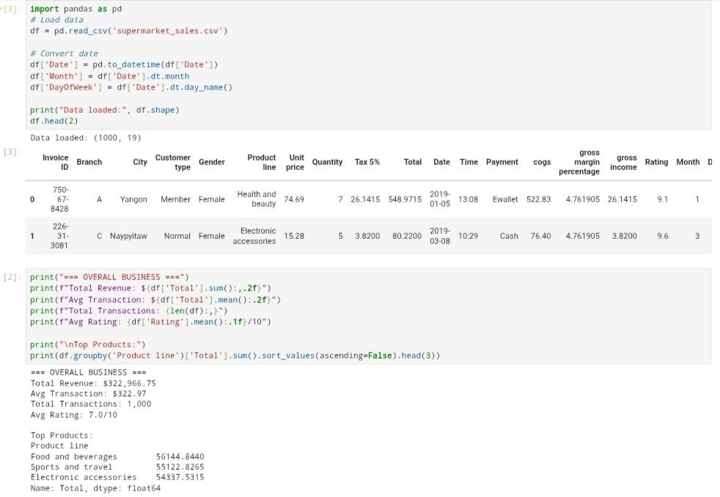

Data Loading & Overall Business:
The dataset loads correctly with 1000 records. Total revenue is strong at $322k, with an average sale of $322.97 and a 7.0/10 rating. Top revenue products are Food & Beverages, Sports & Travel, and Electronic Accessories.

—

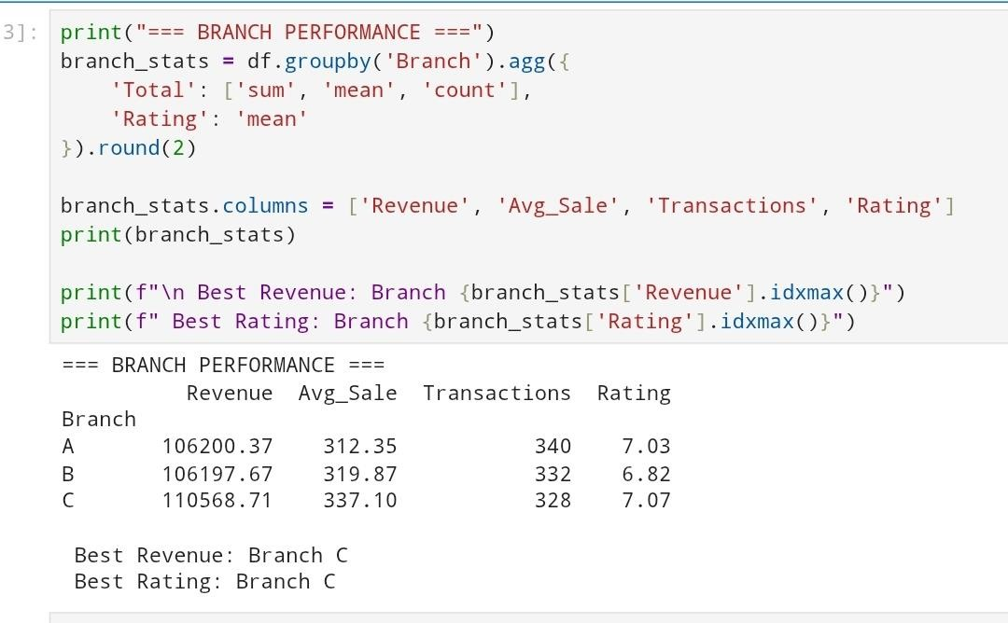

Branch Performance:
All branches perform similarly, but Branch C leads in both revenue and rating. Branch A and B have nearly identical revenue, though A rates slightly higher.

—

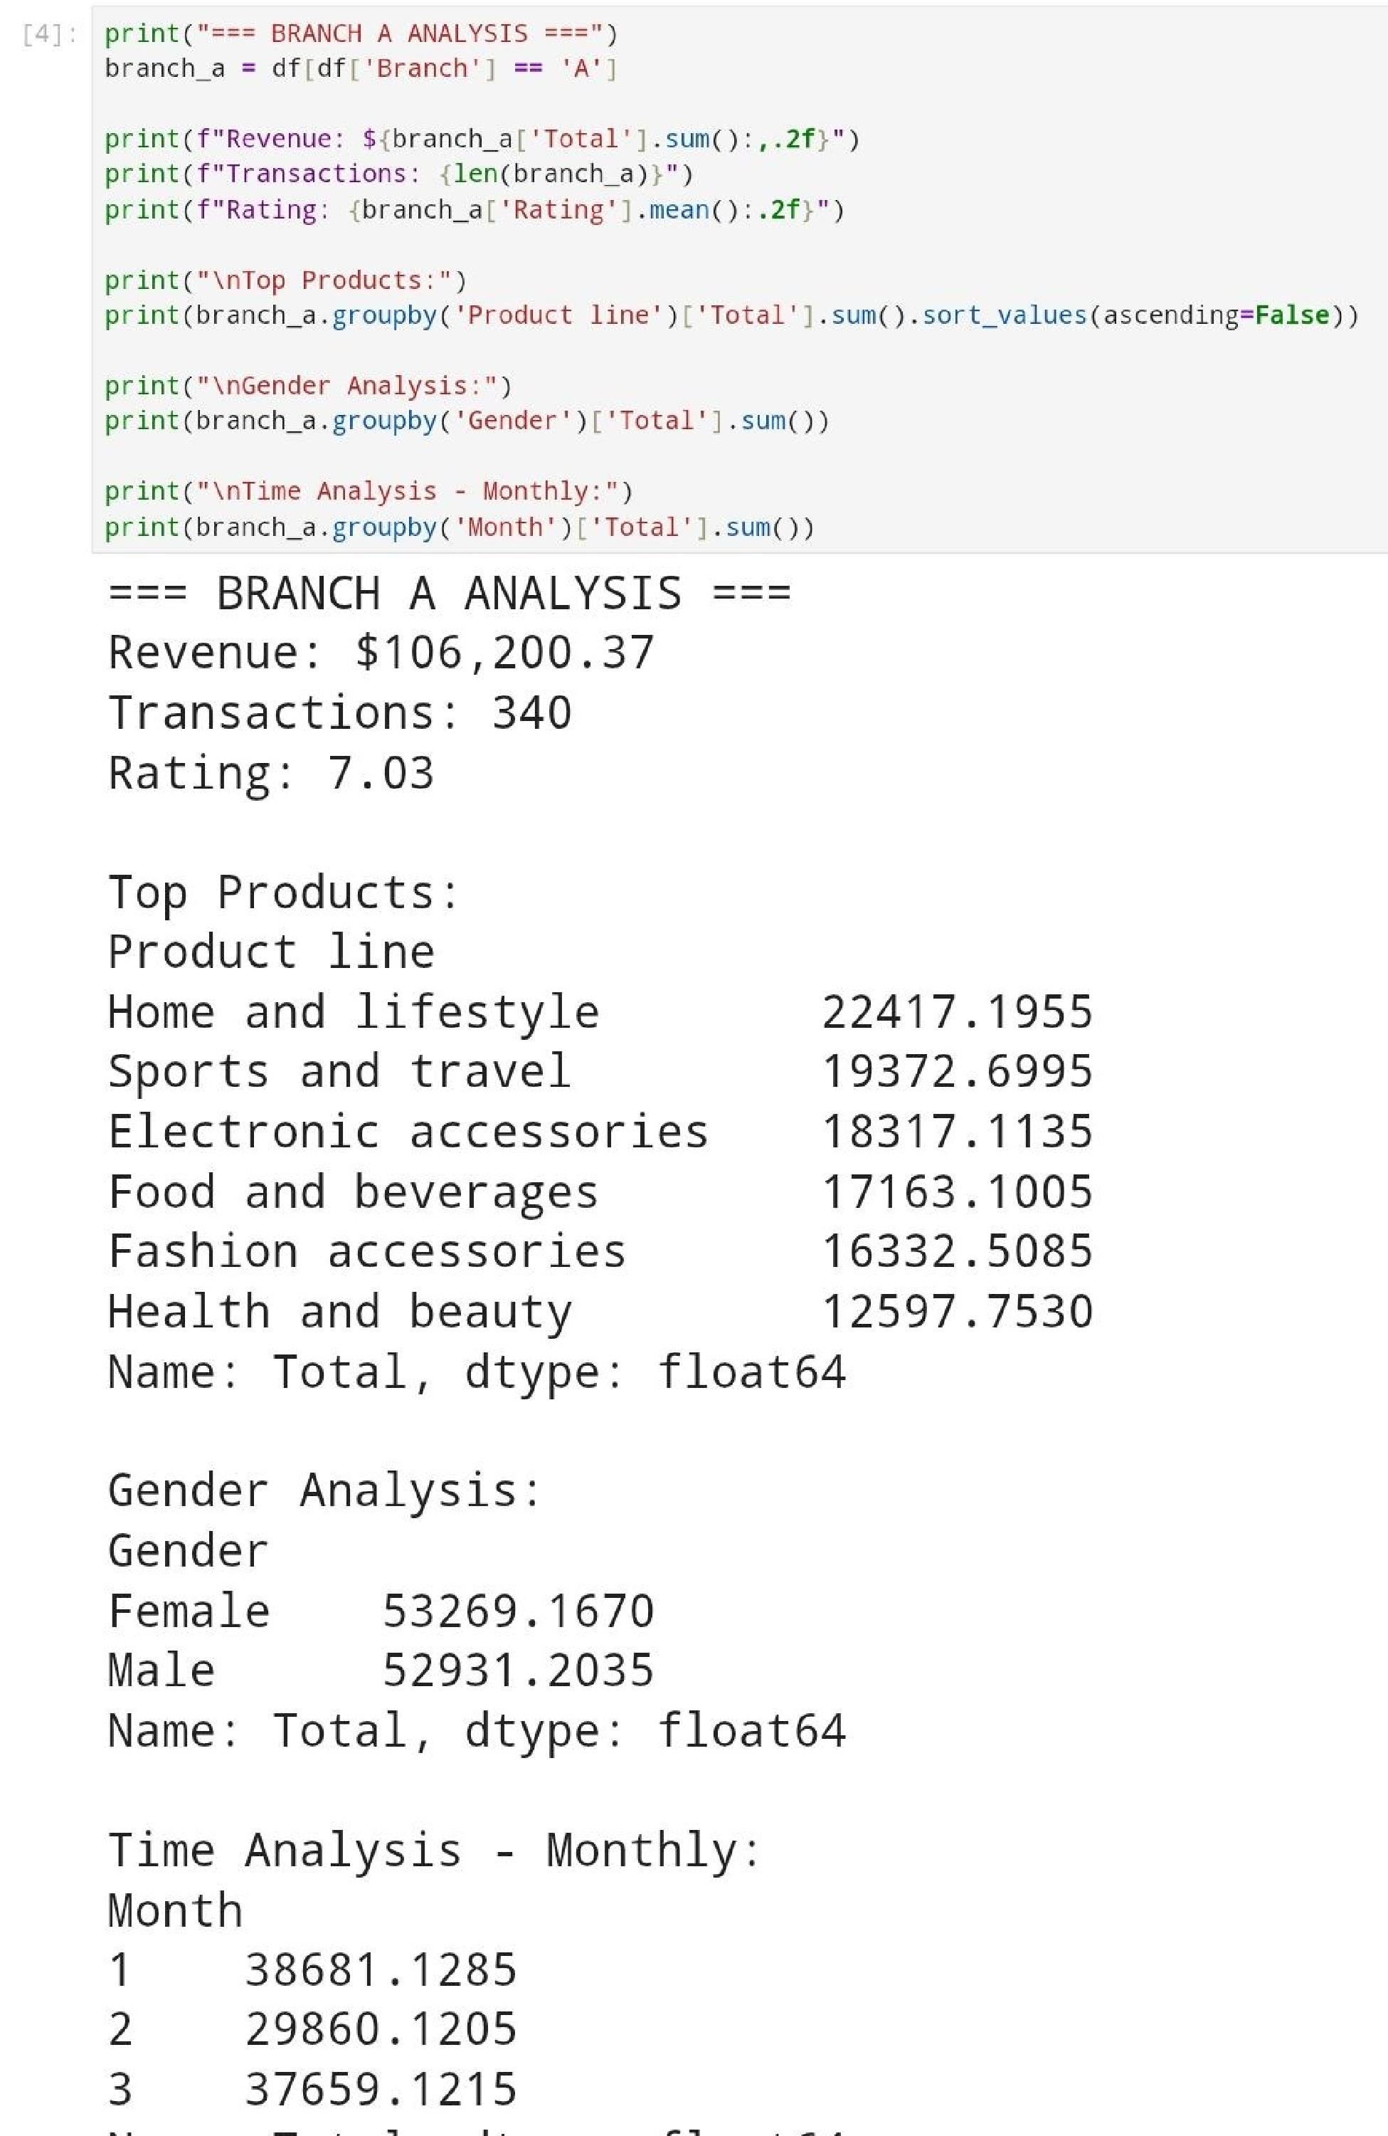

Branch A Analysis:
Branch A generates $106,200.37 from 340 transactions, with a customer rating of 7.03. Its topperforming product line is Home & Lifestyle, indicating strong local preference for household and lifestyle items. Revenue contribution from females is slightly more than males but we can say it's almost equal. Monthly analysis shows that January and March were stronger months, with a dip in February.
—

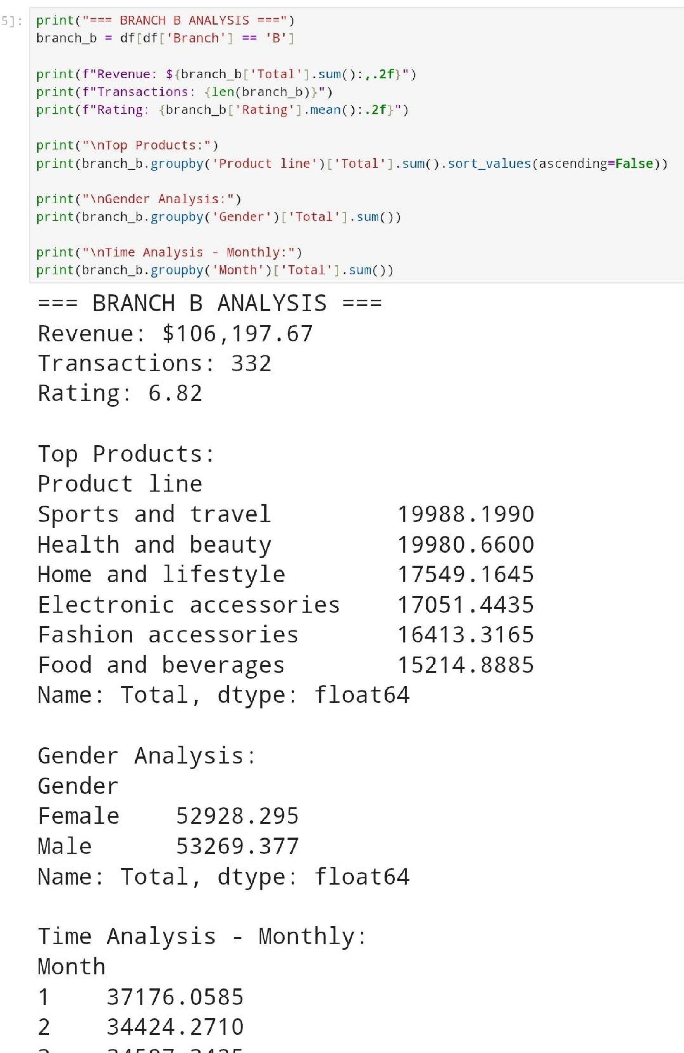

Branch B Analysis:
Branch B also generates around $106k, but it receives the lowest branch rating (6.82). The leading categories here are Sports & Travel and Health & Beauty, suggesting that this branch serves a customer base more focused on personal care and travel products. Gender-based revenue from males is a little bit more than females but we can call it balanced. Monthly revenue is fairly consistent across all three months.

—

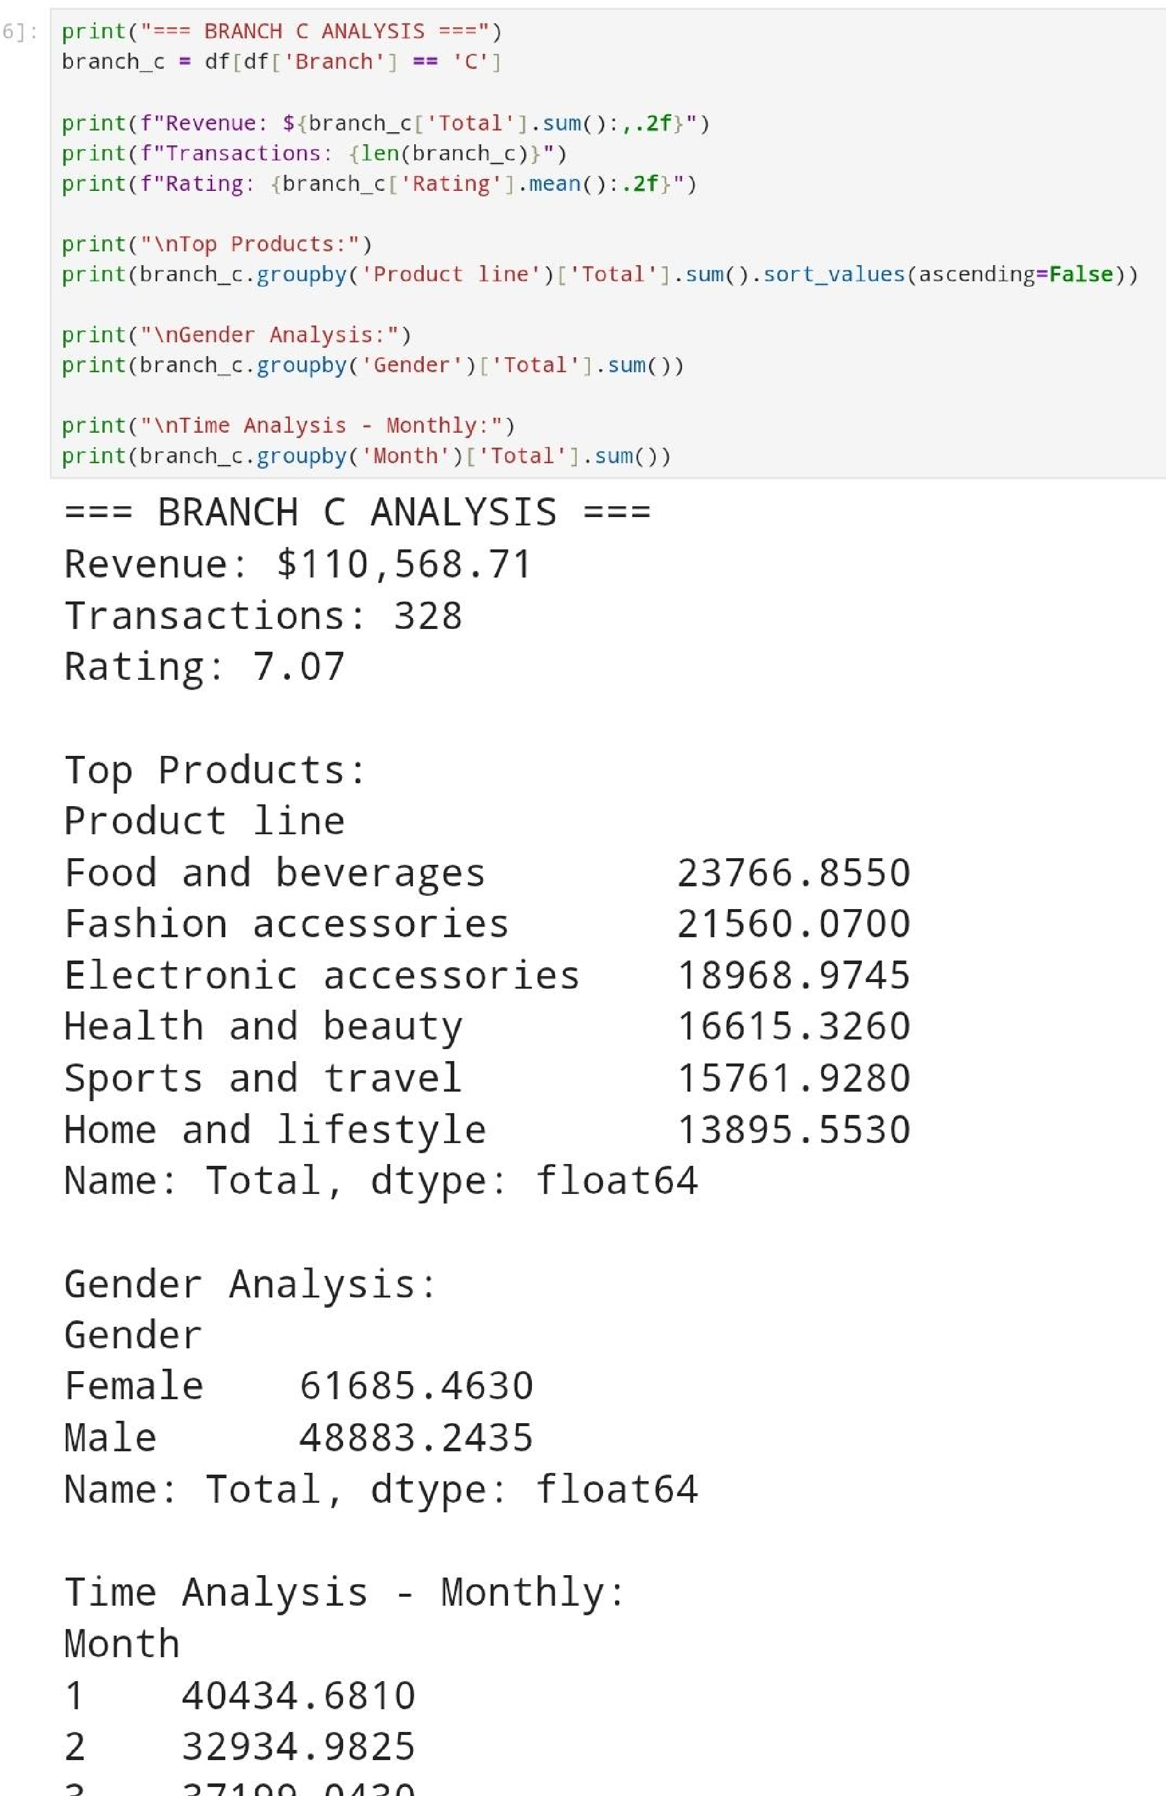

Branch C Analysis:

Branch C is the strongest branch overall. It produces $110,568.71 and holds the highest rating (7.07). Its top-selling product line is Food & Beverages, showing strong demand for consumable goods. Female customers contribute significantly more revenue than males, unlike the other branches. Revenue remains strong across all months, with January showing the highest sales.

—-

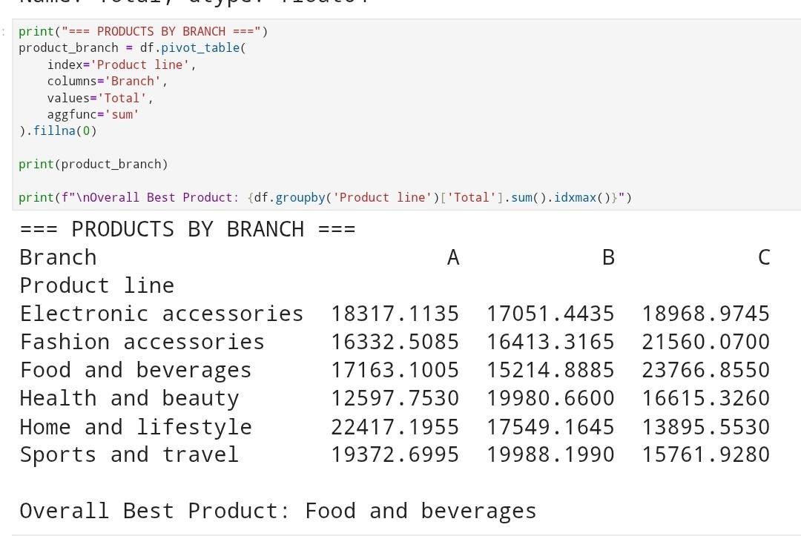
Products by Branch:

Each branch has its own strongest product line:

- Branch A: Home & Lifestyle

- Branch B: Sports & Travel, Health & Beauty

- Branch C: Food & Beverages, Fashion Accessories

Across all branches combined, Food & Beverages is the overall highest revenue generator, confirming it as the chain’s most consistent performer.

—

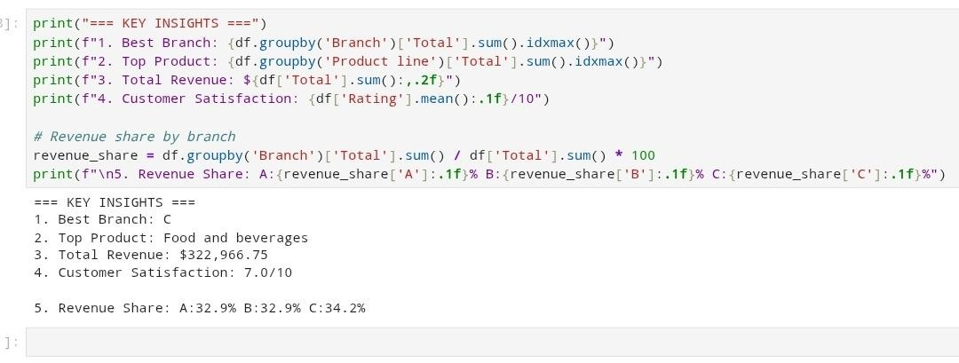

Key Insights:

Branch C stands out as the top branch in terms of both revenue and customer satisfaction. The most profitable product category for the entire business is Food & Beverages. Revenue contribution is evenly distributed across A, B, and C, showing balanced branch performance. The average customer rating of 7.0/10 suggests stable but improvable customer experience across the chain.

