Junio, Toong

Machine Problem #2 (Python)

Points: (1,-6), (2,1), (5,2)

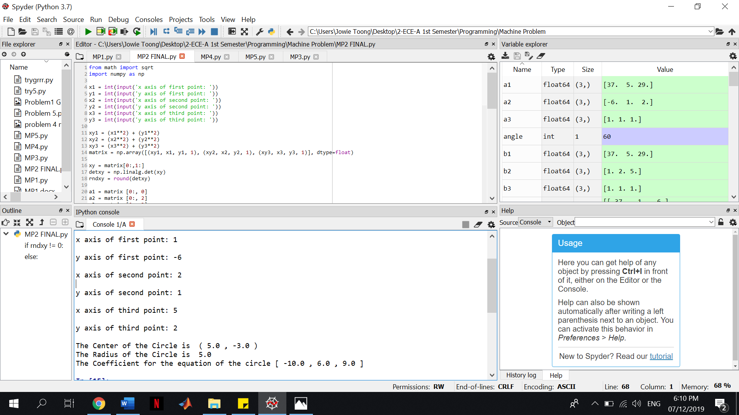

Points: (2,1), (0,5), (-1,2)

