Problem 1

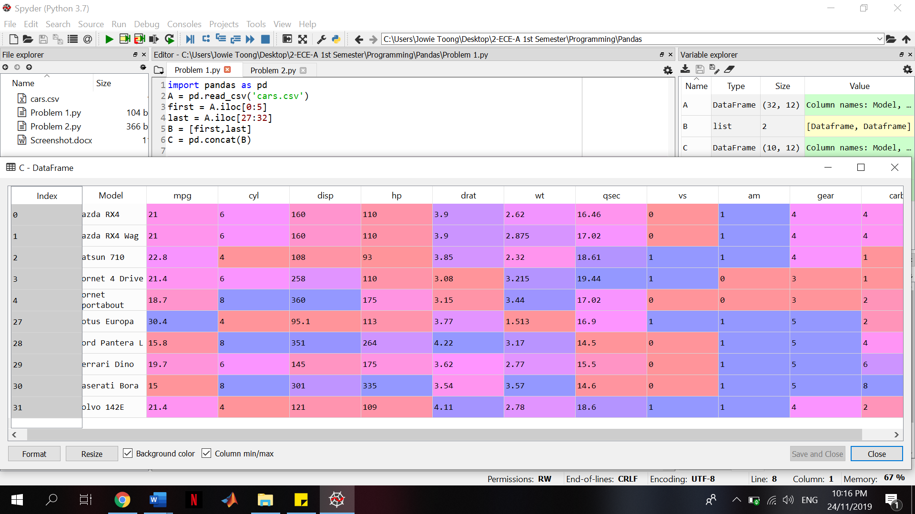

Problem 2a

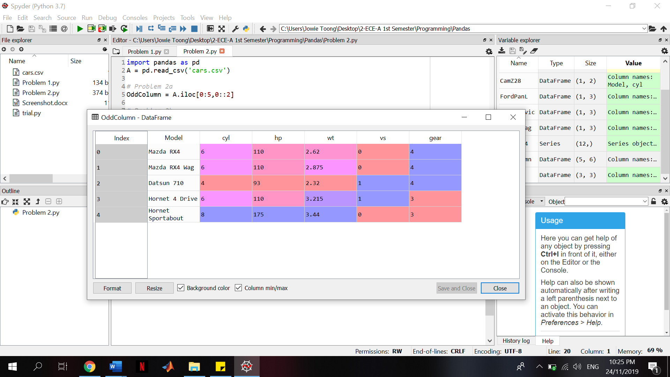

Problem 2b

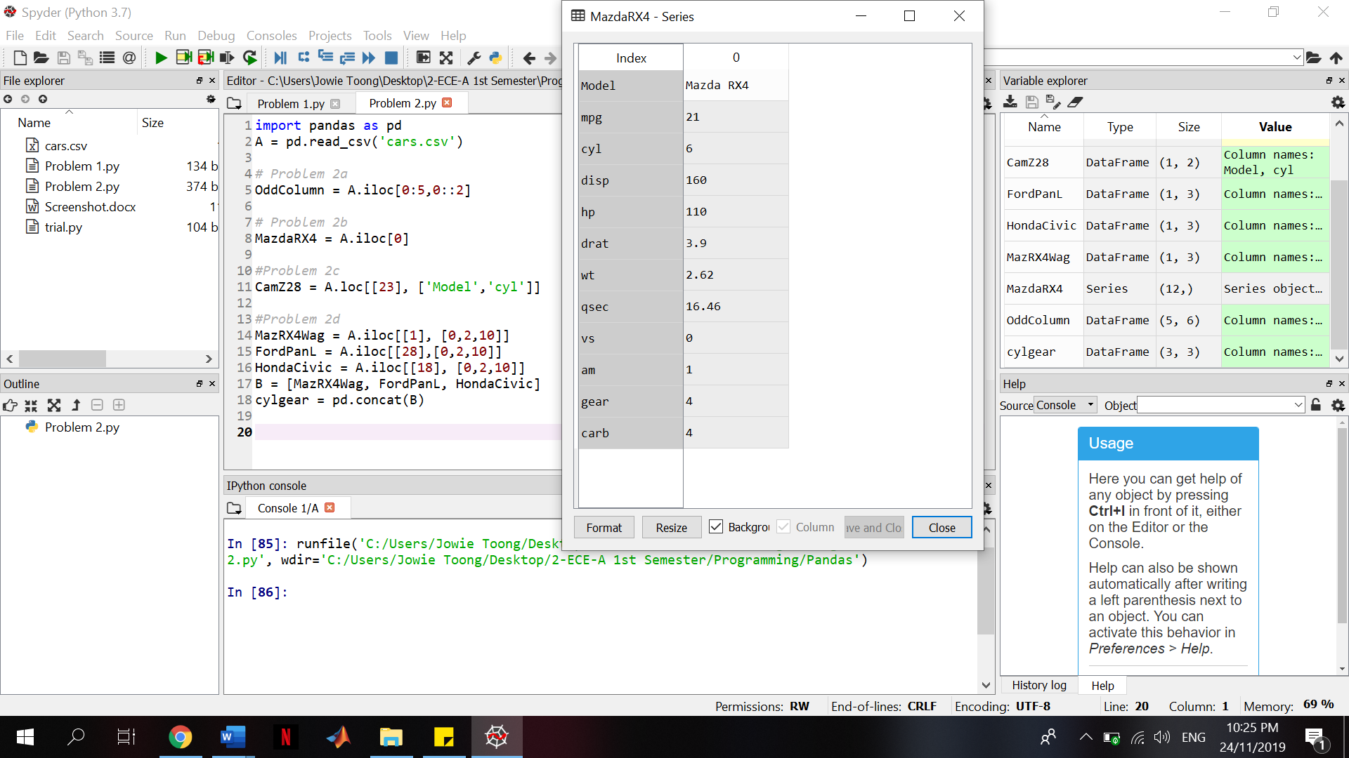

Problem 2c

Answer: 8

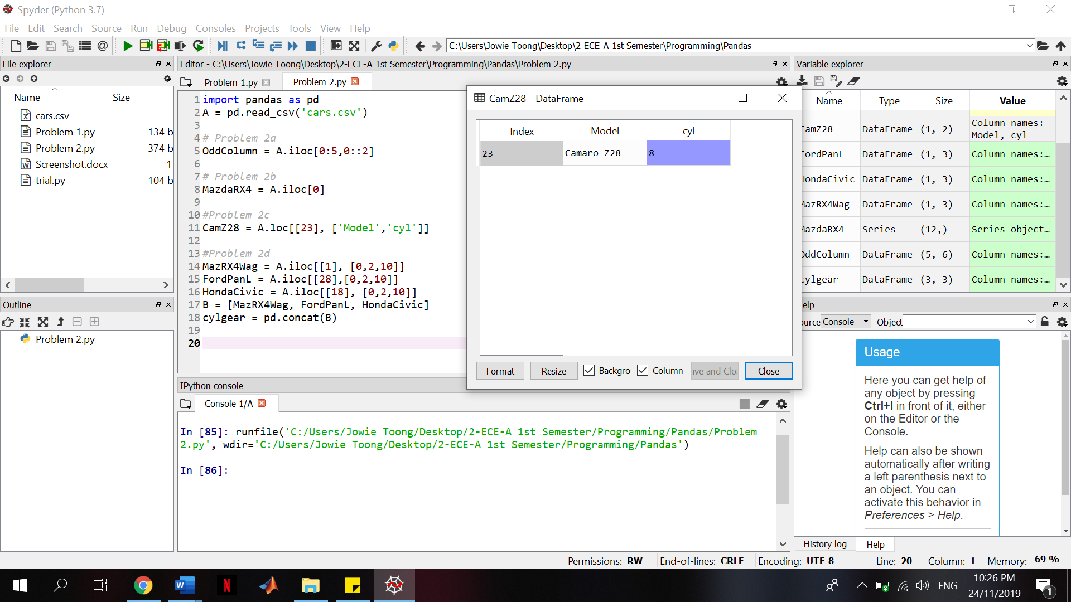

Problem 2d

Answer:

Mazda RX4 Wag: cyl = 6

gear = 4

Ford Pantera L: cyl = 8

Gear = 5

Honda Civic: cyl = 4

Gear = 4

