**Project Proposal in CSE 103 – Computational Science**

**Project Title: TP - TrashPoints**

**Background**

**General:**

TrashPoints is a waste exchange system that will help people segregating their trash while also allowing them to earn points in the process. If the trash is biodegradable, the weight will be scaled; if it is non-biodegradable, trashpoint will count the amount of waste bits and convert them into points that will be credited to the individual who dispose the trash.

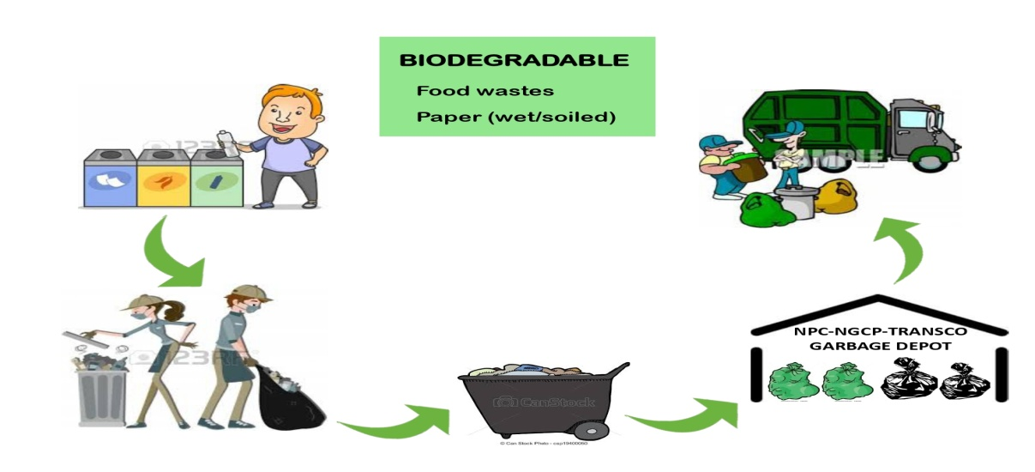 **Specific:**

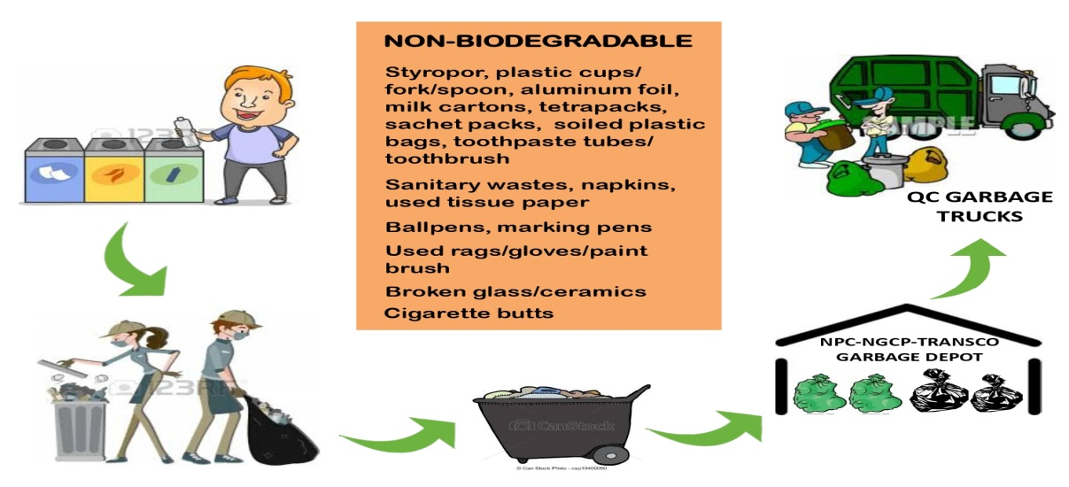

**Reference:**

https://www.napocor.gov.ph/images/advocacies/Eco-Friendly_Office_Program/Waste_Management.pdf

**Objectives**

1. To be innovative in waste management by developing a new system.

2. Assist environmental organizations in keeping the environment clean and safe.

3. To provide a means for underprivileged individuals to obtain food by contributing to the cause.

4. To serve as a means of instilling in persons the value of waste management.

**Scope**

1. Trashpoints will have a create account function for users.

2. The users will be able to trade trash for points.

3. Trashpoints will let users exchange biodegradable and non-biodegradable trash.

4. Biodegradable trash will have points based on their scale and non-biodegradable trash will be pointed based on quantity.

5. The points that the users will have can be exchange for foods or items in the system.

**Limitations**

1. Trashpoints system are for waste managements use only.

2. The points that the users will acquired can be exchanged using Trashpoints system only.

3. The items that can be exchanged are the ones that is only available on Traspoints system.

**Requirements**

**Hardware:**

1. Arduino UNO

2. Metal Detector

3. Camera

4. LCD 16x2 Display

**Software:**

1. Arduino IDE/ Arduino Code

2. Trashpoint System

3. Notification System

4. Visual Studio Code

**Members:**

Hular, Macy

Velasquez, Marvin Ryan

Briones, Dan Kagi

Bance, Joanna Marie

Diendo, John Ace

Digno, Jhones

Dionson, Jerald

Tumanon, Royben

Hiquiana, Al Cedric