TO generate .env file

cp .env.example .env

Prevent “property of non-object” error

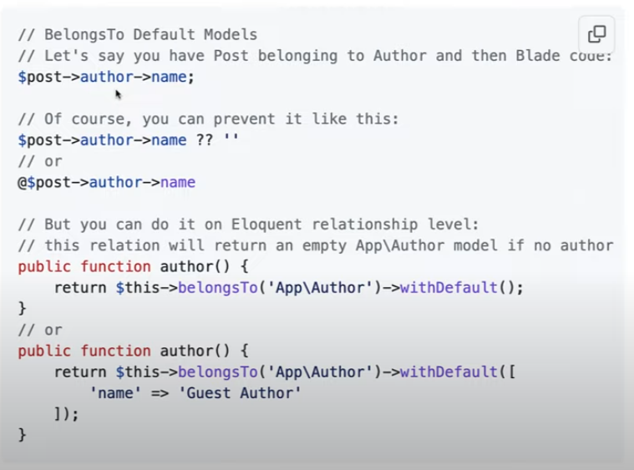

Querry Deeper Relationship

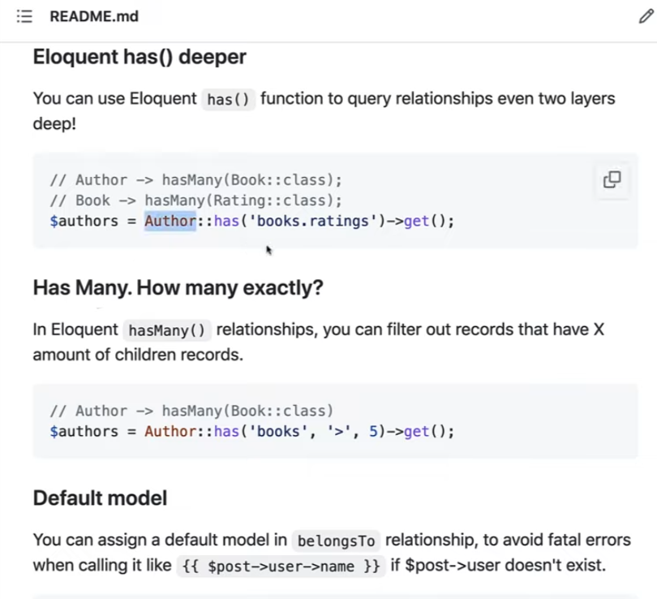

Getting only what columns you need

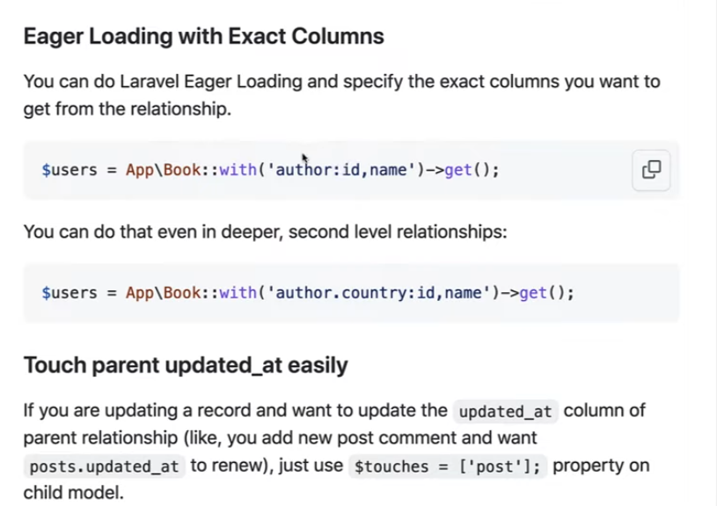

Fetch random data

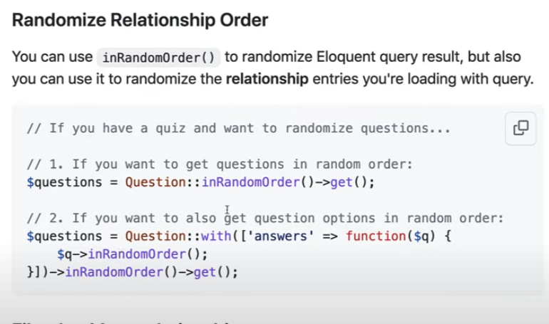

Simple Custom Error Handling

*App/Exceptions/Handler.php*

$this->renderable(function (\Exception *$e*, *$request*) {  
 if(*$request*->wantsJson()){  
  
 //Throw custom error if Not Found Http Exception Thrown  
 if(*$e* instanceof NotFoundHttpException){  
 return response()->error('Object not found');  
 }  
  
 //Throw custom error if the Http Request is incorrect  
 if(*$e* instanceof MethodNotAllowedHttpException){  
 return response()->error('Http Request Incorrect');  
 }  
  
 }  
});

My Custom ApiController extending the main Controller

protected function isOwnedByUser(*$action*, *$model*)  
{  
 if(auth()->user()->can(*$action*, *$model*)){  
 return true;  
 }  
}

To trigger function everytime the user creates

public static function boot()  
{  
 parent::boot();  
 self::creating(function (*$model*) {  
 *$model*->id = IdGenerator::generate(['table' => 'users', 'length' => 11, 'prefix' => *date*('Yis')]);  
 });  
}

To substitute id for referencing

*\*add this to model*

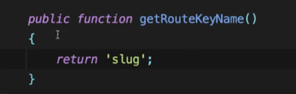

Rules to add to except field when updating

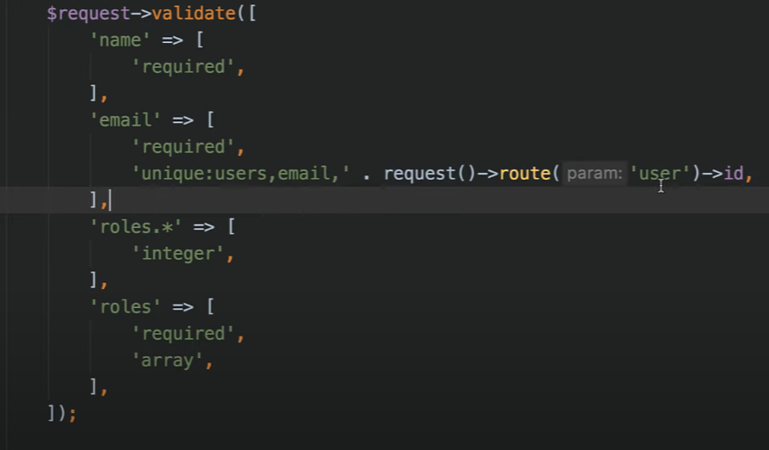

Validating date, must not pass if date is more than now

