WeatherWear Database Documentation
PostgreSQL OLTP schema, integrity, roles, test data, and verification
Project | WeatherWear Backend
Database category | Relational transactional database (OLTP)
DBMS | PostgreSQL 16
Reviewed | 2026-04-30
This document packages the database requirements evidence for the WeatherWear backend: data dictionary, logical schema, DDL/migrations, integrity rules, access roles, test data, and verification steps.

Contents
- Scope and DBMS choice
- Requirement coverage
- Deployment and versioning
- Logical schema
- Data dictionary
- Normalization and relationships
- Integrity and transactions
- Indexes
- Roles and security
- Views, masking, and reporting
- Test data
- Restrictions compliance
- How to verify
- Appendix: database requirements checklist

Reviewed: 2026-04-30

1. Scope and DBMS Choice
WeatherWear uses a relational transactional database because the main data is structured application data: users, preferences, chat sessions, messages, recommendation history, feedback, and cached weather responses. The project uses PostgreSQL 16 through Spring Data JPA and Flyway migrations.
This project belongs to the Transactional Database (OLTP) category. OLAP and NoSQL are not required for the current scope because the application does not implement a separate analytical warehouse and does not require a document, graph, key-value, or column-family database as a core storage model. Weather cache is a helper table inside the OLTP database, not a separate database part.

2. Requirement Coverage
Requirement | Status | Project artifact
Modern relational DBMS | Done | PostgreSQL 16 in docker-compose.yml
Database structure created by scripts/migrations | Done | src/main/resources/db/migration/V1__init_schema.sql, V2__database_integrity_and_reporting.sql
DDL script in version control | Done | Flyway migration files
Data dictionary | Done | Section 5 of this document
Logical schema | Done | Documentation/database_schema.mmd and section 4
Keys and relationships | Done | PK/FK/UNIQUE constraints in migrations
Data integrity constraints | Done | NOT NULL, UNIQUE, FK, CHECK constraints, triggers
Transactions | Done | Spring Data transaction boundaries, explicit @Transactional, SQL test-data transaction
Test data | Done | src/main/resources/db/testdata/weatherwear_test_data.sql
Roles and access rights | Done | src/main/resources/db/security/roles_and_grants.sql, Docker init app user
Application must not run under superuser | Done for Docker setup | Backend uses APP_DB_USER / APP_DB_PASSWORD; PostgreSQL admin user is separate
Passwords encrypted | Done | BCrypt in SecurityConfig; test data stores BCrypt hashes only
Indexes | Done | User, cache, history, feedback, chat indexes in V1
Views / masking | Done | v_anonymized_users, v_user_recommendation_summary in V2
Triggers / UDF | Done | weatherwear_set_updated_at, weatherwear_mask_email in V2

3. Deployment and Versioning
Flyway is the source of truth for the database structure. Production profile enables Flyway and validates JPA mappings:
- spring.flyway.enabled=true
- spring.jpa.hibernate.ddl-auto=validate
Version history is stored in Git through migration files:
- V1__init_schema.sql: base tables, primary keys, foreign keys, initial checks, indexes.
- V2__database_integrity_and_reporting.sql: additional integrity checks, triggers, masking function, reporting views.
Manual database changes should not be applied directly in production. Every structure change should be added as a new migration, for example V3__add_new_feature.sql.
For local Docker deployment, PostgreSQL starts with an admin account (weatherwear_db_admin), and the application connects through a separate non-superuser login (weatherwear_app by default). The app credentials must be stored in .env, GitHub Secrets, Railway variables, or another secure secret storage. They must not be committed to Git.

4. Logical Schema
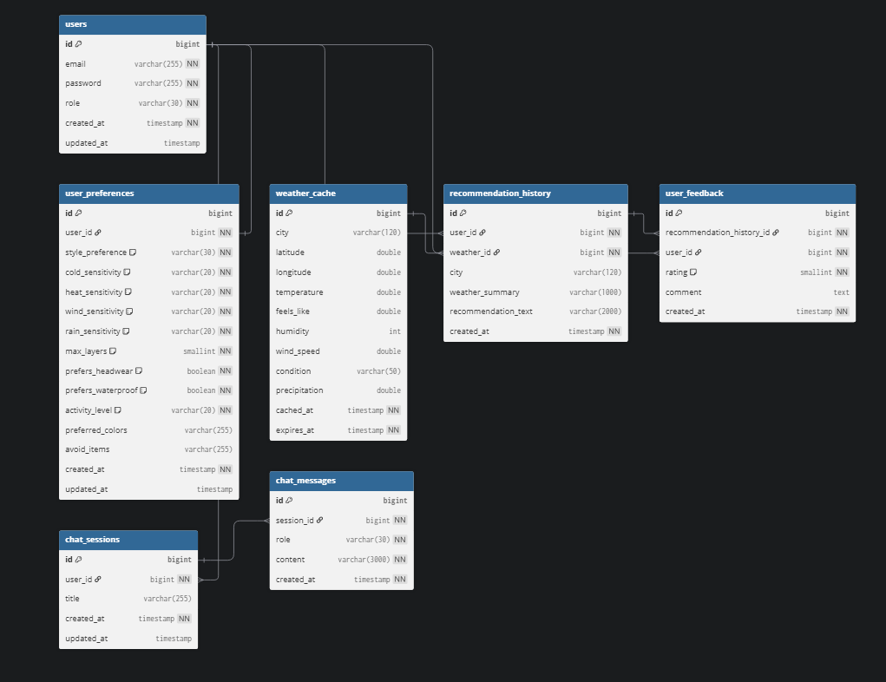
Figure 1. WeatherWear logical database schema reference
Note: The submitted image is used as the visual reference, but the current source of truth is the Flyway schema. One difference is important: the image shows recommendation_history.weather_id, but the current application stores a weather snapshot in weather_summary and does not have a foreign key from recommendation_history to weather_cache.
Main blocks:
Block | Tables | Purpose
Identity | users | Authentication, roles, account timestamps
Personalization | user_preferences | Style, weather sensitivity, activity preferences
Weather | weather_cache | Temporary cached weather data from external API
Recommendations | recommendation_history, user_feedback | Generated outfit advice and user evaluation
Chat | chat_sessions, chat_messages | Conversational style assistant history

5. Data Dictionary

users
Column | Type | Keys / constraints | Quality expectation
id | BIGSERIAL | PK | Generated by database
email | VARCHAR(255) | UNIQUE, NOT NULL, email format CHECK | Valid e-mail, unique account identifier
password | VARCHAR(255) | NOT NULL | BCrypt hash, never plain text
role | VARCHAR(30) | NOT NULL, CHECK USER/ADMIN | Application authorization role
created_at | TIMESTAMP | NOT NULL, default NOW() | Creation time
updated_at | TIMESTAMP | trigger-maintained | Last update time

user_preferences
Column | Type | Keys / constraints | Quality expectation
id | BIGSERIAL | PK | Generated by database
user_id | BIGINT | FK to users(id), UNIQUE, NOT NULL, ON DELETE CASCADE | Exactly one preference record per user
style_preference | VARCHAR(30) | NOT NULL, enum CHECK | One of supported style values
cold_sensitivity | VARCHAR(20) | NOT NULL, enum CHECK | LOW, MEDIUM, or HIGH
heat_sensitivity | VARCHAR(20) | NOT NULL, enum CHECK | LOW, MEDIUM, or HIGH
wind_sensitivity | VARCHAR(20) | NOT NULL, enum CHECK | LOW, MEDIUM, or HIGH
rain_sensitivity | VARCHAR(20) | NOT NULL, enum CHECK | LOW, MEDIUM, or HIGH
max_layers | SMALLINT | NOT NULL, CHECK 1..5 | Reasonable clothing layer count
prefers_headwear | BOOLEAN | NOT NULL | Headwear preference
prefers_waterproof | BOOLEAN | NOT NULL | Waterproof clothing preference
activity_level | VARCHAR(20) | NOT NULL, enum CHECK | LOW, MEDIUM, or HIGH
preferred_colors | VARCHAR(255) | nullable | Optional comma-separated color preference
avoid_items | VARCHAR(255) | nullable | Optional items to avoid
created_at | TIMESTAMP | NOT NULL | Creation time
updated_at | TIMESTAMP | trigger-maintained | Last update time

weather_cache
Column | Type | Keys / constraints | Quality expectation
id | BIGSERIAL | PK | Generated by database
city | VARCHAR(120) | indexed | City name from request/API
latitude | DOUBLE PRECISION | CHECK -90..90 | Valid latitude or NULL
longitude | DOUBLE PRECISION | CHECK -180..180 | Valid longitude or NULL
temperature | DOUBLE PRECISION | reasonable range CHECK | Celsius temperature
feels_like | DOUBLE PRECISION | reasonable range CHECK | Celsius perceived temperature
humidity | INT | CHECK 0..100 | Percent humidity
wind_speed | DOUBLE PRECISION | CHECK >= 0 | Wind speed from API
condition | VARCHAR(50) | enum CHECK | Supported weather condition
precipitation | DOUBLE PRECISION | CHECK >= 0 | Precipitation amount
cached_at | TIMESTAMP | NOT NULL | Cache creation time
expires_at | TIMESTAMP | NOT NULL, indexed | Cache expiry time

recommendation_history
Column | Type | Keys / constraints | Quality expectation
id | BIGSERIAL | PK | Generated by database
user_id | BIGINT | FK to users(id), NOT NULL, ON DELETE CASCADE | Owner of recommendation
city | VARCHAR(120) | nullable | City used for recommendation
weather_summary | VARCHAR(1000) | nullable | Weather snapshot stored at recommendation time
recommendation_text | TEXT | nullable | Generated clothing advice
created_at | TIMESTAMP | NOT NULL | Recommendation time

user_feedback
Column | Type | Keys / constraints | Quality expectation
id | BIGSERIAL | PK | Generated by database
recommendation_history_id | BIGINT | FK to recommendation_history(id), NOT NULL, ON DELETE CASCADE | Feedback target
user_id | BIGINT | FK to users(id), NOT NULL, ON DELETE CASCADE | Feedback author
feedback_type | VARCHAR(30) | NOT NULL, enum CHECK | RATING, LIKE, DISLIKE, COMMENT
rating | SMALLINT | CHECK 1..5 | Optional numeric rating
comment | TEXT | nullable | Optional text comment
created_at | TIMESTAMP | NOT NULL | Feedback time

chat_sessions
Column | Type | Keys / constraints | Quality expectation
id | BIGSERIAL | PK | Generated by database
user_id | BIGINT | FK to users(id), NOT NULL, ON DELETE CASCADE | Session owner
title | VARCHAR(255) | NOT NULL, default Style chat | Human-readable session title
created_at | TIMESTAMP | NOT NULL | Creation time
updated_at | TIMESTAMP | trigger-maintained | Last message/update time

chat_messages
Column | Type | Keys / constraints | Quality expectation
id | BIGSERIAL | PK | Generated by database
session_id | BIGINT | FK to chat_sessions(id), NOT NULL, ON DELETE CASCADE | Parent chat session
role | VARCHAR(30) | NOT NULL, enum CHECK | USER, ASSISTANT, or SYSTEM
content | TEXT | NOT NULL, not blank CHECK | Message text
created_at | TIMESTAMP | NOT NULL | Message time

6. Normalization and Relationships
The schema is normalized to 3NF:
- User identity data is stored only in users.
- User style settings are separated into user_preferences with a one-to-one relationship.
- Generated recommendations are separated from feedback to avoid repeating feedback attributes for each recommendation row.
- Chat sessions are separated from chat messages to support one-to-many conversation history.
- Weather cache is isolated because cached external API data has a different lifecycle from user-owned recommendation history.
Relationship types:
- One-to-one: users to user_preferences.
- One-to-many: users to recommendation_history, users to chat_sessions, chat_sessions to chat_messages.
- Many-to-one: user_feedback points to both users and recommendation_history.

7. Integrity and Transactions
Data integrity is maintained through:
- Primary keys on all tables.
- Foreign keys with ON DELETE CASCADE for user-owned data.
- Unique constraints for users.email and user_preferences.user_id.
- CHECK constraints for enum-like values, ratings, humidity, coordinates, weather numeric ranges, message content, and feedback content.
- Triggers for updated_at consistency.
- Application-level validation through Jakarta Validation DTO annotations.
Transactions:
- Spring Data JPA repository methods run inside Spring transaction boundaries.
- HistoryService.clearCurrentUserHistory() is explicitly marked with @Transactional.
- Flyway runs migrations transactionally where PostgreSQL supports transactional DDL.
- Test data script uses explicit BEGIN / COMMIT, so partial seed data is not left behind if an insert fails.

8. Indexes
The schema includes indexes that match application query patterns:
Index | Purpose
idx_user_preferences_user_id | Fast lookup of preferences by user
idx_weather_cache_city | Cache lookup by city
idx_weather_cache_coordinates | Cache lookup by latitude/longitude
idx_weather_cache_expires_at | Cleanup or freshness checks
idx_recommendation_history_user_id | Recommendation history by user
idx_user_feedback_user_id | Feedback list by user
idx_user_feedback_recommendation_history_id | Feedback by recommendation
idx_chat_sessions_user_id | Chat sessions by user
idx_chat_messages_session_id | Chat messages by session

9. Roles and Security
The project defines least-privilege database roles:
Role | Purpose
app_read | Read-only access to tables and views
app_write | Application read/write access
app_admin | Schema management and administrative access

The local Docker setup creates the application login user from APP_DB_USER / APP_DB_PASSWORD. This user is granted application-level permissions and is not a PostgreSQL superuser. The PostgreSQL admin user is only used for database initialization.
Passwords and tokens must be stored only in secure storage:
- Local .env file, not committed to Git.
- GitHub Secrets for CI/CD.
- Railway variables for production.
User passwords are stored as BCrypt hashes through Spring Security BCryptPasswordEncoder.

10. Views, Masking, and Reporting
V2__database_integrity_and_reporting.sql adds:
- weatherwear_mask_email(input_email TEXT): masks e-mail addresses.
- v_anonymized_users: exposes user metadata without full e-mail or password hashes.
- v_user_recommendation_summary: aggregates recommendations, feedback count, average rating, and latest recommendation date.
These objects support reporting and personal-data minimization without exposing raw user credentials or full e-mail addresses.

11. Test Data
The test data script is:
src/main/resources/db/testdata/weatherwear_test_data.sql
It inserts:
- demo users with BCrypt password hashes,
- preferences covering normal and edge cases,
- weather cache records for rain, snow, clouds, and extreme heat,
- recommendation history,
- user feedback,
- chat session and messages.
Run it only in local or test databases:
psql "$DATABASE_URL" -f src/main/resources/db/testdata/weatherwear_test_data.sql

12. Restrictions Compliance
The project does not use CSV or Excel files as primary storage. It does not store passwords in plain text. It does not use JSON as an unstructured substitute for a relational model. Database integrity is not ignored: keys, constraints, indexes, transactions, migrations, and permission scripts are all present in version control.

13. How to Verify
- Start a fresh local database:
docker compose down -v
docker compose up --build

- Check that migrations are applied:
SELECT version, description, success
FROM flyway_schema_history
ORDER BY installed_rank;

- Check that the backend is not using a superuser:
SELECT rolname, rolsuper
FROM pg_roles
WHERE rolname IN ('weatherwear_app', 'app_read', 'app_write', 'app_admin');

- Check tables and views:
\dt
\dv
SELECT * FROM v_user_recommendation_summary;

- Load demo data in a local/test database:
psql "$DATABASE_URL" -f src/main/resources/db/testdata/weatherwear_test_data.sql

- Confirm password hashes are not plain text:
SELECT email, password LIKE '$2%' AS is_bcrypt_hash
FROM users;

Appendix. Database Requirements Checklist

Category
The project uses a relational transactional database (OLTP): PostgreSQL. OLAP and NoSQL are not required for the current WeatherWear backend scope.

Minimum Requirements for OLTP
Point | Done | Evidence
Data dictionary | Yes | Documentation/database_documentation.md
Describe tables, columns, data types, keys, and quality expectations | Yes | Data dictionary section
Describe integrity and transactions | Yes | Documentation section 7, migrations, Spring services
Logical schema | Yes | Documentation/database_schema.mmd and DOCX figure
DDL script | Yes | src/main/resources/db/migration/V1__init_schema.sql, V2__database_integrity_and_reporting.sql
Modern relational DBMS | Yes | PostgreSQL 16
3NF design | Yes | Documentation normalization section
Enough tables and relationships | Yes | 7 tables, 1:1 and 1:N relationships
PK/FK/constraints | Yes | Flyway migrations V1 and V2
Meaningful data types | Yes | BIGSERIAL, VARCHAR, TEXT, BOOLEAN, TIMESTAMP, DOUBLE PRECISION
Structure created by scripts/migrations | Yes | Flyway
Scripts in Git | Yes | src/main/resources/db
Test records | Yes | src/main/resources/db/testdata/weatherwear_test_data.sql
Reference/fixed data approach | Yes | Enum-like values are constrained in V2 and documented
Roles/access rights | Yes | src/main/resources/db/security/roles_and_grants.sql
Application not superuser | Yes | Docker uses APP_DB_USER; admin user is separate
Passwords encrypted | Yes | BCrypt encoder and BCrypt test-data hashes
Data integrity through constraints/transactions | Yes | FK, UNIQUE, CHECK, triggers, @Transactional

Maximum / Extra Requirements Covered
Point | Status | Evidence
Database versioning | Covered | Flyway migrations and Git
Indexes with reasoning | Covered | Database documentation index section
Triggers/UDF | Covered | weatherwear_set_updated_at, weatherwear_mask_email
Views | Covered | v_anonymized_users, v_user_recommendation_summary
Data masking/anonymization | Covered | v_anonymized_users and masking function

Not Applicable
Requirement | Reason
OLAP analytical DBMS | The project has no analytical warehouse/reporting pipeline requirement
Raw/staging/data mart layers | Not needed for OLTP application data
NoSQL DBMS | Project data is structured relational data; NoSQL would be unjustified
Multiple DBMS types | Current scope does not require a second DBMS
SCD / analytical dimensions | OLAP-only requirement, not part of this backend

