Compiler And Executable

Scripting Process, Format, Outline

Screenshot

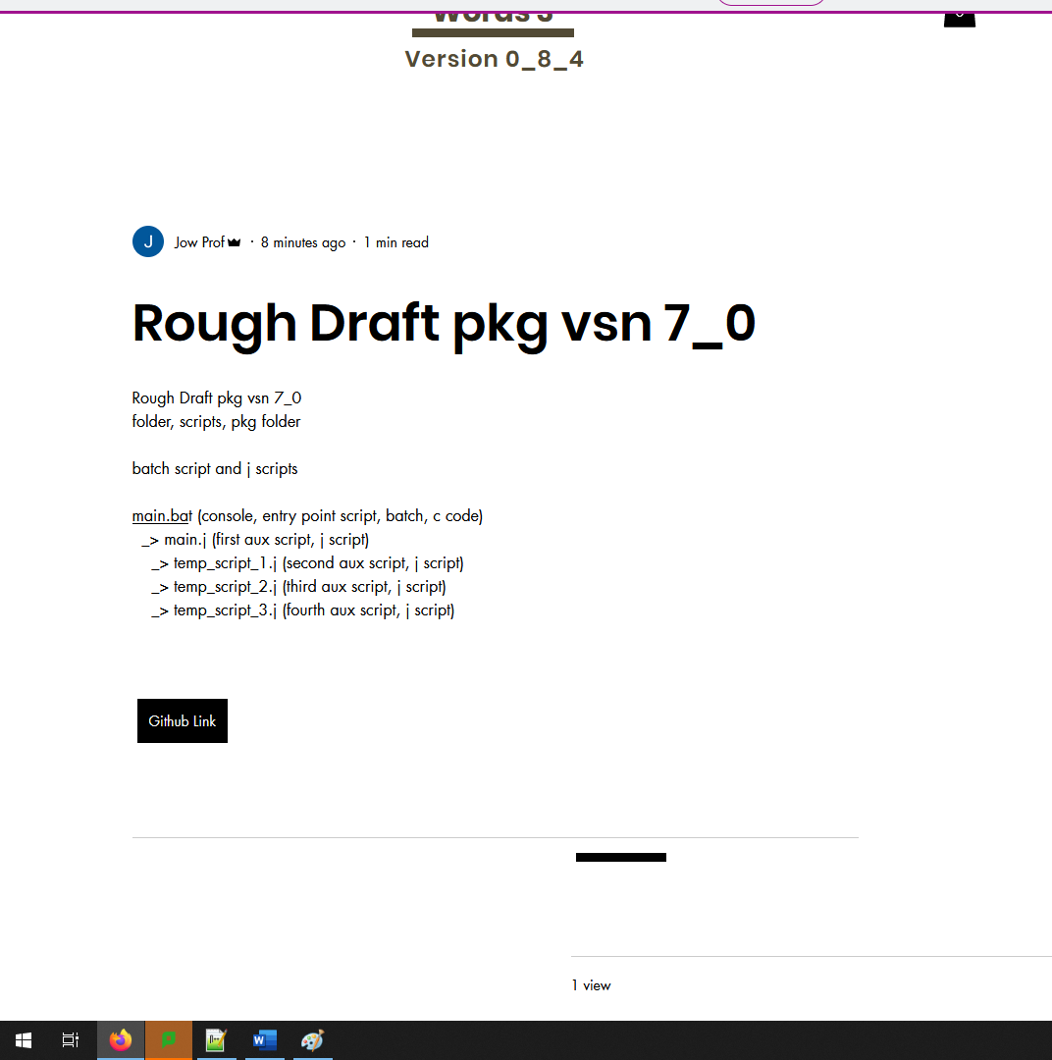

Main.bat entry point console code, key words, scripts, outline

EntryPoint, Main.bat

* Main.j
* -> Temp_script_1.j
* -> Temp_script_2.j
* -> Temp_script_3.j

Main.bat

Echo main.j

Echo temp_script_1.j

Echo temp_script_2.j

Echo temp_script_3.j

Main.bat example 2

Echo 31

Echo 32

Echo 33

Echo 34

Main.j

valueThatShouldBePrinted = 31;

MyPrint();

valueThatShouldBePrinted = 32;

MyPrint();

valueThatShouldBePrinted = 33;

MyPrint();

valueThatShouldBePrinted = 34;

MyPrint();

Main.bat example 3

Echo “main.j”

Echo 31

Echo 32

Echo 33

Echo 34

Echo “done printing vals.”

Echo …

Native C Path, Easy like Lua

This one is like C code, like SDL.

Native J Path, Interesting, like SDL, or Firefox, emulator, like HTML

This one is like notebooks, like Mozart.

Compiler And Executable

Written in C code, Windows 98

Compiler And Executable

Written in J Code, MS Paint, And Batch Scripts (console scripts, “c code”)

Windows, 98

Signed,

JHEM

You could make both, you could pick one, or you could pick a different one like Java, or HTML, or some other combination.

To make it more easy or manageable, you could accept the Batch Script idea for console scripts so it makes it like CodeBlocks like Windows 98, if you used Text Files and scripts primarily.

|-> Text File, Script, “main.j”

__ Text File, Script, “console_main.bat” (Console, Cmd, Entry Point, Script)

|-> Text File, Script, “temp_script_1.j”

|-> Text File, Script, “temp_script_2.j”

|-> Text File, Script, “temp_script_3.j”

Main.j

valueThatShouldBePrinted = 31;

MyPrint();

valueThatShouldBePrinted = 32;

MyPrint();

valueThatShouldBePrinted = 33;

MyPrint();

valueThatShouldBePrinted = 34;

MyPrint();

Main.bat example 3

Echo “main.j”

Echo 31

Echo 32

Echo 33

Echo 34

Echo “done printing vals.”

Echo …