# Practical Application Assignment #1

## Link to Jupyter Notebook

<coupon_analysis.ipynb>

## EDA

* Missing values were present in 6 columns
* The cars column had a large amount of missing values and was dropped.
* The remaining 5 columns had a very small percentage of missing values.
* The remainder of examples with missing values were dropped as they were a small percentage of the overall dataset.
* The temperature column has only three distinct values, which suggests that it is not very precise

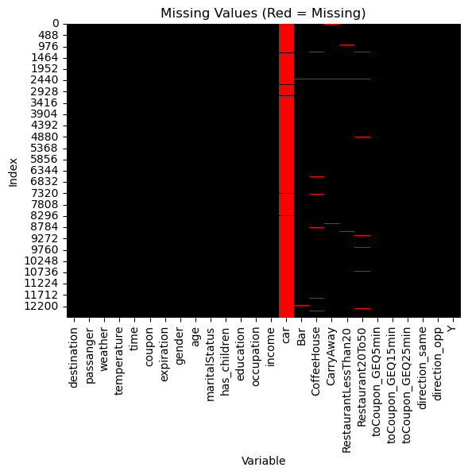

missing

## Findings

* 57% of drivers accepted coupons
* Coffee House coupon were the most frequently offered.

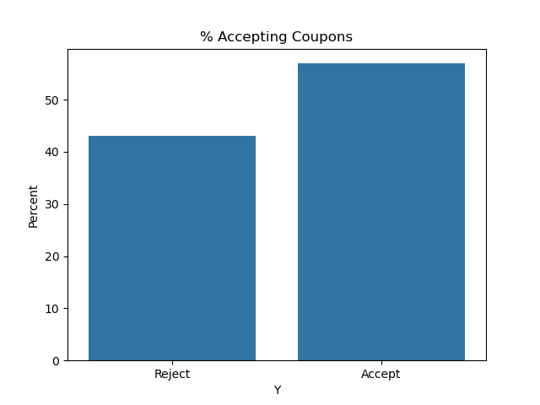

accepting

### Bar Coupons

* ~59% of Bar coupons were accepted
* Those who went to a bar more than 3 times per month were much more likely to accept bar coupons
* Driver over 25 and going to the bar more than once a month were also very likely to accept coupons
* Drivers who had passengers that were not kids, and who occupation was not in farming, fishing, or forestry were also mor likely to accept coupons
* Those who go to bars more than once a month, and had passengers that were not a kid, and were not widowed were likely to accept coupons
* Those who go to bars more than once a month and are under the age of 30 were also likely to accept coupons

### Expensive Restaurant Coupons

* Those who have kids are marginally less likely to accept coupons for more expensive restaurants.

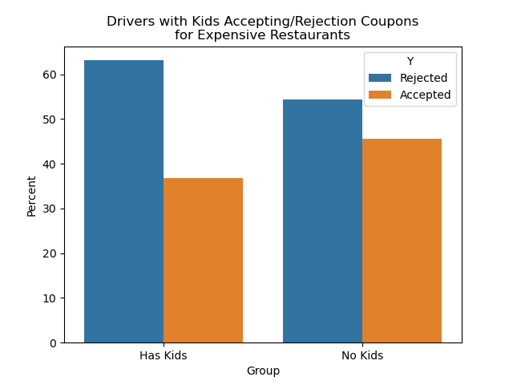

alt text

## Next Steps

* Target offering Bar coupons to the those who visit the bar frequently
* Maybe offer less expensive or coupons for kid friendly restaurants to those with kids
* Further investigation into the types of coupons that are accepted most by those with kids could be next steps.