|  |  |
| --- | --- |
|  | Faculty of Information Science And Technology  Universiti Kebangsaan Malaysia  43600 Bangi  Selangor |
| **Project Title:**  Online Shopping    **Lecturer:**  **Prof. Madya Dr. Ravie Chandren A/L Muniyandi**    **Students Details:** | |

Chen Hui Xuan A160687

Loo Xin Yong A60195

**1.0 Problem Statement**

Online business requires a simple system to allow customer to do online shopping and calculate their total amount for the items in the shopping cart.

**2.0 Objective**

Create a simple online shopping system to allow customer to do shopping easily by adding items wanted into the cart and get the total amount that they need to pay at the checkout.

**3.0 Sub-problem**

1. View items
2. Add and delete items into and from shopping cart
3. View shopping cart
4. Calculate total amount

**4.0 10 system requirements**

1. Sign up 6. Sort item by type (category)
2. Login 7. Add item into cart
3. View available items 8. Delete item from cart
4. View id of the items 9. View shopping cart
5. View price of the items 10. Calculate total amount/ receipt

**5.0 Software Development Life Cycle (SDLC)**

The SDLC model used is Waterfall model as all the system requirements are sorted out and the system is a simple system with a few functions needed to meet the requirements. This model is chosen because it is simple to use and understand.

**6.0 Software Design - Data Flow Diagram (DFD)** 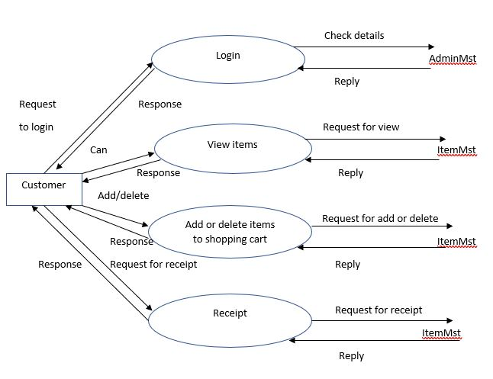

**6.0 Programming Language**

C Programming language is chose to write the program as it allows a complex program to be broken into simpler programs like functions. It also allows free movement of data across these functions. For example, C language allows the passing of item price and item id across the functions in our program by using pointer. C program is also highly portable and can easily run on another computer without any change.

**6.0 Test plan**

**6.1 Objective:**

The objective of the test is to test the function and completeness of the designed system to make sure that the system meets all the functional and non-functional requirement. It is also very important to make sure that the system meets the customer’s expectation. The expected functions of the system are login, view items, adding items to cart and removing items from cart, and confirming transaction.

**6.2 Process of system testing**

**6.2.1 Function Test**

The integrated system is tested to ensure that it performs as promised by the requirement specification. The four functions of the program: login, view items, adding items to cart and removing items from cart, and confirming transaction(printing receipt) are tested one after another after the integration.

**6.2.2 Performance Test**

Performance test is carried out to meet non-functional requirement. The arrangement of the item id and item price are designed to be easy for the customer to view and the same arrangement is used in viewing available items, viewing shopping cart and confirming transaction to avoid confusion.

**6.2.3 Acceptance Test**

The program is also tested by several students to test its acceptance to ensure that the system meets the customer’s requirement.

**6.3 Item Pass/Fail Criteria**

For each function, the functions is considered failed if it does not function as expected by the requirement. For example, the confirm transaction function view display all the items in the cart and the total amount of the items selected. The system pass the testing for the function if it is able to view all the items that are selected in the cart and display the correct total amount for checkout, else, the system fail the testing.

**6.4 Test Environment**

The test is to be carried out on any laptop/PC with Windows 10 installed. The system is an offline system, hence network connection is not required.

**6.5 Regression Testing (for System Testing)**

Regression testing is carried out to identify new faults when the correction is done on previous fault. The testing can also verify that the new version of the system still performs in the same manner as the previous version after the changes applied to ensure that the changes have not introduced new faults. The process includes re-running previously completed tests and checking whether there is still error from previous version or new changes.

**6.6 Software Testing**

|  |  |  |  |  |  |  |
| --- | --- | --- | --- | --- | --- | --- |
| Test Scenario | Test  Case | Test  Step | Test  Data | Expected Result | Actual Results | Pass/Fail |
| Check login functionality | Check response on entering username and valid password (in digit only) | 1.Launch application  2.Enter Username  3.Enter Password  4.Press ‘Enter’ in the keyboard | Username: Ali    Password: 12345 | Login must be successful | Login successful | Pass |
| View items functionality | Check response on entering ‘1’ | 1.Enter ‘1’  2. Press ‘Enter’ in the keyboard | Input: 1 | View items must be successful | View items successful | Pass |
| Add items into cart functionality | Check response on entering ‘2’ | 1.Enter ‘2’  2.Enter ‘1’ to add items  3.Enter the item’s ID  4. Press ‘Enter’ in the keyboard | input: 3 | Added item into cart must be successful | Successful added item | Pass |
| Delete items from cart functionality | Check response on entering ‘2’ | 1.Enter ‘2’  2. Enter ‘2’ to delete items  3.Enter the item’s ID  4. Press ‘Enter’ in the keyboard | Input: 3 | Deleted item from cart must be successful | Successful delete item | Pass |
| View shopping cart functionality | Check response on entering ‘3’ | 1.Enter ‘3’  2. Press ‘Enter’ in the keyboard | Input: 3 | View shopping cart must be successful | View shopping cart successful | Pass |
| Calculate total amount functionality | Check response on entering ‘4’ | 1.Enter ‘4’  2. Press ‘Enter’ in the keyboard | Input: 4 | Calculate total amount must be successful | Successful calculate total amount | Pass |