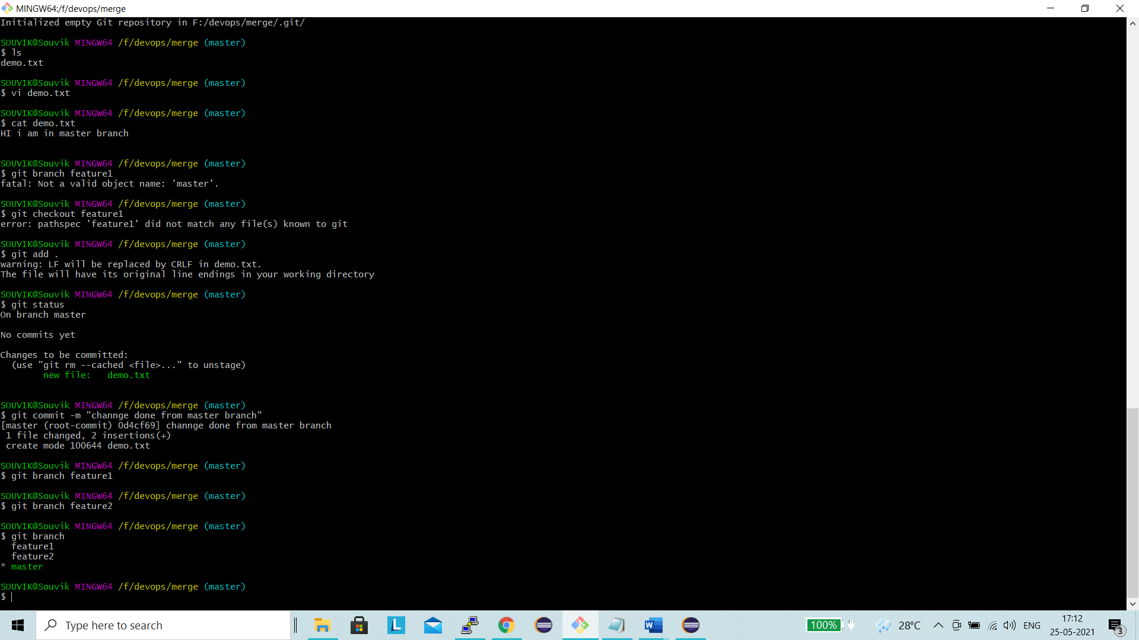

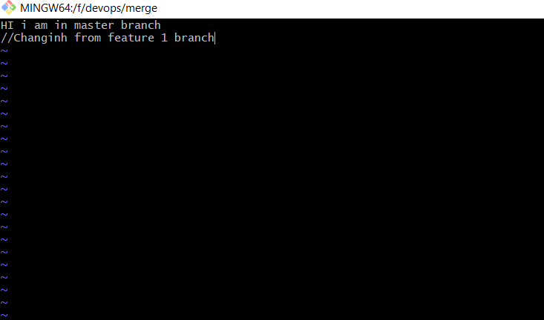

Changes done in same file from both the branches

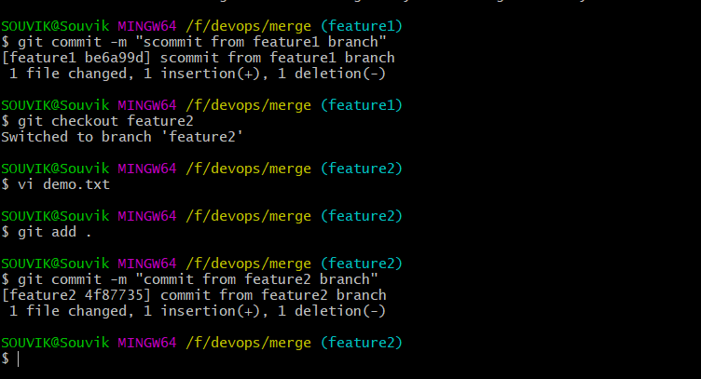

Merge master branch from feature 1 branch and changes also reflect in demo.txt file

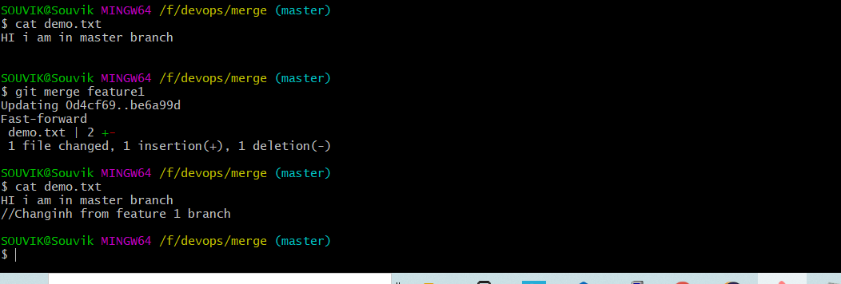

Conflict arise when trying to merge from feature 2 branch

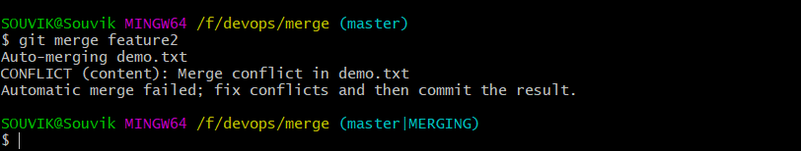

Launch mergetool from gitbash

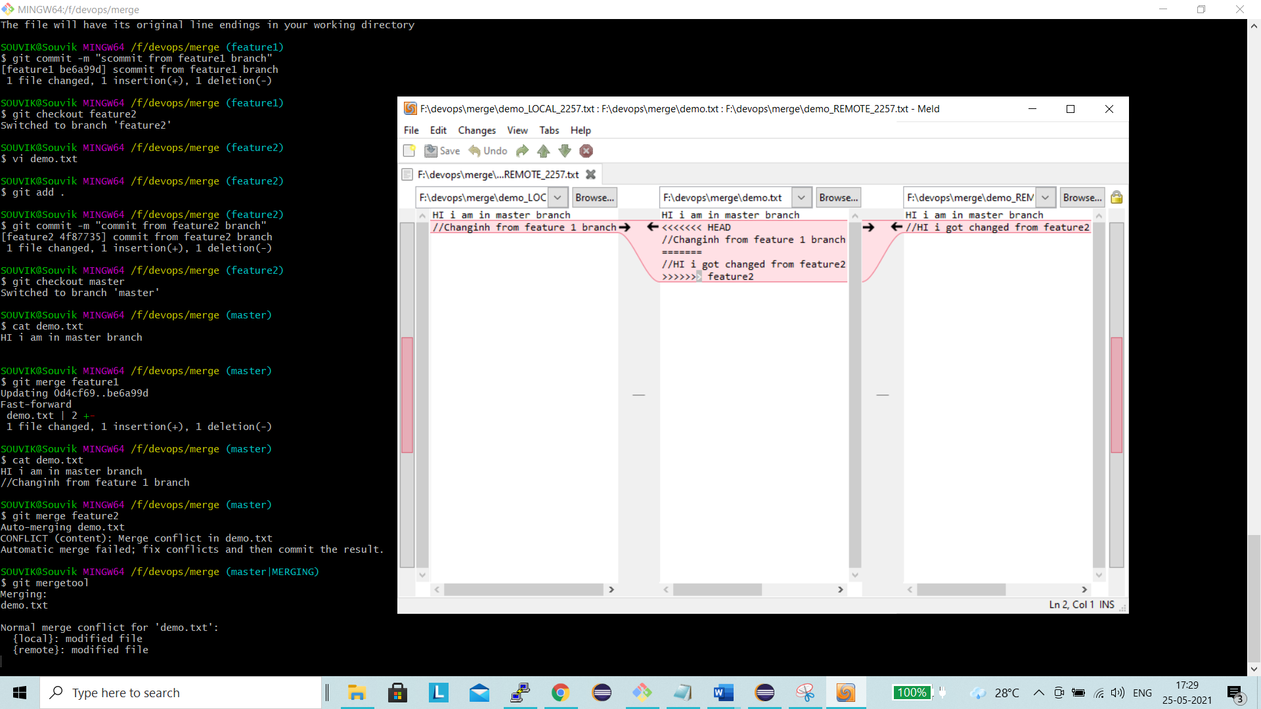

Taken feature 2 branch changes and merge it

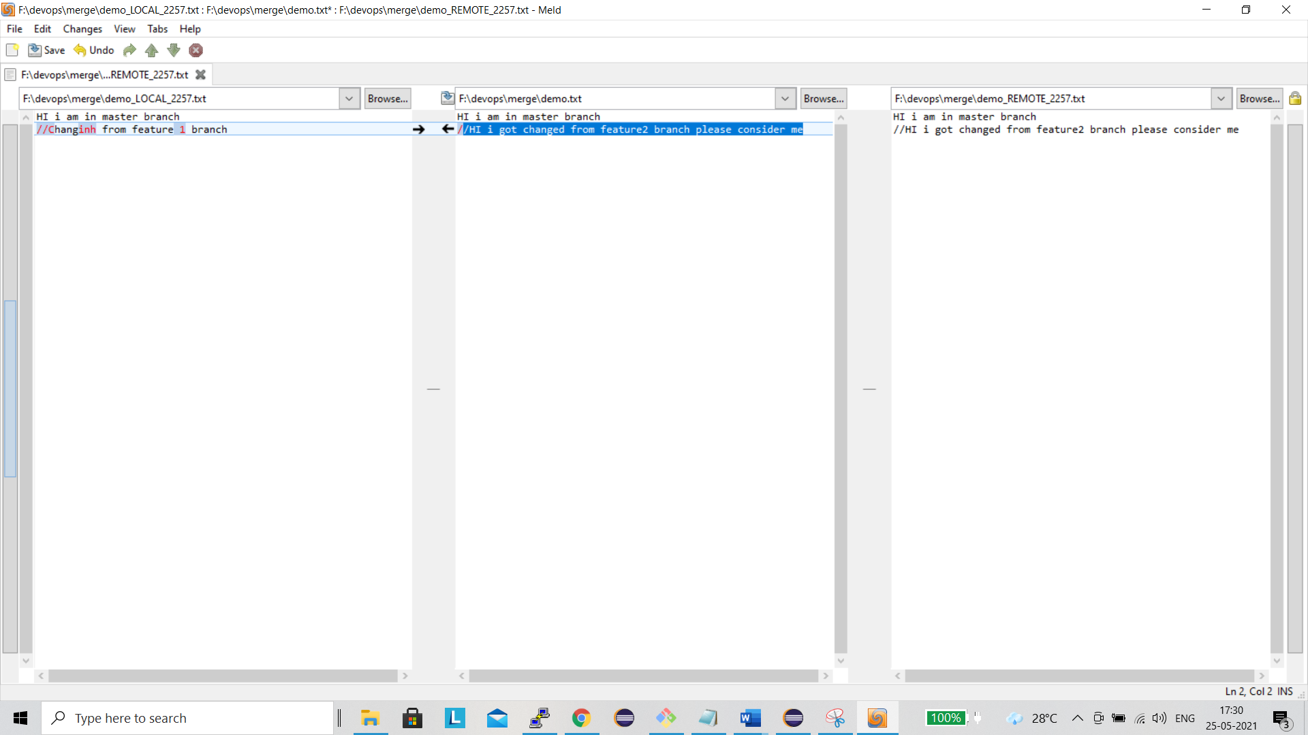

New changes from feature2 branch got merged in to local system

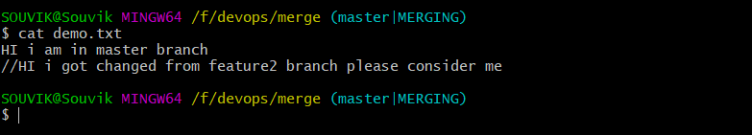

Commit the updated changes from master branch

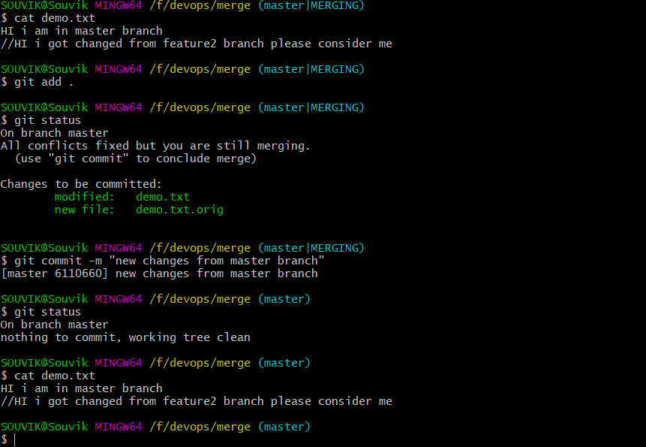

Jenkins============================================================================

Created New EC2 instance

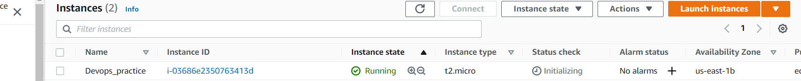

Install Jenkins and check its up and running

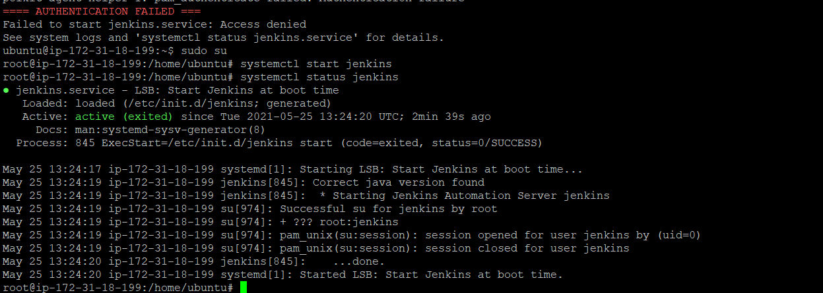

Install Tomcat and check the status

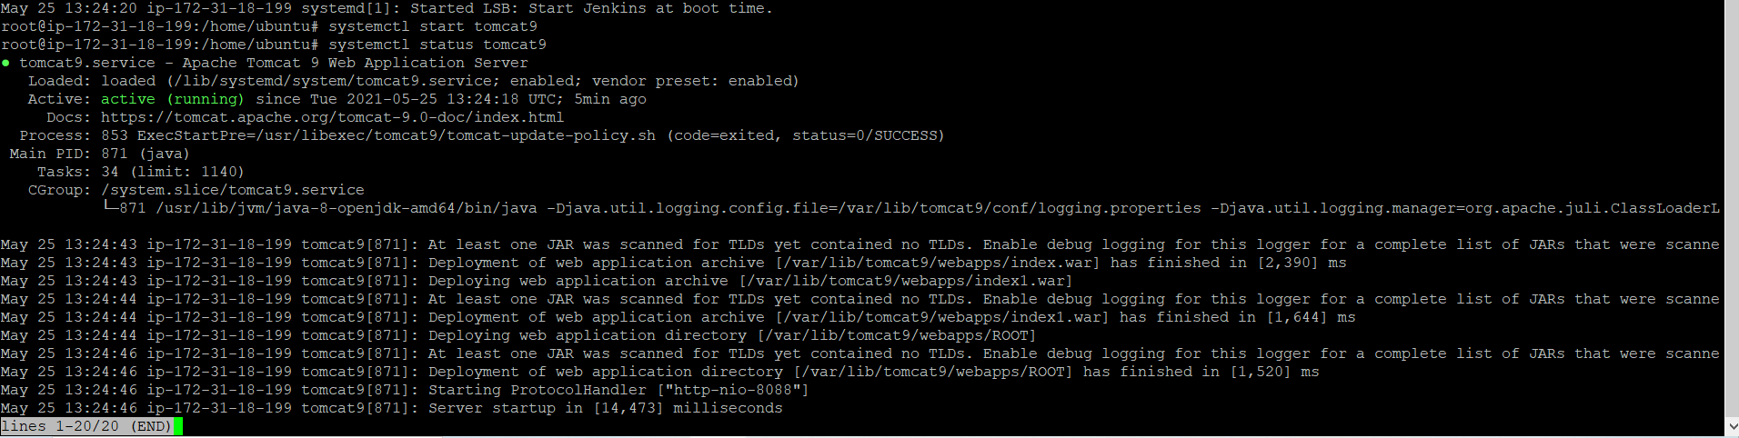

Creted Buildpipeline name testPipeline

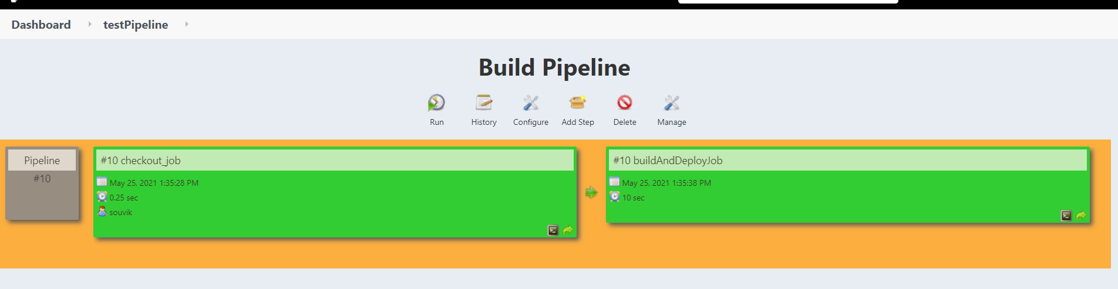

Console output for checkout job

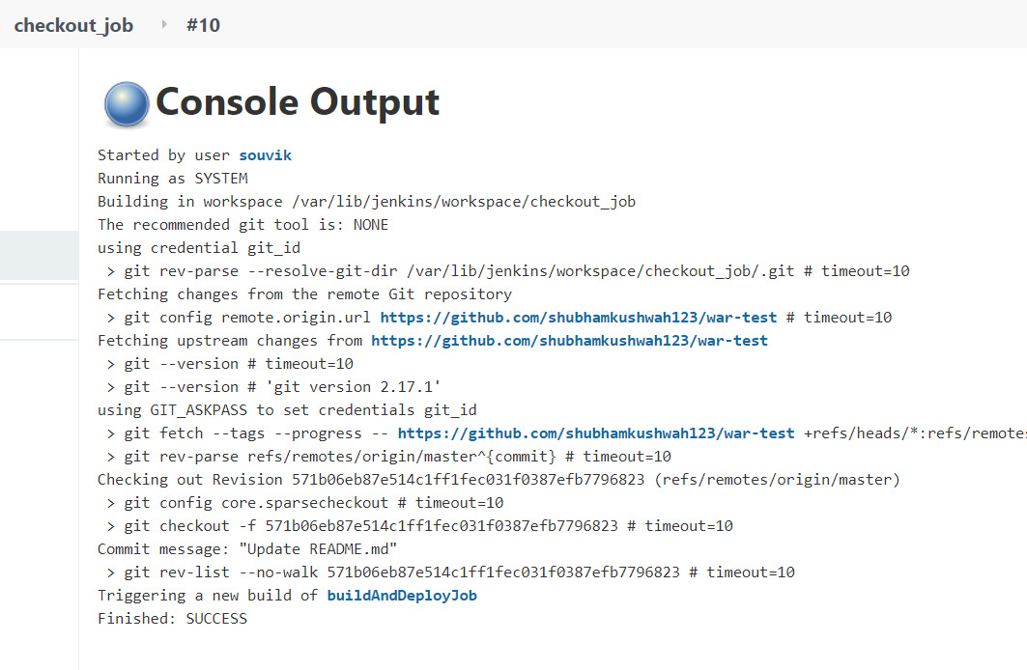

Console log for buildanddeploy job

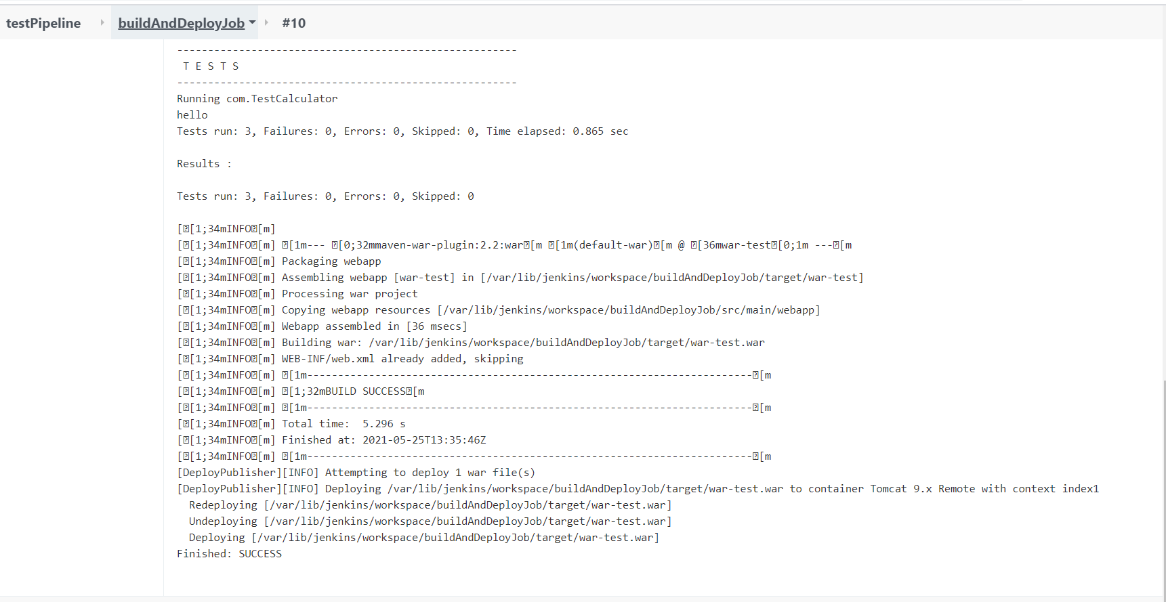

Add contex path as index1 in build configuration

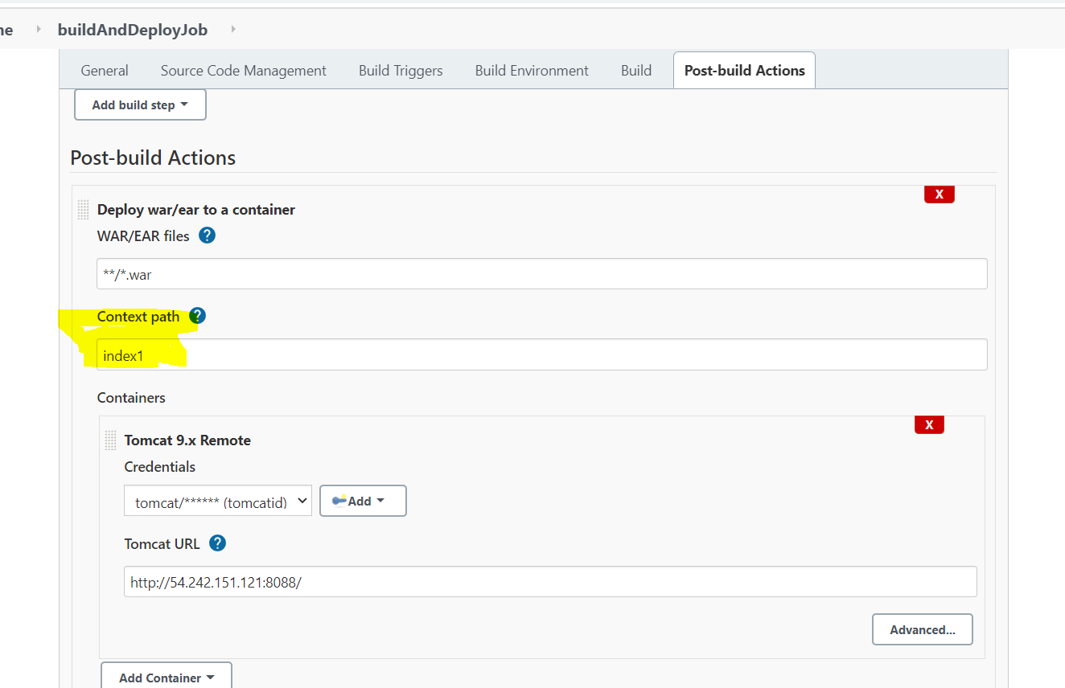

New war file in updated to tomcat server

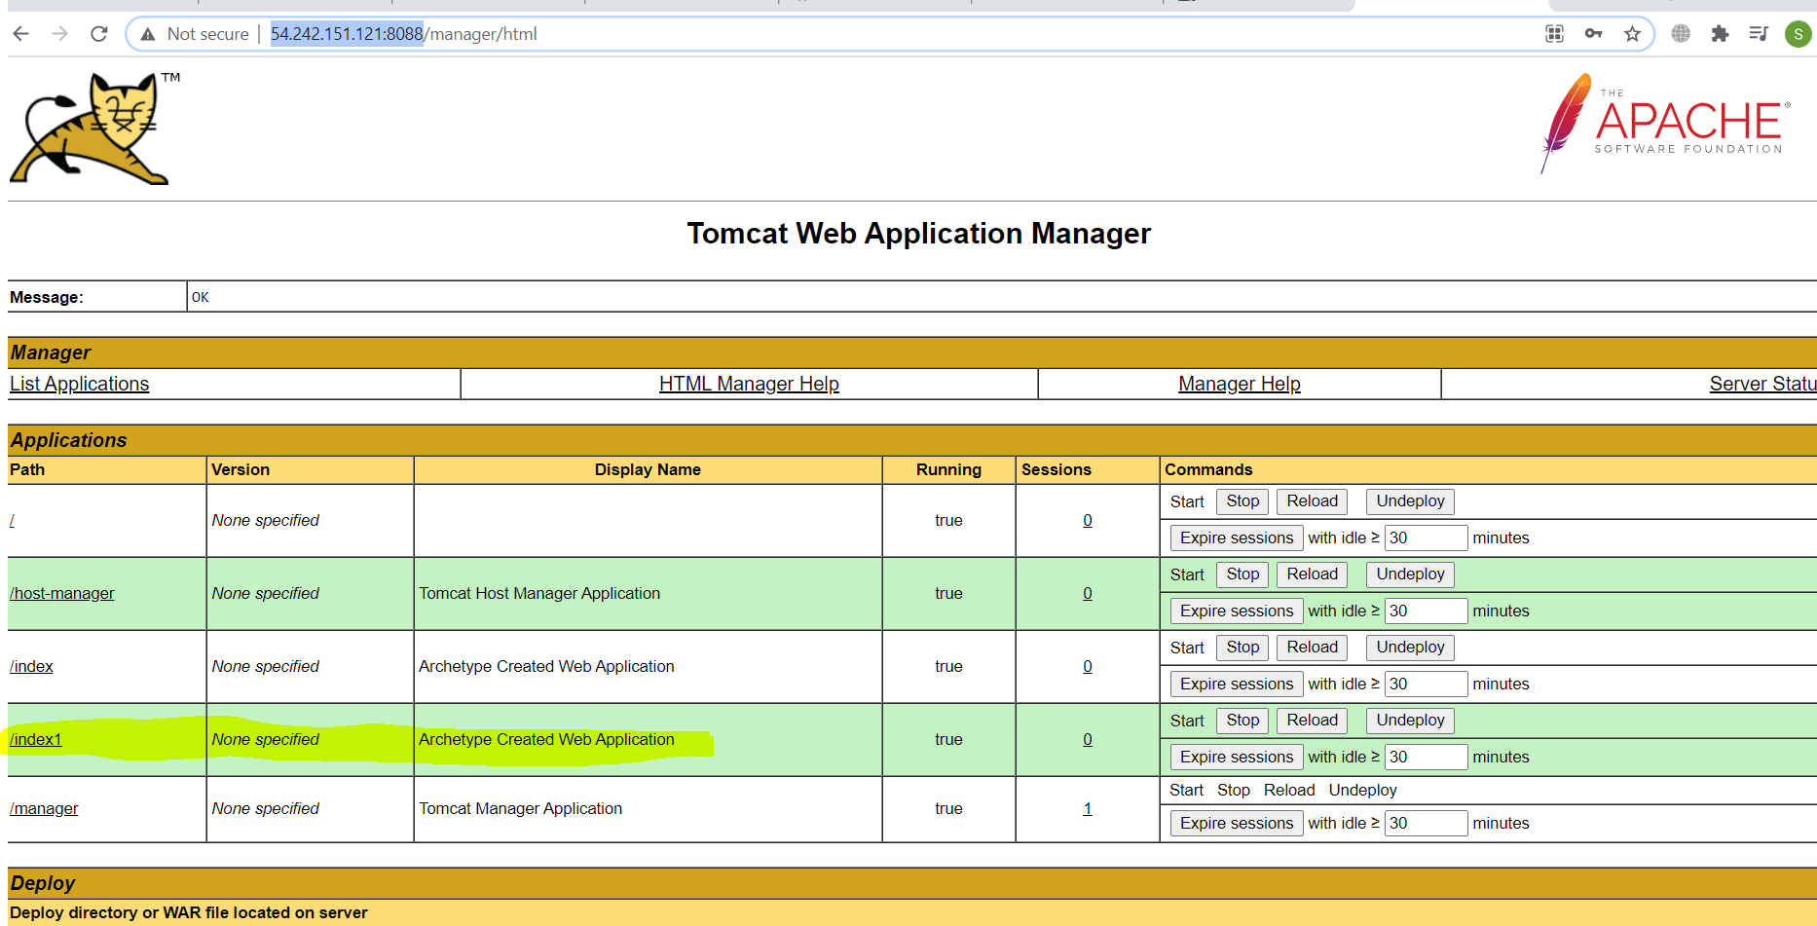

Display page

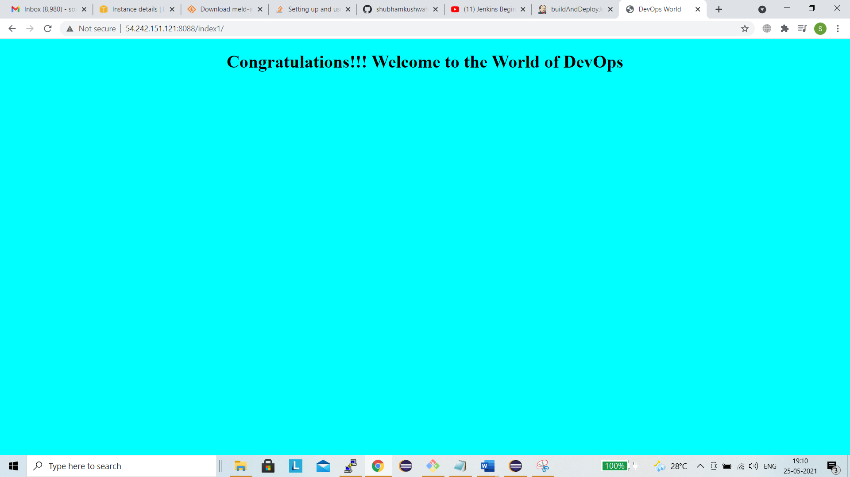

Create pipeline using Groovy script

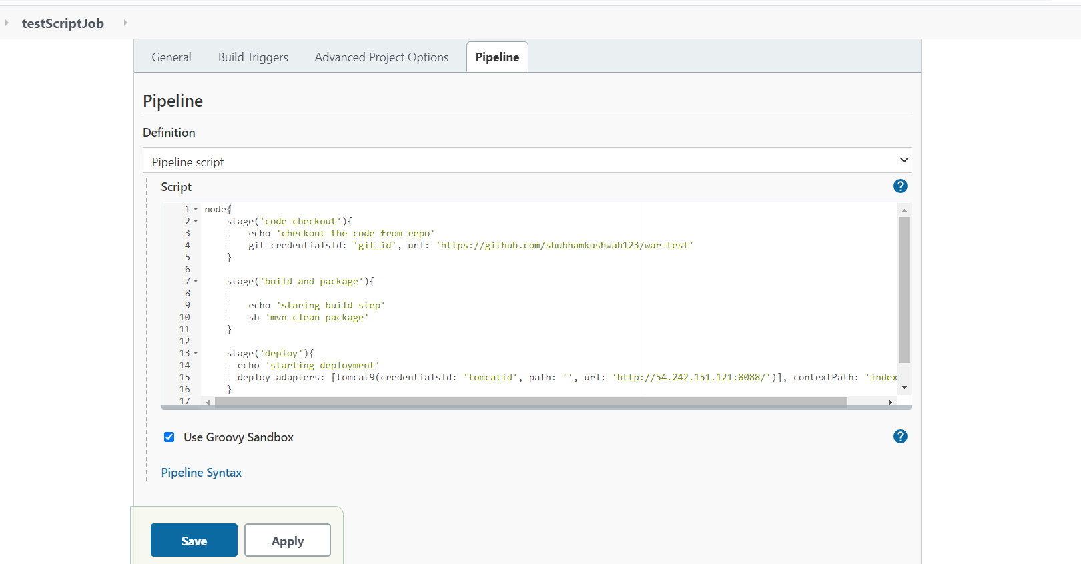

Build is successful

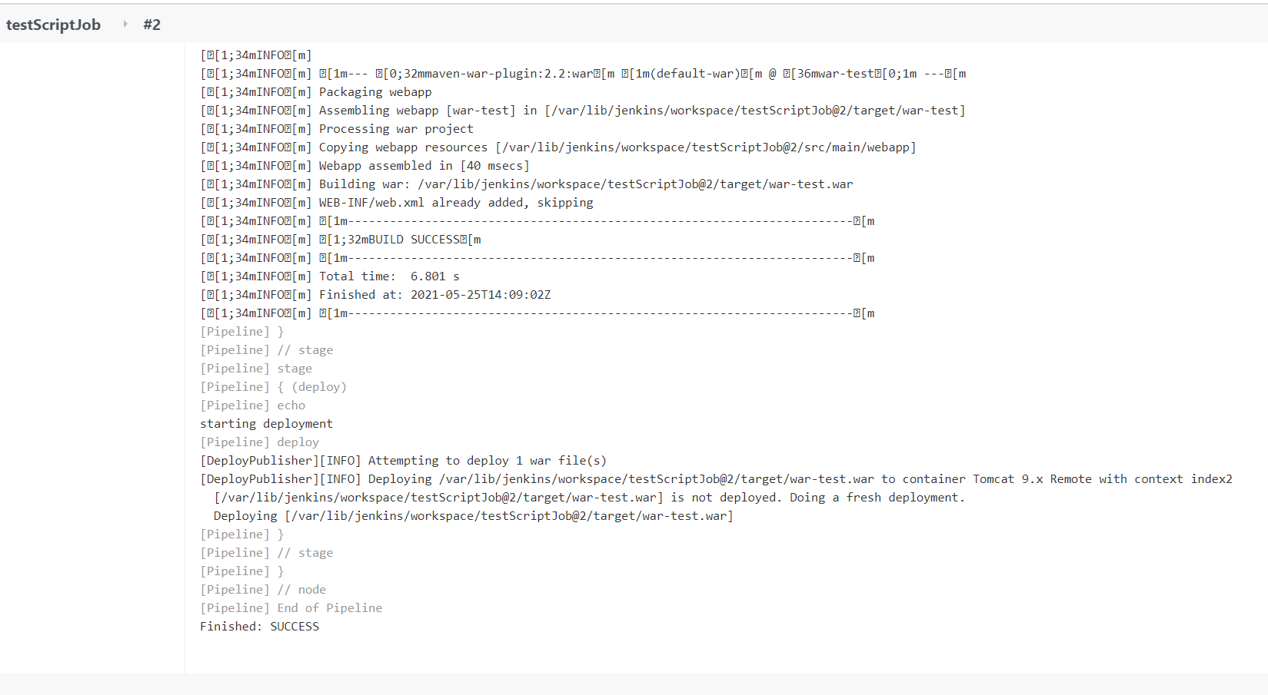

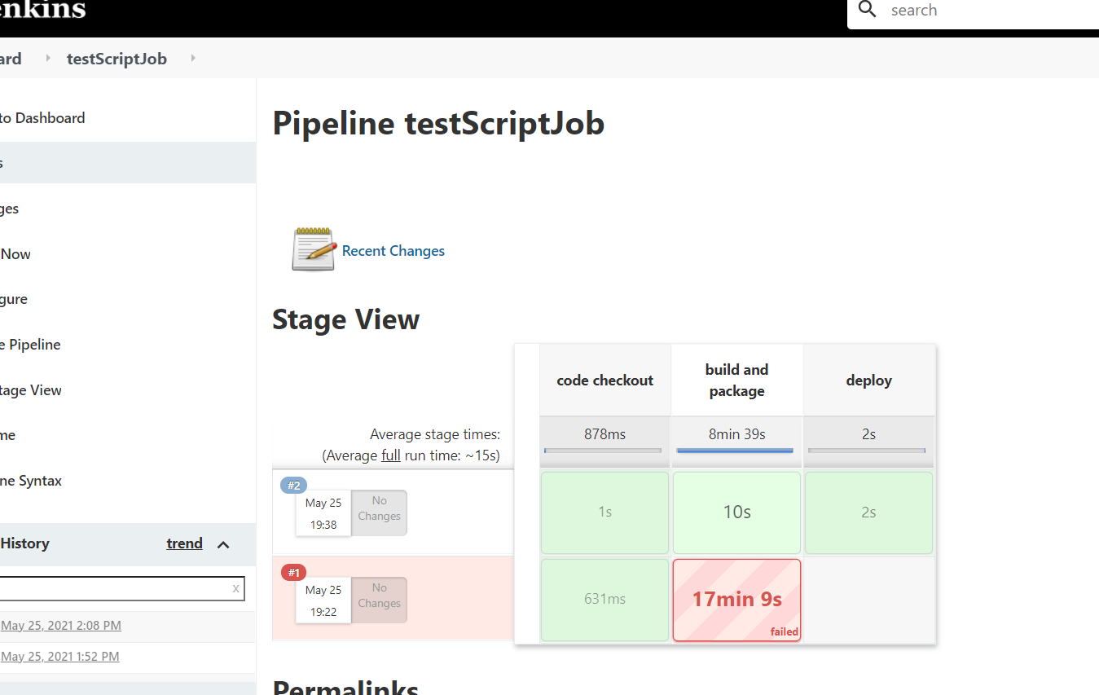

Added context path as index2

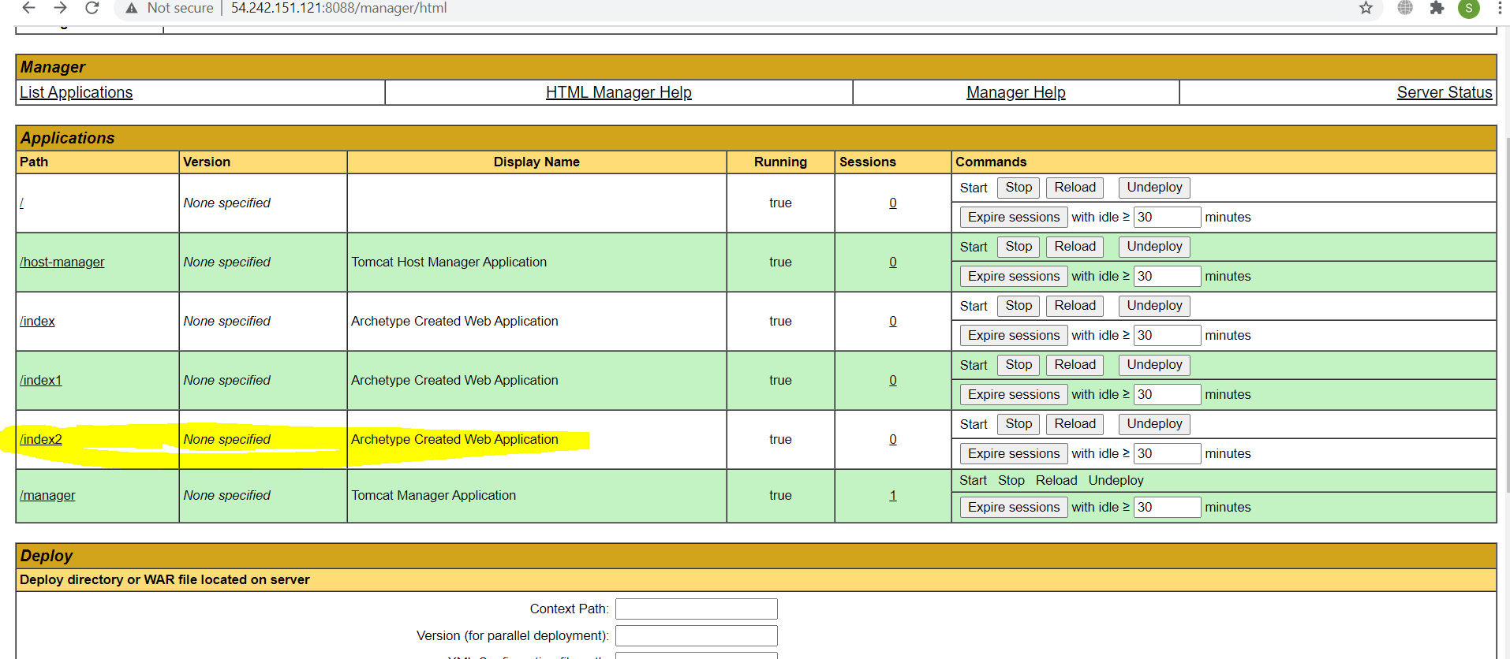

App is up and running

