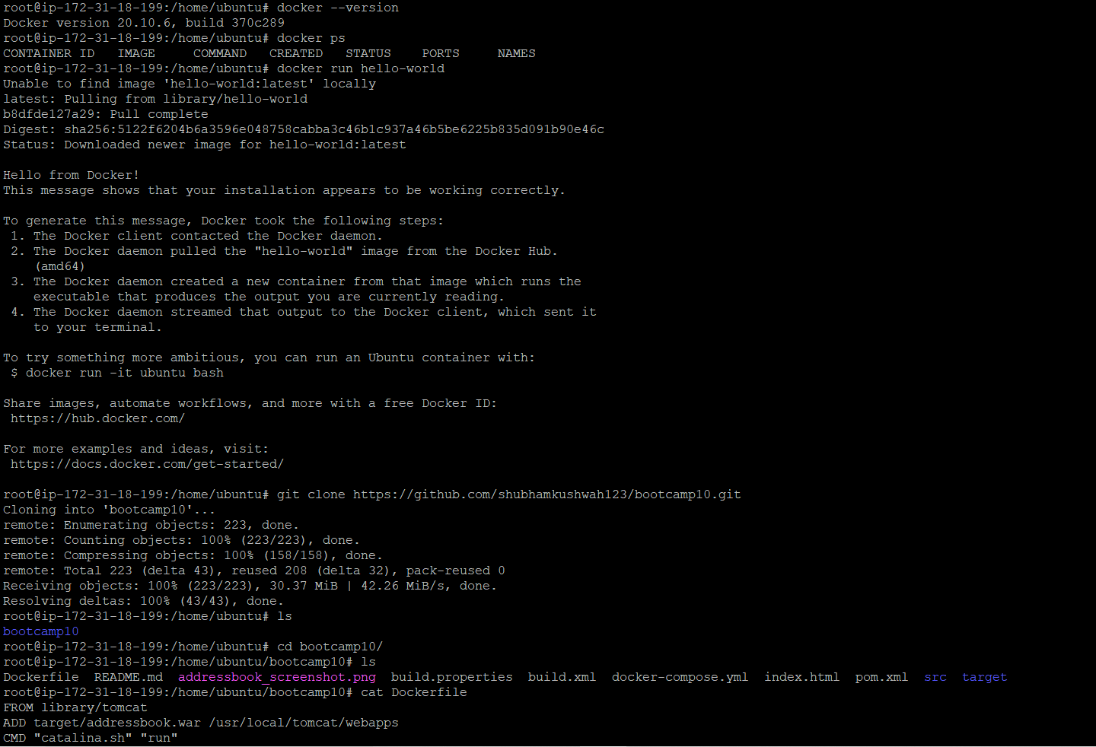

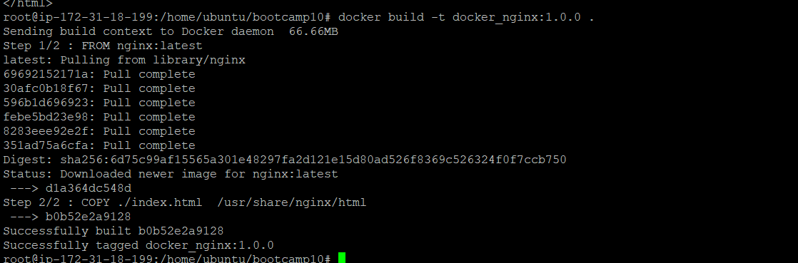





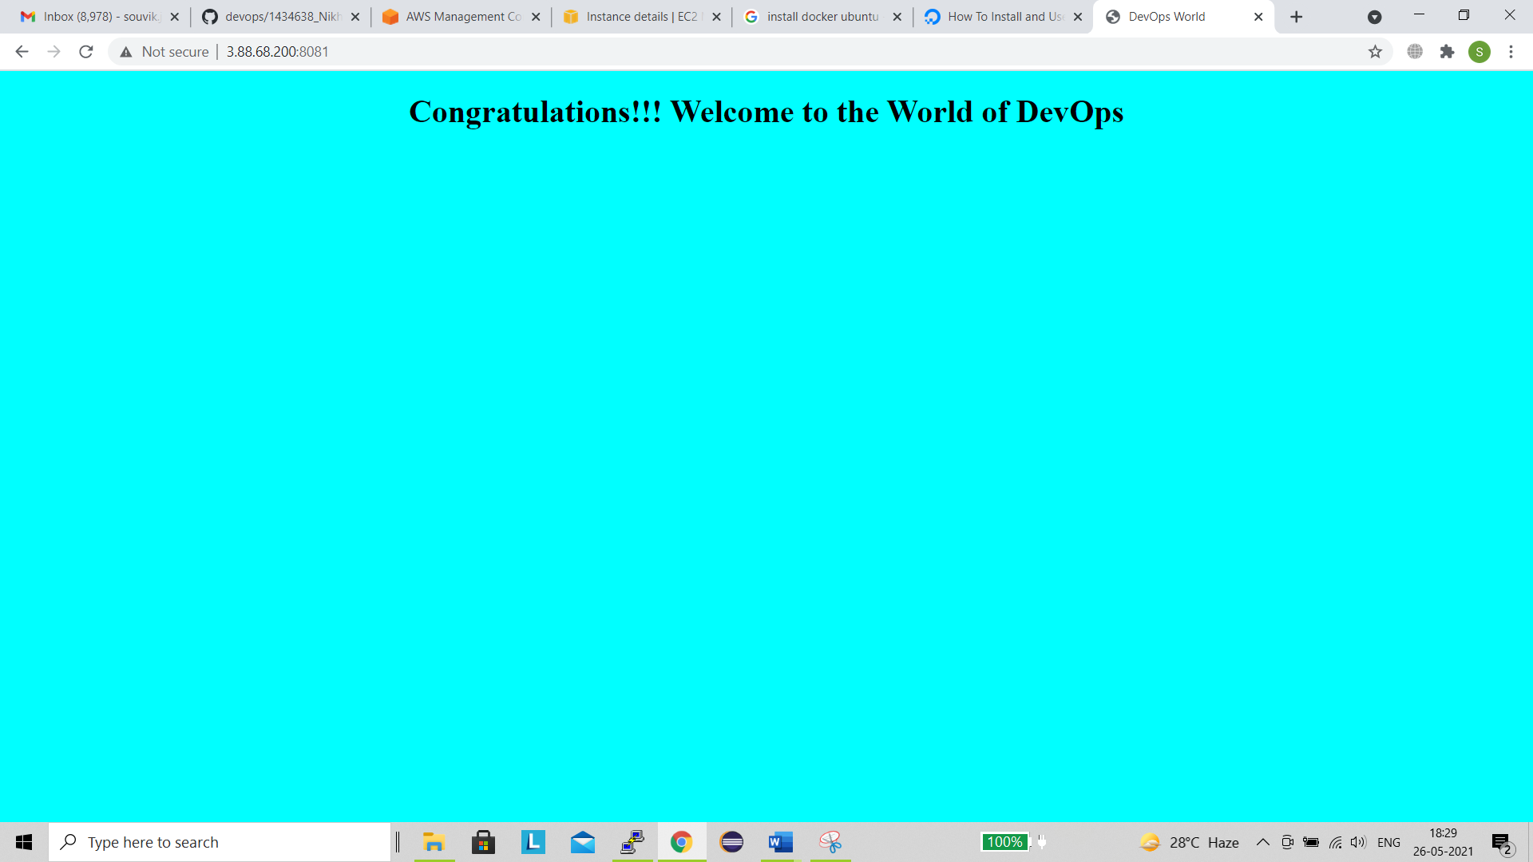

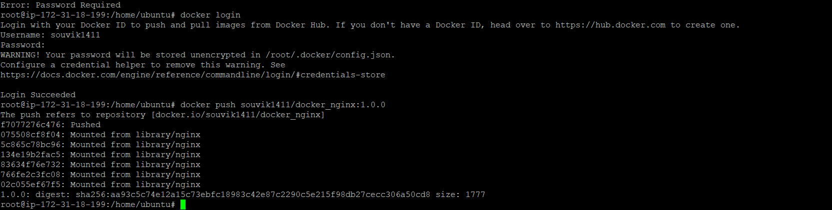

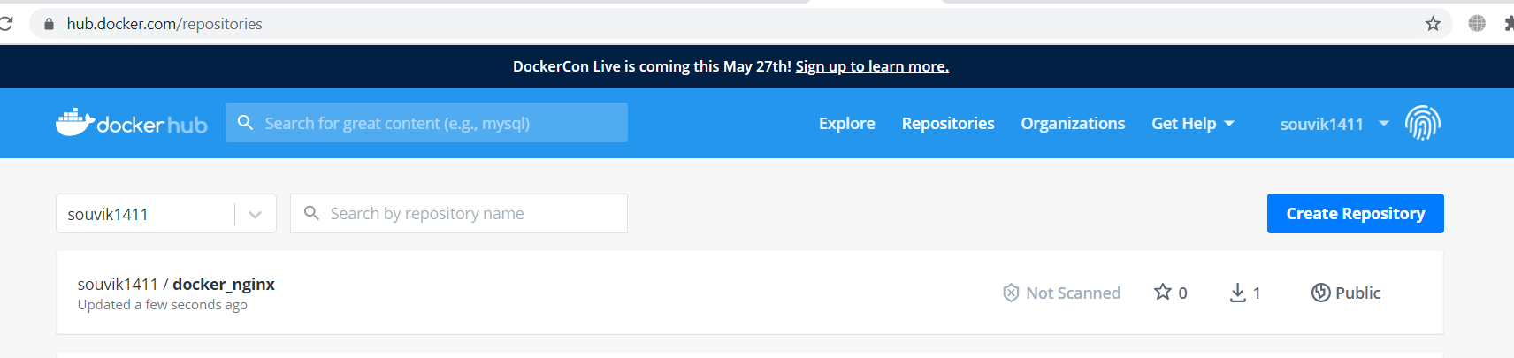



Docker Compose

Due to High cpu utilization not able to proceed docker compose Assignment..Will try later