Created two node one master and another slave node in AWS

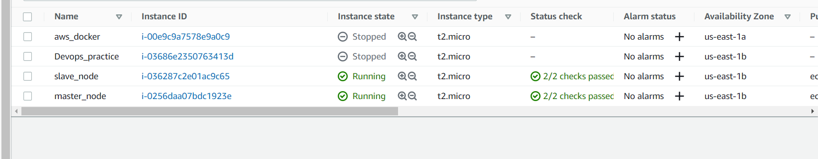

Copy local .pem file from local to Master node

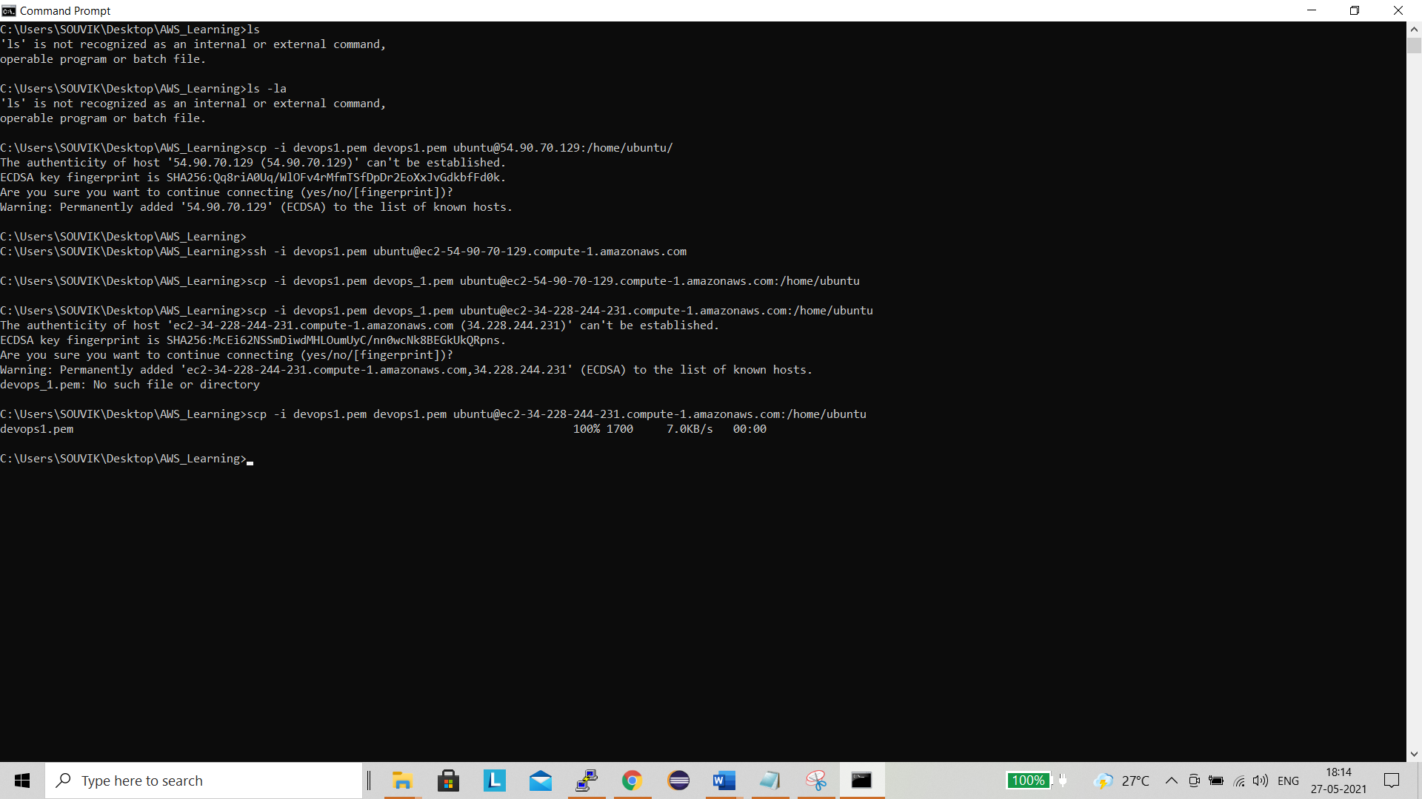

Change hostname to master and check .pem copied

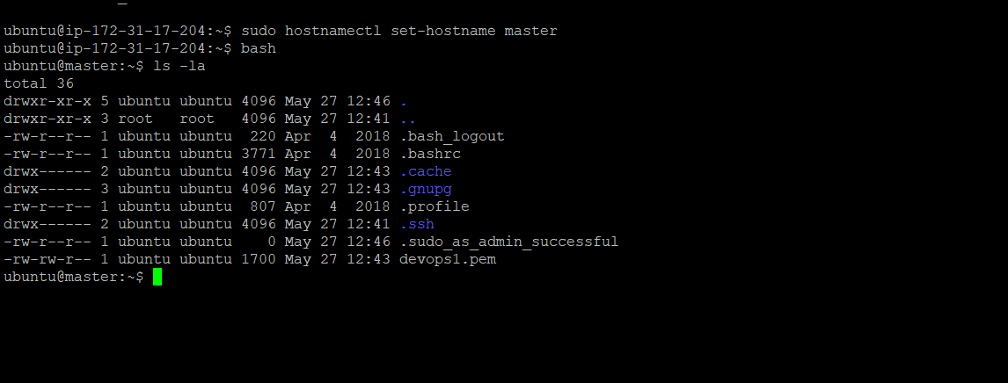

Ssh and agent service is up and pid also assign

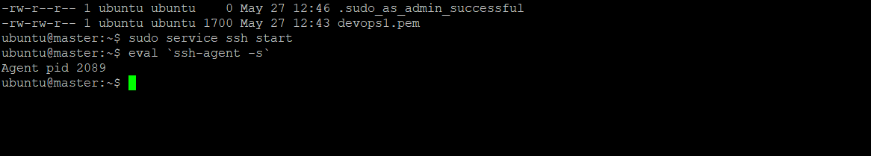

Change .pem file permission and able to login slave machine from master

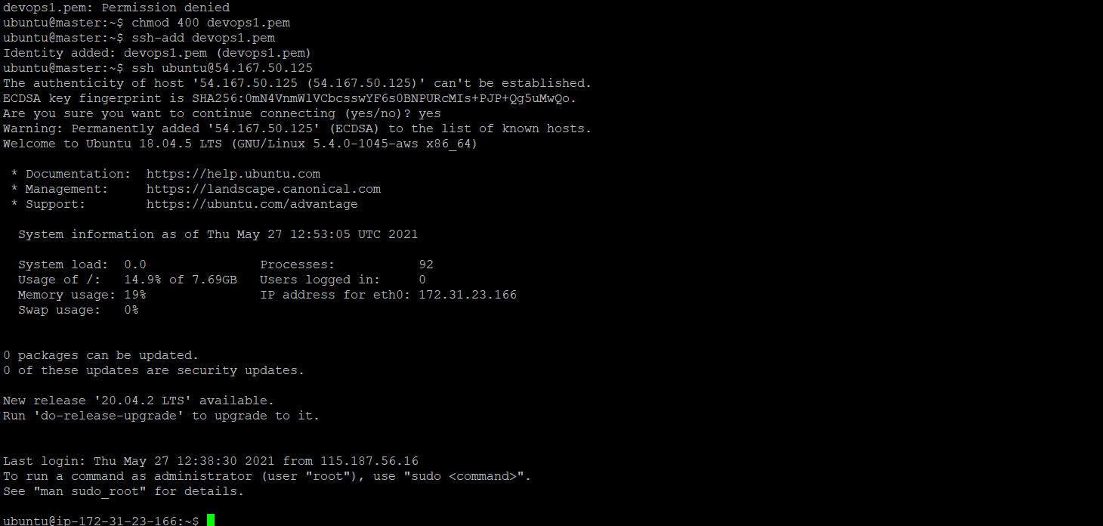

Add eval ‘ssh-agent -s’ and ssh-add devops1.pem in .bashrc file

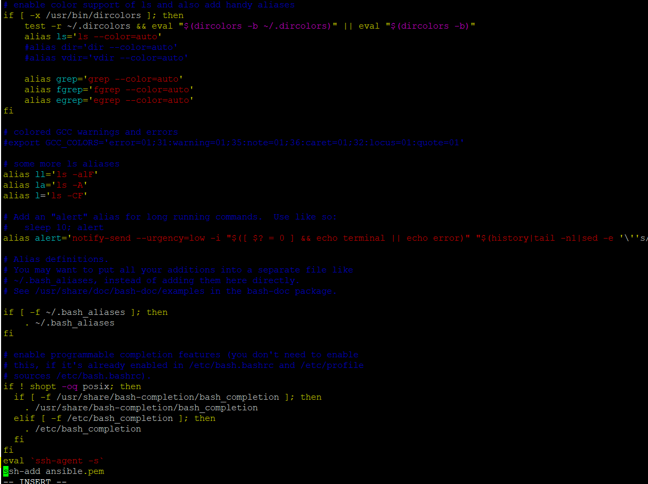

Installed ansible and private ip of client in host file /etc/ansible/ host file and successfully ping from ansible ping command

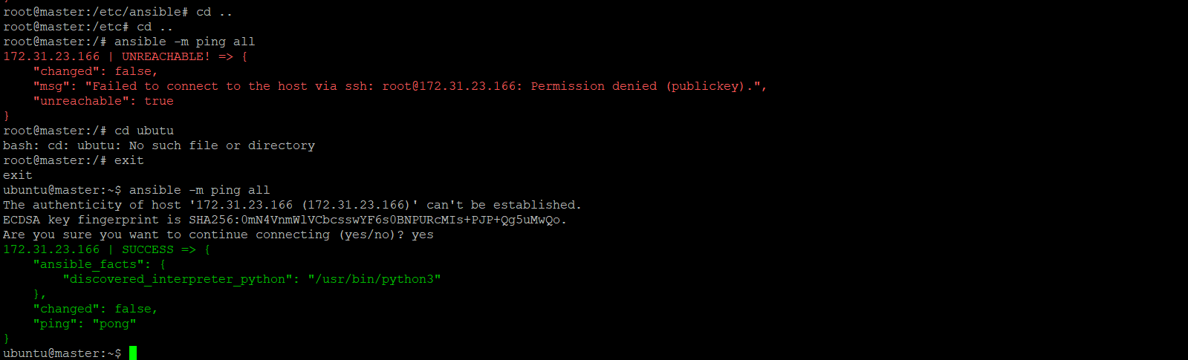

Created ansible playbook

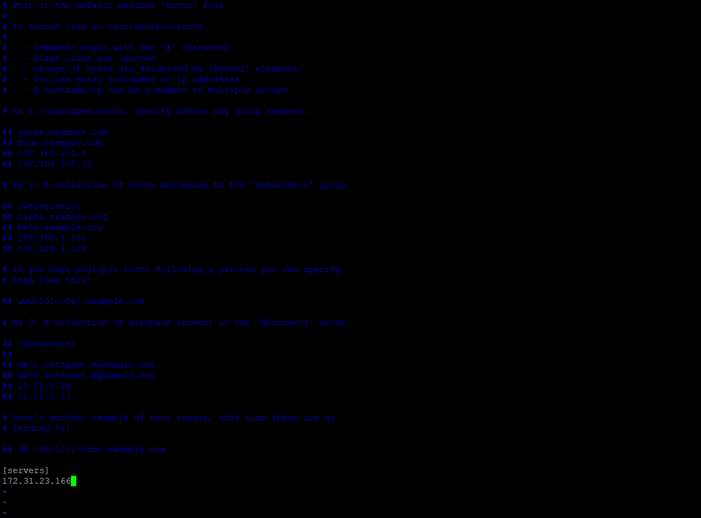

Ansible play book

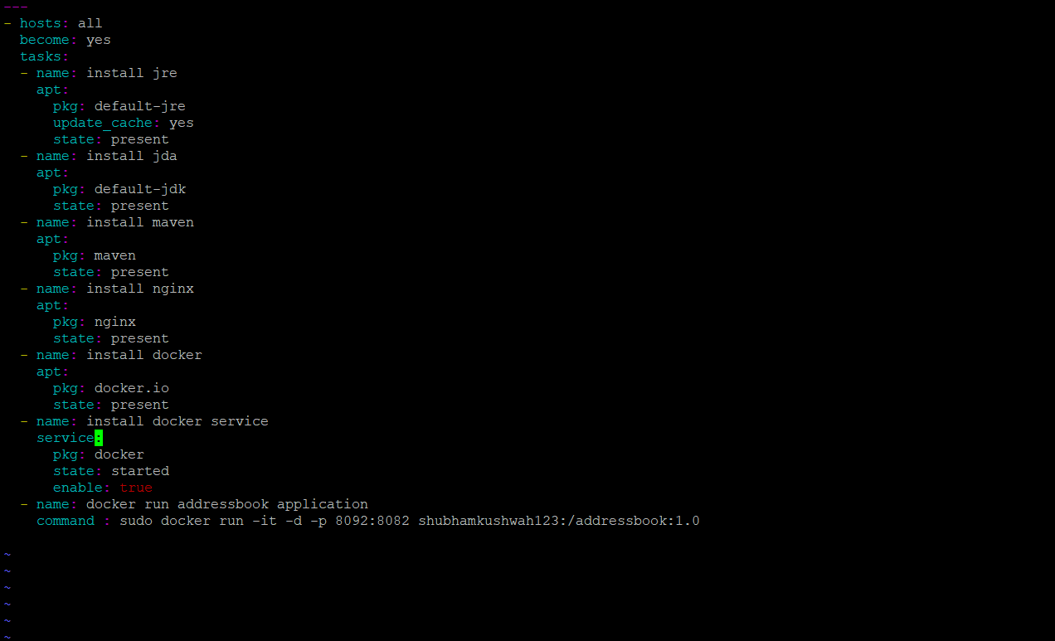

Run the play book but docker run command is not working

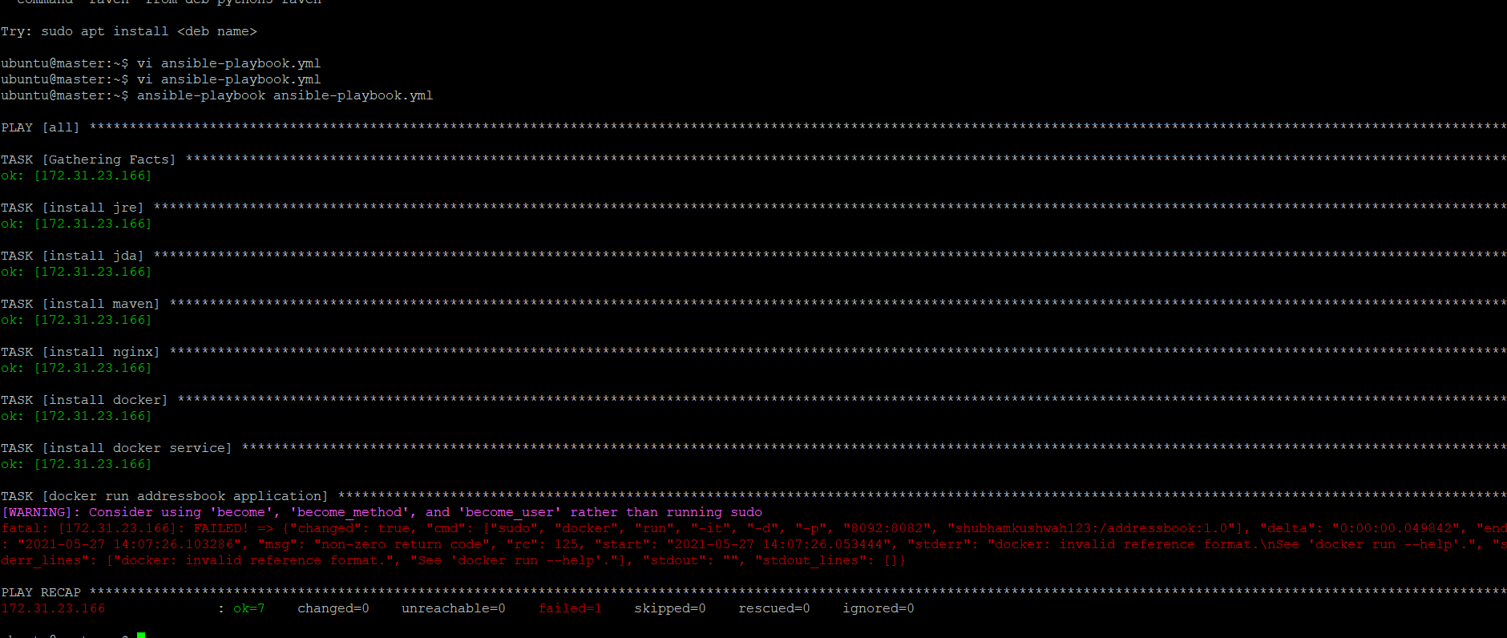

Not able to run docke images