- Election candidates reflect on negative social media


- 'They said it isn't real': Ebola rumours fuel attacks on health workers
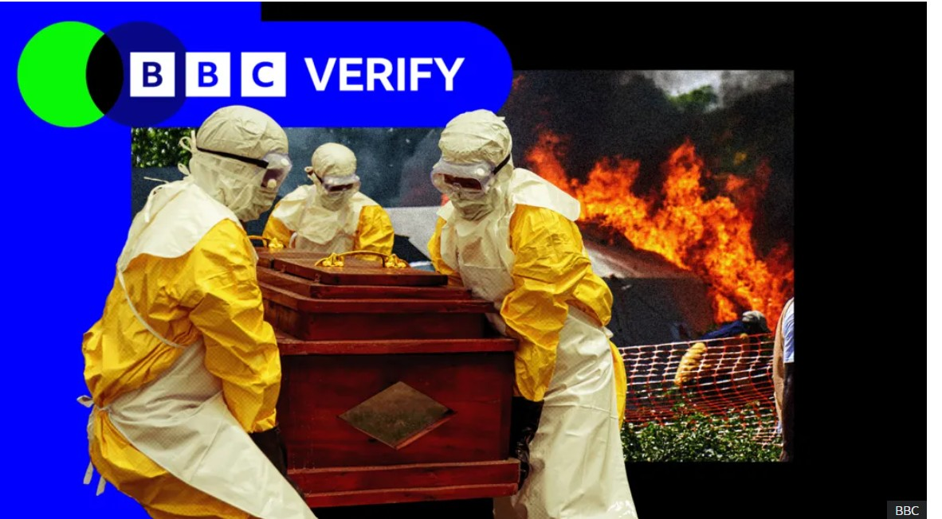

- dog leaning on elbow giving the sideeye


- irritated tree whyd you chop me down
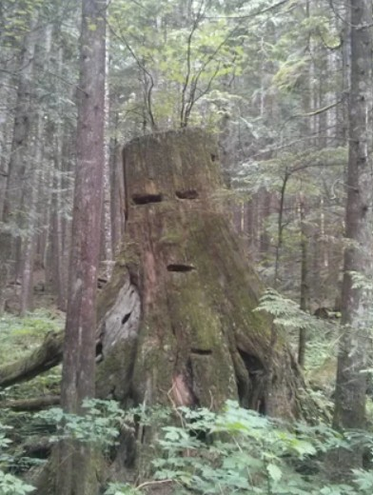

- Jesus Christ converting local teens to Christianity repainted and then colorized (circa 1 AD)
