1. CyclicBarrier：

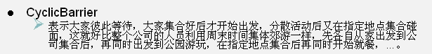

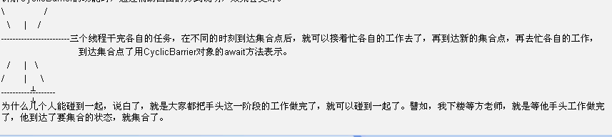

1. CyclicBarrier简单实例

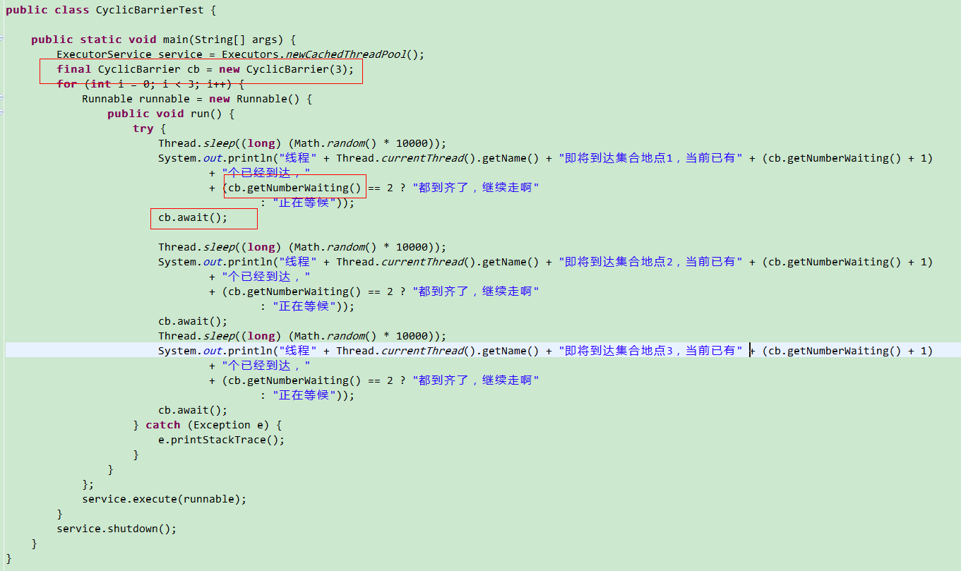

1. CountDownLatch

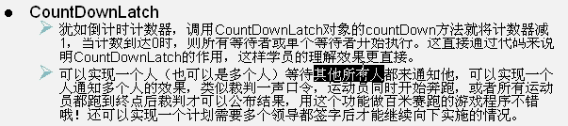

1. CountDownLatch简单实例

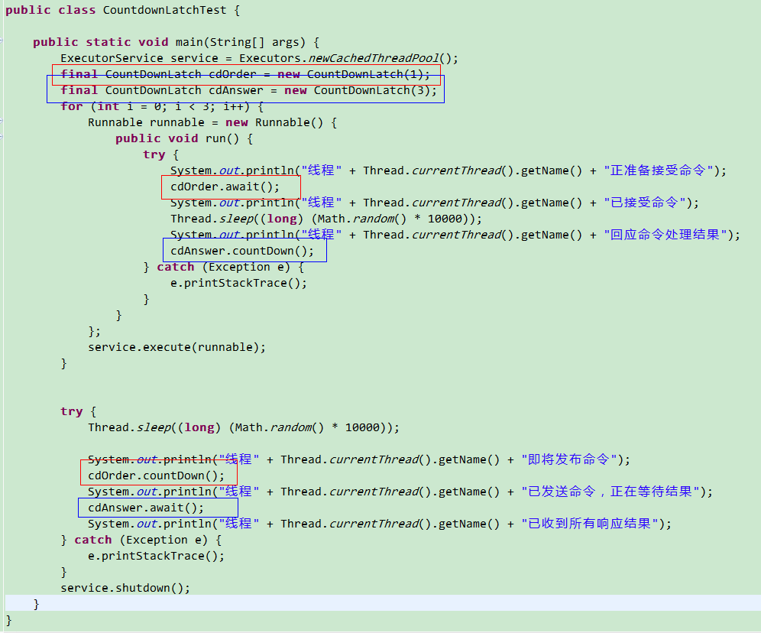

1. Exchanger

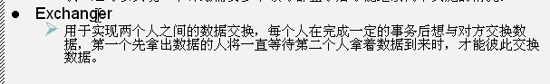

1. Exchanger简单实例

