JOY KARMOKAR

ID-18-39263-3

COA (I)

LAB TEST

QUESTION 1

.MODEL SMALL

.STACK 100H

DATA SEGMENT

MSG DB "INPUT FIRST CHAR(UPER CASE): $"

ENDS:

CODE SEGMENT

ASSUME DS:DATA CS:CODE

MAIN PROC

MOV AX,DATA

MOV DS,AX

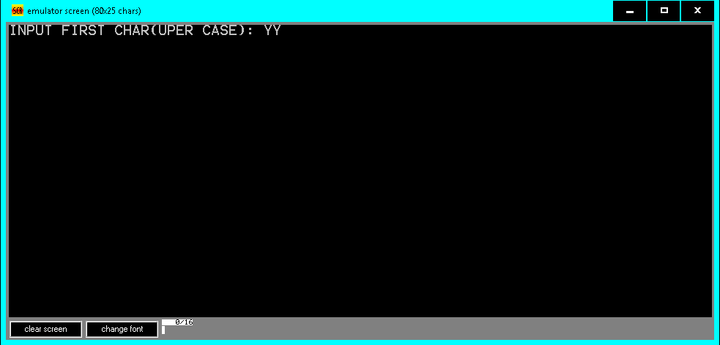 LEA DX,MSG

MOV AH,9

INT 21H

MOV AH,1

INT 21H

MOV DL,AL

MOV AH,2

INT 21H

MOV AH,4CH

INT 21H

MAIN ENDP

END MAIN

QUESTION 2

DATA SEGMENT

MESSAGE DB "ENTER A CHARATER YOU HAVE ENTERED:Y$"

ENDS

START:

MOV DL, MESSAGE

MOV AH,9

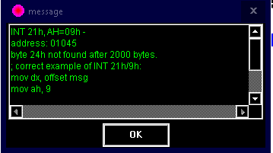INT 21H

ENDS

ENDS START

QUESTION 3

.MODEL SMALL

.STACK 100H

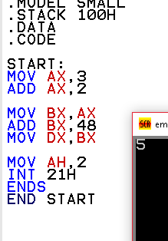.DATA

.CODE

START:

MOV AX,3

ADD AX,2

MOV BX,AX

ADD BX,48

MOV DX,BX

MOV AH,2

INT 21H

ENDS

END START

QUESTION 4

.MODEL SMALL

.STACK 100H

.DATA

.CODE

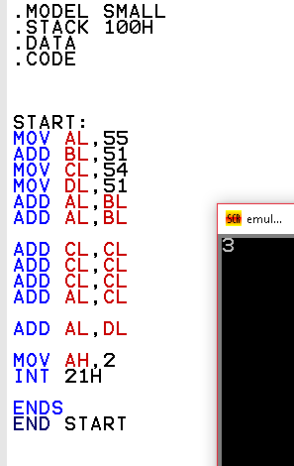START:

MOV AL,55

ADD BL,51

MOV CL,54

MOV DL,52

ADD AL,BL

ADD AL,BL

ADD CL,CL

ADD CL,CL

ADD CL,CL

ADD AL,CL

ADD AL,DL

MOV AH,2

INT 21H

ENDS

END START

QUESTION 5

INCLUDE 'EMU8086.INC'

.model SMALL

.stack 100h

DATA SEGMENT

MSG DB "HELLO WORLD$"

MSG1 DB "BYE WORLD$"

ENDS:

CODE SEGMENT

ASSUME DS:DATA CS:CODE

MAIN PROC

MOV AX,DATA

MOV DS,AX

MOV CX,50

MOV BX,60

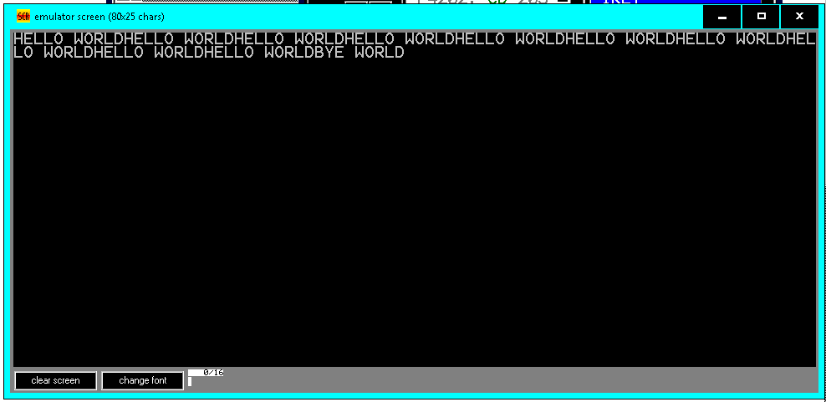 TOP:CMP BX,CX

JE LAST

LEA DX,MSG

MOV AH,9

INT 21H

DEC BX

JMP TOP

LAST:

LEA DX,MSG1

MOV AH,9

INT 21H

MOV AH,4CH

INT 21H

MAIN ENDP

END MAIN