Name: JOY KARMOKAR

ID: 18-39263-3

Section: L

ABCD = 1839

ABCD into 7-Bit ASCII characters: 1000110000111011001101001110

|  |  |  |  |  |  |  |  |
| --- | --- | --- | --- | --- | --- | --- | --- |
| Bit Position | 7 | 6 | 5 | 4 | 3 | 2 | 1 |
| 1 | 0 | 1 | 1 | 0 | 0 | 0 | 1 |
| 8 | 0 | 1 | 1 | 1 | 0 | 0 | 0 |
| 3 | 0 | 1 | 1 | 0 | 0 | 1 | 1 |
| 9 | 0 | 1 | 1 | 1 | 0 | 0 | 0 |

(a) Unipolar NRZ: +V=1, 0=0

1 0 0 0 1 1 0 0 0 0 1 1 1 0 1 1 0 0 1 1 0 1 0 0 1 1 1 0

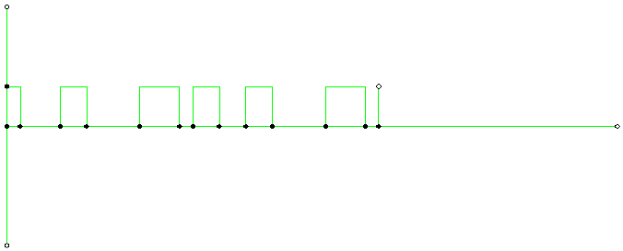

No self-synchronization if long 0s or 1s, Have DC component problem

(b) Polar NRZ- L: +v = 1, -v = 0

1 0 0 0 1 1 0 0 0 0 1 1 1 0 1 1 0 0 1 1 0 1 0 0 1 1 1 0

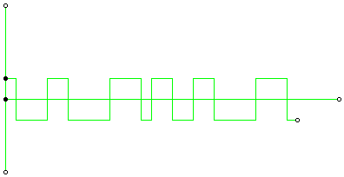

No self-synchronization if long 0s or 1s, Have DC component problem

(c) Polar NRZ-I: No inversion = Next bit is 0, Inversion: Next bit is = 1

1 0 0 0 1 1 0 0 0 0 1 1 1 0 1 1 0 0 1 1 0 1 0 0 1 1 1 0

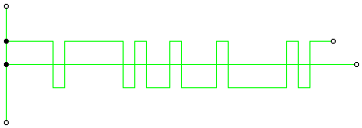

No self-synchronization if long 0s or 1s, Have DC component problem

(d) Polar Manchester:

1 0 0 0 1 1 0 0 0 0 1 1 1 0 1 1 0 0 1 1 0 010 0 1 1 1 0

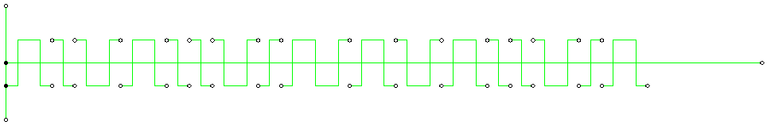

(e) Polar Differential Manchester: No inversion = Next bit is 1,

Inversion: Next bit is = 1

1 0 0 0 1 1 0 0 0 0 1 1 1 0 1 1 0 0 1 1 0 010 0 1 1 1 0

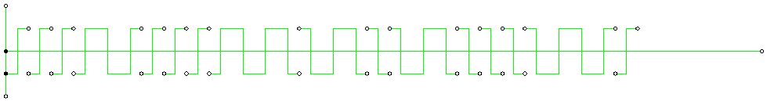

(f) Bipolar AMI: 1.The neutral zero voltage represents binary 0.

1. Binary 1s are represented by alternating positive and negative voltages.

1 0 0 0 1 1 0 0 0 0 1 1 1 0 1 1 0 0 1 1 0 1 0 0 1 1 1 0

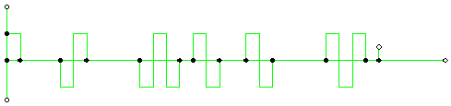

No self-synchronization if long 0s or 1s, No DC component problem

(g) Bipolar Pseudoternary: Same as AMI, but 1 bit is encoded as a zero voltage and the 0 bit is encoded as alternating positive and negative voltages

1 0 0 0 1 1 0 0 0 0 1 1 1 0 1 1 0 0 1 1 0 010 0 1 1 1 0

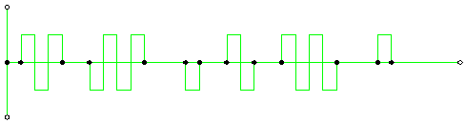

No self-synchronization if long 0s or 1s, No DC component problem

(h) 2B1Q:

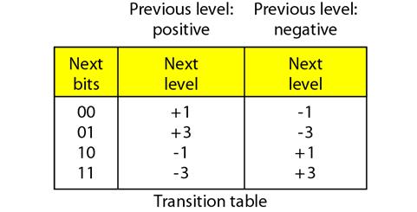

1 0 0 0 1 1 0 0 0 0 1 1 1 0 1 1 0 0 1 1 0 1 0 0 1 1 1 0

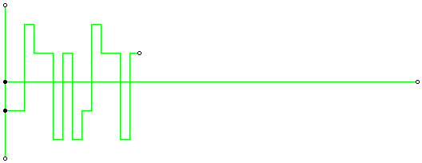

No self-synchronization if long 0s or 1s, Have DC component problem

Bitrate = EFGH*100 = 2633*100 = 263300 bit/sec

Unipolar NRZ bandwidth: N/2 = 263300/2 = 131650 Hz

Polar NRZ -L: N/2: 263300/2 =131650 Hz

Polar NRZ-I: N/2: 263300/2 = 131650 Hz

Polar Manchester: 2*NRZ = 2*131650 = 263300 Hz

Polar Differential Manchester: 2*NRZ = 2*131650= 263300 Hz

Bipolar AMI: N/2= 263300/2 = 131650 Hz

Bipolar Pseudoternary: N/2: 263300/2 = 131650 Hz

2B1Q: N/4: 263300/4 = 65825 Hz