**Introduction:**

The objective of this experiment is to understand the quantization concept and how to implement it in Matlab. When a signal is quantized, it is actually divided into a quanta (partitions). Quantization is opposite to sampling. It is done on y axis. On the x axis of the signal, are the co-ordinate values, and on the y axis, we have amplitudes. So digitizing the amplitudes is known as Quantization.

Quantization is a non-linear transformation which maps elements from a continuous set to a finite set. It is also the second step required by A/D conversion. And it is opposite to sampling. It is done on y axis. When you are quantizing a signal, you are actually dividing a signal into quanta (partitions). On the x axis of the signal, are the co-ordinate values, and on the y axis, we have amplitudes. So digitizing the amplitudes is known as Quantization.

There are two types of quantization.

1. Mid-rise type uniform quantization
2. Mid-tread type uniform quantization

**Performance Task for Lab Report: (ID = 18-39263-3)**

**Generate a analog signal using the following equation,  
x1(t) = A1 cos(2π(CDE*100)t )  
(a) Select the value of the amplitudes as follows: let A1 = GD and A2 = AF.  
(b) Assuming that a 4-bit ADC channel accepts analog input ranging from 0 to 5 volts, determine

1. The number of quantization levels.
2. The step size of the quantizer or resolution.
3. The quantization level when the analog voltage is 3.2 volts.
4. The binary code produce by the ADC.
5. Implement it in MATLAB

**Answer:**

1. A1= GD= 39

A2= AF= 16

**Matlab Code:**

fs=20000;

fc=39; * [CDE=392 this value but we can use only CD=39 value because

A1=39; taking three values increases the number of lines]

A2=16;

t=0:1/fs:0.1;

x=A1*cos(2*pi*fc*t);

m=4;

L=(2^m)

delta=(max(x)-min(x))/L

xq=min(x)+(round((x-min(x))/delta))*delta;

figure;

plot(t,x,'r','Linewidth',1.5);

hold on

stairs(t,xq,'b','Linewidth',1.5)

hold off

title('Quantization of Signal')

xlabel('Time')

ylabel('Amplitude')

legend('Original Signal','Quantized Signal')

**Waveform:**

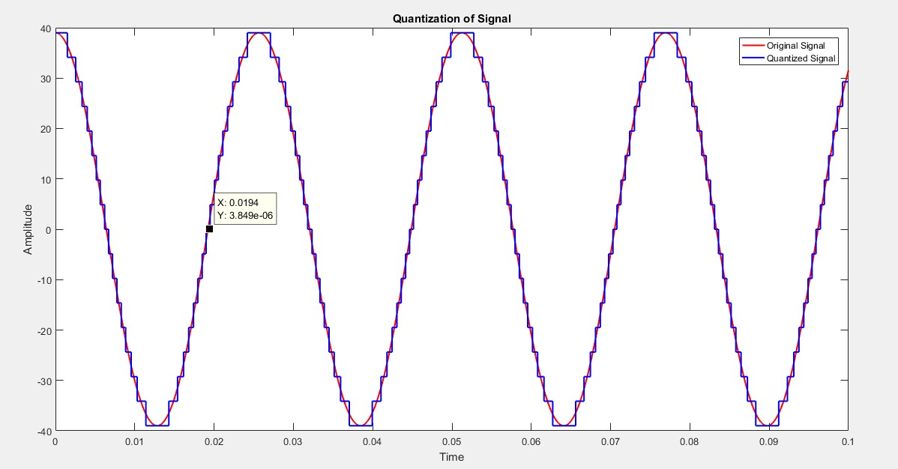



(b)

1. The number of quantization levels is 16
2. The step size of the quantizer or resolution is 12.
3. The quantization level is 12 when the analog voltage is 3.2 volts.
4. There are 16 levels. So, the binary code produced by the ADC is-

0000

0001

0010

0011

1000

0100

0111

0110

0101

1111

1110

1101

1100

1011

1010

1001

**Conclusion:** In this following experiment, the quantization of a signal is done using Matlab. The signal is not totally accurate due to the value of amplitudes and frequencies.