1. Apply PCA on CC dataset.

Reading the CC_GENERAL file and then using Imputer filling the null values to prevent the PCA.

Then creating a PCA object with n_components=2, and Fitting the PCA to the input data and transform. Lastly, connect the columns with labels, axis along horizontally.

* Performing the elbow method to find the best number of suitable clusters for the given data to implement k-means

Elbow method used to calculate the Within Cluster Sum of Squares (WCSS) against the no. of clusters.

After finding the no. of clusters, we are using K-mean Algorithm to assign the cluster labels to each data set. Finally, we calculate the Silhouette score for the clustering solution with PCA.

Next, Apply the scaling on the dataset. Then apply the scaling transformation to the input data. PCA with k value as 2 again. And print the final df.

now applying k-means to scalar PCA. Finding the Silhouette score with k-mean clustering.



We can observe that the Score is reduced after performing k-means to scaled PCA.

* Speech Features

Applying PCA with 3 components and fit transform it concatenate the training and labels and printing the final data frame.

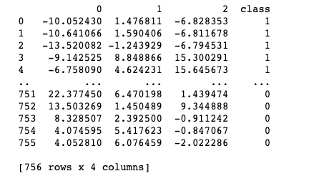

* Apply SVM classifier. Find Accuracy score and classification report for the above classifier

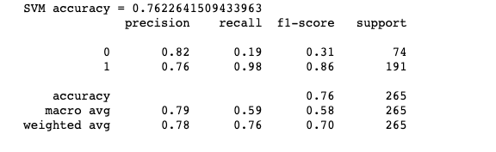

* IRIS

apply the standard scalar Method. Label encoding the species column. Apply LDA on dataset. Do the fit transform t LD1 and LD2

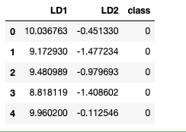

Difference between PCA and LDA:

PCA performs better when the number of samples per class is less. Whereas LDA works best with large datasets with several classes, class separability is critical for lowering dimensionality. PCA finds maximum variance directions regardless of class labels, whereas LDA finds maximum class separability directions.